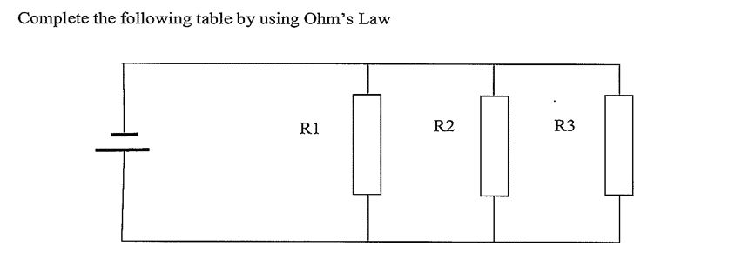

|  |  |  |  |  |  |  |  |  |  |
| --- | --- | --- | --- | --- | --- | --- | --- | --- | --- |
|  | **VS** | **R1** | **R2** | **R3** | **RT** | **IR1** | **IR2** | **IR3** | **IT** |
| 1 | 25 V | 15 Ω | 25 Ω |  | **9.4 Ω** | **1.66 A** | **1 A** |  | **2.66 A** |
| 2 | 100 V | 25 Ω | 50 Ω |  | **16.7 Ω** | **4 A** | **2 A** |  | **6 A** |
| 3 | 10 V | 35 Ω | 50 Ω | **25 Ω** | 11.35 Ω | **286 mA** | **200 mA** | **396 mA** | **881 mA** |
| 4 | 10 V | **200 Ω** | 150 Ω | 250 Ω | **64 Ω** | **50 mA** | 66.6 mA | **40 mA** | 156 mA |
| 5 | 100 V | **1000 Ω** | **500 Ω** | **334 Ω** | **167 Ω** | 100 mA | 200 mA | **300 mA** | 600 mA |
| 6 | 100 V | 1 kΩ | 2 kΩ | 3k5Ω | **560 Ω** | **100 mA** | **50 mA** | **28 mA** | 178 mA |
| 7 | 50 V | 10 kΩ | 15 kΩ | **25 kΩ** | **4k84 Ω** | **5 mA** | **3 mA** | **2 mA** | 10 mA |
| 8 | 55 V | 25 kΩ | 15 kΩ | **12k5 Ω** | **5k36 Ω** | 2m2A | **3m6A** | 4m4A | 10m25A |
| 9 | 100V | **2k9 Ω** | **4k Ω** | **2k5 Ω** | **1k Ω** | 35 mA | 25 mA | 40 mA | **100 mA** |