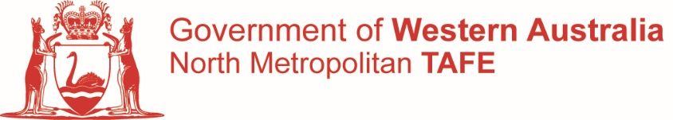

UEE22020 Certificate II in Electrotechnology – Career Start

State Code: BFP1 – Pathway Code: AC54

**UEECD0052 - Use routine equipment/plant/technologies in an energy sector environment**

**Resource Book**

Based on:

National Electrotechnology Standards



AQF Level:

Certificate II in Electrotechnology

Compiled by B.L.Kinsella.

Revised by J M Waswo

North Metropolitan TAFE

June 2021

## COPYRIGHT STATEMENT

This workbook has been compiled by B.L. Kinsella of North Metro TAFE for educational purposes. It was revised by John Waswo in June 2021

This Resource Book is intended for use by NMTAFE students only.

Some of the material and graphics in this workbook may have been reproduced from the following published material by NMTAFE for educational purposes under Part VB of the Copyright Act 1968.

- *National Curriculum* - EE-Oz Training Standards Australia

All rights reserved. Apart from any use as permitted under the Copyright Act 1968, no part

may be reproduced without the prior written permission of NMTAFE.

This permission does not extend to the making of copies for use outside the immediate training environment for which they are made, nor the making of copies for hire or resale to third parties.

Requests and enquiries concerning other reproduction and rights should be directed in the first instance to the Manager Publications and Distributions.

Manager Publications and Distributions NMTAFE

P.O. Box 1336

MIDLAND WA 6936

Telephone: +61 08 9267 7649

Facsimile: +61 08 9267 7516

**Disclaimer:**

Whilst every effort has been made to ensure the accuracy of the information contained in this publication, no guarantee can be given that all errors and omissions have been excluded. No responsibility for loss occasioned to any person acting or refraining from action as a result of the material in this publication can be accepted by NMTAFE.

# **Printed by** NMTAFE **Printing Service**

**UEECD0052 - Use routine equipment/plant/technologies in an energy sector environment**

**Modification History**

Release 1. This is the first release of this unit of competency in the UEE Electrotechnology Training Package.

**Application**

This unit involves the skills and knowledge required to use routine equipment, plant, technologies and personnel protective equipment (PPE) in an energy sector environment. It includes preparing and using equipment, plant, technologies and PPE, and completing workplace requirements in an energy sector work environment. No licensing, legislative or certification requirements apply to this unit at the time of publication.

**Pre-requisite Unit**

UEECD0007 - Apply work health and safety regulations, codes and practices in the workplace

**Elements and Performance Criteria**

|  |  |  |  |
| --- | --- | --- | --- |
| **ELEMENTS** | | **PERFORMANCE CRITERIA** | |
| Elements describe the essential outcomes. | | Performance criteria describe the performance needed to demonstrate achievement of the element. | |
| **1** | **Prepare to use equipment**, **plant and technologies** | **1.1** | Work instructions in the use of equipment, plant or technologies are obtained, interpreted and followed |
|  |  | **1.2** | Work health and safety (WHS)/occupational health and safety (OHS) policies and workplace procedures are identified, communicated and confirmed to ensure they are applied in the carrying out of work activities in an energy sector environment |
|  |  | **1.3** | Tools, equipment and PPE necessary for work are identified, scheduled and checked to ensure they work correctly and are safe to use in accordance with workplace procedures |
|  |  | **1.4** | Relevant person/s is consulted to ensure the work is coordinated effectively with others |
|  |  | **1.5** | Resources and materials needed for work are confirmed, scheduled and obtained in accordance with workplace procedures |
|  |  | **1.6** | Schedule of work, including practices for working safely, are confirmed in accordance with workplace instructions and requirements |
| **2** | **Use equipment**, **plant and technologies** | **2.1** | WHS/OHS policies and workplace procedures for safe work practices are followed to eliminate or minimise incidents |
|  |  | **2.2** | Equipment, plant or technologies are used in accordance with schedule of work to ensure work is completed in agreed timelines, to required quality standard and with a minimum of waste |
|  |  | **2.3** | Unplanned situations are responded to in accordance with workplace procedures in a manner that minimises risk to personnel and equipment |
|  |  | **2.4** | Regular checks of work quality are undertaken in accordance with work instructions and job requirements |
| **3** | **Complete use of equipment**, **plant and technologies** | **3.1** | Regular checks are made to ensure the safe use of equipment, plant or technologies in accordance with job instructions and requirements |
|  |  | **3.2** | Relevant person/s is notified of work completion using equipment, plant or technologies |
|  |  | **3.3** | Tools, equipment and surplus resources and materials are appropriately cleaned, checked and returned to storage in accordance with workplace procedures |
|  |  | **3.4** | Work area is cleaned, made safe and sustainable energy practices are followed |
|  |  | **3.5** | Workplace record/s are updated in accordance with work instructions and workplace procedures |

**Assessment Requirements for UEECD0052 Use routine equipment/plant/technologies in an energy sector environment**

**Performance Evidence**

Evidence required to demonstrate competence in this unit must be relevant to and satisfy all of the requirements of the elements and performance criteria on at least two separate occasions and include:

* applying relevant work health and safety (WHS)/occupational health and safety (OHS) requirements, including:
  + applying risk control measures
* following workplace procedures and instruction
* applying sustainable energy principles and practices
* completing workplace documentation
* dealing with unplanned events/situations in accordance with workplace procedures in a manner that minimises risk to personnel and equipment
* maintaining a clean worksite and equipment
* preparing and using equipment, plant and technologies, including:
  + completing schedule of work
  + using and returning tools, equipment, personnel protective equipment, surplus resources and materials
* updating work records.

**Knowledge Evidence**

Evidence required to demonstrate competence in this unit must be relevant to and satisfy all of the requirements of the elements and performance criteria and include knowledge of:

* electrical concepts, including: · electrical supply and distribution within a building or premises
* arrangement of circuits
* protection for safety requirements and their practice
* difference between alternating current (a.c.) and direct current (d.c.)
* measurement and calculation of voltage, current, resistance and power in practical circuits
* concepts and applications of magnetism and electromagnetic induction
* transformer operating principles and their application
* hazards associated with electrical systems and apparatus
* energy sector tools, equipment and technology
* relevant energy sector industry standards
* relevant manufacturer specifications
* operating instruction for tools, equipment and technologies
* relevant job safety assessments or risk mitigation processes
* relevant sustainable energy practices
* relevant WHS/ OHS legislated requirements
* relevant workplace documentation
* relevant workplace policies, procedures and instructions.

**Assessment Conditions**

Assessors must hold credentials specified within the Standards for Registered Training Organisations current at the time of assessment. Assessment must satisfy the Principles of Assessment and Rules of Evidence and all regulatory requirements included within the Standards for Registered Training Organisations current at the time of assessment.

Assessment must occur in suitable workplace operational situations where it is appropriate to do so; where this is not appropriate, assessment must occur in simulated suitable workplace operational situations that replicate workplace conditions. Assessment processes and techniques must be appropriate to the language, literacy and numeracy requirements of the work being performed and the needs of the candidate. Resources for assessment must include access to: · a range of relevant exercises, case studies and/or simulations · relevant and appropriate materials, tools, facilities, equipment and personal protective equipment (PPE) currently used in industry · applicable documentation, including workplace procedures, equipment specifications, regulations, relevant industry standards, codes of practice and operation manuals.

**Contents**

1. Pre-requisites, Elements and Performance Criteria.

2. Required Skills and Knowledge.

3. Development of Electricity Supply Systems

4.

Modern generation methods

Electricity transmission and distribution systems

Distribution of electricity to consumers

Distribution of electricity in the consumer’s installation

References

* + Electrical Wiring Practice Volume 1,Chapter 1 Keith Pethebridge and Ian Neeson, McGraw-Hill Australia
  + WA Electricity (Licensing) Regulations 1991
  + UEE Electrotechnology Training Package or extracts.
  + WA Electrical Requirements
  + Australian/New Zealand Wiring Rules AS/NZS 3000:2018

Note: This information and current details of critical aspects for each competency standard unit (CSU) in this qualification can be found at www.training.gov.au

**Energy Sector Equipment, Plant and Technologies and Practises**

Achievement Record Sheet

|  |  |  |
| --- | --- | --- |
| Name: | NMTAFE Student ID: |  |
|  |  |  |

|  |  |  |  |  |
| --- | --- | --- | --- | --- |
| Activity | Topic | Date | Lecturer | Notes |
| Sheet 1-1 | Electrical energy past present and future |  |  |  |
| Activity 1-1 | Researching a significant event in the history of the electricity supply industry |  |  |  |
| Activity 1-2 | To research a significant person in history of electrical generation |  |  |  |
| Activity 1-3 | To research a generation method (Presentation) |  |  |  |
| Worksheet 1-4 | Direct and Alternating Current |  |  |  |
| Activity 1-4 | Magnetism Practical |  |  |  |
| Activity 1-5 | Transformer and Induction Practical |  |  |  |

**Workplace Rules:**

Rule 1 Follow the instructions

Rule 2 Tolerate ambiguity

Rule 3 Meet your obligations

|  |  |  |  |
| --- | --- | --- | --- |
| North Metro TAFE | **Electrotechnology Industry** |  | BLK 04/2013 |
|  |  | Introduction |  |
| Electrical Trades |  | 1-1 |  |

**Development of Electricity Supply Systems**

**Task:**

To develop an understanding on the history and the development of modern electricity supply systems. Electricity is a major modern energy source and this section outlines the process of generation, transmission and distribution of electricity.

**Why:**

Knowledge of the history is necessary so that those involved in the industry are aware of the part electricity plays in modern society and why distribution systems are important.

**To Pass:**

1. You must correctly answer the questions on the Work Sheets provided and demonstrate a level of competency in a knowledge test for each relevant topic.

2. You must satisfactorily complete the set activities and laboratory tasks.

3. You must achieve 100% in a final practical competency assessment.

**Equipment and resources:**

Enrolment in unit module on Blackboard LMS

Access to workshop equipment, appliances and tools

**References:**

* + Electrical Wiring Practice - Volume 1, Pethebridge and Neeson.(Chapter 1)
* <http://www.powerworks.com.au>
* <http://www.aemo.com.au> (regarding National Electricity Market)
* <http://www.snowyhydro.com.au/>
* <http://www.etsautilities.com.au/centric/home.jsp>
* <http://www.ena.asn.au/>
* <http://inventors.about.com/library/inventors/blelectric.htm>
  + WA Electricity Licensing Regulations
  + UEE Electrotechnology Training Package
  + WA Electrical Requirements
  + Australian/New Zealand Wiring Rules AS/NZS 3000:2018

|  |  |  |  |
| --- | --- | --- | --- |
| North Metro TAFE | **Electrotechnology Industry** |  | BLK 04/2013 |
|  |  | Summary |  |
| Electrical Trades |  | 1-1 |  |

**Development of Electricity Supply Systems**

**Objectives**

* To provide an overview of the history of the development of the electricity supply system.
* To discuss modern methods of generation including renewable energy and sustainable energy practices.
* To describe the electricity transmission and distribution systems.
* To introduce the three-phase, four-wire electrical supply system.
* To consider the process of obtaining connection to the electricity supply system.

1. Study the following sections in the recommended references:

## Electrotechnology Practice:

Electrical Wiring Practice - Volume 1, Pethebridge and Neeson. (Chapter 1 Section 1.1, 1.2, 1.4, 1.5 and 1.6

Electrical Licensing and 3.2 Standards)

WA Electrical Requirements Section 6

Australian/New Zealand Wiring Rules AS/NZS 3000:2018 (Scope and Application

The following websites;

* http://www.powerworks.com.au
* http://www.aemo.com.au (regarding National Electricity Market)
* http://www.snowyhydro.com.au/
* http://www.etsautilities.com.au/centric/home.jsp
* http://www.ena.asn.au/
* http://inventors.about.com/library/inventors/blelectric.htm

2. Read the Pethebridge and Neeson Volume 1 Chapter One and practise answering the questions provided on the Work Sheets. Refer to other relevant texts if you feel it is necessary.

3. Answer the questions given on the Work Sheets. Use a separate answer sheet or sheets for each Work Sheet. Note that you are required to answer ALL questions correctly, although not necessarily at the same time.

4. Complete the activities in this Section.

5. Submit your answers to the Work Sheets and your completed activity sheets to your Lecturer for discussion.

|  |  |  |  |
| --- | --- | --- | --- |
| North Metro TAFE | **Electrotechnology Industry** | Study Guide | BLK 04/2013 |
|  |  | 1-1 |  |
| Electrical Trades | Section 1 |  |  |

**Development of Electricity Supply Systems**

Suggested Self-Study Guide

Read the following information provided and use as a reference to answer the worksheet questions.

An excerpt of the following is available on the Blackboard LMS module for this unit.

Read Pethebridge and Neeson Volume 1 Chapter 1 Section 1.1 **A brief history of electrical production and supply**

Discoveries and development of electrical energy, Table 1.1

Brief history of the electrical supply industry, Table 1.2

Read Pethebridge and Neeson Volume 1 Chapter 1 Section 1.2, **Modern generation**

**methods**

Figures 1.2 a, b, c and d.

Read Pethebridge and Neeson Volume 1 Chapter 1 Section 1.3 **Renewable energy and**

**sustainable energy practices**

Renewable energy sources, Figures 1.3a, b, c, d, e, f, g and h.

Generating and using energy efficiently

Read Pethebridge and Neeson Volume 1 Chapter 1 Section 1.4 **Electricity transmission**

**and distribution systems**

Figures 1.4 a, b and c

Read Pethebridge and Neeson Volume 1 Chapter 1 Section 1.5 **Distribution of electricity to consumers**

Page 16, Figures 1.5 a and b

Read Pethebridge and Neeson Volume 1 Chapter 1 Section 1.6 **Distribution of electricity to consumer’s installation**

Getting connected to the supply network, Figure 1.6

Notification of intention to carry out electrical work, Table 1.3

Financial contribution

Verification of compliance, Figure 1.6b

Connecting the supply

Dealing with defective work

Situations requiring special procedures

|  |  |  |  |
| --- | --- | --- | --- |
| North Metro TAFE | **Energy Sector equipment/plant/technologies** |  | BLK 04/2013 |
|  |  | Work Sheet |  |
| Electrical Trades | Section 1 | 1-1 |  |

Answer all of the following review questions taken from page 21 of Pethebridge and Neeson Volume 1 Chapter 1

1. How does coal-powered thermal generation work?
2. In what year did Western Australia first receive a public electricity supply?
3. What invention is considered to be the introduction of public electricity supply?
4. Describe the basic principle of electricity generation in an alternator.
5. At what voltages do steam turbine driven alternators produce electricity?
6. How is the steam that is used to drive the turbine, isolated from the reactor in nuclear-powered thermal generation?
7. How is the thermal efficiency of a gas turbine alternator increased?
8. Why is it important to drive a generator at a particular constant speed?
9. Apart from being a clean energy source, name an advantage hydro generation has over steam generation?
10. What is hot rock technology?
11. How can water be reused for power generation in a hydro scheme?
12. List some common applications of direct power generation.
13. Give an example of efficient use of energy.
14. What is an advantage of the three-phase a.c. systems?
15. What was the main disadvantage of the original d.c. supply systems?
16. Describe the principles and advantages of modern d.c. transmission.
17. How are the conductors in a three phase low-voltage system designated?
18. The force of attraction between two electric charges is inversely proportional to the square of their distance, is a law is of electrical physics. Who is the law named after?
19. What are the typical primary and secondary transmission voltages?
20. What role does the sub-station play in the transmission and distribution of electricity?
21. Who or what determines how much energy is needed from the electricity supply system at any one time?
22. What is the most common distribution system to consumers in Australia and New Zealand?
23. Explain the function of the fourth conductor in the three-phase low voltage distribution system.
24. Illustrate the SWER system showing the typical voltages it supplies.
25. List the configurations of low-voltage supply to consumers.
26. How is the protective earth and neutral (PEN) conductor arranged in the consumer’s installation?
27. Describe the wiring rules requirement for arrangement of electrical installations.
28. List the components of a consumer’s installation that are installed at a main switchboard.
29. Briefly describe the main process involved in connecting supply to a consumer’s installation.
30. What actions are taken if an inspector finds an installation to be defective?
31. Name three aspects of electrical work typically covered in service and installation rules.
32. Describe a situation where special procedures are used for inspection and connection or disconnection of supply.

|  |  |  |  |
| --- | --- | --- | --- |
| North Metro TAFE | **Energy Sector equipment/plant/technologies** |  | BLK 04/2013 |
|  |  | Activity |  |
| Electrical Trades | Section 1 | 1-1 |  |

#### Researching a significant event in the history of the electricity supply industry

# **Objective**

To research one of the significant events set out in tables 1.1 and 1.2 (pages 3 and 4 Pethebridge and Neeson).

# **Equipment**

Internet

Library

# **Procedure**

1. Access the Internet or Library and obtain enough information to fill one type written A4 page.

1. Use the Internet or Library catalogue to search for the information required to fill in the A4 page.
2. Submit your research as a completed activity sheet to your Lecturer for discussion.

|  |  |  |  |
| --- | --- | --- | --- |
| North Metro TAFE | **Energy Sector equipment/plant/technologies** |  | BLK 04/2013 |
|  |  | Activity |  |
| Electrical Trades | Section 1 | 1-2 |  |

**In your opinion who made the most important contribution to the electrical industry? Give substantial reasons for your decision.**

# **Objective**

To research a significant person from tables 1.1 and 1.2 (pages 3 and 4 Pethebridge and Neeson).

# **Equipment**

Internet

Library

# **Procedure**

1. Access the Internet or Library and obtain enough information to fill one type written A4 page.

1. Use the Internet or Library catalogue to search for the information required to fill in the A4 page.
2. Submit your research as a completed activity sheet to your Lecturer for discussion.

|  |  |  |  |
| --- | --- | --- | --- |
| North Metro TAFE | **Energy Sector equipment/plant/technologies** |  | BLK 04/2013 |
|  |  | Activity |  |
| Electrical Trades | Section 1 | 1-3 |  |

**Choose a modern electrical generation method and produce a presentation for the rest of the group.**

# **Objective**

To research a generation method (pages 5 to 12 Pethebridge and Neeson).

# **Equipment**

Internet

Library

Overhead projector

Classroom computer

# **Procedure**

1. Access the Internet Library and Pethebridge and Neeson to obtain enough information to present information to the group that is more detailed than in Pethebridge and Neeson or explores some aspect that is not covered in Pethebridge and Neeson.
2. The information is to be presented to the group in any form that makes it relevant and interesting. A PowerPoint presentation is one option. Diagrams, videos and talks are other suggestions.
3. Submit your research as a completed activity sheet to your Lecturer for discussion.

|  |  |  |  |
| --- | --- | --- | --- |
| North Metro TAFE | **Energy Sector equipment/plant/technologies** |  | TOG 06/2018 |
|  |  | Section |  |
| Electrical Trades |  | 1-4 |  |

**Direct and Alternating Current**

**Sources of Alternating and Direct Current**

1. Direct continuous current is primarily produced using a chemical reaction such that which occurs in a battery. Direct Current is also outputted by Photo-Voltaic cells such as Solar Panels.
2. Direct Current can be produced by using a generator however the output D.C. is not “pure” as it contains “Ripple”. Essentially the output is Alternating Current but converted into Direct Current by mechanical or electronic switching mechanisms.
3. Alternating current is producing using a mechanically driven generator, large volumes of electricity can be supplied in this way and it forms the basis of all modern electricity supply systems.
4. Alternating current is used for supply authority distribution systems, because it has several advantages over a direct current distribution system. The main advantages include:
   1. The voltage can be increased or decreased more easily and economically using transformers.
   2. A.C. motors are often simpler, more reliable and require less maintenance than d.c. motors.
   3. A three phase a.c. supply system provides two voltage levels.
   4. A.C. can be transmitted over long distances at high voltages with minimum losses.
   5. Large a.c. generators (alternators) are generally easier to build and maintain than d.c. generators.
5. Although a.c. is generally more economical to produce and distribute than d.c., the behaviour of a.c. is much more complex than d.c., because the effects of inductance and capacitance are of a major significance, this due to the characteristics of the A.C. sine wave (or sine curve) output.

**Waveforms**

1. It is frequently necessary to describe a voltage or current by graphing its value over a given period of time. Direct current maintains the same magnitude and polarity over time, and can be represented as shown in Figure 1.



Figure 1 - A graph of direct current

1. A sinusoidal a.c. voltage waveform is a graph of the magnitude and polarity of the voltage induced in a coil rotating uniformly through a two pole magnetic field for one complete revolution or cycle – a cycle is the time taken for the process to begin repeating itself. The number of cycles which occur in a given period is called the **frequency** and is usually expressed in cycles per second. The unit ‘cycles per second’ is given a special name – Hertz (Hz).

Note: Period – The time it takes to complete one cycle.

1. The frequency of the 240/415Vac supply is 50Hz (50 cycles per second), so the current (and voltage) is rising and falling at a known rate in such a way that one complete cycle occurs in 1/50th of one second, or 0.02 seconds (20ms). These relationships for a single phase a.c. sine wave are shown graphically in Figure 2.



 

Figure 2 - Single phase a.c. sine wave

1. All a.c. supply systems generate a sine wave, but other waveforms are used in electronic applications. The most common of these are:



1. **Rectangular Waveform**



1. **Triangular Waveform**

Figure 3 – Waveforms

**Single Phase Transformers**

7. A transformer is a stationary device used to increase or decrease the voltage of an a.c. supply with very low losses.

8. A transformer has at least two windings wound on a magnetic core. The winding connected to the input is called the PRIMARY and the winding connected to the output is called the SECONDARY. Many variations of the coil arrangement are possible.

9. The core is usually made from a high quality laminated stalloy or ferrite, to reduce iron losses such as eddy currents and hysteresis. Many small to medium sized transformers use grain oriented 'C Cores' instead of laminations.

10. The two main core shapes are 'core type' and 'shell type'.

Typical core shapes and winding styles are shown in Figures 1 and 2.

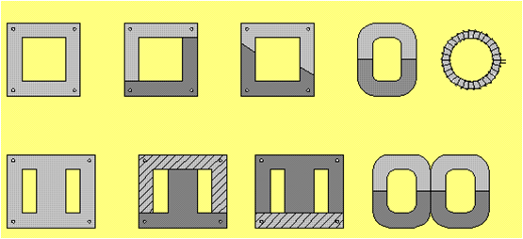

Figure 1 - Typical single phase core shapes

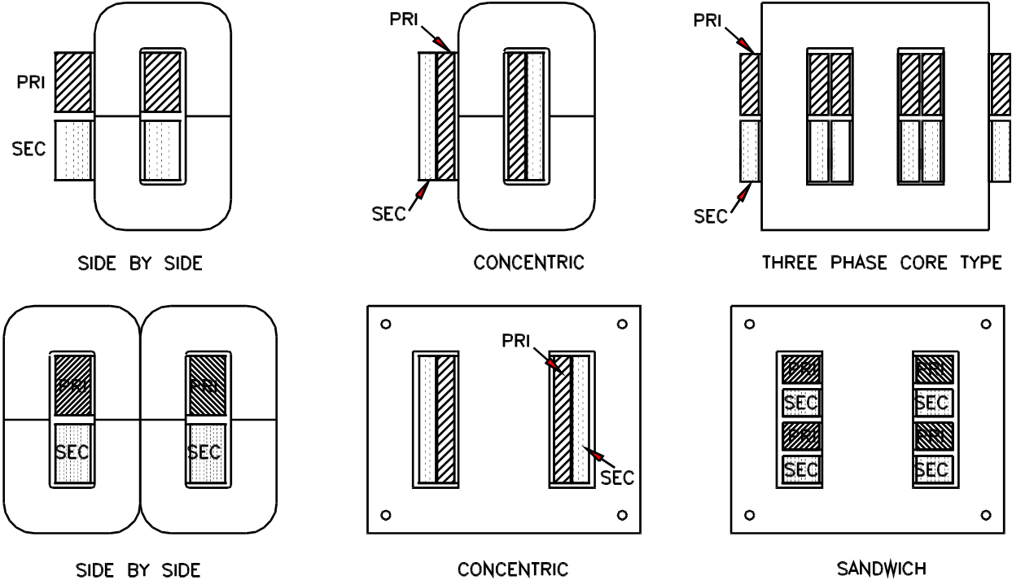

Figure 2 - Typical winding styles

The top 3 diagrams are examples of Core type construction and the bottom 3 diagrams are examples of shell type construction.

11. Electrical insulation in the form of an oxide, a powder, or a thin mylar film is provided between laminations. This insulation should not be damaged. Ferrite is a very good magnetic conductor but it is a very poor electrical conductor.

**Double Wound Transformer**

12. In this type, the primary and secondary windings are insulated electrically, but they are connected magnetically (by mutual induction). The symbol for a double wound transformer is shown in Figure 3:

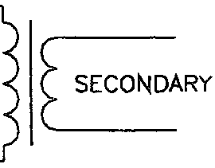

PRIMARY

Figure 3 - Single phase transformer symbol.

If the output voltage is higher than the input, it is a STEP UP transformer. If the output voltage is lower than the input, it is known as a STEP DOWN transformer.

In a step DOWN transformer the resistance of the primary winding is usually higher than the resistance of the secondary winding and visa versa because the winding with the lowest voltage is usually wound with a heavier gauge wire. Some transformers have 'tapped' primary or secondary windings to allow for more than one primary or secondary voltage.

**Double Wound Transformer Construction**

13. Figure 4 shows a typical layout and construction for a double wound single phase shell type transformer which has one primary winding and one secondary.

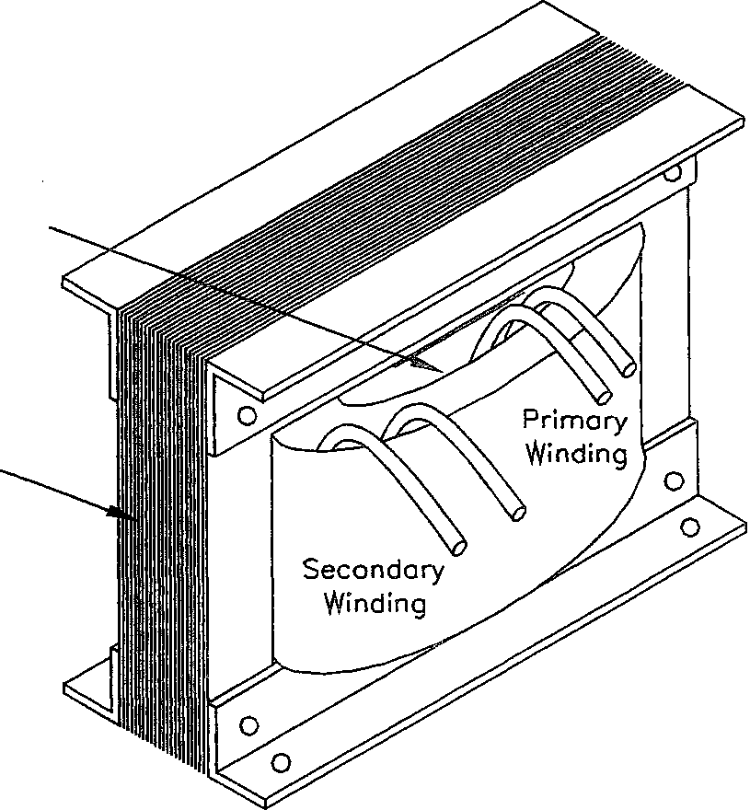

Electrostatic Shield

(if fitted)

laminations

Figure 4 - Shell type transformer

**Electromagnetism and Magnetic Circuits**

**Electromagnetism**

14. When current passes through a conductor, a magnetic field is produced around the conductor and at right angles to it. If the current flow is away from the observer, the magnetic field is in a clockwise direction around the conductor.

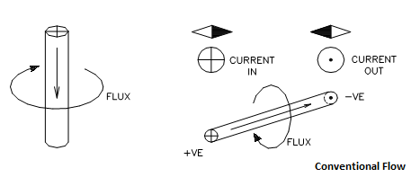

  
**Applications of an Electromagnet**

15. Electromagnets are used in most machines where electrical energy is converted into motion and visa versa. Typical uses are:

a. MRI machines.

b. Door Strikes.

c. Speakers.

d. Motors.

e. Generators.

f. Magnetic relays, starters and contactors.

g. Electromagnets for lifting steel objects.

h. Solenoids (electromagnets with a moving core).

i. Magnetic brakes and clutches.

j. Magnetic circuit breakers and overload sensors.

k. Magnetic reed switches and inductive limit switches.

**Electromagnetic Induction (EMI)**

16. When a conductor is moved across a magnetic field, a voltage is INDUCED in the conductor. The process is known as electromagnetic induction (EMI) or Faraday's Law of magnetic induction. If the conductor is part of a closed electrical circuit a current will flow.

17. The value of the voltage induced in the conductor, and hence the current, will be proportional to:

a. The strength of the magnetic field - a stronger field causes a higher voltage.

b. The number of turns in series - more turns gives a higher total voltage.

c. The speed at which the conductor cuts or links with the lines of magnetic force - the greater the speed the greater the voltage.

d. The angle at which the conductor cuts the lines of magnetic force - the closer the angle of cutting is to 90º, the greater will be the voltage induced. Thus, a conductor moving at 0º (or parallel) to a flux has no voltage induced in it.

18. The direction of induced current in a conductor depends on the polarity of the magnetic field and the direction of movement of the conductor in that field. If the conductor is not moving, no voltage is induced so no current will flow.

19. A conductor moving CLOCKWISE under the influence of a NORTH magnetic pole has induced current flowing away from the observer, assuming that current flows from positive to negative (conventional flow) in an external circuit.

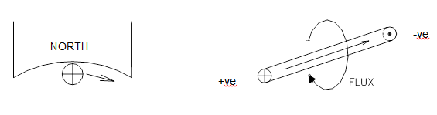

**Figure 1. Conductor under a North Pole**

20. If any one of the three variables are changed, the induced current will be reversed. If two variables are changed, the induced current remains in the same direction.

**Main Applications of Electromagnetic Induction**

21. **Generation** If a loop or coil of wire is rotated through a magnetic field an emf will be induced in the coil - if the coil forms a closed loop a current will flow in the circuit. This is the principle on which alternators and generators are based. If the coil is rotated at a constant speed sinusoidal alternating current can be produced as shown below:

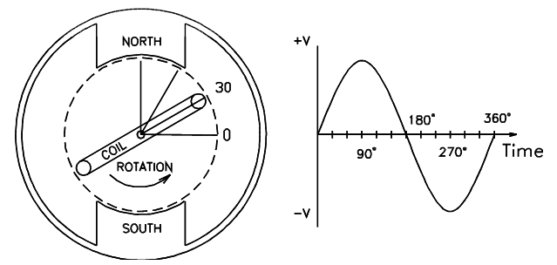

**Figure 2. Coil rotated through a magnetic field**

22. **Induction Motors** mainly a.c. motors have a series of stationary electromagnetic coils wound in such a way as to produce a magnetic flux within which a rotor is located. The rotor has conductors, but there is no electrical connection between the stationary winding (the stator) and the rotor. The alternating current flowing in the stator induces current in the rotor winding and the interaction between the magnetic fluxes causes the rotor to rotate.

|  |  |  |  |
| --- | --- | --- | --- |
| North Metro TAFE | **Energy Sector equipment/plant/technologies** |  | TOG 06/2018 |
|  |  | Worksheet |  |
| Electrical Trades | Section 1 | 1-4 |  |

## Magnetism and Electro-magnetic Induction

1. List four basic properties of magnets or magnetic fields.

2. The strongest magnetic flux of a magnet is at the………….of the magnet.

3. Do unlike magnetic poles attract or repel each other?

4. Is magnetic flux strongest at the pole ends or in the middle of a magnet?

5. In which direction are magnetic flux lines assumed to travel around a magnet?

6. Describe Faraday’s law of electromagnetic induction.

7. Identify three main requirements to induce a voltage into a conductor under Faraday’s law.

8. State three factors which govern the value of voltage induced in a conductor when it is moved across a magnetic flux.

**Alternating Current**

8. What condition is necessary for a voltage to be induced in a conductor by a magnetic field?

1. Can a current be induced in a conductor when it is moved parallel to the flux in a magnetic field?
2. What is the most common name for the rotating electrical device used to produce alternating current?
3. What effect does it have on the frequency of the output from an alternator if the number of magnetic poles are increased?
4. What is the unit of frequency at which alternating current changes at expressed in?
5. What is the meaning of the term “Hertz” when it is applied to the specification of frequency?
6. A conductor is rotated within a two pole magnetic field system. At what point(s) in the cycle does the conductor experience its maximum induced voltage?
7. What is the standard supply frequency of the a.c. distribution system in Australia?

**Single Phase Transformers**

16. Can typical single phase transformers be used to raise or lower d.c. voltages?

17. What are the names given to the two windings on a basic single phase step-down transformer?

18. Which winding on a basic single phase step-down transformer has the lowest d.c. resistance?

19. What name is given to a basic transformer in which the primary and secondary windings are electrically separate from each other?

20. To which winding in a single phase double wound step-down transformer is the input voltage normally connected?

21. From which winding in a single phase double wound step-down transformer is the output voltage normally taken?

22. What name is given to a transformer in which the secondary voltage is greater than the primary voltage?

23. From what material is the core of a power transformer normally made?

|  |  |  |  |
| --- | --- | --- | --- |
| North Metro TAFE | **Energy Sector equipment/plant/technologies** |  | TOG 06/2018 |
|  |  | Activity |  |
| Electrical Trades | Section 1 | 1-4 |  |

**Magnetism Practical**

**Task:**

To identify types of permanent magnets and their magnetic field patterns.

**Equipment:**

Sample permanent magnets with keepers

Toroidal ferrite permanent magnet

Magnetic compasses

Small pieces of soft iron (about 10x3x10 mm)

Small transparent PVC separators (about 10x3x10 mm)

Transparent plate and iron filings

**Method:**

1. Examine the sample permanent magnets supplied. Place each permanent magnet under a transparent plate and sprinkle iron filings on top of the plate. Tap the plate gently to distribute the iron filings. Do not allow the iron filings to come in contact with the magnet - they would be difficult to remove.

2. Sketch each magnet and the pattern formed by the iron filings. Use the outlines on the attached sheet as a guide. (Next Page)

3. Use the magnetic compass to determine the polarity of the poles of each magnet (check the polarity of the magnetic compass before each observation - the marked end should be pointing to geographic North).

4. Position two bar magnets as shown on the attached sheet and sketch the resulting magnetic fields. Use a non-magnetic spacer to keep the magnets apart where necessary.

5. Select one permanent magnet and a piece of soft iron, and devise a method of demonstrating the principle of magnetic induction. Sketch the resulting magnet field.

**Questions**:

1. What is the assumed polarity of the marked end of a magnetic compass?

______________________________________________________________

2. Where the magnetic field strongest around a magnet?

______________________________________________________________

3. Do like magnetic poles attract or repel?

Sketches: Draw the Magnetic Lines of Force how they move around each of the following:

Single bar Magnet

Like poles facing each other

Unlike poles facing each other

|  |  |  |  |
| --- | --- | --- | --- |
| North Metro TAFE | **Energy Sector equipment/plant/technologies** |  | TOG 06/2018 |
|  |  | Activity |  |
| Electrical Trades | Section 1 | 1-5 |  |

**Transformer and Induction Practical**

**Objective:**

Identify connections to small double-wound transformers

Determine electrical characteristics of the transformers.

Document the rated values of the transformers

Take resistance readings of primary and secondary windings.

Lecturer to demonstrate transformer action (and as such electromagnetic induction) to the class using a variable A.C. supply connected to a Double-wound transformer connected to a load (Lamp).

**Equipment required:**

Two Double-wound Transformers (Less than 200VA)

Multimeter

**Task:**

Obtain two different small transformers and find the available information on each.

Document the values obtained.

Perform resistance tests on the transformer windings to determine which of the leads would be connected to the Primary winding and which leads are connected to the secondary winding.

**Results:**

Sketch a circuit diagram of the transformer showing each of the electrical windings of the transformer.

Indicate the Primary and Secondary windings of each transformer

**Table your results on the next page.**

**Results Table**

|  |  |  |
| --- | --- | --- |
|  | Transformer A | Transformer B |
| Primary  Voltage |  |  |
| Secondary  Voltage |  |  |
| Primary  Current |  |  |
| Secondary  Current |  |  |
| Transformer  VA  Rating |  |  |
| Primary  Resistance |  |  |
| Secondary  Resistance |  |  |
| Step-Up?  Step-Down? |  |  |

**Draw your diagrams here:**

Label the primary and secondary windings.

Indicate the input and outputs

**End of Resource Book**

**Ensure you have all your assignments signed off as completed by your Lecturer.**