

UEE20 Training Package Support Materials

Based on:
National Electro-technology Industry Standards

Resource Book

UEECD0046

Solve problems in Single Path circuits.

North Metropolitan TAFE

© North Metropolitan TAFE
Version 1.6.1 – 18/09/2025
Acknowledgements
This Unit Guide has been prepared by NMTAFE.
It is intended for North Metropolitan TAFE students only.
COPYRIGHT STATEMENT
This unit outline has been created by Balga Campus Lecturers for educational purposes.
Any third-party content contained in the unit outline is copied with permission of the copyright owner or under Statutory License Section 113P of the Copyright Act 1968.
ALL RIGHTS RESERVED
Apart from any use as permitted under the Copyright Act 1968, no part may be reproduced without the prior written permission of Balga Campus Lecturers.
Requests and inquiries concerning other reproduction and rights should be directed in the first instance to the Manager Publications and Distributions.
Manager Publications and Distributions
North Metropolitan TAFE
Locked Bag 6, Northbridge
Telephone: +61 1300 300 822
www.northmetrotafe.wa.edu.au

Disclaimer:
While every effort has been made to ensure the accuracy of the information contained in this publication, no guarantee can be given that all errors and omissions have been excluded. No responsibility for loss occasioned to any person acting or refraining from action as a result of the material in this publication can be accepted by NMTAFE
UEECD0046 – Solve problems in Single Path Circuits.

C O N T E N T S

Competency Standard Unit Elements and Performance Criteria UEECD0046

Work Performance Tasks for On-the-Job profiling – Not required for Certificate II.

Learning Plan Assessment Strategy

Danger Tag Procedure Laboratory and Workshop Safety Instructions

UEECD0046 Training Achievement Record

Name: | Student No: | Apprenticeship No
Employer: |  | College:

Competency Standard Units

UEECD0046 – Solve problems in Single Path Circuits.

Prerequisite Units, Required Skills and Knowledge, Elements and Performance Criteria can be found at –

www.training.gov.au

Search on UEECD0046

Assessment Strategy

Conditions of Assessment:

Normally learning and assessment will take place in an integrated classroom/ laboratory environment.

It is essential to work through the worksheets and activities in this workbook and follow the guidance of your lecturer. The worksheets and practical activities will provide the required skills and knowledge outlined in this Unit and assists you in achieving competency.

Assessment Methods:

Resource Book - The satisfactory completion of all worksheets and practical activities is required.

Written Question-based Assessment – based on the REQUIRED SKILLS AND KNOWLEDGE. You must achieve a mark of 75% or more in this assessment. After which the remaining questions will be confirmed verbally, or by Open Book assessing to gain the required 100%

Observed Practical Assessment – based on the Elements and Performance Criteria of this Competency Unit UEECD0046. You must achieve a mark of 100% in this assessment.

On-Job-Training:

Logging of on-the-job training not required for Certificate II.

Sufficiency of Evidence:

In all instances competency is to be attributed on evidence sufficient to show that a person has the necessary skills required for the scope of work. These include:

• Task skills - performing individual tasks
• Task management skills - managing a number of different tasks
• Contingency management skills - responding to irregularities and breakdowns in routines
• Job/role environment skills - dealing with the responsibilities and expectations of the work
environment including working with others.

Evidence must demonstrate that an individual can perform competently across the specified range of activities and has the essential knowledge, understanding and associated skills underpinning the competency.

 | Solve problems in Single Path Circuits | Section 1 - 1  Summary | Ver 1.6  18/09/2025  CD0046

Overview of the Electrotechnology Industry

Electrotechnology is a high tech, diverse industry that impacts every aspect of daily life.

It encompasses occupations such as electrical, communications, electronics and instrumentation.

People employed in the industry can be found across all major sectors such as generation, transmission and distribution of electricity, manufacturing, maritime, mining, construction and renewable energy technologies.

Electricity has been heavily reliant on fossil fuels for generation in the past, especially coal and oil.

The drive to reduce damage to the environment has forced a shift in technology towards sustainable, greener ways to generate electricity such as wind, solar and tidal energy.

Generated electricity from power stations around the country are transported over high voltage transmission lines to substations, where the voltage, through the aid of transformers will be reduced to a more manageable level and is distributed to households and businesses.

Once the electricity reaches its final destination it is used, or converted by a load. This load will convert the electrical energy to another form whether it is heat for cooking, mechanical energy for motors or light for us to see.

Electrical and Mechanical Units

The SI System of Measurement

1. The SI System is a metric system which has been the standard system of measurement in Australia since the early 1970's. It is used in many other countries with the notable exception of the United States of America.

2. In the superseded imperial system of measurement, different units of the same basic quantity had different names.

For example, the quantity 'length' could be expressed in inches, feet, yards, chains and miles, and there was no apparent relationship between the units (12 inches = 1 foot, 3 feet = 1 yard, 22 yards = 1 chain and so on).

3 In the metric system there are seven base units. Each unit can be expressed as a multiple (larger unit) or sub-multiple (smaller unit) by applying metric prefixes such as kilo or milli - the metric prefixes always vary the base unit by a multiple of 10.

All other units are derived from these seven base units, and all multiples and sub-multiples can be expressed using the metric prefixes.
4. The seven base metric units are:

Quantity | Quantity Symbol | Unit | Unit Symbol
Length | L | Metre | m
Time | t | Second | s
Mass | m | Kilogram | kg
Current | I | Ampere | A
Temperature(absolute) | T | Kelvin | K
Amount of substance | n | Mole | mol
Luminous intensity | I | Candela | cd

5. There are many other quantities used in electrical work. All other quantities are derived from the base units, so they are called 'derived units'. The most common units used in basic electrical or electronic work are:

Quantity | Quantity Symbol | Unit | Unit Symbol
Force | F | newtons | N
Pressure | P | newtons/m² | Pa
Electromotive force | E or V | volts | V
Electrical resistance | R | ohms | Ω
Electric Current | I | amperes | A
Energy | E | joules | J
Work | W | joules | J
Power | P | watts | W
Temperature | t | degrees Celsius | ◦C
Charge (or quantity) | Q | coulomb | C

Note: Students must learn and remember the relevant QUANTITY SYMBOLS so that their respective values can be inputted into given equations and formulas. Just as important are the UNIT SYMBOLS so the student can apply the correct symbols denoting the unit values!

Force

6. Force can be generally defined as that which produces changes or stops the motion of a body (mass x acceleration). The basic unit of force is the newton (N). One newton is the force required to move a mass of 1 kg in free space (away from the force of gravity). The amount of force required to lift a body vertically at sea level is 9.8 newtons per kilogram.

Pressure

7. Pressure is the force exerted on a given area. The basic unit of pressure is the newton per square metre (N/m²). One newton per square metre is given a special name, one Pascal (Pa). Since the Pascal is a small unit, a more common unit of pressure is the kilopascal (kPa). In imperial units a common unit of pressure is the pound per square inch (psi). 1 psi = 6.89 kPa.

Electromotive Force

8. An electromotive force (emf) is a force which causes electrons ('electricity') to flow in a conductor. This electrical force is also described as a POTENTIAL DIFFERENCE or a VOLTAGE DROP between two points. Electromotive force or potential difference is measured in VOLTS, and the unit symbol for volts is V. The quantity symbol for electromotive force is E. The quantity symbol for potential difference is V or U.
Electric Current

9. Electric current is the flow of electrons in a material. The base unit of electric current flow is the AMPERE, and the unit symbol is A. The quantity symbol for electric current flow is I. One ampere is the current which will flow in a circuit with a resistance of one ohm if the applied voltage is one volt.

Resistance

10. Electrical resistance is the opposition to the flow of current in any material (solids, liquids or gases). Resistance to current flow is measured in OHMS, and the unit symbol is the Greek 'omega' (Ω). The quantity symbol is R.

Energy and Work

11. Energy is the ability to do work. Energy cannot be created or destroyed; it can only be converted from one form to another. The most common forms of energy in electrical trade applications are electrical energy, mechanical energy, light energy and heat energy. Work is done whenever energy is converted from one form to another. An electric motor, for example, converts electrical energy to mechanical energy. The basic unit of energy is the joule. The quantity symbol for energy is E and the basic unit symbol is J.
Work (W) is also expressed in joules.

Power

12. Power is the rate of doing work, or the rate at which energy is converted from one form to another (e.g. electricity into heat). The basic unit of power is the watt which is 1 joule per second. The quantity symbol for power is P and the basic unit symbol is W. The basic unit of power in the old imperial system is the horsepower. There are 746 watts in one horsepower. A 100 watt electric motor converts electrical energy to mechanical energy (or work) at the rate of 100 joules per second (J/s). A 200 watt motor would do the same amount of work in half the time so the relationship between power and work or energy can be shown as the following equations:

Energy = Power x Time

Energy
Power = ------------
Time

Where:
Energy is in joules
Power is in watts
Time is in seconds

Temperature

13. Temperature is the level of heat in a body. The quantity symbol for temperature is t and the customary unit is the degree Celsius (ºC).

The imperial unit of temperature is the degree Fahrenheit (ºF). Although degrees C and degrees F are both units of temperature, they are on different scales. Water freezes at 0ºC or 32ºF, and boils at 100ºC or 212ºF.
Quantity of Electricity (Charge)

14. The unit of electrical quantity is the coulomb, i.e. the quantity of electricity passing a given point when a current of 1 ampere is maintained for 1 second.

The quantity symbol for charge is Q and the basic unit symbol is C. The basic equation for calculating the quantity of electricity is:

Q = I x t i.e. Coulombs (C) equals Amps (A) multiplied by Seconds (s)

Where Q is in Coulombs (C)
I is in amperes (A)
t is in seconds (s)

Metric Prefixes

15. The metric prefixes mean 'multiply the unit by a power of 10'. In electrical engineering applications the preferred metric prefixes are those which are a multiple of 3. The specific powers of 10 referred to in the most common prefixes are:

Common Metric Prefixes

Term | Symbol | Multiply by | Example
tera | T | 1 000 000 000 000 (10¹²) | 4 TB = 4 000 000 000 000 bytes
giga | G | 1 000 000 000 (10⁹) | 3 GW = 3 000 000 000 watts
mega | M | 1 000 000 (10⁶) | 62 MΩ = 62 000 000 ohms
kilo | k | 1 000 (10³) | 22 kV = 22 000 volts
Base Unit |  | 1 (10⁰)
milli | m | 0.001 (10⁻³) | 8 mA = 0.008 amps
micro | µ | 0.000 001 (10⁻⁶) | 1 µF = 0.000 001 farads
nano | n | 0.000 000 001 (10⁻⁹) | 5 nA = 0.000 000 005 amps
pico | p | 0.000 000 000 001 (10⁻¹²) | 2 pA = 0.000 000 000 002 amps

16. Examples: Examples of the most commonly used prefixes in electrical and electronic
work are:

5 MΩ means 5 times 1 000 000 ohms or 5 000 000 ohms.
3 mA means 3 times 0.001 amps or 0.003 amps.
9 mm means 9 times 0.001 metres or 0.009 metres.
2 kV means 2 times 1000 volts or 2000 volts.
6 nV means 6 times 0.000 000 001 volts or 0.000 000 006 volts.
7 µA means 7 times 0.000 001 amps or 0.000 007 amps.
17. When expressing metric quantities there are several conventions recommended in Australian
Standards (AS 1000 and AS 1046). For example:

- When a metric prefix is combined with a unit name the resulting multiple is written as one word:

millimetre not milli metre

- A space should be left between the number and the unit symbol:

10 mm not 10mm

- Separate groups of three digits with a space if there are five or more digits (in some countries the comma is used as the thousands separator):

20 000 not 20000

- A leading zero should always be placed in front of a decimal number less than 1 (in some countries the comma is used as the decimal point):

0.001 not .001

- It is frequently necessary to convert a quantity from one metric unit to another. All that is
necessary is to move the decimal point to the right or left the number of places which corresponds to the meaning of the metric prefix.

Prefix | Symbol | To add prefix,  move decimal point | To remove prefix,  move decimal point
mega | M | 6 places to the left  e.g. 1000 000 Ω = 1 MΩ | 6 places to the right  e.g. 1 MΩ = 1 000 000 Ω
kilo | k | 3 places to the left  e.g. 1000 V = 1 kV | 3 places to the right  e.g. 1 kV = 1 000 kV
BASE Unit
milli | m | 3 places to the right  e.g. 0.001 A = 1 mA | 3 places to the left  e.g 1 mA = 0,001 A
micro | µ | 6 places to the right  e.g. 0.000 001 A = 1 µA | 6 places to the left  e.g. 1 µA = 0.000 001 A

- Convert 867 mm to metres. The symbol m means ‘milli’ or times 0.001, so to convert the unit back to metres shift the decimal point three places to the left.
867 mm = 0.867 metres.

- Convert 0.027 amps to milliamps. The prefix 'milli' means times 0.001, so to convert amps to milliamps shift the decimal point three places to the right.
0.027 amps = 27 milliamps.

- Convert 2000 volts to kilovolts. The prefix 'kilo' means times 1000, so to convert volts to kilovolts shift the decimal point three places to the left.
2000 volts = 2 kilovolts.
- When converting quantities from one prefix to another it is important to look carefully at your
result to see that it makes sense. If you converted 5 kW to 0.005 watts by shifting the decimal place three places to the left it should be obvious that you have shifted the decimal point in the wrong direction because 0.005 is less than 1.

- Exercise Convert the following units as indicated:

- Convert 11 kV to volts. ____________________

- Convert 0.002 A to milliamps. ____________________

- Convert 12 MΩ to ohms. ____________________

- Convert 0.000 001 V to microvolts. ____________________

- Convert 3859 mm to m. ____________________

- Convert 0.0003 mA to microamps. ____________________

Engineering Notation

21. In electrical work it is frequently necessary to work with very small or very large quantities such as millionths of amps or millions of ohms. In such cases it is often convenient to express the value as a decimal number between 1 and 10 followed by a power of ten - this is known as scientific notation.

22. In engineering applications, the number is arranged so that the power of 10 (also called the index or exponent) is given as a multiple of 3 -this is a special form of scientific notation known as 'engineering notation'.

The following examples illustrate engineering notation:

230 000 volts = 1.23 x 10⁶ volts

0.000 001 2 amps = 1.2 x 10⁻⁶ amps

0.0025 watts = 2.5 x 10⁻³ watts

11 230 ohms = 11.23 x 10³ ohms

23. When performing calculations involving quantities expressed in engineering notation the main rules are:

For multiplication: Add the exponents
For division: Subtract the exponents

Examples:

12 x 10³ times 5 x 10⁶ = 12 x 5 x 10³⁺⁶ = 60 x 10⁹

6 x 10⁶ divided by 3 x 10³ = 6/3 x 10⁶⁻³ = 2 x 10³

Scientific Notation

24. When calculating equations involving very large and small numbers and using multiplication or division, it is more practical to convert those numbers into “Scientific Notation”.
Essentially the same as Engineering Notation with the exception that the number to the power of ten can be any whole number in either a positive or negative sign. The number is best expressed as a primary number between 1 and 9.99 multiplied by 10 ^{X}. The primary number is rounded to 2 decimal points.

When numbers are expressed in this format it is possible to simply add the powers of ten when multiplying or subtracting the powers when dividing to find the resulting power of ten.

Example 1:
Multiply: 2,447,002 times 304,799

Round off: 2.45 x 10⁶ x 3.05 x 10⁵

Join powers and multiply primary numbers:

2.45 x 3.05 = 7.47 and 10⁶ x 10⁵ is 10⁶⁺⁵ = 10¹¹

Note: for electrical units it is best to convert the 10 to the power of digit to a multiple of three to align with unit prefixes.
i.e. 7.47 x 10¹¹ rewritten as 747 x 10⁹ or if units were ohms, then 747 Gigaohms

Example 2:
Divide: 287,765,223 by 6,853,924

Round off: 2.88 x 10⁸ divided by 6.86 x 10⁶

Join powers and divide primary numbers:

2.88 / 6.86 = 0.42 and 10⁸ / 10⁶ is 10⁸⁻⁶ = 10²

Ans. = 42

25. Note that the process of adding or subtracting exponents does NOT apply when adding or subtracting numbers expressed in engineering notation.

When adding or subtracting numbers expressed in scientific notation it is usually preferable to write the numbers in their decimal form, perform the operation, then convert them back into engineering notation.

Significant Figures

26. When quantities are being calculated or measured it is often necessary to use approximations rather than exact figures.

Approximations are often adequate, bearing in mind that measuring instruments are not 100% accurate. When using approximations in a practical situation you need to make a judgement about how many figures are significant - this is usually governed by the type of measuring instrument you are using.

27. If a calculation gave a result of 12.345 678 volts it is unlikely that an instrument would be available to indicate to that degree of accuracy, so you would approximate the result by rounding to 3 or 4 significant figures.

The most significant figures are those with the largest place value (i.e. from left to right).

28. When you have decided on the number of significant figures you then consider the digit after the number of significant figures - if it is 5 or more the last digit is increased by 1.

29. The number 12.342 678 rounded to four significant figures would become 12.34. If the same number was rounded to five significant figures it would become 12.343 (the last digit is increased by 1 because the sixth digit is greater than 5).

30. Exercise: Round the following numbers to the values indicated.

Round 3.7892 to 2 significant figures ____________________
Round 0.3452 to 2 significant figures ____________________
Round 82.002 to 3 significant figures ____________________

Rounding Decimals

31. Rounding a decimal to a given number of places is similar to the process of rounding to significant figures except that the rounding always begins at the decimal point.

When you have decided on the number decimal places required you consider the digit after the number of places if it is 5 or more the last digit is increased by 1.

32. Examples

145.456 34 rounded to three decimal places is 145.456
0.266 98 rounded to two decimal places is 0.27
3.6 to three decimal places is 3.600
0.004 53 rounded to three decimal places is 0.005

33. Exercise: Round the following numbers to the places indicated.

Round 1342.15 to 1 decimal place _____________________
Round 0.000 161 to 4 decimal places _____________________
Round 412 234.574 to 2 decimal places _____________________

34. When you are performing electrical calculations, it is usually adequate to round to two decimal places or three significant figures depending on the accuracy required.

Examples:
1.42
556
0.021
327,000

 | Solve problems in single path circuits | Section 1-1  Work Sheet 1-1 | Ver 1.6 18/09/2025  CD0046

Electrical and Mechanical Units

- Complete the following tables:

Common SI Units:

Quantity | Quantity Symbol | Unit | Unit Symbol
 |  | metre
Temperature
 |  |  | s
 | m
Electric current
 |  | volt
 |  |  | W
 | R
 |  | joule
 | Q
Pressure

Common Metric Prefixes:

Metric Prefix | Meaning of Prefix | Symbol
 |  | m
 | times 0.000 001
giga
 | times 1 000
 | times 0.000 000 001
 |  | p
 |  | M

- Write the quantity symbol for time? _____________
- Write the quantity symbol for length? ______________
- Write the quantity symbol for electromotive force? __________
- Write the quantity symbol for electrical resistance? ___________
- Write the quantity symbol for electric current? __________
- Write the quantity symbol for power? ___________
- Write the unit symbol for EMF? __________
- Write the unit symbol for the basic unit of resistance? _________
- Write the unit symbol for the base unit of current? _________
- Write the unit symbol for the basic unit of power? _________
- Write the unit symbol for the basic unit of energy? __________
- Write the unit symbol for the basic unit of mechanical pressure? __________
- How many watts are there in one horsepower? __________
- Express 0.000 000 017 2 ohms in scientific notation. ______________
- Express 2 400 000 watts in engineering notation. ______________
- Round 231 825 to three significant figures. _________

 | Solve problems in single path circuits | Section 1 – 2  Summary | Ver 1.6  18/09/2025  CD0046

Basic Electrical Physics

Structure of the Atom

1. Matter can be described as anything which occupies space. Matter exists in three forms:-

- Solid - In this form matter maintains its own shape.

b. Liquid - In this form matter takes the shape of the container.

c. Gas - In this form matter expands to fill the container.

2. All matter consists of the same basic parts, but in different combinations. The basic parts are the electron, the proton and the neutron. Each proton has a positive electrical charge. Neutrons have no electrical charge. An electron has a negative charge equal in magnitude to that of a proton (but opposite in polarity). The movement of these small negative particles (electrons) is known as a current flow.

3. Different combinations of these basic particles make up ATOMS and different combinations of atoms make up MOLECULES of a substance. A material which consists of only atoms of the same material is known as an ELEMENT.
Two or more elements can combine to form a COMPOUND.

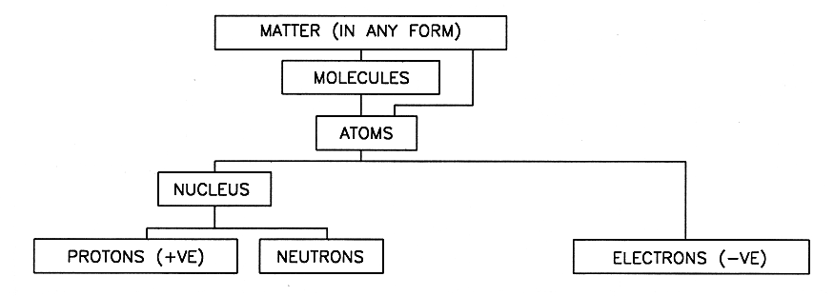

4. Electrons revolve around the nucleus in much the same way as the earth revolves around the sun.

5. A stable atom of a material has as many protons (positively charged) as it has electrons (negatively charged) so the overall charge is neutral.

Ionisation

6. If an electron is added to or removed from an atom the resulting particle is known as an ion. An ion with a deficiency of electrons is positively charged and is known as a positive ion. An ion with an excess of electrons is negatively charged and is known as a negative ion. The process whereby ions are produced is called ionisation. When an electrical arc (or spark) occurs as in an arc welder, or when contacts open, the visible arc is air which has been momentarily ionised.

Electrons in Orbit

7. All of the electrons orbit their associated nucleus but not all of them are the same distance away. Each orbit is known as a ring or shell. More than one electron can exists in one shell.

8. Electrons in the inner rings or shells are held to the nucleus more tightly than those in the outer rings or shells. The outer orbit is known as the valency ring or valency shell.
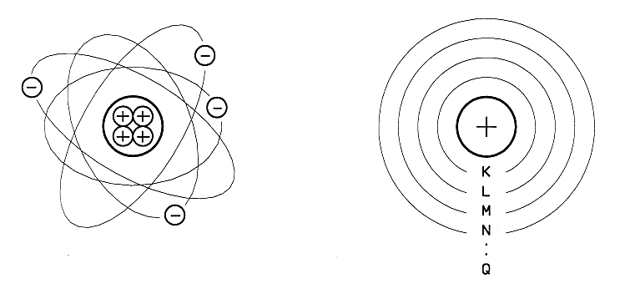

9. In some materials the electrons in the outer or valency shell are not tightly bound to the nucleus and move freely about within the material. These electrons are known as free electrons.

10. Materials with many free electrons are usually good conductors of electricity.

11. Materials with 1, 2 or 3 electrons in the valency shell are usually good CONDUCTORS. Silver, copper and aluminium are good conductors of electricity. Brass, lead and iron are also common metallic electrical conductors, but all metals are relatively good conductors. Tap water is a good conductor. Conductors are used to provide a path for the flow of electrons.

Typical conducting materials and their applications are:

- Copper Used for many electrical cables
- Aluminium Large cables and busbars
- Brass Structural parts which carry current
- Nichrome A resistance wire designed to heat up when current passes through
it - as in a heating element
- Carbon Brushes in rotating electrical machines
- Mild steel The outer metal casing of electrical devices
- Silver Contacts for switches and contactors.

Tap water and sea water are good conductors of electricity, so they must be kept away from electrical appliances unless they are designed to operate under damp or wet conditions. All metals are conductors.

12. Materials with 4 electrons in the valency shell are called SEMI-CONDUCTORS. Silicon and germanium are semi-conductors used in the manufacture of electronic components such as diodes and transistors.

Semiconductors are special materials which are conductors under some conditions and insulators under others.

Semiconductors in the form of devices such as transistors, diodes and integrated circuits form the basis for the electronic industry.

The two most common types of semiconductor material are silicon and germanium.

13. Material with 7 or 8 electrons in the valency shell are called INSULATORS. Mica, glass, PVC and porcelain are good insulators.

Under normal operating conditions insulators are used to prevent the flow of electrons.

The term 'insulator' is a relative term which means that the material does not allow current to flow through it under normal operating conditions.

However, if the electrical pressure (or voltage) is increased to a value above a designed limit the insulation may 'break down' and allow current to flow through it (and the material is destroyed).

Insulating materials are available in hundreds of types, including solids, liquids and gases - often with special names or trade names.

Common insulating materials and typical applications are:

- PVC Used as insulation on many electrical cables
- Glass Glass-cartridge fuses
- Porcelain Structural insulating components such as fuses
- Rubber Protective gloves and cable insulation
- Air Parts separated by air are insulated from each other at low
voltages
- Bakelite Structural moulded insulating components
- Mylar Sheet insulation in electrical coils
- Red fibre General purpose sheet or solid insulation
- Transformer oil Liquid insulation in large transformers
- Mica Insulation or supports for heating elements.

The term 'insulation resistance' is used to describe the resistance of the insulation between live parts - in most cases it is required to be one million ohms (1 meg-ohm) or more for appliances which operate on 240 volts.

14. In special cases some atoms may share an electron. This is known as covalent bonding and is very important in electronic devices such as and transistors.

15. Electric current flow is based on the principle that LIKE CHARGES REPEL and UNLIKE CHARGES ATTRACT.

Electromotive Force

16. An electromotive force (emf) is a force which causes electrons ('electricity') to flow in a conductor. This electrical force is also described as a POTENTIAL DIFFERENCE or a VOLTAGE DROP between two points.

Electron Theory of Current Flow

17. Electron Flow: When an electromotive force is applied to a conductor, the free electrons are repelled by the negative charge and they move from atom to atom along the conductor and out through the source of the electromotive force. The controlled movement of electrons in a conductor is known as an ELECTRIC CURRENT or an ELECTRON FLOW and the direction of an electron flow is from NEGATIVE to POSITIVE.
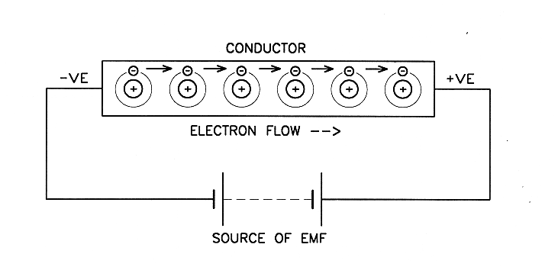

18. Conventional Current Flow: Early scientists assumed that current flowed from positive to negative because deposits form on the negative terminal of an electroplating bath, and many magnetic rules were based on this direction. Current flow from positive to negative in the external circuit is known as conventional current flow, and it is the opposite of electron flow (negative to positive). However, most modern text books outside the U.S.A. retain the use of conventional current flow for all Electrical and Electronic usage, so care must be taken when studying, to establish which theory of current flow is used.

19. The direction of electric current flow for the remainder of this course is assumed to be CONVENTIONAL FLOW which is from POSITIVE to NEGATIVE in the external circuit.
However, for the purposes of DC circuits without electronic or magneto-motive components it matters little which direction the current flows as the heating effect is the same.

20. HEAT and MAGNETISM are always produced when an electric current is
flowing in any part of a material.

Current Flow in Gases and Liquids

- Current flow in gases and liquids is similar to that in metallic conductors, except that as electrons move in one direction the ions produced (by the removal of an electron from an atom) move in the opposite direction. The liquid in a typical car battery (sulphuric acid) acts as a conductor, whereas special oil known as transformer oil is a good insulator. Liquids which conduct electricity are often known as electrolytes. A fluorescent tube contains a gas mainly argon) which becomes ionised and acts a conductor. A VACUUM acts as an insulator.

Resistance

22. All materials offer some opposition to the flow of electric current. This property is known as RESISTANCE, and each material has a different value. Materials which offer comparatively little resistance to the flow of current are known as conductors, and materials which do not allow current to flow through them under normal operating conditions are known as insulators. Silver and copper are good conductors and porcelain and PVC are good insulators.

23. Resistance to current flow is measured in OHMS, and the unit symbol is the Greek 'omega' (Ω). The quantity symbol is R.

24. The factors which govern the resistance of any material are: (MALT)

- Type of Material All materials have a different resistance for a given quantity of the material.
- Cross Sectional Area As the cross-sectional area of a material INCREASES the resistance DECREASES. Thus, a large conductor has LESS resistance than a small conductor of the same length, material and temperature

- Length As the length of a material increases the resistance increases if all other factors remain the same.

- Temperature All materials change their resistance as their temperature changes. Some materials increase in resistance as the temperature increases, while others decrease in resistance as the temperature increases. The resistance of most metals increases as the temperature increases.

25. A conductor with a low resistance allows more electric current to flow than a conductor with a high resistance if the voltage remains constant. Electrical devices designed to reduce the current flow in a circuit supplied from a constant voltage source are known as RESISTORS and they are available in several forms.

26. The lowest possible resistance is ZERO ohms (or NO resistance). If a circuit has NO resistance MAXIMUM current can flow in the circuit. In practical terms a circuit approaching zero ohms is known as a SHORT CIRCUIT.

27. The highest possible resistance is an infinite number of ohms (or infinity). If a circuit has an infinite resistance NO CURRENT can flow in the circuit. In practical terms a circuit approaching infinity is known as an OPEN CIRCUIT.

28. An OPEN switch has infinite resistance which means the circuit is off.

29. A CLOSED switch has zero resistance meaning the circuit is on.

30. The “better” a conductor is the lower its resistance will be, meaning the electrons which are moving in a current can flow more easily through it. All materials will have some amount of resistance.

31. The better an insulator is then the less likely any current at all will flow through the material. Good insulators have infinite resistance.
 | Solve problems in single path circuits | Section 1-2  Work Sheet 1-2 | Ver 1.6 18/09/2025  CD0046

Basic Electrical Physics

  - In which direction do electrons flow in an electrical conductor with regards to electron flow?

a.) Positive to Negative
b.) Negative to Positive

2. What is the main difference between an electrical conductor and an insulator?

3. What is the approximate resistance of a 'short circuit'?

4. What is the approximate resistance of an 'open circuit'?

 | Solve problems in single path circuits | Section 1 – 3  Summary | Ver 1.6  18/09/2025  CD0046

Transposition of Equations

1. An essential process in electrical calculations is transposing an equation for any variable in the equation.

2. An equation or formula is a mathematical statement of equality.

The value to the left of the equals sign is exactly equal to the value on the right hand side. In equations, symbols are called variables because they can take on a variety of different values.

3. To ‘solve’ an equation means to find the value for the variable which makes the equation a true statement.

The process of solving an equation for a given variable is also known as ‘transposing’ the equation, or making a nominated variable the ‘subject’.

- The solution of equations is based on the following rules:
Both sides of an equation are equal
- If the same mathematical operation is performed on EACH SIDE of the equals sign the sides remain equal (as long as it does not involve division by a value which could be zero).
- Any value which appears on the top and bottom of the same side of an equation which does not involve plus and minus signs can be cancelled.
- Cross multiplication is always valid across an equals sign – i.e. multiply the top of each side by the bottom of the other side to bring all the terms to the top line.

5. The examples which follow illustrate the method of solving simple equations. Note that equations involving terms with plus and minus signs are handled differently to those involving multiplication and division only.

As a class exercise, your lecturer will explain how to transpose the following examples.

B Brackets (x), {x} or [x]
I Indices x², √x
M Multiplication X x Y, or X.Y
D Division x ÷ y or x/y
A Addition x + y
S Subtraction x - y

 | Solve problems in single path circuits | Section 2  Summary | Ver 1.6  18/09/2025  CD0046

Practical Electrical Circuits and Protection

Parts of a Circuit

1. Electric current can only flow in a closed circuit. Any electrical circuit must have at least three basic parts - these parts are:

a. A voltage source such as a battery, a generator or an alternator. This provides the electromotive force (emf) necessary to force current to flow in the circuit.

b. Conductors to provide a path for the current. The path must always be continuous for current to flow. The most common type of conductor is insulated copper wire.

c. A load such as a lamp, motor, heating element, solenoid or coil. The load is usually some device designed to convert electrical energy into some other form of energy. A load can consist of several components connected in ‘parallel’.

2. The individual parts of an electrical circuit are usually represented by symbols. A typical basic circuit is shown below.
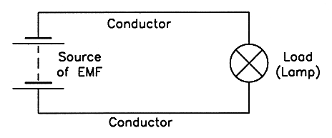

3. An electrical circuit MUST have the three parts listed above, but most have additional components such as a switch to control the circuit and a fuse to protect it.

A fuse is designed to automatically disconnect the voltage source from a load under certain fault conditions.

A fuse is connected in ‘series’ with the circuit it protects. A series circuit which incorporates a switch and a fuse is shown below.
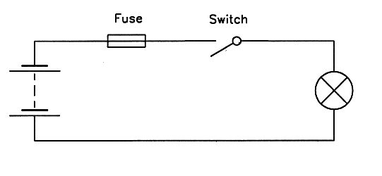

Short Circuits

4. Electric current is inversely proportional to the resistance of a circuit.

This means that as the resistance decreases the current increases. If the resistance of a particular circuit falls to a value approaching zero ohms a SHORT circuit is said to have occurred and a high current flows in the circuit.
A short circuit is said to have a resistance of ‘zero’ ohms.

5. The degree of the short circuit is often described using the terms 'dead short' and 'partial short', where a dead short is virtually no resistance between the two points.

Open Circuits

6. If an unwanted break occurs in a series circuit no current can flow, and an OPEN circuit is said to exist. An open circuit is said to have a resistance of ‘infinity’ ohms.

Overload

7. Circuits are usually designed to have a maximum current rating - a value of current which should not be exceeded under normal operating conditions.

The maximum current rating or the current carrying capacity of a circuit depends mainly on the size of cable and the current rating of the protective device.

8. If the current rating of a circuit or component is exceeded, it results in overheating of the
component or circuit and they can be permanently damaged.

The condition where the maximum current rating of a circuit or component is exceeded is known as an overload.

Protective Devices

9. The purpose of an electrical protective device is to automatically take some pre-determined action if a specified type of fault occurs in a circuit while it is operating.

Typical types of faults which can be protected against include:

- Short circuits
- Open circuits
- Sustained over current
- Sustained under voltage
- Sustained over voltage
- Transient (momentary) under voltage
- Transient (momentary) over voltage.
- Earth faults (a live part comes in contact with an outer metal casing or the general mass of earth).

10. The most common types of overcurrent protective devices are fuses and circuit breakers.
11. Wiring Rules

A fuse is a device which has a short length of wire of known current carrying capacity (called the fusible element), enclosed in a suitable insulated carrier (known as the fuse carrier or fuse wedge) - See AS/NZS 3000 (Wiring Rules) Clause 1.4.68.

The fuse is connected in series with the supply line, so that if the current flow in the circuit exceeds a critical value the fusible element will melt, thus interrupting the supply of current to the circuit.

Clause 2.5 of the AS/NZS 3000 Wiring Rules contains the requirements relating to the devices for protection against overcurrent, current rating and types of protective device.

In general, the protective device must interrupt overload currents flowing in the circuit before such currents cause a temperature rise detrimental to insulation, joints, terminations or surroundings of the conductors.

12. Fuses

The most common types of fuses are:

- High rupturing capacity (HRC) fuses
- Glass cartridge fuses
- Semi-enclosed rewire-able fuses (older existing installations only)

The symbol for a fuse is shown below:

13. Fuses are rated according to the maximum current which they can carry continuously under normal conditions (not the current at which they will interrupt the supply).

A 10 amp fuse does not 'blow' at 10 amps.

14. The fusing current depends on the type of fuse and the magnitude and duration of the fault current. A 10 amp semi-enclosed rewire-able fuse element may not melt until the current reaches about 18 amps if the fault current is increased gradually; an HRC fuse element (or link) would melt at more than 10 amps but less than about 18 amps.

Thus fuses provide protection against high short circuit currents, but not against relatively small excess currents which would occur if a motor was slightly overloaded. In the latter case additional motor protection would need to be provided in the form of motor 'overloads' or direct temperature sensing devices such as Thermistors, Microtherms or Klixons.

15. If a fuse operates it indicates a fault condition in the relevant circuit. The fault must be located and corrected before the fuse element is replaced. When the fault has been corrected the procedure for replacing the fuse element(s) is as follows:

a. Turn the main isolating switch off.

b. Carefully withdraw the fuse carrier from the fuse base.

c. Replace the fuse with the same size and type as the original (after checking to see that the size of fuse matches the fuse rating marked on the fuse base).

d. Turn the main isolating switch on.

16. Typical approximate current ratings for fuse elements composed of tinned copper wire for existing semi-enclosed rewireable fuses are:

8 amps - 0.315 mm diameter
10 amps - 0.355 mm diameter
16 amps - 0.500 mm diameter
20 amps - 0.560 mm diameter

17. Semi-enclosed rewire-able fuses shall not be installed in electrical installations, see AS/NZS3000:2018 clause no. 1.7.2 (h).

High Rupturing Capacity (HRC) Fuses

18. A high rupturing capacity (HRC) fuse link is a special type of cartridge fuse in which the silver fusible element is completely sealed inside a thick ceramic tube. When an HRC fuse 'blows' the resulting arc is contained inside the ceramic tube. The time taken to interrupt the supply in an HRC fuse is much more predictable than a semi-enclosed rewire-able fuse. A typical shape for an HRC fuse is shown below:

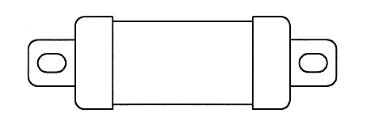

19. HRC fuse links are not repairable and must be replaced with the same size and type as the original. It would be highly dangerous to replace an HRC fuse link with a length of fuse wire of the same current rating, because the HRC fuse carrier is not designed to contain the arc which would result if the fuse blew. The time taken for an HRC fuse to interrupt a circuit under fault conditions is much more predictable than semi-enclosed rewire-able fuses, so rewire-able fuses are rarely used for currents over about 100 amps.

20. The fusing requirements for a motor circuit are different to those of, say, a circuit involving resistive components because motors have a high short-time starting current. Most HRC fuse manufacturers provide different fuse links for each purpose and they are generally known as either motor fuse links or general fuse links. Information on the characteristics and ratings of each type is available from fuse manufacturers.

Circuit Breakers

21. A circuit breaker is a switch which automatically opens a circuit under pre-determined fault conditions (see Wiring Rules Clause 1.4.30).

The operating mechanism can be thermal, magnetic or a combination of both, but in all cases the circuit breaker must be capable of interrupting any current up to and including the prospective short circuit current at the point where the device is installed (see Clause 2.5.2).

Small moulded case circuit breakers (MCCB's) are sealed and are not usually repairable. The symbol for a circuit breaker is shown below:
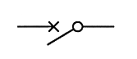

22. Air circuit breakers (ACBs) have similar operating characteristics to HRC fuses, but they have the advantage that power can be restored to the circuit by simply turning them back on (after the fault has been corrected).

Another advantage is that multi-phase circuit breakers disconnect all phases if a fault occurs on one phase.

23. Care must be taken when examining the status of air circuit breakers because they are usually ON in the fully UP position; this is the reverse of the usual convention used for switches in W.A., where the UP position is OFF.

24. When an air circuit breaker trips due to overcurrent in the circuit the operating toggle usually remains in a position slightly less than fully up.

25. All circuit breakers must automatically switch OFF to clear a fault when the current exceeds 1.45 X of the nominal current rating of the circuit breaker (see AS/NZS 3000 Clause 2.5.3.1).

To reset these circuit breakers (after the fault has been located and cleared) it is necessary to push the operating toggle down to the OFF position, then back up to the ON position.

Residual Current Devices (RCDs)

26. A residual current device (RCD) or 'safety switch' is a means of providing protection from electric shock if a person touches a live terminal while in electrical contact with earth.

RCDs can be installed as the main switch for an installation, or they can be incorporated in extension sets which have multiple socket-outlets. Installation of an RCD does not remove the need to earth single insulated appliances.

The symbol for a single phase residual current device (RCD) is shown below:

27. An RCD is designed to interrupt the supply to the protected circuit if the current in the incoming active conductor is not the same as the current in the associated neutral conductor.

If a person comes in contact with a live terminal while an appliance is switched on, some current will flow through him or her instead of returning to the supply via the neutral conductor.
If this earth leakage current exceeds 10 to 30 milliamps (depending on the design and setting of the RCD), the RCD will operate and isolate the circuit from the supply within about 10 to 50 milliseconds, thus reducing the possibility of a lethal electric shock.

28. RCDs do not provide protection against a person coming in contact with active and neutral simultaneously, nor do they provide protection against excessive current or overload faults.

29. RCDs are mandatory for the protection of all final subcircuits in domestic installations (see AS/NZS 3000 Clause 2.6.3.2.2).

30. Each RCD should protect no more than three circuits and not all of the same circuit type i.e. power and light circuits (see AS/NZS 3000 Clause 2.6.2.4 (b)).

Other Types of Protection

31. Other types of protection such as under-voltage protection, over voltage protection and overload protection will be covered later in this course.

 | Solve problems in single path circuits | Section 2  Work Sheet 2-1 | Ver 1.6 18/09/2025  CD0046

Practical Electrical Circuits and Protection

1. What are the five essential parts of any electrical circuit?
1)
2)
3)
4)
5)

2. Why is necessary to include a FUSE or circuit breaker in all electrical circuits?

3. What two basic faults do fuses and circuit breakers detect in an electrical circuit?

4. What does an RCD provide protection against?

5. Sketch and label the circuit diagram of a simple series circuit below.

 | Solve problems in single path circuits | Section 3  Summary | Ver 1.6  18/09/2025  CD0046

Ohm's Law

1. In any direct current electrical circuit there is a specific relationship between the voltage, the resistance and the current flow. This relationship is often expressed as 'Ohm's Law' which states that:

"The current flowing in a DC circuit or any part of a circuit is directly proportional to the applied voltage and inversely proportional to the resistance of a circuit".

2. This means that if the voltage across a particular component is increased the current flow will increase (a DIRECTLY proportional relationship), and if the resistance of the circuit is decreased the current flow will increase (an INVERSELY proportional relationship).

Thus, the current in any DC circuit can be determined by dividing the voltage by the resistance.

3. Ohm's Law can be expressed as a mathematical relationship or equation:

Voltage E
Current = ------------- or I = ---
Resistance R

4. Since voltage can be expressed as an electromotive force, E (the CAUSE of the current flow), or as a potential difference (the EFFECT of the current flow), the mathematical equation for Ohm's Law can also be written as:

Potential Difference V
Current = -------------------------- or I = ---
Resistance R

Constant Resistance Constant Voltage
I I

$\begin{matrix}I∝ & \begin{matrix}1 \\ R\end{matrix}\end{matrix}$
I is directionally proportional to V I is inversely proportional to R

V R

When the resistance in a circuit stays constant, current will change proportionately with the applied voltage. That is, value of current is directly proportional to applied voltage.

If the voltage doubles the current flow doubles and if voltage halves the current flow halves for a constant value of resistance.

When the applied voltage stays constant, current changes are inversely proportional to changes in resistance.

That is if resistance doubles, the current flow halves and if resistance halves, the current flow doubles when the applied voltage is constant.

5. The equation for Ohm's Law can be transposed to find any value if the other two are known, so the three ways which Ohm's Law can be expressed are:

(Current) (Voltage) (Resistance)

V V
I = --- V = I x R R = ---
R I

6. A memory aid which is frequently used to show these relationships is:

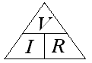

Note: Cover the wanted variable to see the mathematical expression which can be used to find it.

Solving Ohm's Law Problems

7. An Ohm's Law problem is one in which two circuit values are known and the third is to be found.

Most Ohm's Law problems can be solved using the same basic sequence.

8. Example

Find the current flowing in a circuit in which a voltage of 24 volts DC is connected to a resistance of 8 ohms.
9. Steps for Solution

a.) Read the question carefully and make
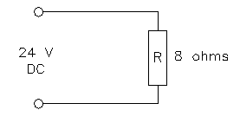
sure you know what value is to be found.

a.) Draw a circuit diagram and insert the
known values in BASIC units (e.g.
amps, not milliamps if applicable).
V
c.) Select the correct equation for I = ---
the problem. R

24
d.) Substitute the known valued in the I = ---
equation (in BASIC units). 8

e.) Solve the problem using arithmetic. I = 3

f.) Express the answer in convenient
units (using multiples or sub-multiples I = 3 A
where required). =======

g.) Check your answer - does it LOOK correct?

10. All Ohm's Law problems can be solved in the above sequence, but in circuits involving more than one component, care must be taken to use the correct values in each calculation.

It is often useful to add the calculated values to the diagram as they are determined.

11. Examples for Practice

Note: You should always draw a diagram of the circuit.

  - How much current would flow in a circuit in which a 6 ohm resistor was connected to a 24 volt supply?

  - If 24 amps flowed in a circuit when a potential difference of 12 volts was applied to it, what would be the resistance of the circuit?

  - What voltage would have to be applied to a 100 ohm resistor to cause a current of 0.25 amps to flow through it?

  - The potential difference across a 3 kilo ohm resistor is 9 volts. How much current would be flowing in the circuit?

- A particular resistor allows 2 milliamps to flow when the potential difference across it is 40 volts. What is the resistance of the resistor?

- What value of voltage would be required to allow a current of 50 micro-amps to flow through a resistance of 1 meg-ohm?

 | Solve problems in single path circuits | Section 3  Work Sheet 3-1 | Ver 1.6 18/09/2025  CD0046

Ohm's Law

1. How much current would flow in a circuit that includes a 3 ohm resistor connected across a 24 volt supply? Draw a diagram to show the circuit. Write the formula used.

2. If 6 amps flowed in a circuit when a potential difference of 12 volts was applied to it, what would be the resistance of the circuit? Draw a diagram to show the circuit. Write the formula used.

3. What voltage would have to be applied to a 10 ohm resistor to cause a current of 5 amps to flow through it? Draw a diagram to show the circuit. Write the formula used.

4. The potential difference across a 2 kilo ohm resistor is 20 volts. How much current would be flowing in the circuit? Draw a diagram to show the circuit. Write the formula used.

5. A particular resistor allows 2 milliamps to flow when the potential difference across it is 40 volts. What is the resistance of the resistor? Draw a diagram to show the circuit. Write the formula used.

more…
6. What value of voltage would be required to allow a current of 20 micro-amps to flow through a resistance of 1 meg-ohm? Draw a diagram to show the circuit. Write the formula used.

7. Write the three equations which represent 'Ohm's Law'.

8. A 12 volt circuit is connected to a single 6 ohm resistor. How much current would flow in the circuit if the resistor became open circuited? Draw a diagram to show explain the circuit.

9. A 12 volt circuit has a single 2 ohm resistor. How much current would flow in the circuit if the resistor was short circuited? Draw a diagram to show explain the circuit.

 | Solve problems in single path circuits | Section 4  Summary | Ver 1.6  18/09/2025  CD0046

Resistance Measurements

1. The resistance measuring instruments you are likely to use most frequently in the electrical industry are:

a. Multimeters - to measure voltage, current and resistance.
b. Insulation Resistance testers (Meggers) – to test the insulation resistance of circuits
c. Bridge Meggers (Wheatstone bridge) – to accurately test circuit resistance

2. Two general forms of resistance measuring instrument are available - analogue and digital. An analogue instrument has a moving pointer and a graduated scale, and a digital instrument gives a direct numerical read-out.

All types of digital instruments and resistance indicating instruments require a battery; most analogue ammeters and voltmeters do not require a battery.

You should switch all battery operated instruments off when you are not using them to avoid premature battery failure.

3. The general rule for testing the resistance of an electrical circuit is to ensure the power supply is disconnected and no other component is connected in parallel with the circuit to be tested.

The reason is that resistance testers including insulation resistance testers will be damaged sometimes beyond repair, if connected to an external power supply.

4. Connecting a multimeter set on the Ohms range can cause catastrophic damage to the meter than can injure the operator. Always test an existing circuit for voltage before connecting a meter to read resistance.

Ohmmeters

5 An ohmmeter has a small internal battery which causes a small current to pass through the component being measured; an incorrect reading will be obtained if the battery voltage is not above a specified value.

Stand-alone ohmmeters are not always available so it is more usual to use a multimeter with resistance ranges for general resistance measurement.

Most ohmmeters (including analogue multimeters with ohms ranges) have a reverse scale - the lowest value is at the RIGHT end of the scale and highest value is at the LEFT.

Scales on ohmmeters are usually non-linear, meaning that the distance between divisions is not equal.

Example scale over the page:

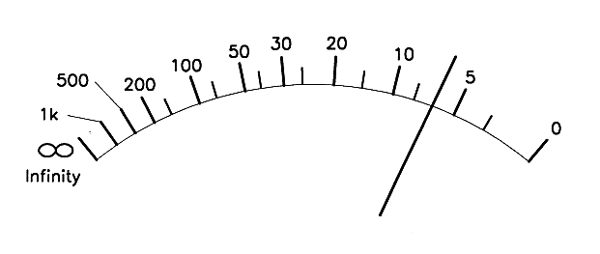
Example Scale of an analogue multimeter:

You must take the following precautions when measuring resistance with an ohmmeter or multimeter:

  - Make sure that the supply has been disconnected from the component to be measured.

  - Use the 'Ohms Adjust' knob to set the instrument to full scale deflection (FSD) with the test probes short circuited. If the pointer on the instrument cannot be adjusted to zero ohms it indicates that the internal battery needs replacing.

  - Make sure that there are no other components in parallel with the one being measured.

  - Switch the instrument off after use.

Multimeters

6. A multimeter is an instrument which has various functions and ranges so that it can be used for measuring various values.

The most common functions are current, voltage and resistance, but some digital types have special functions such as audible continuity, diode test and transistor test.

Multimeters are connected in series for current ranges and parallel for voltage ranges. You must take care to select the correct function and range on the selector mechanism.

Multimeters should be switched off or to the highest available a.c. range when they are not in use.

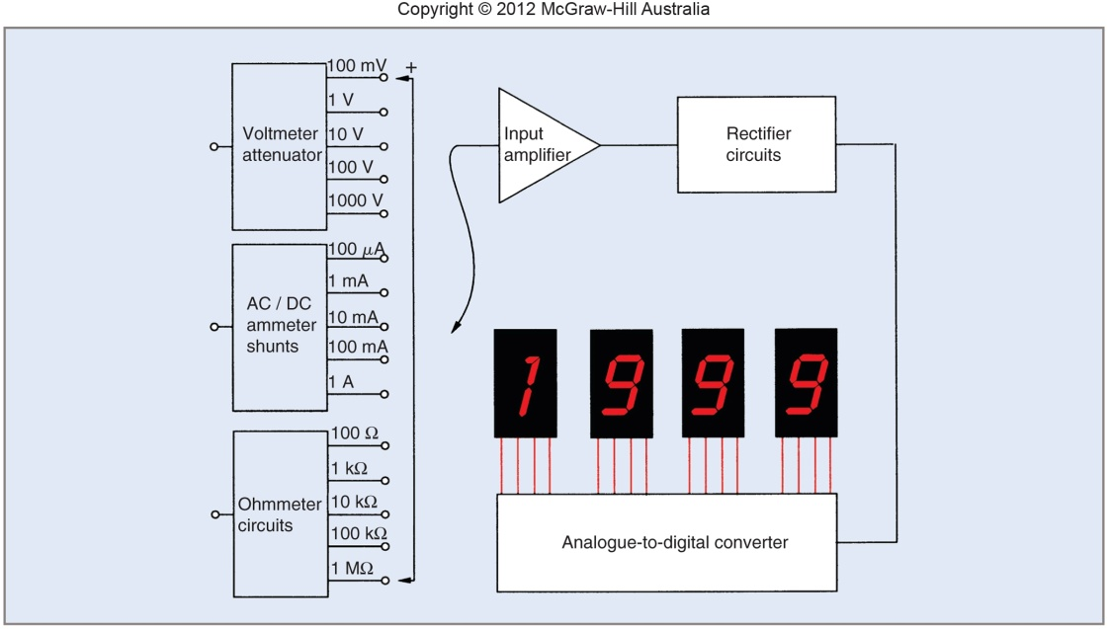

Block diagram of the internal circuits of a digital multimeter

Circuit Continuity

7. Continuity is a term used to describe the condition in which a conductor is continuous from one end to the other.

The most common method of checking continuity is to use a resistance measuring instrument such as a multimeter; if a zero or low resistance is indicated the circuit is usually continuous.

A reading of infinity between the two ends of the conductor indicates that the conductor is open circuited.

8. If you are to check a conductor for continuity, you must disconnect the supply voltage and at least one end of the conductor to avoid obtaining a false reading through other conductors in the circuit.

Insulation Resistance Testers (Meggers)

9. The purpose of an insulation resistance tester is to ensure that the live parts (Active and neutral conductor) do not come in contact with exposed parts or earth, of an electrical installation.

The insulation between any live part and earth, or any exposed metal frame of a single insulated appliance or installation must be capable of withstanding a direct current at 500 volts (see AS/NZS3000:2018 clause no. 8.3.6.2.)

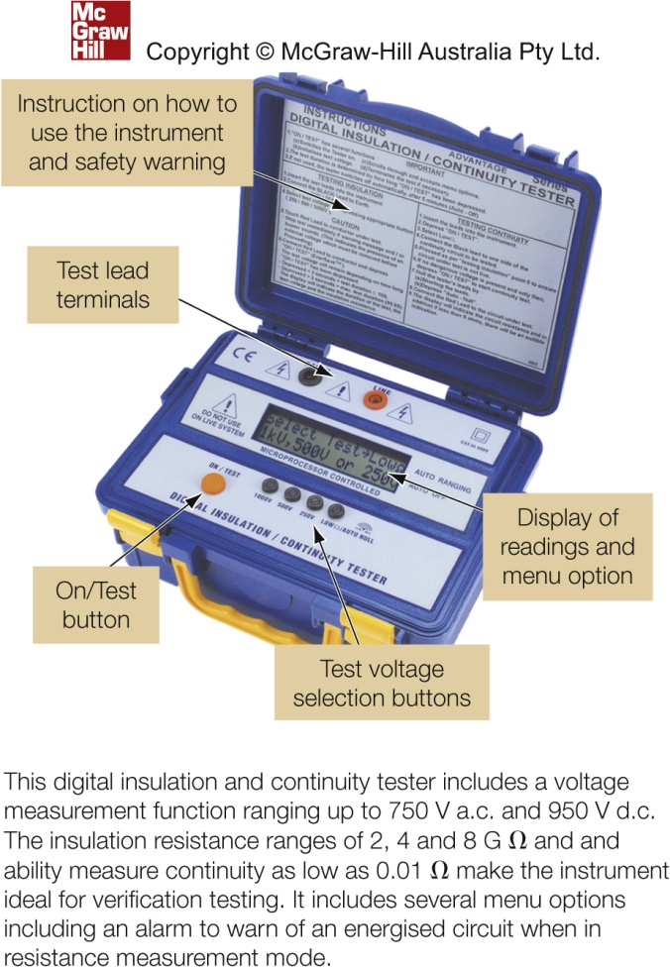
10. Insulation resistance testers are available
in hand driven generator or battery
operated electronic push button types;
with a range of output voltages:
typically: 250 V DC to 1000 V DC

11. The scale on an insulation resistance
tester is usually calibrated in Meg-ohms
(MΩ) from zero to infinity (∞)

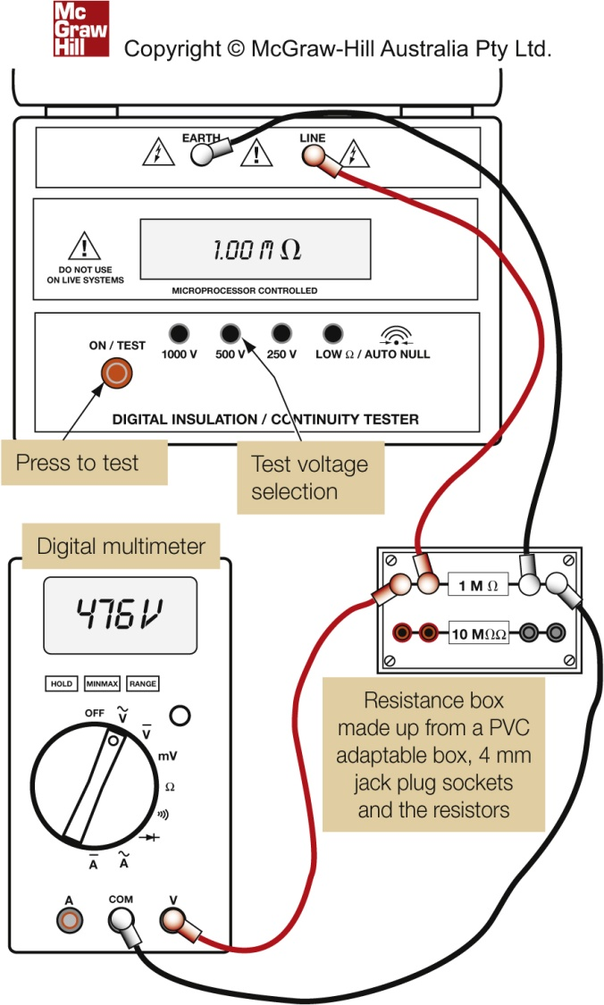

Calibration checks for IR Testers

12. Insulation resistance tester must maintain a consistent terminal voltage for valid test results.
AS/NZS 3000 Wiring Rules states that an IR tester must maintain its terminal voltage within +20% and -10% of the nominal open circuit voltage of 500 V DC when measuring a resistance of 1MΩ.
(see AS/NZS3000:2018 clause 8.3.6.2)

Bridge Meggers

13. A bridge megger is a test instrument which has several functions. It can be used as a 500 volt high voltage insulation tester (megger), or an accurate ohmmeter (bridge).

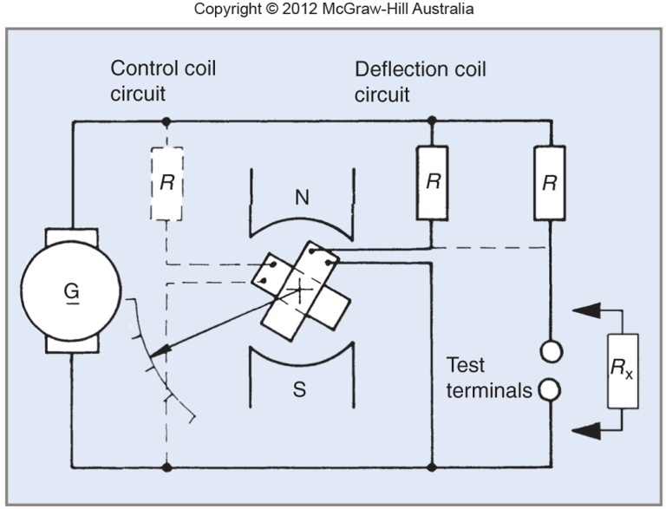

Bridge megger circuit

14. To use the instrument to measure an unknown resistance:

a. Make sure that the component to be tested is not connected to the supply.
b. Set the function to ‘bridge’.
c. Connect the component or circuit to the test terminals L and G.
d. Set the bridge ratio switch to a value based on the estimated resistance. The available ratios are: ÷100, ÷10, ×1, ×10 and ×100.
e. Wind the handle and turn the four decade dials until the balance indicator remains steady in the mid position.
f. Note the four numbers showing on the decade dials. The resistance reading is the four numbers showing on the decade dials multiplied by the ratio setting.

Care and Storage of Instruments

15. Electrical measuring instruments contain delicate components that can be easily damaged by rough handling, excessive temperatures or using them on incorrect ranges.

When they are not in use you should switch them off (if they are battery operated) and store them with any connecting leads neatly wrapped.

You should avoid storing them with other equipment on top of them.

16. It is a bad practice to tap the glass on any measuring instrument because the glass can be dislodged.

17. If you are to transport an analogue multimeter, setting it to the highest available current range will provide maximum damping for the pointer, however, setting it to the highest current range also means that there is a very low resistance between the connecting leads, so you must take care to select the appropriate function and range before you use it.

If the instrument is to be stored you should switch it off or set it to the highest available a.c. voltage range.

18. All clips, probes and leads should be maintained in safe working order.
If any connecting lead becomes damaged you should have it replaced immediately.

 | Solve problems in Single Path Circuits | Section 5  Summary | Ver 1.6  18/09/2025  CD0046

Selection of meters to measure electrical circuit quantities

1. The measuring instruments you are likely to use most frequently in the electrical industry are:

a. Ammeters to measure electric current.
b. Voltmeters to measure electrical pressure.
c. Multimeters to measure voltage, current and resistance.
d. Non-contact testers volt-sticks (to test for the presents of power)
e. Circuit indicators series test lamps (to test for voltage)

2. Two general forms of measuring instrument are available - analogue and digital.

An analogue instrument has a moving pointer and a graduated scale, and a digital instrument gives a direct numerical read-out.

All types of digital instruments and resistance indicating instruments require a battery; most analogue ammeters and voltmeters do not require a battery.
You should switch all battery operated instruments off when you are not using them to avoid premature battery failure.

3. Some instruments are designed to operate on alternating current, some are designed to operate on direct current, and others are designed to operate on both a.c. and DC

You must examine the markings on an instrument before you use it, otherwise it could be damaged. A straight line under the function marking on an instrument (A or V), indicates a DC instrument, and a small sine curve indicates an a.c. instrument.

If an instrument is designed for DC the connecting terminals are usually colour coded red and black to indicate their polarity; red is positive and should be connected to the more positive terminal.

4. You must determine the FUNCTION and RANGE of a measuring instrument before you connect it into a circuit. Typical functions are DC volts, DC amps, a.c. volts, a.c. amps and resistance. Typical ranges are 0-1, 0-5, 0-10, 0-100 and 0-500, but many others are used.

Ammeters

5. An ammeter (not amp-meter) is used to measure the current flow in a circuit; therefore, you must connect it in SERIES with the component in which the current is being measured - as shown below.

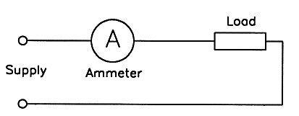
A typical ammeter has a very low internal resistance; an explosion can result if it is incorrectly connected in parallel with a supply.

6. If you are to measure the current in an existing circuit or component you must isolate the supply and temporarily alter the wiring in order to connect an ammeter in series with the relevant part of the circuit.

7. Clip-on Ammeters

A special type of ammeter is available which can be used to measure the circuit current without having to disconnect any wiring.

They are known as clip-on ammeters, link-test meters, clamp-meters or Tong-testers.

The instrument is designed to detect the magnetic field resulting from the current in the conductor and convert it to an indication on an analogue or digital meter.

Analogue instruments are available in two general types - moving iron and inductive or transformer types - inductive clip-on ammeters are only suitable for use on a.c.

They are not usually as accurate as fixed ammeters, but the accuracy can be improved by looping the insulated conductor around the magnetic jaws two or more times, then dividing the reading by the number of times the conductors pass through the jaws.

8. Both analogue and digital clip-on ammeters have a meter lock which enables the reading on the instrument to be locked so that meter can be read in a more convenient and safe position.

You must check the meter lock to see that it is off before attempting to take another reading.

9. Analogue clip-on instruments have provision for selecting different scales; it can be a normal range selection control, a mechanical mechanism which physically changes the scale under the pointer, or a system which allows the entire meter mechanism to be replaced with another with a more convenient scale.

Clip-on instruments can also have provision for voltage and resistance ranges so that they can be used as a multimeter, in which case external test probes are required.

10. Press-To-Read Button

If you are to use an ammeter to determine the current in an electric motor the meter needs to be able to safely withstand an initial starting current of about 5 to 8 times the full load current.

Damage to the meter can be prevented by connecting a normally closed 'press-to-read' button in parallel with the ammeter as shown below; the reading must be taken with the button pressed.

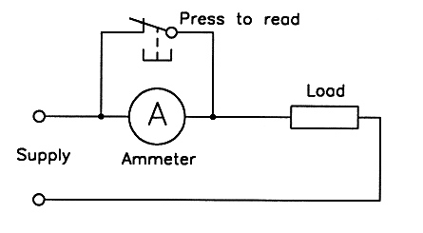

Voltmeters

11. A voltmeter is used to measure the electrical pressure between two points in a circuit; therefore, you have to connect it in PARALLEL with the component across which the pressure is being measured - as shown below.

A typical voltmeter has a comparatively high internal resistance.

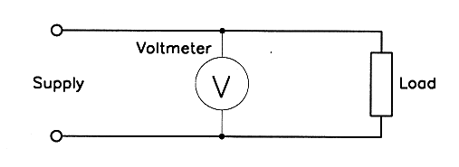

Voltmeter Loading Effect

12. When you connect a voltmeter to measure the voltage in a circuit it becomes part of the circuit and current flows through it.

Although it has a high resistance, the effect is to place additional load on the circuit in parallel with the component - this voltmeter loading effect can result in false readings on the voltmeter.

The loading effect is most evident in low current electronic circuits.

13. The loading effect of a voltmeter is known as its sensitivity and it is expressed in ohms per volt.

Individual voltmeters can have sensitivities ranging from about 500 ohms per volt to several meg-ohms per volt.

A sensitivity of 1 meg-ohm per volt or more is usually preferable in electronic circuits. Digital multimeters typically have a high sensitivity on voltage ranges.

15. You must take the following precautions when measuring resistance with an ohmmeter or multimeter:

a. Make sure that the supply has been disconnected from the component to be measured.

b. Use the 'Ohms Adjust' knob to set the instrument to full scale deflection (FSD) with the test probes short circuited. (Note: If the pointer on the instrument cannot be adjusted to zero ohms it indicates that the internal battery needs replacing).

c. Make sure that there are no other components in parallel with the one being measured.

d. Switch the instrument off after use.

Multimeters

15a. Safe use of multimeters

All multimeter and test equipment probes necessarily have bare ends so that they can make proper electrical contact at the point being tested.

The bare ends often extend back up to about 25 mm from the point of the probe so that it can be inserted in sockets and other confined spaces.

You need to take extreme care when using such probes. Do not touch the metal probe tips.

If you do not have a correct grip (fingers behind knurls) on the probes your fingers can slip down and come in contact with a live conductor, or if you position the probe carelessly it may provide a short circuit between adjacent metallic parts and result in the unexpected operation of a part of the circuit or, in the case of a short circuit to earth, an explosion.

16. A multimeter is an instrument which has various functions and ranges so that it can be used for measuring various values.

The most common functions are: current, voltage and resistance. Some digital types have special functions such as audible continuity, diode test and transistor test.

Multimeters are connected in series for current ranges and parallel for voltage ranges.

You must take care to select the correct function and range on the selector mechanism.

Multimeters should be switched off or to the highest available a.c. range when they are not in use.

17. When measuring an unknown voltage or current with a multimeter you should set the instrument to the highest available range first.

18. Multimeters set to an appropriate voltage range are frequently used for fault finding in operational circuits.

You should note that the voltage across an open switch or contact (or blown fuse) in a circuit which is otherwise complete is the line voltage, and the voltage across a closed switch is zero - as shown below:

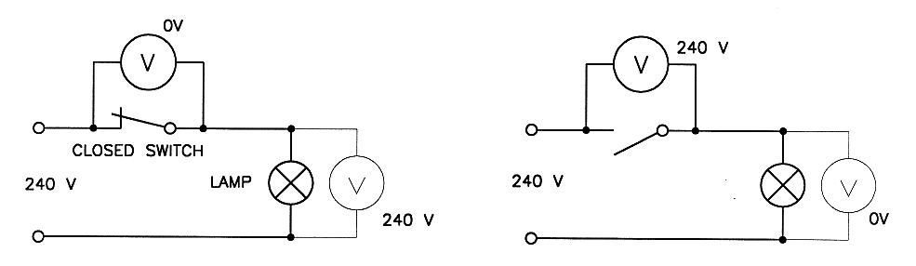

Circuit Continuity

19. Continuity is a term used to describe the condition in which a conductor is continuous from one end to the other.

The most common method of checking continuity is to use a resistance measuring instrument such as a multimeter; if a zero or low resistance is indicated the circuit is usually continuous.

A reading of infinity between the two ends of the conductor indicates that the conductor is open circuited.

20. Continuity can also be checked using a battery connected in series with a suitable incandescent lamp (a battery test lamp), bell or buzzer. If the lamp lights up when the two free ends of the test lamp are connected to the conductor it indicates that the circuit is continuous.

Battery test lamps are not reliable when testing an element or winding for continuity because the resistance of the element or winding may be too high to allow the lamp to light up.

It is essential to check the checker before and after any continuity test.

21. If you are to check a conductor for continuity, you must disconnect the supply voltage and at least one end of the conductor to avoid obtaining a false reading through other conductors in the circuit.

Care and Storage of Instruments

22. Electrical measuring instruments contain delicate components that can be easily damaged by rough handling, excessive temperatures or using them on incorrect ranges.

When they are not in use you should switch them off (if they are battery operated) and store them with any connecting leads neatly wrapped.

You should avoid storing them with other equipment on top of them.

23. It is a bad practice to tap the glass on any measuring instrument because the glass can be dislodged.

24. If you are to transport an analogue multimeter, setting it to the highest available current range will provide maximum damping for the pointer, however, setting it to the highest current range also means that there is a very low resistance between the connecting leads, so you must take care to select the appropriate function and range before you use it.

If the instrument is to be stored you should switch it off or set it to the highest available a.c. voltage range.

25. All clips, probes and leads should be maintained in safe working order.

If any connecting lead becomes damaged you should have it replaced immediately.

 | Solve problems in single path circuits | Section 5  Work Sheet 5-1 | Ver 1.6 18/09/2025  CD0046

Selection of meters to measure electrical circuit quantities

1. What is the name of the electrical measuring instrument used to measure the CURRENT flowing in a circuit?

2. What is the name of the electrical measuring instrument used to measure the electrical PRESSURE in a circuit or part of a circuit?

3. What is the name of the electrical measuring instrument used to measure the RESISTANCE of a circuit?

4. How should AMMETERS be connected in a circuit?

5. How should VOLTMETERS be connected in a circuit?

6. Which measuring instrument has the lowest internal resistance, an ammeter or a voltmeter?

7. Which measuring instrument has the higher internal resistance, an ammeter or a voltmeter?

8. Describe a method of overcoming ‘parallax’ error when reading an analogue scale.

 | Solve problems in single path circuits | Section 6 Summary | Ver 1.6  18/09/2025  CD0046

Electrical Power

- Power is the rate at which work is done or the rate at which energy is converted from one form to another.
All electrical devices have a power 'rating' which must not be exceeded under normal operational conditions - if the power rating is exceeded the device will overheat and permanent damage may result.
Power (P) is expressed in watts (W). 1 watt = 1 joule per second.

- Since the power dissipated by a resistor is critical to safe operation, it is often necessary to calculate the actual power dissipation for a given fixed or variable resistor to ensure that it is not exceeded.
The actual power dissipation on DC can be calculated using any one of the three basic power equations:
V²
P = V x I P = I² x R P = ---
R

- Example 1:
Calculate the power dissipated by a resistor if the current through it is 10 amps and the applied voltage is 100 volts.

P = V x I
= 100 x 10
= 1000 watts (W)

- Example 2:
Calculate the power dissipated by a 100 ohm resistor if the applied voltage is 20 volts.

V² 20²
P = --- = ----- = 4 watts (W)
R 100

= 4 watts

- Example 3:

Calculate the power dissipated by a 5 ohm resistor if the current through it is 10 amps.

P = I² x R
= 10² x 5
= 500 watts

- Example 4:

A particular 240 volt heating element has a power rating of 1200 watts. How much current would be drawn by the element?

P
P = V x I so I = --- (by transposition)
V
P
I = ---
V

1200
= -------
240

= 5 amps.

- It is important to be aware that the power dissipated by a resistor increases in proportion to the square of the current – i.e. if the current is doubled the power dissipated is quadrupled!
Quantities: Voltage - 12V Current – 3A Resistance - 4Ω

- Example 1 P = I²R P = 3² x 4 P = 9 x 4 P = 36 W
If we double the current value to 6A
P = I²R P = 6² x 4 P = 36 x 4 P = 144 W
- Example 2
V² 12² 144
P = ----- P = ------- P = --------- P = 36 W
R 4 4
If we double the voltage to 24V
V² 24² 576
P = ------ P = ------- P = --------- P = 144 W
R 4 4
- Example 3
P = V x I P = 12 x 3 P = 36 W
If we double the current to 6A
P = V x I P = 12 x 6 P = 72 W
This value is only doubling the power not quadrupling. This is because we know from basic ohms law that voltage and current are directly proportional. Therefore if we are to use this formula we must also double the voltage.
P = V x I P = 24 x 6 P = 144 W

Exercises

- Exercise 1
A particular 12 volt heating element has a power rating of 40 watts and a resistance of 4 ohms. How much power would it dissipate on 12 volts? How much power would it dissipate if the applied voltage was increased to 24 volts?

- Exercise 2
A 120 ohm, 10 watt resistor is found to have a voltage of 40 volts across it. What effect would you expect this to have on the operation of the resistor?

Formula Circle

- The relationships between voltage, current, resistance and power can be summarised in the following Formula Circle:

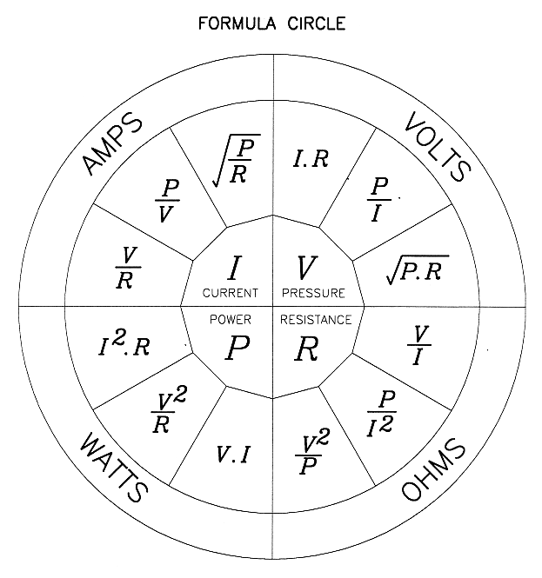

 | Solve problems in single path circuits | Section 6 Work Sheet 6 – 1 | Ver 1.6 18/09/2025  CD0046

Electrical Power

- A 240 volt heating element has a resistance of 48 ohms. How much power would be dissipated by the element when it is connected to the 240 volt supply? Write the equation.

- A 240 volt lighting circuit consists of 4 x 60 watt lamps and 2 x 100 watt lamps. Calculate the current flow in the circuit. ? Write the equation.

- Calculate the resistance of a 1200 watt - 240 volt rated heating element. Write the equation.

- Calculate the volt drop across a 100 watt resistor when 8.33 amperes is flowing through the circuit. Write the equation.

- If the current in a circuit is doubled, what factor does the power dissipated in the circuit increase by? Prove by example.

 | Solve problems in single path circuits | Section 7 Summary | Ver 1.6  18/09/2025  CD0046

Effects of Electrical Current

1. Physiological Effect

When electric current flows through the human body it can cause abnormal muscular contractions or heating of body tissue and it is known as an electric shock.

A small electric shock can cause a mild tingling sensation in the muscles of the arm, but a severe shock causes a sudden contraction of the heart muscles which can stun the victim and may have one or more of the following effects:

a. The victim stops breathing.
b. The victim's heart stops, or quivers rapidly without pumping blood a condition known as ventricular fibrillation.
c. The victim suffers severe burns.
d. The victim suffers traumatic shock to the nervous system.
e. The victim suffers muscular paralysis and may be unable to release his/her grip on a live machine.

2. Factors

The main factors which affect the seriousness of electrical shock are:

a. The amount of current passing through the body.
b. The path of the current through the body.
c. The voltage of the circuit.
d. The duration of contact with the live part.
e. The resistance of the body at the time of contact.
f. The surface area of the skin in contact with the live component.
g. The period of the cardiac (heartbeat) cycle during which the shock occurs.
h. The individual - some people are affected more than others.

It is not possible to define precisely the effects of a given current on the body, but the general effects of alternating current are shown in Figure 1.

Figure 1 - General effects of electric shock

Effects and Uses of Current Flow

3. Static Electricity
This is so called because it is electricity at rest. Static electricity is produced when two objects are rubbed together. Lightning is a form of static electricity.

The attractive force of static electricity is used in industry to clean air or smoke by electrostatic precipitation. Static electricity can be hazardous in areas containing flammable materials if equipment is not adequately earthed.

Adequate earthing is also required to prevent damage from static electricity when handling sensitive electronic components.

4. Electrical Heating
When electricity flows through a material heat is always produced. This is put to use in electric radiators, ovens, heating elements and so on.

In many cases such as cables, motors, generators and transformers the heating effect is unwanted and the devices must be designed or installed so that the heat cannot cause damage.

- Light

The heating effect of an electric current passing through a conductor can be used to produce light, as in an incandescent lamp.

When electricity is passed through a gas both heat and light are produced. In many cases the light produced is invisible to the human eye and special chemicals are required to convert the invisible light to visible light, as in a fluorescent tube.

- Magnetism

When electric current passes through any material a magnetic flux or field is produced.

If current is passed through a coil or wire wound around a steel core, an electromagnet is produced.

The electromagnetic effect is used to advantage in many electrical devices such as electric motors, transformers, generators, solenoids, relays, magnetic starters and so on.

The strength of the magnetic field produced depends largely on the current in the circuit, and in high current circuits the magnetic field produced can cause high mechanical stress on components, so components often need to be mechanically supported to avoid damage.

Some devices such as measuring instruments can be affected by strong magnetic fields, so they need to be kept away from components which produce such fields.

- Chemical

When two dissimilar metals are immersed in a conducting liquid (an electrolyte), and a voltage is applied to the metals, one of the metals can be chemically decomposed and deposited on the other.

This effect is used to advantage in the electroplating process and for chemical refining.

- Corrosion of Metals

The chemical effect occurs when two dissimilar metals are positioned so that they are touching (in a liquid or in air).

The resulting chemical decomposition of one of the metals is known as electrolytic corrosion or galvanic action.

Using zinc-plated (galvanized) saddles to fix bare copper sheathed cables, or bolting copper and aluminium together causes unwanted electrolytic corrosion if special precautions are not taken.

Principles of Protection

9. The Wiring Rules (Clause 1.5) provides fundamental principles for the protection against the effects of current flow.

Protection can be achieved by preventing a current from passing through the body of any person, or limiting the current which can pass through a body to a value lower than the shock current.

The Wiring Rules defines two types of contact - direct contact and indirect contact
(see Figures 1.2 and 1.3 on page 39 of AS/NZS 3000:2018)

Basic protection against direct contact with live parts can include:

a. The insulation of live parts.
b. The use of barriers or enclosures.
c. The use of obstacles.
d. The placing of live parts out of reach.

- Methods of providing fault protection against indirect contact with exposed conductive parts which can become live under fault conditions can include (see AS/NZS 3000:2018 Clause 1.5.5):

a. Automatic disconnection of the supply on the occurrence of a fault likely to cause a current flow passing through the body.
b. Preventing a fault current passing through a body by the use of Class II equipment (double insulation).
c. Preventing a fault current passing through a body by electrical separation systems
d. Limit the fault current that can pass through a body to a value lower than the shock current.

- Protection against the dangers that may arise from contact with exposed conductive parts may be provided by means including the following:

a. The automatic disconnection of the supply.
b. The use of double insulation.
c. The suitable location of exposed conductive parts.
d. The use of equipotential bonding.
e. The electrical separation of exposed conductive parts.

 | Solve problems in single path circuits | Section 7 Worksheet 7 – 1 | Ver 1.6 18/09/2025  CD0046

Effects of Electrical Current

- List four physiological effects of current flow on the human body.

- List four factors which affect the severity of an electric shock.

- State two common effects of electric current flow and give one beneficial example of each.

- Give two examples each for measures that can be taken to prevent the “Direct contact” and “Indirect contact” with live parts.

 | Solve problems in single path circuits | Section 8 Summary | Ver 1.6  18/09/2025  CD0046

Sources of Electromotive Force (EMF)

Methods of Producing Electricity

1. An Electromotive Force or EMF can be produced in a variety of different ways and each has different applications in industry. The methods of producing an EMF broadly fall into the five different categories as listed below.

Magnetic
Heat
Light
Pressure
Chemical
Friction

Magnetic/Mechanical - If relative motion is achieved between a conductor and a magnetic field and EMF will be produced.

This can be either a conductor being moved through a stationary magnetic field or a changing magnetic field cutting a conductor.

This is the principle on which an electric generator operates.

The voltage output produced depends on the strength of the magnetic field, the speed at which the conductor passes through it and the angle at which the conductor is passing through the magnetic field.

In general, “Base-Load” power comes from this source by burning fossil fuels or using a nuclear reaction to heat water that produces high-pressure steam, the steam is then forced through a turbine causing it to rotate which in turn provides the mechanical rotation required for a generator to produce its output.

Wind and wave energy, tidal energy and hydro-electric systems also use this generation method.

Heat - If the junction of two dissimilar metals is heated, a small amount of electricity is produced.

The voltage depends on the types of metal and the temperature of the junction.

Thermocouples are classed by the operating temperature and sensitivity of the metals used and given a letter designation.

For example a K-Type Thermocouple is a combination of Chromel and Alumel alloys.

The typical application for thermocouples is temperature sensing where the voltage produced is displayed on a voltmeter calibrated to read degrees Celsius.

Light - When light falls on certain materials a voltage is produced.

This is known as the 'photovoltaic effect'.

The use of P-type and N-type silicon creates electron movement when exposed to visible light.

Photovoltaic (PV) cells or solar panels (as they are more commonly known) are used to take advantage of this electron movement and are now used extensively to power our homes and businesses. They have reduced our reliance on burning fossil fuels which helps the environment. They also power space satellites, electronic devices and are used as a source of electricity in remote areas.

Pressure (Piezo Electric) - A voltage is produced when pressure is applied to or taken off certain substances such as crystals or quartz.

The voltage produced depends on the type of crystal and the amount of pressure applied. Push-button igniters for hot water systems and barbeques are common uses for piezoelectricity in a domestic situation. Industry incorporates the use piezoelectricity in load cells for measuring force.

Chemical - If two dissimilar metals called electrodes are placed in a suitable conducting liquid (an electrolyte) a voltage is produced.

The voltage depends on the types of metal and the type of conducting liquid - typically between 1 and 2 volts.

This is then called an electric CELL or they can be connected together to form a ‘battery’. There are two main types of cell - primary cells and secondary cells, and there are several different variations. In primary cells the negative electrode is ‘consumed’ and the cell cannot be recharged.

In secondary cells the process can be reversed so they can be re-charged.

Another type of cell used to produce electricity via chemical means is the fuel cell. A fuel cell is a device which converts chemical energy from a fuel, like hydrogen, into electricity through a chemical reaction.Fuel cells can produce electricity indefinitely as long as the fuel is continually supplied.

Friction - By rubbing (friction) you can create charges which are responsible for generating electricity. ... Friction produces static electricity by initiating the transfer of electrons between two or more objects. With regards to electron transfers, objects are either conductors or insulators.

Types of Supply

2. Alternating Current (AC) changes its direction through a conductor each and every “half” cycle. AC is derived by mechanically rotating a conductor through or around a magnetic field.

All generators produce sinusoidal AC as its prime current. The electricity provided by the Supply Authority is in alternating current form.

The voltage constantly changes in magnitude and polarity but it is symmetrical in form.
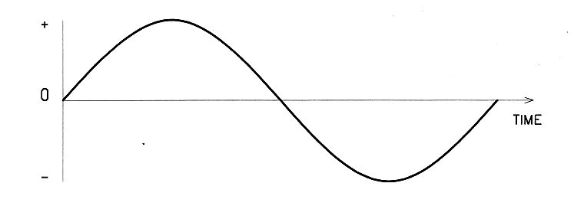

Alternating Current

Direct Current (DC) flows only in one direction as the polarity of the supply remains constant.

There are two general categories of DC; steady DC and rippled DC

a. Steady DC. is obtained from devices such as batteries, cells, fuel cells, thermocouples and solar cells.
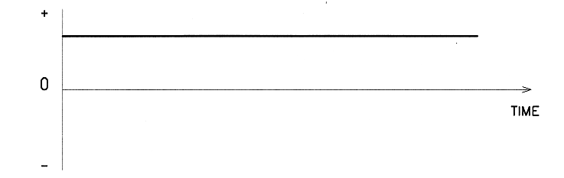

Direct Current

b. Pulsating DC is obtained from a generator that uses “Commutation” to convert the prime AC into the pulsing DC shown below. The remaining “AC” after this conversion is called its “Ripple”.
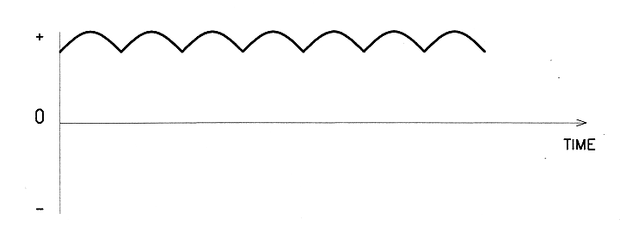

Rippled Direct Current

For practical purposes, the supply from a battery and that from a DC generator are both known as DC, however “Ripple-free” DC is only attainable from non-magnetic sources.

Distribution System

3. The main electrical supply system urbanised areas in WA is a three-phase four-wire system that comprises three active conductors and one neutral conductor.

This system can supply alternating current (a.c.) in two voltages to a consumer - 240 volts single phase and 415 volts three phase.

Both voltages are potentially lethal, so live terminals must not be touched under any circumstances.

Two basic rules must always be observed by electrical workers when carrying out isolation procedures: They are 'Test Before You Touch' and 'Always Check the Checker'. The supply must be isolated prior to commencing work on any live or potentially live circuits.

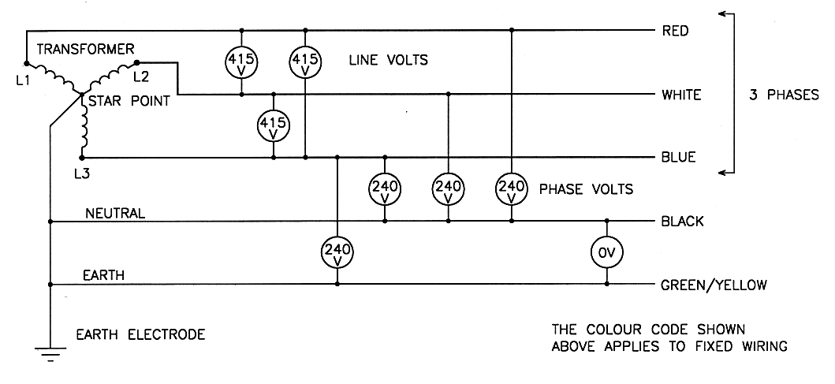

Note: Relevant parts of AS/NZS 3000 assume a nominal single phase voltage of 230 volts and a phase-to-phase voltage of 400 V as used in rest of Australia and in New Zealand.

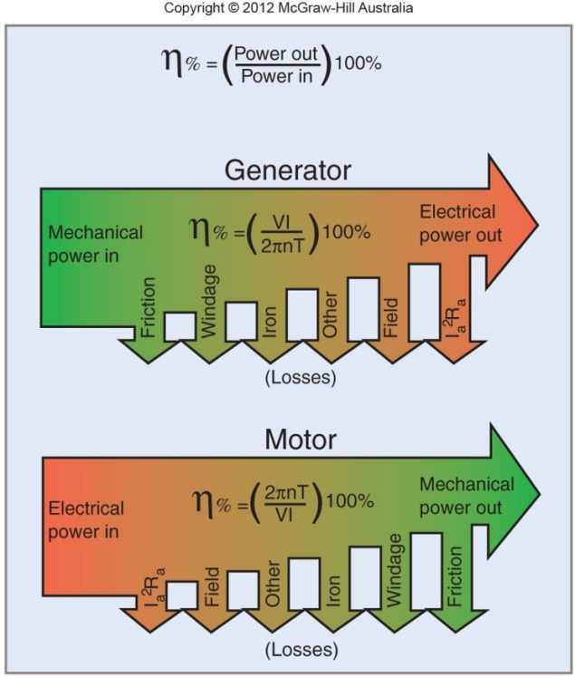
Efficiency of Electrical Systems and Machines

4. Efficiency of a machine is measuring input power against the output power which is the conversion of energy from one form to another. For example, an electrical generating unit converting mechanical power into electrical power will have losses.

The two principle mechanical losses in a generator are friction and windage. The two main electrical losses in a generator can be group as magnetic field losses and electrical resistance losses.

The formula to calculate machine losses is

$$\begin{matrix}η\% & = & (\frac{Power out}{Power in})\end{matrix}100\%$$

 | Solve problems in single path circuits | Section 9  Summary | Ver 1.6  18/09/2025  CD0046

Practical Resistors

Resistance

1. All materials have the property of resistance, and each material has a different value.

Devices which make use of the property of resistance are known as resistors, and when they are arranged in groups they are known as resistor networks or banks.

Figure 1a: shows the Australian standard symbol for a resistor.

Figure 1b: shows a superseded resistor symbol which is widely used in texts and other technical
publications.

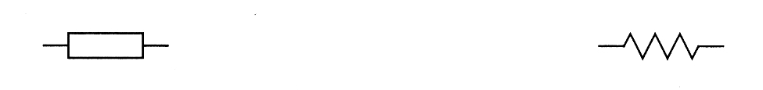

1a - Standard symbol 1b - Common symbol.

Figure 1 - Resistor symbols.

2. A conductor with a low resistance allows more current to flow than a conductor with a high resistance if the voltage remains constant, so current is inversely proportional to resistance.

This relationship can be expressed as a mathematical equation known as 'Ohm's Law':

$I=\frac{V}{R}$

Current = Voltage ÷ Resistance

3. The following examples show that current increases as resistance decreases.

4. Example 1

Calculate the current which would flow in a 6 ohm resistor if a voltage of 12 volts was applied to it.

V
I = ---
R
12
= ---
6

I = 2 amps
==========

- Example 2

How much current would flow in the 12 volt circuit if the resistance was reduced to 3 ohms?

V
I = ---
R

12
= ---
3

I = 4 amps
==========

Types of Resistor

6. Most practical resistors can be classified in the following main groups:

a. Fixed or variable resistors which are used to control current or voltage in a circuit
b. Resistors used as heating elements
c. Resistive devices used as illuminating lamps
d. Temperature dependent resistors (thermistors)
e. Light dependent resistors (LDRs)
f. Voltage dependent resistors (VDRs)

7. Voltage Control - When several components are connected end-to-end they are said to be connected in series.

Under these conditions the voltage across each component depends on the resistance of the component (the higher the resistance the higher the voltage).
Connecting resistors in series is a method of obtaining a specified voltage between particular points in a circuit, and resistors are used in this way in most electronic circuits.

8. Elements and Lamps - When current is passed through any material, heat is produced. Some types of resistors are specifically designed to exploit this characteristic - they are known as heating elements or power resistors.

The trade name of a resistance wire specially intended for use in heating elements is Nichrome.

Other types of resistive devices are designed to produce enough heat to cause visible light to be emitted from a tungsten wire filament -these are known as incandescent lamps (or light globes).

A sustainable energy management principle is to always use the most efficient devices that are available. Incandescent lamps are very low in efficiency and their use should be avoided if possible.

9. Thermistors - The resistance of a resistor depends on the temperature of the resistor.

The change in resistance for each degree change in temperature is called the 'temperature coefficient of resistance' - if the resistance increases as the temperature increases the material is said to have a POSITIVE temperature coefficient, if it decreases the material is said to have a NEGATIVE temperature coefficient.

10. A family of small resistive devices is available which increase or decrease their resistance by a large amount for a comparatively small change in temperature - they are known as thermistors.

If their resistance increases as the temperature increases they are known as PTC (positive temperature coefficient) thermistors - if their resistance decreases as the temperature increases they are known as NTC thermistors.

Thermistors are used to sense temperature and operate temperature-sensing instruments or over-temperature protective devices. The symbols for PTC and NTC thermistors are shown in Figure 2.
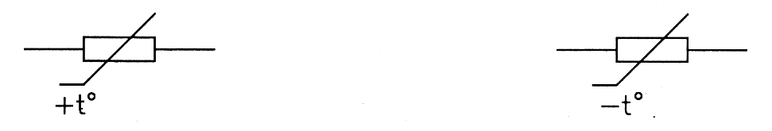

PTC thermistor symbol. NTC thermistor symbol.

Figure 2. - Thermistor symbols.

11. LDRs - Cadmium sulphide is a material which changes its resistance when it is exposed to light - it is said to be photo-conductive.

Cadmium sulphide is used to manufacture small light dependent resistors (LDRs). The passive component is basically a resistor whose resistance value decreases when the intensity of light decreases - the change in resistance is exploited to control other devices or processes.

The symbol for a LDR is shown in Figure 3.

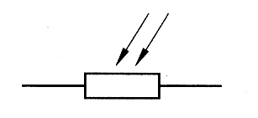

Figure 3. - Light dependent resistor symbol.

12. VDRs - A voltage dependent resistor (VDR) is a special resistive component in which the resistance falls quickly when the voltage across it increases to over a designed value.

They are also known as varistors. VDRs are used to protect other sensitive components from the effects of over-voltage, such as voltage surges in the supply system, lightning strike, or high induced voltages when large DC electromagnets are de-energised.

Each individual VDR has a specific designed 'break-over voltage' at which it allows enough current to flow to cause the circuit protection device to operate. The symbol for a VDR is shown in Figure 4.
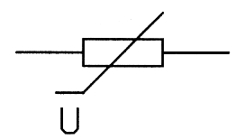

Figure 4. Voltage Dependent Resistor symbol - VDR.

Variable Resistors (Rheostats or Potentiometers)

13. It is frequently necessary to have a resistor in which the resistance can be altered manually - these are known as variable resistors. In a variable resistor a mechanical wiping or clamping mechanism is provided so that the resistance can be varied by positioning the wiping or clamping mechanism at the required place on the resistive portion of the device. Several variations are available, some with special names - including:

a. High power potentiometers (pots) - up to about 500 watts.
b. Low power potentiometers - up to about 2 watts.
c. Multi-turn potentiometers - up to about 1 watt.
d. Low power trimmers - up to about 1 watt.
e. Linear potentiometers - up to about 2 watts.
f. Logarithmic taper potentiometers - up to about 2 watts.
g. Wire wound variable resistors - up to about 200 watts.

As a rule, Rheostats are used to control current and have two connections in a circuit. Rheostats generally produce a fair amount of heat and require ventilation.

Potentiometers are most likely to be used to control voltage and normally have three connections to a circuit.

14. Most types of variable resistor have one of the two general shapes illustrated in Figure 5.

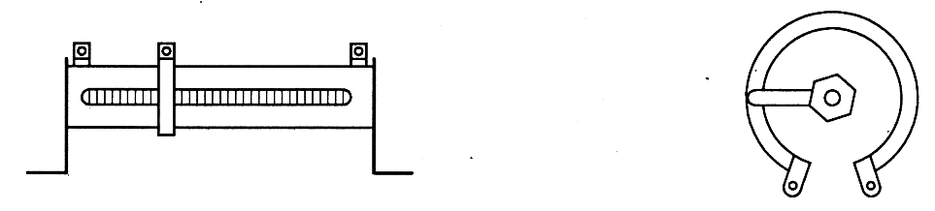

Figure 5 - Two common shapes of variable resistor.

Determining Resistance

15. Before attempting to measure the ohms of a resistor it is important to do the following beforehand to ensure your safety and to achieve an accurate reading;

a. Ensure the supply has been isolated from the circuit/s you will be working on.

b. Make sure your instrument is working properly and on the correct settings.

c. Disconnect at least one end of the resistor to ensure there are “No Parallel Paths”.

The resistance of a component can be measured directly using the following common instruments.

  - A multimeter selected to the 'ohms' range.
  - An Insulation Resistance selected to the appropriate 'ohms' range.
  - A Wheatstone bridge instrument.

Note: Some people refer to the instrument (b) as a “Megger”, this is the trade name for a manufacturer of electrical measuring instruments commonly used in the electrical trades.

16. In electronic circuits resistors can often be identified by the presence of between three and five bands of colour painted on the body of the resistor; these bands of colour are used to indicate the resistance of the resistor.

Some other components have bands of colour, so the presence of coloured bands is not a positive indication that the component is a resistor.

17. In order to determine the resistance of a colour coded resistor it is necessary to know the number which corresponds to the various colours.

This information is obtained from a Resistor Colour Code.

A simple version of the resistor colour code is shown in Table 5.3

18. Most colour coded resistors have three or four bands of colour.

Example: To determine the resistance of a resistor, that has the following colours:

Yellow Violet Red Gold

a. Position the resistor so that the band closest to the edge of the resistor is to your left.

b. Note the colours of each band reading left to right.

c. Determine the numbers that correspond to colours given in the chart above for the first two bands; in this case it is 47

d. Note the colour of the third band.
Write down the number of zeros corresponding to the number of the colour after the first two numbers. Should read; 4700

The resistor has a resistance of 4700 ohms (or 4.7kΩ). Note the letter “k” is “kilo” shortened prefix for “kilo-ohms” .This can also be expressed as “4k7”.

Tolerance

19. The fourth band of colour is the 'tolerance band'.

Manufacturers of colour coded resistors do not usually attempt to make the resistors to the exact resistance indicated by the colour code; they specify upper and lower limits between which the actual resistance will be.
The percentage above or below the marked value is known as the 'tolerance. If there is no fourth band of colour the tolerance is plus or minus 20%; if there is a fourth band the indicated tolerance can be obtained from the colour code. In the case of the example above, the colour GOLD corresponds to a tolerance of 5%, so the actual resistance of the resistor would be somewhere between 4700 - 5% and 4700 + 5% ohms.

/ +5% = 4700+235 Ω = 4935 Ω (Maximum)
4700 Ω
\ -5% = 4700-235 Ω = 4465 Ω (Minimum)

21. Exercise Refer to a Resistor Colour Code and complete the following table.

Coloured Bands |  |  |  | Resistance  In Ohms | Tolerance  %
First | Second | Third | Fourth | Resistance  In Ohms | Tolerance  %
Green | Yellow | Yellow | Silver
 |  |  | Brown | 56 000
 |  |  | Gold | 39 MΩ
Blue | Grey | Orange |  |  | 2%
Brown | Yellow | Gold | Gold
 |  |  |  | 2k2Ω | 5%
Note: The letters R, k or M are sometimes used in place of a decimal point & prefix.

Power Rating

22. All resistors are given a maximum power rating. This is the maximum value at which the resistor can safely operate and it must not be exceeded.

If the power rating is exceeded it means that the resistor is producing too much heat and it can burn out or it can damage other components nearby.

Typical power ratings for colour coded resistors range from 0.125 watts to 5 watts, while large fixed or variable resistors can have a power rating in the order of kilowatts.

23. The power rating is not usually indicated on colour coded resistors; it has to be determined from information supplied by the manufacturer or by experience.

However, it can be stated that, as the physical size is of the resistor is increased, then the higher its power rating or dissipation rate will become.

24. For large power resistors, the power rating is usually marked on the component. These resistors are often wound on porcelain grooved cylinders or fully enclosed in metal-sheathed elements.

For motor starting units, the resistors can take the form of large grid-type resistors made from cast-iron or pressed sheet-metal.

25. Since the power dissipated by a resistor is critical to safe operation, it is often necessary to calculate the actual power dissipation for a given fixed or variable resistor to ensure that it is not exceeded.

The actual power dissipation can be calculated using any one of the three basic power equations:

V²
P = V x I P = I² x R P = ---
R

26. The method involving voltage and resistance is particularly useful in cases where the resistor is connected in an operational circuit because it is not necessary to disconnect the resistor to measure the current in the circuit.

27. It is important to be aware that the power dissipated by a resistor increases in proportion to the SQUARE of the current - i.e. if the current is doubled the power dissipated is quadrupled.

28. Exercise: A 120 ohm 1 watt carbon composition resistor has a voltage of 10 volts across it when it is operating normally.

Determine the power dissipated with 10 volts across it, and the power which would be dissipated if the voltage was doubled to 20 volts.

 | Solve problems in single path circuits | Section 9 Worksheet 9 -1 | Ver 1.6 18/09/2025  CD0046

Practical Resistors

1. What is a potentiometer?

________________________________________________________

2. What is a rheostat?

_________________________________________________________

3. What is the special characteristic of a VDR or Varistor?

_________________________________________________________

4. What is the special characteristic of an LDR?

__________________________________________________________

5. What is the special characteristic of a negative temperature coefficient thermistor?

_____________________________________________________________

6. What is the resistance of a colour coded carbon composition resistor which has the following bands of colour: RED VIOLET ORANGE SILVER

_____________________________________

7. What is the tolerance of a colour coded carbon composition resistor which has a SILVER tolerance band?

__________________________________________________

8. What is the tolerance of a colour coded carbon composition resistor which has a GOLD tolerance band?

_________________________________________________

9. What effect does it have on the power dissipated by a resistor if the applied voltage is doubled?

______________________________________________________________

 | Solve problems in single path circuits | Section 11  Summary | Ver 1.6  18/09/2025  CD0046

Factors Effecting Resistance

Resistance

1. All materials have the property of resistance, and each material has a different value.

2. There are four factors which govern the resistance of any material are:

- Type of Material:

Different types of materials will have a unique value of resistance for a given specified quantity of material.

To compare different materials with how each conducts electricity its “resistivity” must be determined.

RESISTIVITY is determined by accurately measuring the resistance between two opposite sides of a cubic shape with each side being 1 square metre.

The lower the value recorded the better or easier the material can conduct electricity, pure solid copper has a resistivity of about 1.72 x 10⁻⁸ ohm-metres.

The quantity symbol used for Resistivity is the Greek letter “Rho” ( ρ ) which looks a bit like a cross between a “p” and an “r”.

- Cross Sectional Area:

As the cross-sectional area of a material INCREASES, its resistance DECREASES.
Thus, a thicker conductor has LESS overall resistance than a thinner conductor of the same length, material and temperature.

The cross sectional area of a conductor can be determined by calculating the surface area of the end of the conductor if it has been very neatly cut. A bit like slicing bread with a knife to make a sandwich. The surface where you put the butter on would be the breads’ cross-sectional area.

Most conductors are circular or rectangular and the cross-sectional area can be calculated using geometric formulae i.e.

For circular conductors; $A=πr^{2}$ or $A= π\frac{D}{4}$

Multi-stranded circular conductors; calculate the area of an individual strand and multiply by the no. of strands to find total area.

For rectangular conductors; $A =side A x side B$

Area should converted into square metres (m²) 1mm² = 1 x 10⁻⁶ m²

- Length:

As the length of a material increases the resistance increases if all other factors remain the same i.e. the longer the cable the more resistance it will have from one end to another.

It is similar to trying to drink a thick shake through a straw, the longer or thinner the straw is, the more difficult it becomes to suck the liquid up through the straw.
Likewise with electrical current, the longer the cable is or the smaller the cross-sectional area becomes, then the more resistance there will be to current flow in the cable.

- Temperature:

All materials change their resistance as their body temperature changes.

Pure elemental metals increase their resistance as their temperature increases, so they have what is called a “Positive Temperature Co-efficient” or PTC.

Some materials, such as carbon and silicon, decrease their resistance as their temperature increases and so they have a “Negative Temperature Co-efficient” or NTC.

Some specially formulated alloys of metals have very little increase in resistance over a wide temperature range and as such these alloys are useful in manufacturing high temperature resistors that can be used as heating elements and so on.

3. A useful way of remembering these four factors is the acronym “M.A.L.T.” (see page 26)

Calculating Resistance

4. The approximate resistivity of several common metals used in the electrical industry is given below:

Material | Resistivity (Ω.m) at 20˚C | Applications
Silver  Copper  Aluminium  Tungsten  Brass  Iron  Manganin  Nichrome (NiCr)  Kanthal (FeCrAl) | 1.63 x 10⁻⁸  1.72 x 10⁻⁸  2.83 x 10⁻⁸  5.51 x 10⁻⁸  7.00 x 10⁻⁸  10.00 x 10⁻⁸  45.00 x 10⁻⁸  110.00 x 10⁻⁸  139.00 x 10⁻⁸ | Contacts  Conductors  Conductors  Lamp filaments  General construction  General construction  Ammeter shunts  Heating elements  Heating elements

5. To determine the value of resistance of any conductor we use the following equation.
* For the purposes of simplicity, we assume the temperature of the conductor is at room temperature or 20ºC.
$Resistance= \frac{\begin{matrix}Rho & x & Length\end{matrix}}{Area}$ or

Where: Resistance is in ohms
Rho ( ρ ) is in ohm metres
Length ( ℓ ) is in metres
Area is the cross-sectional area in square metres ( m² )

Example. Calculate the resistance of 1000 metres of 2.5 square mm copper building wire given that the resistivity of copper is 1.72 x 10⁻⁸ ohm-metres.

Note: convert mm² to m²

$= \frac{\begin{matrix}\begin{matrix}1.72 & x\end{matrix} & \begin{matrix}{10}^{-8} & x & 1000\end{matrix}\end{matrix}}{\begin{matrix}2.5 & x & {10}^{-6}\end{matrix}}$

= 6.88 Ω

Exercise 1: Calculate the resistance of 500 metres of 4mm² copper building wire if the
Resistivity of copper is 1.72 x 10⁻⁸ ohm metres.

Exercise 2: Calculate the length of 0.6mm² Kanthal resistance wire which would
be required to make a heating element with a cold resistance of 60 ohms.

Effect of Temperature on Resistance

6. The resistance of all metallic conductors increases as the temperature increases, some by a lot and others very little. To compare how much change occurs we give each conductor a value by which the amount by which the resistance will change for every degree Celsius.

It is known as the Temperature Coefficient of Resistance and it is given the Greek letter Alpha (α).

7. Approximate values of the Temperature Coefficient of Resistance for different metals are shown below:

Material | Temperature Coefficient of Resistance  (Ohms per Ohm per degree C (0˚ - 100˚)
Copper  Aluminium  Nichrome  Silver  Manganin  *Carbon | + 0.004 27  +0.003 88  +0.000 16 to 0.000 44  +0.003 77  +0.000 011 to 0.000 039  -0.000 5

17. To find the resistance after a given change in temperature in a metal conductor we use the following equation:

R_{T} = R_{o} (1+α.t) N.B. α.t means - α multiplied by t
≡ means - ‘equivalent to’

Where: R_{T} = the resistance of the conductor after the temperature has changed
Ro ≡ Rref = the resistance at its referenced temperature before it changed
α = the Temperature Coefficient of Resistance
t = the temperature change in degrees Celsius

18. Example: A conductor has a resistance value of 100Ω when its body temperature is at 0ºC, calculate its resistance value if the body temperature of the conductor increases to 60ºC?

R_{T} = R_{o} (1+αt)

= 100(1 + 0.004 27 x 60) BIMDAS Rule: Multiply before addition!

= 125.62 ohms (Ω)

19. The resistivity of copper cable increases as the temperature increases.

The resistivity of a typical copper cable at an operating temperature of 75 degrees C can be taken as 2.25 x 10⁻⁸ ohm metres.

 | Solve problems in single path circuits | Sections 12  Summary | Ver 1.6 18/09/2025  CD0046

Series Circuits

1. When resistors or other electrical components are connected 'end to end' as shown in the diagram below they are said to be connected in SERIES.

A simple test to determine whether or not the components are in series is to isolate the supply and disconnect any one component; if it is a series circuit then no current will flow in the circuit.

Only ONE current path exists in a series circuit. When connected there is only one wire connected to either end of the components.

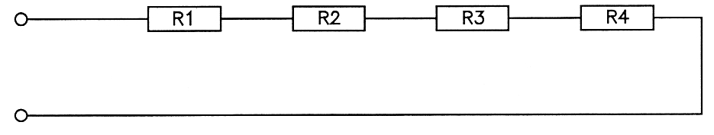

2. As more resistors are added to the circuit in series, then the total circuit or overall resistance will increase. Increasing the total resistance of any circuit will decrease the current flow through it - assuming the applied voltage remains the same (constant).

The total resistance must be greater than the resistance of any single resistor in the series circuit. In a series circuit the total resistance is the SUM of the individual resistors.

Total Resistance (R_{T}) = R₁ + R₂ + R₃ ..... + R_{n}

3. The total circuit resistance can also be expressed as the “equivalent” resistance (R_{e} or R_{eq})' of the circuit. If you were to replace every resistor in a circuit for just one single resistor, then this is the value it would need to be.

Sometimes parts of circuits can also be described as an equivalent resistance for just those parts to help solve more complex circuits.

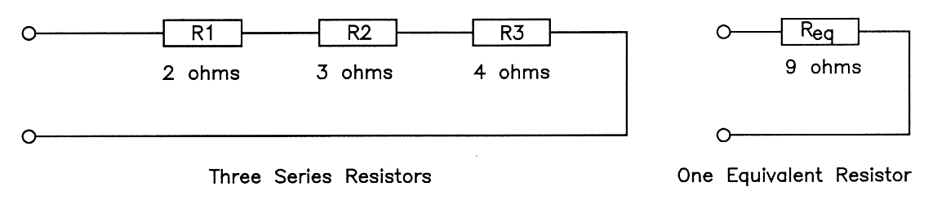

4. The current flowing in a series circuit is common to each and all components of the series circuit, thus the current flowing through each component of the circuit must share the same value.

5. When an electromotive force (E) is applied to a bank of resistors in series the total current in the circuit can be found by finding the total (or equivalent) resistance, then using Ohm's Law (I=E/R), as shown in the following example.

Total Resistance (R_{T}) = R₁ + R₂ + R₃
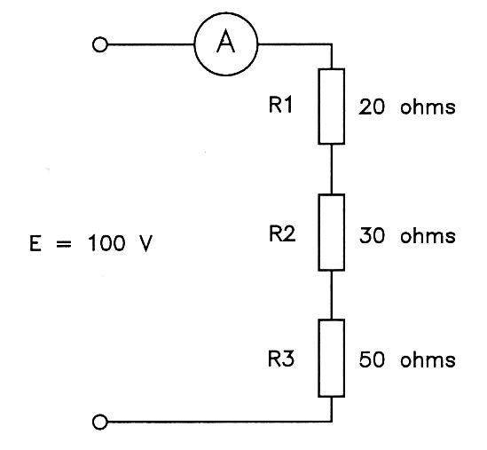

= 20 + 30 + 50

= 100 ohms ==========

E
I = ----
R_{T}

100
= ----
100

= 1 amp
=======

6. Consider a series circuit consisting of two or more resistors having different resistances.

Although the total current must be the same in all parts of a series circuit, the voltage required to cause that particular value of current to flow through each resistor would be different.

If the current is known and the resistance is known the voltage required for EACH resistor can be found by applying Ohm's Law ( V = I.R ) to each resistor.

The voltage which would be measured across each individual resistor is often described as the EFFECT of the flow of current in the circuit and is called 'potential difference ( V )'.

Applying V = I.R to the circuit above, with a current of 1 amp, the potential differences across the resistors would be 20, 30 and 50 volts respectively.

7. Since the electromotive force ( E ) which causes the current to flow in the circuit can be considered as being different to the potential difference which appears across EACH resistor as a result of the current flow, electromotive force and potential difference have different quantity symbols ( E and V respectively ) but the same unit symbol ( V in both cases ).

8. Both E and V are expressed in volts (or any metric multiple or sub-multiple), and Ohm's Law applies in the same way to each, so Ohm's Law can be expressed as E = I.R or V = I.R, depending on the part of the circuit being considered, but care must be taken to make sure that the appropriate circuit values are used during any calculation.

In more modern times the symbol “V” has generally replaced the use of “E” when using Ohm’s Law.

Thus, electromotive force applies to an entire circuit, and potential difference applies to the individual parts of a circuit. Ohm's Law applies to any DC circuit and ANY PART of it.

9. Potential difference is also commonly known as 'volt drop', 'voltage drop' or 'fall in voltage' and is measured with a voltmeter or multimeter.
10. In any circuit consisting of series resistors, the potential difference across each resistor is proportional to the resistance of the resistor (because V=I.R), and the sum of the individual potential differences must be equal to the voltage applied to the circuit.

The potential difference across any individual resistor in a series circuit cannot be equal to or greater than the electromotive force applied to the circuit.

Resistors having the same value of resistance in a series circuit must have the same potential difference across them. If all resistors have the same value, then the applied voltage is equally divided across each resistor.

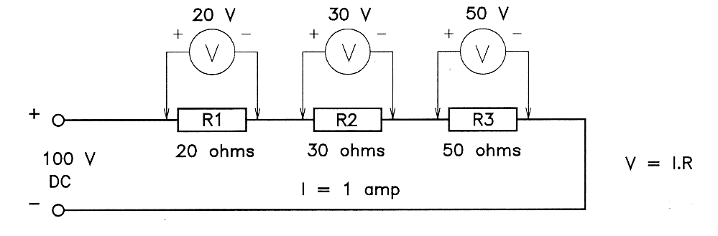
V_{R1} + V_{R2} + V_{R3} = the applied voltage

11. Series circuits are used in most electronic circuits to provide different voltages at different parts of a circuit. Resistors used in this way are referred to as 'voltage dividers'.
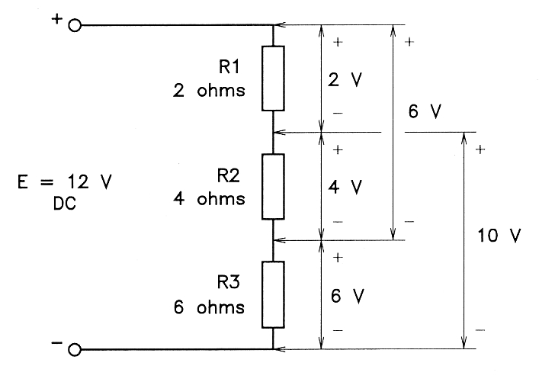

Voltage divider
12. If any component is open circuited in a series circuit in which the supply voltage is still connected, the full supply voltage will be measured across the open component.

This fact is very important when problem solving in a practical circuit.

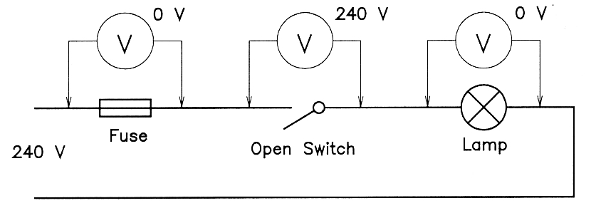

13. The voltage across a closed switch or a short circuited component in a series circuit must be zero, regardless of the applied voltage.
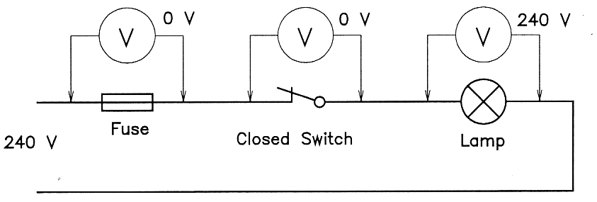

Calculations

14. A circuit consists of three resistors connected in series to a 200 volt supply; their resistances are 20, 30 and 50 ohms respectively.

Find the total resistance, total circuit current and the potential difference across each resistor. Note: ALWAYS draw the circuit first.

If there is more than one component of the same type, use subscripts to indicate which value is being considered in the equation.

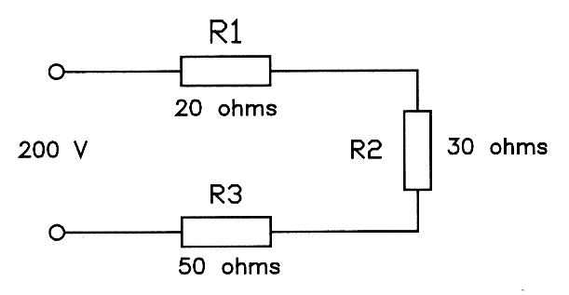

Solutions

Resistance Current

R_{T} = R₁ + R₂ + R₃ E 200
= 20 + 30 + 50 I = --- = ----- = 2 amps
= 100 ohms R_{T} 100 ======
==========
Voltages

V_{R1} = I . R1 V_{R2} = I . R2 V_{R3} = I . R3
= 2 . 20 = 2 . 30 = 2 . 50
= 40 volts = 60 volts = 100 volts
========== ========== ===========

Voltage Check: 40 + 60 + 100 = 200 volts (Correct)

15. The results of the calculation above, show that the potential difference is directly proportional to the resistance (V=I.R) - the highest voltage appears across the highest resistance and vice versa.

Power Calculations

16. Having calculated the current and voltages in the circuit the power being dissipated by each part of the circuit can be calculated by applying any one of the three power equations.

V_{R3}²
P_{R1} = V_{R1} . I P_{R2} = I² . R2 P_{R3} = ----
R3
= 40 x 2 = 2 x 2 x 30
= 80 watts = 120 watts 100 x 100
========== ========== = ------------
50

= 200 watts
============

Total Power = E x I
= 200 x 2
= 400 watts
===========

17. The total power in a circuit is the sum of the individual powers dissipated by each of the components, so the power calculations can be checked.

Total Power = P_{R1} + P_{R2} + P_{R3}

= 80 + 120 + 200
= 400 watts (Correct)
=========

18. In a resistive circuit all of power dissipated in the circuit results in heat being produced. In a series circuit, the resistor with the highest resistance produces the highest quantity of heat.

Problem Solving Exercises:

Note: You should always draw a diagram for calculation exercises.

- Calculate the total resistance of four resistors in series, if their resistances are 5, 10, 15 and 20 ohms respectively.

- The resistances of three resistors in a series circuit have a ratio of 1:3:4 respectively. If the line voltage to the circuit was 80 volts, work out what the potential difference is across each resistor?

- Three resistors in a series circuit have a resistance of 10Ω, 20Ω and 50Ω respectively. How much current would flow in the circuit if the applied voltage was 240 volts?

- The resistances of the three resistors in a series circuit are 10Ω, 20Ω and 30Ω respectively. If the voltage drop across the 10Ω resistor was 20V, what would be the voltage applied to the circuit?

- A switch is connected so that it can turn a 120 ohm load on and off. The voltage applied to the circuit is 240 volts. What voltage would be measured across the SWITCH when it is in the OFF position?

- Consider Circuit A. What is the voltage between each of the following points, if L1 and L2 are identical lamps?

Circuit A
Between B and C _______
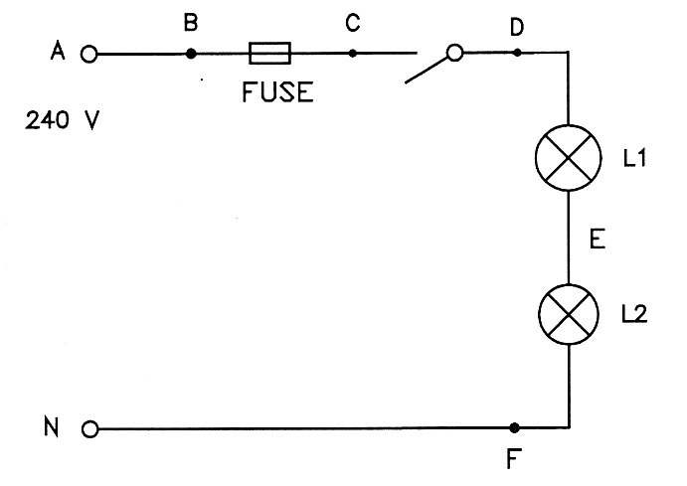

A and D _______

B and F _______

A and E _______

C and D _______

D and E _______

D and F _______

E and F _______

F and N _______

7. Consider Circuit B. What is the voltage between each of the following points, if L1 and L2 are identical lamps, but L1 is short circuited?

Circuit B
Between A and C _______
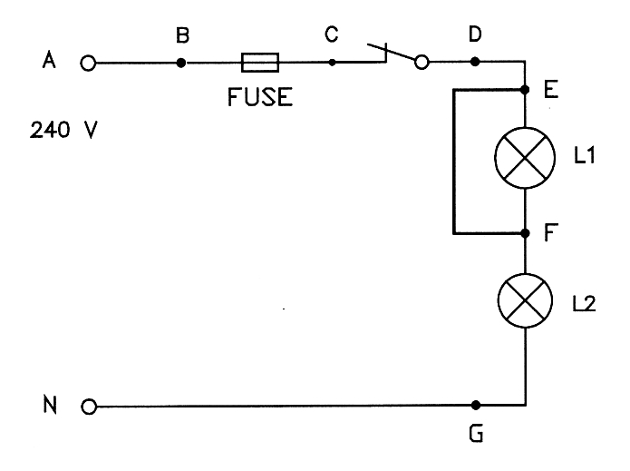

B and D _______

B and E _______

B and F _______

C and D _______

D and F _______

D and G _______

F and G _______

F and N _______

8. Consider Circuit C. What is the voltage between each of the following points if the voltage between A and N is 240 volts?

Circuit C
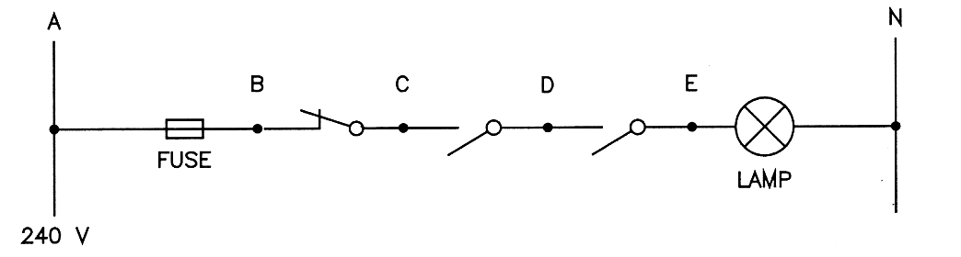

Between A and B _______

A and N _______

A and C _______

C and D _______

C and E _______

D and E _______

D and N _______

E and N _______

Practical Problem Solving

9 Problem solving or fault finding in practical circuits must always be carried out in such as way as to avoid damage to apparatus, circuits or the surrounding environment. If you encounter unexpected situations and you are not sure how to proceed, you should consult your supervisor immediately.

10. When you have completed the task and checked to see that all relevant requirements have been met you need to clean up your work area, make sure that it is safe, and report the completion to your supervisor.

END of WORKBOOK

