Health Champions Newsletter – February 2026
Contents:

- Feature of the Month
- Public Health Campaigns
- Network Spotlight
- Local Events and Activities
- Training and Development
- AOB

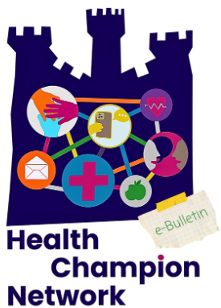

Newcastle Marmot City progress

In 2025, Newcastle became a Marmot City, launching a programme of work to focus on tackling health inequalities and improving wellbeing, working with Professor Sir Michael Marmot and the Institute of Health Equity.

The first Marmot City Advisory Board meeting was held on 19th January and our Chief Executive Lisa Goodwin attended. The advisory board is made up of representatives from across the local authority, NHS and education, and there are plans to include the private sector too. There will be opportunities to be involved in the work via a community partnership, and we will provide further updates at the Health Champions Winter Network Meeting.

Feature of the Month: National Heart Month



  - National Heart Month

February is National Heart Month. It’s run by the British Heart Foundation to help people learn about heart problems, encourage healthy living and raise money for important heart research.

  - Why National Heart Month Matters

Cardiovascular disease is the name for a group of conditions that affect your heart and blood vessels. Cardiovascular disease is very common, and one of the main causes of death in the UK. Every year, it causes about 175,000 deaths. People living in the poorest areas are more likely to die from heart disease.

In Newcastle, over three years (2022–2024), 1,845 people died because of heart and blood vessel problems. This is more than the average for England and the North East.

This shows heart disease is a big problem locally. It is important to help people stay healthy, find problems early, and support healthy lifestyles.

  - Risk Factors

There are things that may make it more likely that you get CVD including:

- Your lifestyle – such as smoking, drinking too much alcohol, being overweight and not being active
- Your age – CVD mainly affects people over 50 years old
- Your sex – men are more likely to get CVD than women
- Your ethnicity – you may be more likely to get CVD if you’re from a South Asian, Black African or African Caribbean ethnic background
- Having family members with CVD
- Having certain conditions, such as diabetes, high blood pressure or high cholesterol.

  - Take Action This Heart Month

- Know Your Numbers

High blood pressure often has no symptoms. This means the first sign could be something serious, like a heart attack or a stroke. The good news is that this can often be stopped by taking medicine and making healthy changes.

The Know Your Numbers! Campaign helps people find out if they have high blood pressure and don’t know it. The campaign helps them get the care and support they need to lower their blood pressure and stay healthy.

How can you check your blood pressure?

You can have your blood pressure checked at any time if you are worried

You can get a free blood pressure check at a local pharmacy if you:

- Are over 40 years old
- Live in England

You cannot get a free pharmacy check if you:

- Already have high blood pressure
- Have had your blood pressure checked by a health professional in the last 6 months

You can find a pharmacy offering free checks here:
https://www.nhs.uk/service-search/pharmacy/find-a-pharmacy-that-offers-free-blood-pressure-checks

Visit this link to find a pharmacy that offers free blood pressure checks: https://www.nhs.uk/service-search/pharmacy/find-a-pharmacy-that-offers-free-blood-pressure-checks

If you are under 40

If you are under 40 and don’t know your blood pressure numbers, it is still a good idea to get checked. You can:

- Book an appointment with your GP or practice nurse
- Check your blood pressure at home

To learn how to check your blood pressure at home, visit: https://www.bloodpressureuk.org/your-blood-pressure/how-to-lower-your-blood-pressure/monitoring-your-blood-pressure-at-home/how-to-measure-your-blood-pressure-at-home/

To record your reading and find out what it means, visit: https://www.nhs.uk/health-assessment-tools/check-your-blood-pressure-reading/enter-reading

- Walk for Hearts

Take on a walking challenge this February. Walk for Hearts is for everyone, and you can take part anywhere.

- Walk 28, 50, or 100 miles during February, wherever you like.
- This can be as little as 1 mile a day to help save lives.
- You can walk on your own or with friends, family, or workmates.
- Every step you take helps keep hearts healthy.

When you take part, you will get support from the British Heart Foundation. You will also be helping your own health. Walking is good for both your body and your mind.
Being active can lower your chance of getting heart and blood vessel disease by up to 35%.

To find out more and sign up, visit: https://www.bhf.org.uk/how-you-can-help/events/virtual/walk-for-hearts

- Community champion links for Cardiovascular Disease and Chronic Kidney Disease

Health Innovation NENC colleagues have been delivering a healthy heart checks project regionally. Part of the programme is aiming to provide education, awareness and training to community champions across the region.

There is free training available around Cardiovascular Disease and Chronic Kidney Disease.

If you’re interested in registering to the training, please email: jack.lyon@nhs.net

- Newcastle GP Services Health Bus (Health Checks and Social Prescribing)

Get a healthy heart check, health advice, your blood pressure checked, or your cholesterol monitored by the Newcastle Community Health bus. Dates, times and locations include:

- Monday 9 February 2026 – 10.30am to 3.30pm (closed for lunch break 1-1.30pm) Heaton Community Centre, Trewhitt Road, Heaton, NE6 5DY

- Tuesday 10 February 2026 – 10.30am to 3.30pm (closed for lunch break 1-1.30pm) St Martins Centre, Roman Avenue, Byker, Newcastle, NE6 2RJ

- Thursday 12 February 2026 – get involved in health research, 10.30am to 3.30pm (closed for lunch break 1-1.30pm) Northumbria Student Union, Northumbria University, Coach Lane, NE1 8JJ

- Friday 13 February 2026 – with HI NENC, 10.30am to 3.30pm (closed for lunch break 1-1.30pm) Bilal Jamia Masjid (Elswick Mosque), Malvern Street, Newcastle Upon Tyne, NE4 6SU

- Monday 16 February 2026 – 10.30am to 3.30pm (closed for lunch break 1-1.30pm) ASDA, Newcastle Shopping Park, Byker

- Tuesday 17 February 2026 – 10.30am to 3.30pm (closed for lunch break 1-1.30pm) Newcastle Cathedral, 42-44 Mosley Street, Newcastle, NE1 1PF

- Thursday 19 February 2026 – with HI NENC, 10.30am to 3.30pm (closed for lunch break 1-1.30pm) Morrisons, Shields Road, Byker, NE6 1EJ

- Monday 23 February 2026 – 10.30am to 3.30pm (closed for lunch break 1-1.30pm) ASDA, Newcastle Shopping Park, Byker

- Thursday 26 February 2026 – with HI NENC, 10.30am to 3.30pm (closed for lunch break 1-1.30pm) BE North, One Strawberry Lane, Newcastle, NE1 4BX

- Friday 27 February 2026 – 10.30am to 3.30pm (closed for lunch break 1-1.30pm) Pure Gym, Stamfordham Road, Westerhope, NE5 5HD

For more information visit: https://newcastle-gp-services.co.uk/community-health-services/

Public Health Campaigns

Make 2026 the Year You Quit Smoking

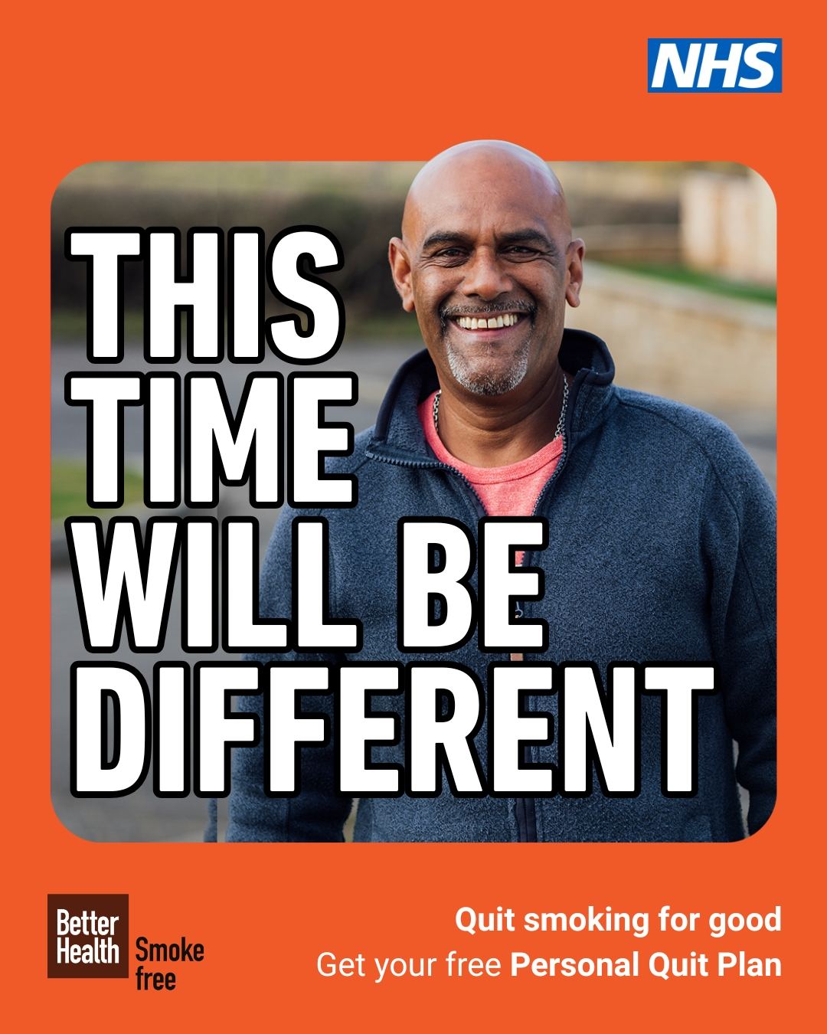

The start of the year is a great time to make a fresh start. Stopping smoking is one of the best changes you can make for your health.

The sooner you stop smoking, the better it is for your health. But it is never too late to quit. Stopping smoking helps your health at any age, even if you have smoked for a long time.

  - Benefits of quitting smoking

When you stop smoking, you can:

- Lower your risk of serious illnesses like heart disease, stroke, lung cancer, and breathing problems
- Help your lungs work better
- Save money – someone who smokes a pack a day can save over £2,400 a year
- Feel better in your mind and mood
- Make the air healthier for your family, friends, and people around you

  - The campaign

The Department of Health and Social Care has support and resources to help people stop smoking this New Year and beyond.

Many people have tried to quit before without help. This campaign shares an important message:
“This time will be different” when you quit with support.

With the right help, stopping smoking is a goal you can stick to.

To access the resources, visit: https://campaignresources.dhsc.gov.uk/campaigns/new-year-202526-quit-smoking/

  - Why this matters:

Smoking is the biggest cause of poor health that can be prevented in England.

- In 2023, 10.7% of Newcastle’s population were current smokers

Smoking is more common among:

- People in manual jobs
- People who are unemployed

Smoking rates have gone down overall, but they have dropped more in higher-paid jobs. This has made health differences bigger between groups. This is why it is important to focus support on people who need it most.

  - Local support: Newcastle Stop Smoking+ Service

The Newcastle Stop Smoking+ Service offers free, friendly support to help people in Newcastle quit smoking for good. It’s a 12-week programme with one-to-one, personalised support, designed to help you stop in a way that works for you.
With expert advice, regular encouragement and free stop-smoking aids such as patches, gum, lozenges, inhalators, mouth spray or vapes, you’re three times more likely to quit successfully.
Quitting can improve your health and wellbeing, and leave you with more money in your pocket too.
If you’d like to start the conversation in the New Year, you can refer yourself online or speak directly to an advisor:
Email: newcastle.stopsmoking@cgl.org.uk
Phone number: 0191 269 1103

Local Events and Activities
  - Action Foundation’s talking therapy provision for people seeking asylum and refugees

Action Foundation are currently offering one to one talking therapy at the Interaction drop-in for asylum seekers and refugees in the North-East.

When: Thursdays from 9:30am-1:30pm
Where: Crisis City Road, Newcastle Upon Tyne, NE1 2JQ
Sign up: Email interaction@actionfoundation.org.uk with name and contact details

  - MELISSA Bus

In the new year Newcastle university third year Dental Surgery BDS students will be visiting different sites around Newcastle and Gateshead to deliver oral health information and dental health checks to community members. Dates and locations include:

- Thu 5 Feb - Cowgate Children Centre, Houghton Avenue, Newcastle upon Tyne, NE5 3UT

- Tues 24 Mar - Foodbank: Holy Spirit Church, West Denton, Dunblane Crescent, NE5 2BE

- Mon 30 Mar - Foodbank: St Silas, Byker, Clifford Street, NE6 1PG

- Fri 1 May - Baltic Square, Gateshead (outside the Baltic Art Centre), NE8 3BA

- Fri 15 May - Gateshead: Comfrey Project, NE8 1QB

- Tues 26 May - Wallsend (Richardson Dees Park), North Road, NE28 8RH

- Mon 29 June - Birtley Family Hub, Gateshead, DH3 2LN

  - Community Health Bus – Pre Ramadan Checks

The community health bus will be at Bilal Jamia (Elswick) Mosque offering Pre Ramadan checks on:

- Friday 06 February 10:30am – 3:30pm (minus 30 minute lunch 12:30 – 1pm)

- Friday 13 February 10:30am – 3:30pm (minus 30 minute lunch 12:30 – 1pm)

  - Home from Hospital Service

Home from Hospital is focused on people living in Newcastle who are over 55 and are set to go into hospital, are currently in hospital or have just been discharged. The aim is to support them to help them make a full recovery. They are a 6-week service that offers support with day-to-day tasks like shopping, getting to the doctors, cleaning etc. after an individual has been discharged from hospital. We offer well-being checks for any mental health struggles that the person may be experiencing.
The service is entirely free
We can still help if the person was discharged a few weeks ago.
You can find more information here or contact by email or telephone
jack.thompson@everyturn.org / 07811902574
francesca.elliott@volunteeringmatters.org.uk / 07534 043 578

  - LGBTQIA+ VCSE Networking Event: Tackling Challenges Together
Wednesday 18th February, 5pm - 7pm , One Strawberry Lane, NE1 4BX
Join us this LGBTQIA+ History Month for a networking event for LGBTQIA+ VCSE organisations and projects. Together, we’ll explore current challenges, share experiences, and discuss ways in which LGBTQIA+ organisations can make the most of Connected Voice’s services, resources and skills.

When: Wednesday 18th February, 5pm - 7pm
Where: One Strawberry Lane, NE1 4BX
Sign up: Find out more and sign up here

Training and Development
  - Hate Crime Champions Training

The Northumbria Police Community Engagement Team are pleased to be offering Hate Crime Champions Training, an important opportunity to help make our communities safer and more inclusive.

There will be two training sessions, and you only need to attend one.

What does the training cover?

This training will give you the knowledge and confidence to:

- Understand what constitutes hate crime and its impact on individuals and communities.
- Learn how to report incidents effectively and support victims.
- Promote awareness and encourage positive action in your community.
Benefits of attending:
- Gain practical skills to help tackle hate crime.
- Join a network of champions committed to equality and safety.
- Make a real difference in your local area.

Both sessions will be held face to face, at Newcastle Civic Centre, Council Chamber

- Session 1: 30th January 2026, 10:30am – 12:30pm (10am arrival)
- Session 2: 4th March 2026, 10:30am – 12:30pm (10am arrival)

Please use the link to sign up and secure your place: Hate Crime Champion Training
If you have already completed this training in the past, you are warmly welcomed to attend again. It’s a great chance to refresh your knowledge, get updated on any changes, and recap key points.

If you have any accessibility needs or questions, please contact sarah.eaglestone@newcastle.gov.uk

  - Free Digital Skills Sessions
4 February, 2-4pm, The Catalyst, Newcastle
AbilityNet provides free digital skills sessions for over 65s and adults with disabilities and are providing three free Digital Skills Sessions at the Newcastle Building Society Monument Branch on the following dates:

- 5 Feb Staying Safer Online
- 12 Feb Entertainment TVs , audio books and more

All sessions are 2-4 pm with the room available from 1.30.pm.

Participants need to book as there are limited places. They also don't have to attend all 3 sessions, just the ones they are interested in.

Email helen.mcguigan@abilitynet.org,uk to request a place or more information.

  - National Energy Action

National Energy Action (NEA) is offering Carbon Monoxide (CO) awareness training in the Newcastle area. More information: Carbon Monoxide Course Outline - National Energy Action (NEA)

  - Newcastle Libraries – 8 week tablet course

Newcastle libraries are hosting an 8-week Tablet Course starting Wednesday 4th February 2026 from 1:30pm – 4:00pm at West End Library Community Room, Newcastle.

Please note: this course runs over half term so childcare must be considered
There are 10 spaces and referrals are now being taken for this course. On completion of the 8 weeks each participant is gifted a new 10’’ Lenovo tablet with a 6-month 40G data SIM

📅 Starts: Wednesday 4th February 2026
📅 Ends: Wednesday 25th March 2026
📍 Location: West End Library Community Room, Newcastle

Course content

- Library membership - instant access to PC usage and online Library platform BorrowBox (free eBooks, eAudiobooks, Magazines and Newspapers).
- Email Account – set up on tablets with training on how to use email confidently and safely, to send documents such as CVs.
- Universal Credit Account – set up on tablet with an explanation of how to manage their online journal.
- NCC Council Tax Account – set up and instructions on how to access and view their account.
- Job Searching sites – create Northeast Jobs and Indeed accounts, with support on how to be confident using these sites for future use.
- Banks and Borrowing – Introduction to ethical lending options (Moneywise Credit Union), and understanding of APR, Loan Sharks and the Illegal Money Lending team.
- Staying Safe Online – Be aware of scams, phishing, viruses, and Social Media presence online.
- WhatsApp – how to connect safely with friends, family, and support networks.

How to refer someone for the course:

Send an email to Getonline@newcastle.gov.uk, with the person’s name and number and quote West End Tablet in the subject field. The team will call the person and confirm their place.

  - Crisis and Resilience Fund: April 2026

The Crisis and Resilience Fund (which is going to replace the Household Support Fund) is set to start in April 2026. The scheme will provide £1 billion annually for emergency funding to low-income individuals across England, enabling councils to offer direct financial assistance for unexpected expenses. Find out more

  - Warm Homes Healthy Futures (WHHF) scheme

This scheme aims to mitigate the risk of hospital admission and serious illness. It ensures that people are linked into appropriate services who provide energy advice/grants for sustainable support. WHHF scheme provides an advice service to review patients’ energy use and provide them with the relevant energy advice, home energy improvements and income maximisation solutions.

Who can refer?

Referrals must be completed by a health or social care service, or Wellbeing Hubs.
Referral Checklist for Staff

To refer someone, you’ll need:

- Name and contact details of the person being referred
- Their health condition
- Confirmation that they are struggling to pay their heating bills

Support Available Through WHHF

- Check energy bills, energy debt and supplier issues
- Check heating and energy saving improvements for the property and funding
- Benefit checks and benefit applications if required
- Gas safety checks and free carbon monoxide CO alarms
- Offer energy bill support if required

Who can be referred?

You can refer anyone who meets the eligibility criteria:

- Must be a resident of Newcastle upon Tyne
- Have a health condition made worse by living in a cold or damp home. The list of eligible conditions is given below.
- Struggling to pay their heating bills (Note: if the patient is a child, their parent(s), guardian(s) struggle to pay their heating bill)

Eligible Health Conditions

Dementia or other neurological condition | Learning Disability
Arthritis/ rheumatism/ MSK with Fit Note signed off work | Mental Health
Cancer | Anxiety
Respiratory condition | Depression
Asthma | Severe mental illness
COPD | Physical Disability
Autism | Diabetes or other metabolic condition (e.g. NAFLD)
Pregnant | Cardiovascular condition
In substance recovery | Kidney Disease

The programme will run till March 2026

- Please use the following link to make referrals - Warm Homes, Healthy Futures
- For more information, please contact Newcastle City Council’s Energy Services team energy@newcastle.gov.uk

AOB
  - Social Tariffs



What are social tariffs?

Social tariffs are cheaper broadband and phone packages for people claiming Universal Credit, Pension Credit and some other benefits. They’re delivered in the same way as normal packages, just at a lower price.

How a social tariff could help you

- It's available to those on a variety of benefits. If you or someone in your household claims Universal Credit, you could switch to any of the tariffs available.
- It's cheaper than a regular package. Current prices range from £10 to £24.
- Fast, unlimited broadband. Most tariffs offer superfast broadband at speeds over 30 Mbit/s – fast enough for you to keep in touch with friends and family, stream HD films or shop online.
- You'll pay next-to-nothing to get set up. If you do have to pay any setup costs, these should only be small. Your provider should tell you before you sign up.
- It could cost nothing to switch. If your provider offers a social tariff, you can switch to it at any time, free of charge.
- The price won't go up mid-contract. You won't pay any more than what you agree at the start of the contract.
- It costs nothing to leave. You won't pay a fee to leave the tariff before the end of your contract.

How to apply

First, check if your current provider offers a social tariff. Our table below lists all of the tariffs available now. You can apply for most tariffs online, or call your provider and ask to switch.
If your provider doesn’t offer a social tariff, you can switch to one that does. Your provider might let you leave your current contract without paying a penalty fee.
For more information visit: https://www.ofcom.org.uk/phones-and-broadband/saving-money/social-tariffs

