To study the Quran one needs to have an open heart and be free from bias. As the teacher of the Quran is Allah (SWT). He says in the Quran that it is HE that guides and misguides. He never guides an evil heart. However, there are some basic criteria one needs to keep in mind when you approach the Quran.

1. **The Merciful God**

If you go to the Quran you will find hundreds of verses mentioning the Mercy of Allah (God). Whether it’s in the creation of man or in providing sustenance for his creatures, or anything else that exists in the universe. Allah (GOD) states in his book that all these things have been created for man as a Mercy from him. You can confirm his Mercy by yourselves, just by looking at the beauty you see in the mountains, seas and rivers. The wonderful food and varieties of it throughout the world. How delicious it tastes.

He has even asked the Angels to serve us:

**“ And (remember) when We said to the angels: “Prostrate yourselves before Adam.” And they prostrated except Iblis(Satan)……” S2v34**

He(SWT)has gone beyond the normal Mercy attributed to him. He calls himself,

**“The MERCIFUL of the MERCIFUL.”**

**Further more every chapter(113 out of 114 Surahs) of the Quran starts with the following verse;**

**\*\*\* In the name of God the most Merciful the Most Kind \*\*\***

**Therefore, anything God asks from you will never be a burden. So be careful don’t bring hardship on yourself.**

**“We did not send the Quran to burden you.” Surah Al-Qamar**

Also Allah (SWT) says anything I have forbidden my servants, it’s because its harmful to them.

1. **No Compulsion in Religion**

**The Quran states:**

**Let there be no compulsion in religion. Truth stands out clear from error; whoever rejects evil and believes in Allah hath grasped the most trustworthy hand-hold that never breaks. And Allah Heareth and Knoweth all things. Surah 2 Ayat 256**

**Therefore, we should not force people into Islam. This applies to Muslims and non-Muslims. Brothers and sisters should be encouraged without force. You may find on the day of judgement that the one who forced the religion on people may be questioned, may be punished. The one who was forced will be forgiven because of the extreme Mercy of Allah.**

**Allah told the prophet* the two paths are clear, let people choose their fate, either in paradise or hell.**

1. **The Freedom to Question and Reason**

**As there are two paths to choose from then surely you must be allowed all types of questioning and proof reading must be allowed to determine the right path. The Quran is very particular about this point. Throughout the book, Allah rather than force you to obey, He guides you through questions so that we may understand Him from our own accord.**

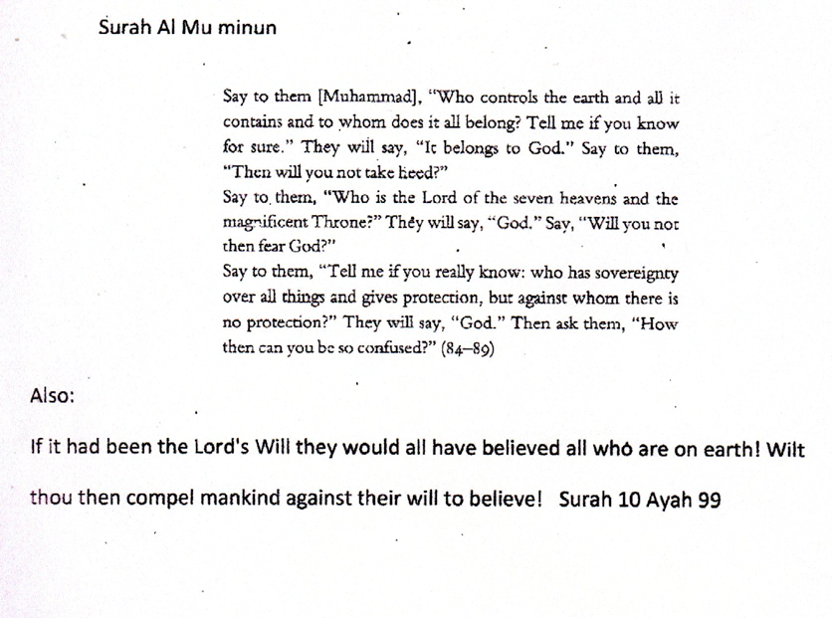

1. To understand God and His will we need to use most importantly our faculty of reasoning, our brain. This is impossible without the use of **Common Sense. The whole Quran is based on this principle.**

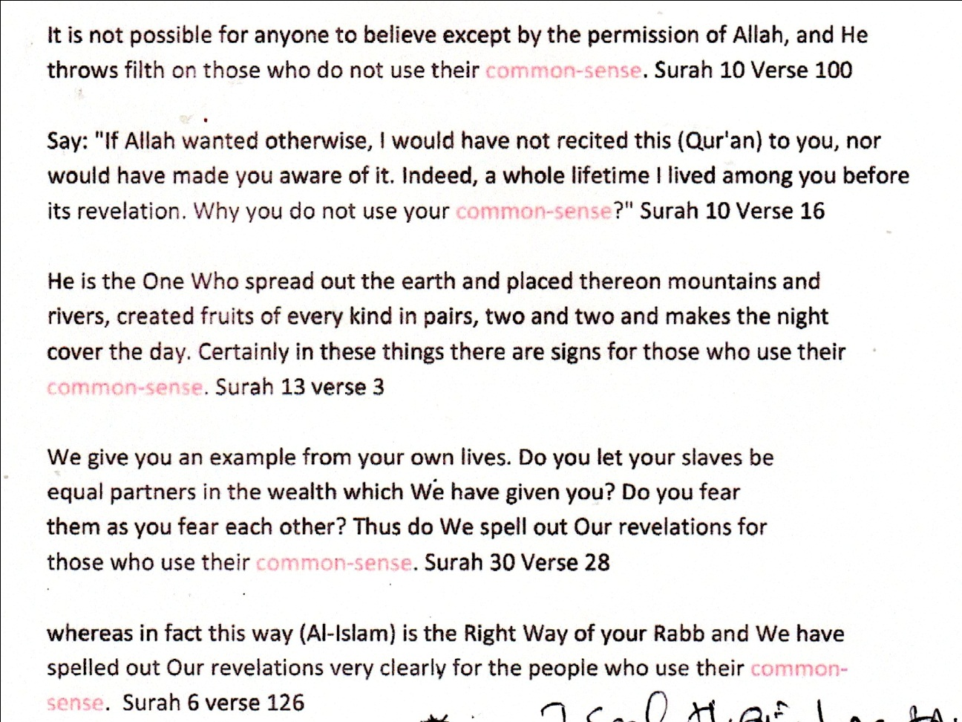

In another verse Allah says, whoever does not use his faculty of reasoning, HE seals his heart. Deaf, Dumb, and Blind will not return to the path of Allah.

The criteria presented above will ensure that you will be on the right path and will protect you from going astray and harm.

**Allah knows best who is rightly guided.**

