Acute and Chronic Wound Management Study Day | 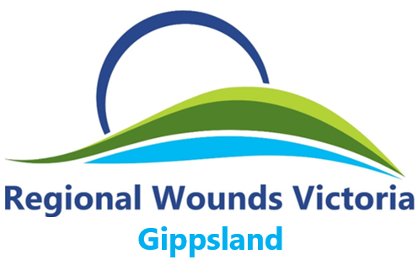
This program is presented by the Regional Wounds Victoria Wound Management Clinical Nurse Consultants. This comprehensive program is suitable for all nurses working in acute, community, GP practice & aged care.  PROGRAM  - Introduction to wound physiology  - Factors affecting healing  - Acute wound management  - Wound Bed Preparation  - Wound assessment and tissue identification  - Identification and management of wound infection  - Pressure injury prevention and management  - Staging of pressure injuries  - Skin tear classification, prevention and management  - Wound product dressing selection  - Case studies and close | MARIANNE CULLEN  Central and East Gippsland  Tues/Thurs and Fridays & alt Weds  Phone: 51711410  Mobile: 0488 602 558  Email: marianne.cullen@lchs.com.au  LINDA RAYMOND  South and West Gippsland  Alternate Tues and Thurs  Phone: 51365444  Mobile: 0409 710 628  Email: linda.raymond@lchs.com.au
DATE
Tuesday 24th Feb
TIME
0900 – 1530hrs
VENUE
Orbost Regional Health
ROOM
Meeting Room
COST
FREE for ORH staff
$50 non staff

BOOKINGS
For booking please, contact Jade McDonald Clinical Nurse Educator.
Phone (03) 5154 6606
Jade.mcdonald@orh.com.au

