

**The Power of “Dutching”**

What is “*Dutching*”?

The term *Dutching* originates from the American Prohibition Era, “Dutch” Schultz, Al Capone’s accountant, backed two or more Runners to win in the same race. He bet in such a way that if any of the Runners he had backed went on to win the race he would end up with the ***same*** amount of profit.

And so, the name “Dutching” was given to this form of betting.

*Dutching* therefore means calculating the amount to bet on each Runner you have selected as a possible winner in a race, so you will receive the ***same*** amount of profit if one of your selections goes on to win the race. The **JSH**spreadsheet calculator which you have at your disposal (accessed is available in JSH Desktop software) will aid you in seeing how this transpires.

Not everyone agrees with Dutching because you end up with one or more losing bets. However, the bettor who always backs one Runner to win will average about 30 to 35 percent wins, whereas the bettor who backs more than one Runner in a race will average about 60 to 65 percent wins. Dutching provides a smaller average net profit for each race but losing streaks will be far less frequent and should be shorter in duration. The larger number of wins should enable you to use a larger percentage of your betting bank for each race and possibly offset the lower net profit disadvantage.

Professional gamblers have known for decades that this form of gambling is one of the most powerful and consistent ways to make money. The best Runner in a race does not always win.

How often have you forecast a single Runner to win, only to have it pipped at the post by a Runner you ***almost*** backed. If you had backed that potential Runner in addition to the one you favoured - well, happy days! There are of course occasions when Dutching is not very advantageous, for example, if you intended to use the favourite in your betting, the odds may be too short to combine with any other selections to generate any worthwhile gamble.

The mathematics involved to calculate how much to wager on each of the 2 selections in a race is quite straightforward.

For example: You have chosen ***Runner A*** and ***Runner B*** as the best of the bunch with the following odds:

Runner A 3/1 and Runner B 6/1

You wish to bet on each of these Runners so that if either one wins you will receive the ***same*** amount of profit.

If you want to make a specific profit of, say £10, you will have to place the following amounts to achieve your selected profit target from each Runner if either wins the race:

**Stake for Runner A= (**Odds Runner B + 1 x £10 Profit) / (Odds Runner A x Odds Runner B - 1)

= (6/1 + 1 x £10) / (3/1 x 6/1 - 1)

= (7 x £10) / (18 -1)

= 70 / 17

= Stake of £4.11

**Stake for Runner B= (**Odds Runner A + 1 x £10 Profit) / (Odds Runner A x Odds Runner B - 1)

= (3/1 + 1 x £10) / (3/1 x 6/1 - 1)

= (4 x £10) / (18 -1)

= 40 / 17

= Stake of £2.35

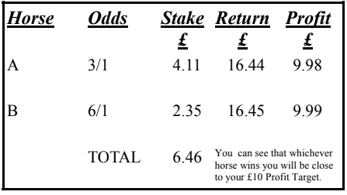

The example above has been for wagering on 2 Runners in the same race. The calculations involved for covering more than 2 Runners can become very cumbersome and to calculate different Profit Targets even more so. this is where **JSH Desktop Dutching** calculator comes in, allowing you to “juggle” your Profit Targets with just a few clicks of a mouse button.

**JSH Desktop Dutching calculator** has been designed to allow bettors to back up to 10 Runners in the same race.

Simply load the spreadsheet, enter the maximum amount that you wish to stake, optionally enter the names of the Runners you wish to Dutch, then enter the odds for each runner. As you type the odds, you will see the interim results immediately, when all odds are entered you will have the calculated stakes required displayed for each entered odds price. In addition, reading across left to right you will see the effect of reducing the number of selections.

This will only be meaningful if you enter the runners and odds in ascending sequence, i.e. lowest odds first.

On the bottom half of the calculator you can also specify a target profit you would like to realise. If specified this will additionally show the revised stakes and returns.

See example below:

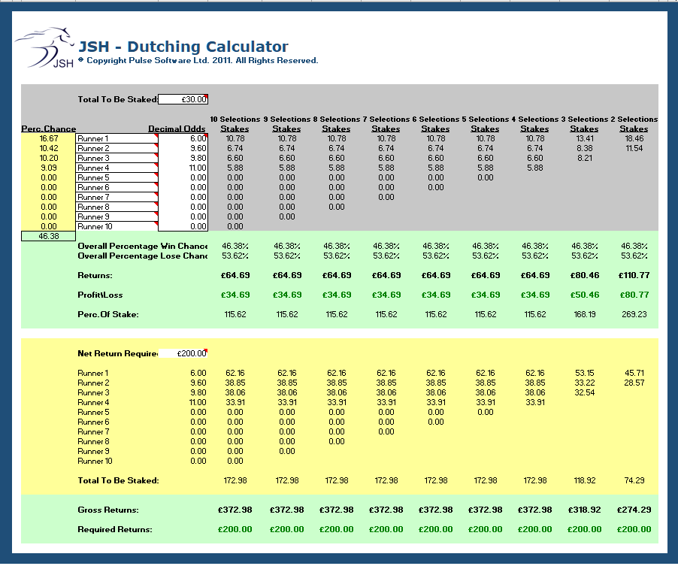

Picking one possible winner consistently is almost impossible so what better way than to back more than one Runner in the same race. This may reduce the overall achievable profit on the race, but wins should be made on a more regular basis leading to long-term sustainable profits.

To make **JSH Desktop Dutching calculator**work for us we obviously must pick winners and to pick those winners from the most suitable types of race.

If we are considering backing 3 Runners from small fields, we may not get suitable odds to work for us; we may be confronted with the situation where we are having to stake too much in relation to possible returns. By contrast an excellent source for better proportioned bets may be found from bigger races.

Handicap races, by their very nature, make the task of picking winners harder but often more generous odds will be on offer. Not so with non-handicap races where the top-rated Runners will attract a range of low odds and it may be at times like this that we may spot a contender, with much better odds, to oppose the favourites.

JSH provides you with a mountain of data available to be used in any way you see fit to isolate possible winners. So much information in fact that it can be difficult to know where to start. If, at this stage, you have your own selection system you may still wish to use it.

To get you started here are a few basic selection methods for consideration, with the advantage that all required data can be obtained from JSH.

**Method 1**

This is a simple method based on the premise that a large percentage of winners come from the first three in the betting.

If you are not around near to the time of the race to determine the top three favoured Runners from live betting odds you can use JSH’s ‘LKBP’ (Last Known Back Price) as an alternative.

**Method 2**

This method is really a filtering system that can be used with Method 1**.**

What we are looking for are types of race which statistically produce a higher percentage of winners from the favourite ranks. Statistics tell us than on average we can expect in the region of 33% winners to be the favourite. If we back the 1st and 2nd favourites, then we can expect to increase our strike rate to between 40% and 60%. Add one more favourite and we can expect our strike rate to increase to 65% or more.

If we take our analysis a stage further by selecting the type of race and the racecourses which produce a higher level of winning favourites imagine what the possible results can be.

It is from these statistics that we can determine the racecourses and the type of races held which will give us an additional edge if we use those producing the higher percentage levels of winning favourites. Currently JSH does not provide a statistical breakdown at this level (it’s in the planning), but this type of information is available on the Racing Post site, probably at a subscription cost.

**Method 3**

This method uses the newspaper tipsters. Do not worry, you won’t have to rush out to purchase all of the daily newspapers from the newsstand because JSH gives you all you need. Simply locate the runners you are interested in on the relevant JSH race and the appropriate runners tab, and for your Dutching activity select the Runners which most of the tipsters favour and in the order at which they are preferred.

**Method 4**

Many forecasting systems involve allocating points to a Runner depending on several criteria. The simplest pointing system is to allocate points based on a Runner’s finishing position in previous races with additional points being added to that Runner if it has ever won at the same course or if it has ever won at the same distance.

If Dutching use the 3 runners with the highest points.

With this method points are allocated for each of the Runners’ previous 2 outings as follows: For each 1st position award 5 points for each 2nd position award 3 points for each 3rd position award 2 points for each 4th position award 1 point

Then:

If Runner is a Course Winner (C) award 1 point

If Runner is a Distance Winner (D) award 2 points

If Runner is a Course & Distance Winner (CD or C & D) award 3 points

**Method 5**

This method is a variation of Method 4 as far as previous form goes. Instead of limiting points to the previous 2 outings points are allocated by reducing the score over the last 3 outings.

**Resulting Position Last time out, Last but One time out and Last but Two time out - points allocation:**

**1st** 9 6 3

**2nd** 6 4 2

**3rd** 3 2 1

**Method 6**

This method selects the highest-ranking Cherry Picks Rating (ECPR) Runners.

**Method 7**

This method selects the highest Alternative Ratings (ACPR) Runners.

**Conclusion:**

JSH advocates looking seriously at specialising in these types of bets because we understand the necessity of maintaining a minimum probability and mathematical return on the bets to generate continuous profits.

The purpose of the **JSH Desktop Dutching calculator** is to bring you the power of Dutching your horse selections combined with systems to strengthen your selection choices.

I hope after reading this short document you will have realised the amount of JSH data available to help you on your way to selecting possible winners in a race and how much better your chances are of winning if you back more than one Runner in a race.

AND of course, the principles of Dutching and the use of the **JSH Desktop Dutching calculator**are not limited to Horseracing.