PAC HOLDINGS
About the Company (Pacific Holdings or just PH)
Pac Holdings (PH) is an IHC (investment holding company) based in Singapore. The company is a pure holding company, which means it only produces income for itself by investing in other companies (PH does not produce or sell any products). PH invests only in the Asia-Pacific region.

Business Holdings:
Direct Investments in Singapore (apx. S$6 million {€4.1 mil.}) PH Direct Ownership
Largest investments include:
- 1 restaurant (1 American) 100%
- 2 restaurants (1 Japanese, 1 Mexican) 50% each
- 1 café 100%
- 1 website & online marketing design company 100%
- 1 small import-export company (clothes, cosmetics, furniture, food, etc.) 50%
- 1 insurance company (insurance for international trade companies) 50%
- 1 small hotel 25%

Business Holdings:
Direct Investments outside of Singapore (apx. S$6 million {€4.1 mil.}) PH Direct Ownership
Largest investments include:
- 1 small hotel (Thailand) 100%
- 1 small hotel (Vietnam) 25%
- 1 restaurant (Vietnam) 50%
- 1 restaurant (Thailand) 25%
- 1 café (Hong Kong) 50%
- 1 English school for kids & adults (Hong Kong) 25%
- 1 Japanese saké maker (Japan) 25%

Passive Investments (apx. S$10 million {€6.8 mil.}) PH Investment
Largest passive investments include:
Global top company stocks & ETFs S$2 million (€1.4 mil.)
Global insurance industry stocks S$1 million (€680k)
USA Banking Industry ETF S$1 million (€680k)
Semiconductor Industry ETF S$600k (€400k)
International Bonds S$600k (€400k)
DeFi “decentralized finance” S$300k (€200k)

PAC HOLDINGS Staff
Current Staff 32
Full-time staff: 15 (9 men & 6 women)
Contract part-time staff: 17 (11 men & 6 women)

WHO TO HIRE?
Evaluate four candidates for one general, entry-level position.
This is a 3-year contract that begins in July 2026.

New Staff Position (3-year contract, entry level position):
Pac Holdings is currently seeking one three-year-contract employee.
The position is for general staff, entry-level position.
After three years, the person can be promoted to full-time.

Position (job) responsibilities:
-The person should have a basic understanding of business and/or investment holdings.
-The person must be able to communicate in English with PH staff and with PH’s companies, some of which are owned or managed by English speakers.
-The person should be able to communicate well in English. Full fluency is not requied, but the person needs to understand essential business English and financial matters.
-The person should be organized and able to consider business matters with critical thought.
-The person should learn the details of companies that PH already owns and manages.
-The person should be able to offer an opinion about existing investments.
-The person should consider new investment possibilities for the company.
-The person should be willing to discuss investment and financial matters with staff and management.
-The person must be able to work in teams and alone, depending on the situation.


Name: Aiko Ayakawa
Passport: Japan
Age: 24
Living in: Japan

Full-time work experience: (none)
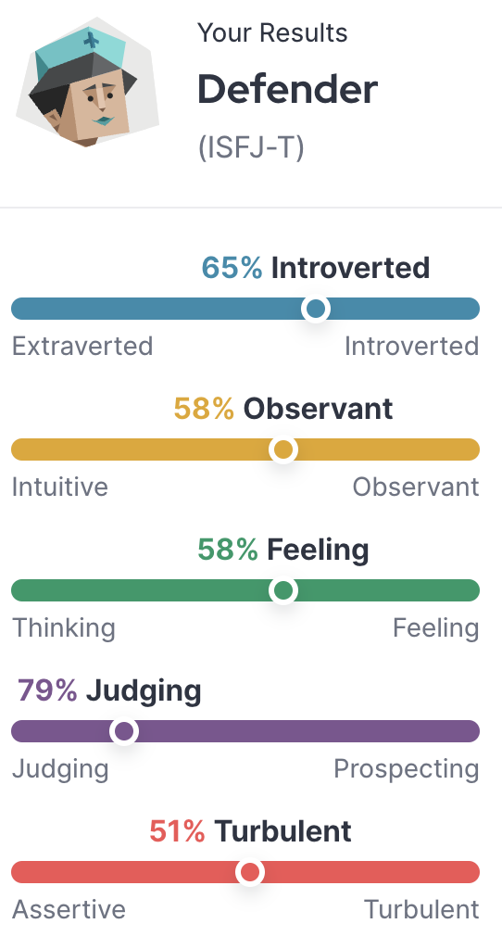
Contract & part-time (student) work experience: (2 jobs)
(1) Cosmetics rep – Tokyo, Ginza – 2 years (2023-2025)
-Was an advertising representative for a cosmetics distributor.
(2) Cosmetics model – Tokyo – 1 year (2025-2026)
-Worked as a cosmetics model. Projects included photo sessions for Shiseido and L’Oreal of Paris.

College Education:
University (2020-24): Showa Women’s University (Tokyo, Japan)
Degree (2024): International Communication
Grades: GPA 3.1 overall (3.1 in major)

Study/work abroad: Boston, USA, one semester (fall 2022)

Languages:
Japanese (native) / English (general conversation)
TOEIC Score = 790

Why do you want to work for Pac Holdings in Singapore?
“I studied abroad for one semester in the USA. I enjoyed the atmosphere and learned many things. I also went to Paris for one month to find modeling jobs. I am mostly interested in cosmetics, but all business is interesting because I think I am a very detailed person. I think that for business opportunities, communicating with people is important. And looking and feeling your best, through clothes and cosmetics, in an important communication style. Especially for women. However, there are not many management positions in Japan for women. This is why I would like to work for an international company. Pac Holdings is Singapore, where I lived for three years as a child. My father worked there as a lawyer for a Japanese company. There is also a strong market for cosmetics and other women’s products in Singapore, so I believe could adjust and contribute there easily.”

Reference notes from interviewer:
Aiko Ayakawa was gentle and polite during her interview. Her English was quite fluent for general, face-to-face communication. However, it was not clear how proficient she is in business English since she seemed a bit confused by business topics. However, as a university student, she won a speech contest in English, about how the cosmetics industry provides opportunities to women in business. She commented that it remains difficult for women to get promoted in typical Japanese companies. She said that she is also one-quarter Korean (Korean grandmother), which she worries will limit her career chances in Japan. Aiko has a rather impressive modeling portfolio, but I was mostly impressed by her marketing and campaign design work, which she did while working part-time in Ginza. Aiko seems like she needs to learn more about business, but she seemed serious about developing a real career. She mentioned that she is in a long-distance relationship with a young man from France, who is currently seeking a job in Singapore. Aiko said she is not interested in the typical marriage-housewife pattern expected of women.
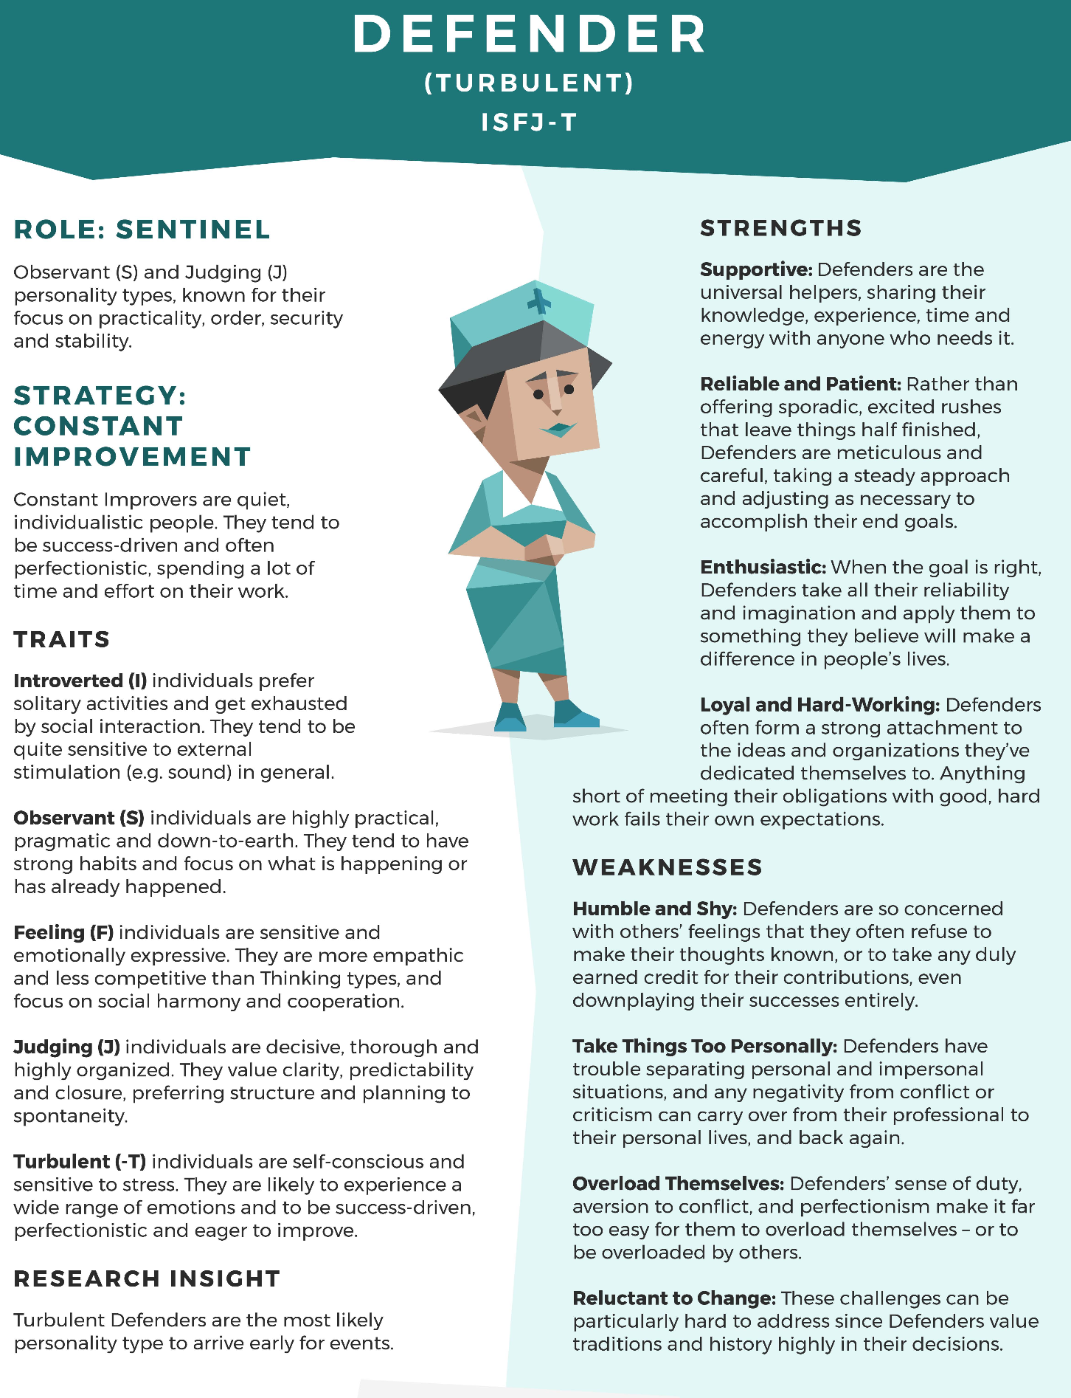
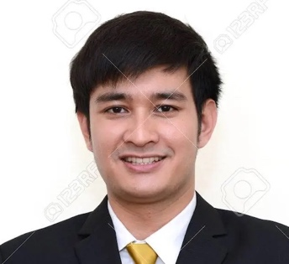
Name: Niran Babu
Passport: Thailand
Age: 26
Living in: Thailand

Full-time work experience: (1 job)
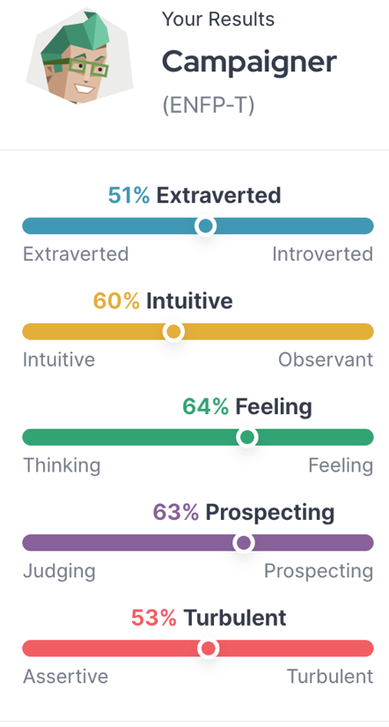
(1) Paradise Hotel – Thailand – 4 years (2022-present):
—Daily hotel management and guest services

Part-time (student) work experience: (3 jobs)
- Starbucks – Thailand – 2 years (2016-2018)
- Restaurant – Thailand – 3 years (2017-2020)
(3) Hotel – Thailand – 2 years (2018-2020)

College Education:
University (2017-21): Siam University (Thailand)
Degree (2021): Hotel & Tourism Management BBA
Grades: GPA 3.2 overall (3.4 in major)

Graduate (2023-present): Northern Arizona University (NAU) (USA)
Degree in progress (finish 2026): Global Business Administration MGBA
Grades: Graduate GPA 3.0

Study/work abroad: Only online through NAU
But lived in the USA for two years as a child.

Languages:
- Thai (native) / - English (fluent)

Why do you want to work for Pacific Holdings in Singapore?
“Pac Holdings is a company with global interests, and Yokohama is an internationally focused part of Japan. I would feel honored to work there as it would be a great educational experience. A holding company presents a unique opportunity to work with and manage a variety of businesses. I am also impressed with PH’s focus on the Asia-Pacific and providing opportunities for people who work hard. I am from a family dedicated to hard work and integrity. However, my work experience after graduating from college was limited due to the Covid pandemic, so I had to adapt and refocus. In my graduate studies, I switched my academic interests to gl0bal business, and I have personal experience in cross-cultural environments, which is important in the people-focused nature of global business. Thank you for considering my application.”

Reference notes from interviewer:
Niran Babu completed his degree in hotel management, in Thailand, during the Covid-19 pandemic, so he could not find a full-time hotel job right away. He decided to use the pandemic time to improve his business English. He eventually got a full-time hotel job. He also started a Master’s course in global business administration through an online program in the USA. Because he can only study part-time now, he plans to finish this degree later in 2026. Niran’s mother is from Thailand and his father is a U.S. citizen originally from India. Niran grew up mostly in Thailand and is fluent in Thai and English. During his interview, he had a positive sense of humor and seemed truly interested in talking with people. His family is not rich, so Niran has paid for most of his education by himself, by working several jobs while a student.

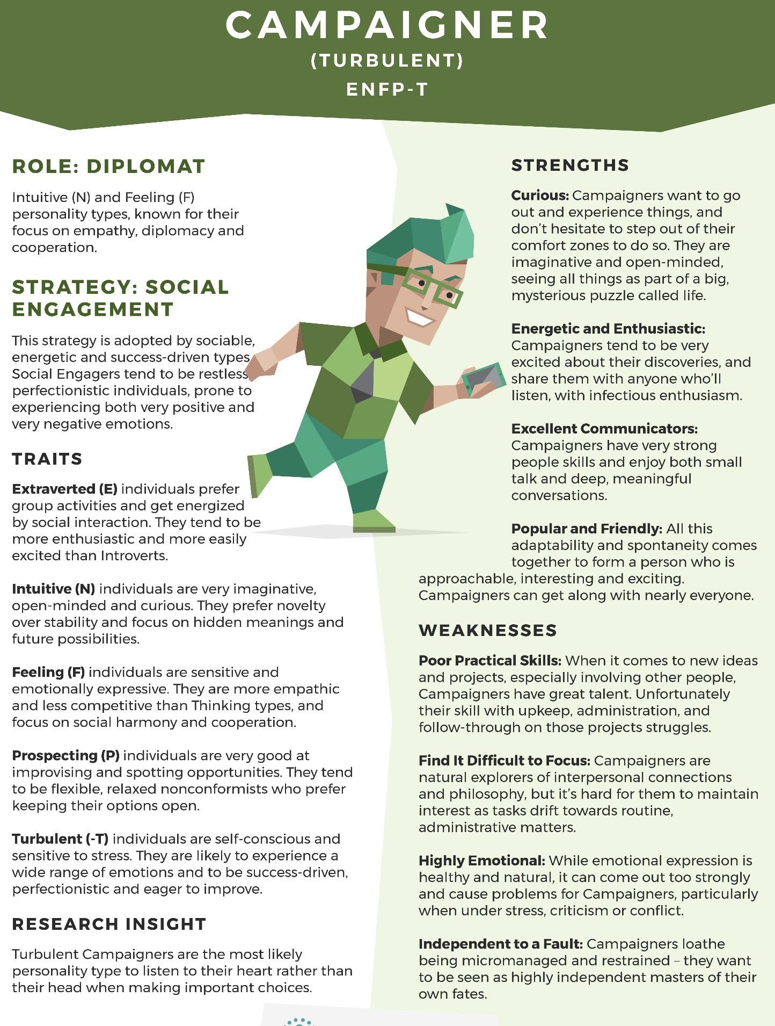
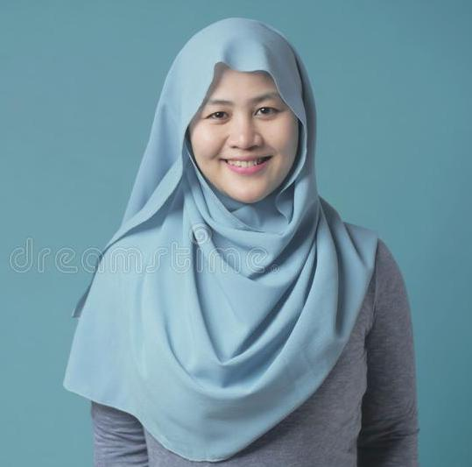
Name: Dhia Hashim
Passport: Malaysia
Age: 24
Living in: Malaysia

Full-time work experience: (1 job)
(1) UNM Department of Business (education assistant) – Malaysia –
2 years (2024-present)

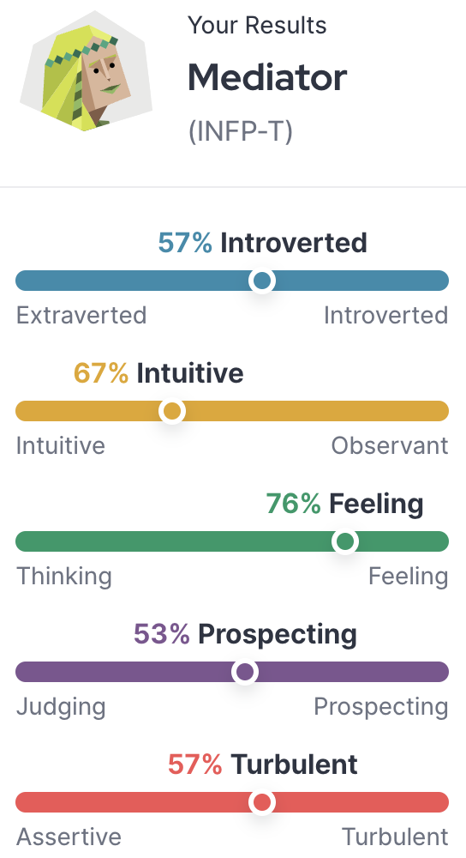
Contract & part-time (student) work experience: (2 jobs)
(1) Prep [cram] school (teaching) – Malaysia – 2 years (2022-2024):
(2) UNM Administration (office staff) – Malaysia – 2 years (2024-present)

College Education:
University (2020-24): University of Nottingham Malaysia (UNM)
Degree (2024): Applied Psychology & Management BSc
Grades: GPA 3.4 overall (3.6 in major)

Study abroad: University of Nottingham (Nottingham, UK) (2022) [Exchange program with home university]

Languages:
Malay (native) / English (fluent) / Indonesian (intermediate)

Why do you want to work for Pacific Holdings in Singapore?
“During my studies at UNM, my professor and some fellow students attended an academic business conference in Singapore. That is where I attended a presentation by Dr. Fairchild of Pacific Holdings, on creativity and psychology. It was fascinating and influenced my senior thesis regarding psychology in the management of small companies. The diversity of working in Japan for a holding company is of great interest to me. Maybe my interests and background can help PH. I must establish myself in the organization in any way that I can. You have my full attention and support.”

Reference notes from interviewer:
UNM is the Malaysian campus of the UK’s Nottingham University. It is one of the top universities in Malaysia and is ranked 158th globally. The Applied Psychology & Management major is an honors (special) degree, in which Dhia had a high GPA. Dhia’s psychology professor provided an excellent letter of recommendation for her. According to PH’s Fairchild, Dhia was the only undergraduate student in her group at the conference in Singapore (other students were graduate students). Dhia speaks English well but with a somewhat strong Malaysian accent. Like many young Malaysians, she hopes for better economic opportunities by working in Singapore.

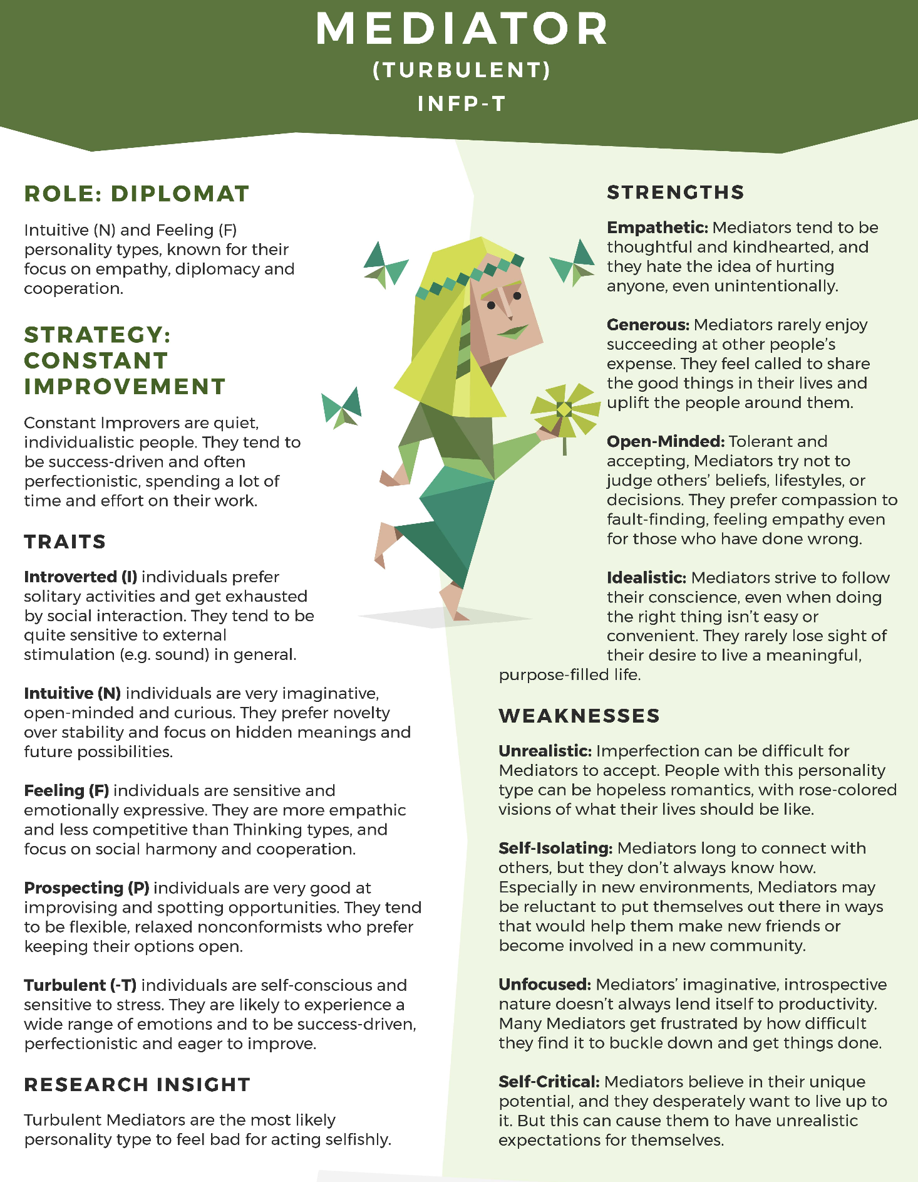

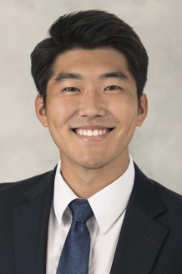
Name: Jason Inagaki
Passport: USA
Age: 25
Living in: Hawaii, USA

Full-time work experience: (1 job)
(1) Bank of Hawaii (account services) – Honolulu – 3 years (2023-present)
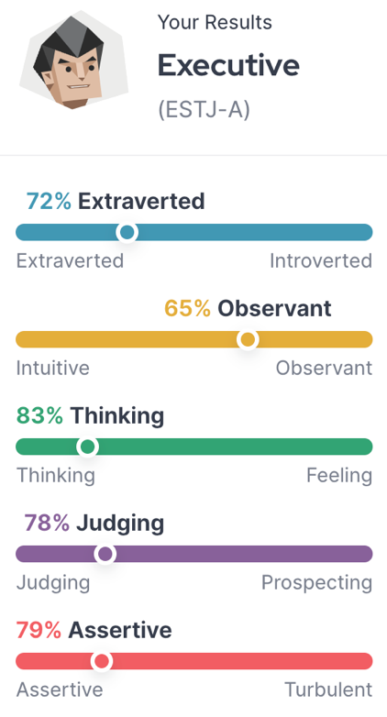
Contract & part-time (student) work & internships: (2 jobs, 1 internship)
(1) Teddy’s Burgers (restaurant) – Honolulu – 2 years (2018-2020)
(2) Internship (4 weeks): Coast Securities – Los Angeles, CA - (2019)
(3) Bongo Surf Shop (shop clerk) – Honolulu – 1 year (2022-2023)

College Education:
University (2019-24): University of Hawaii (USA)
Degree (2024): Economics BA
Grades: GPA 2.8 overall (3.0 in major)
University activities: Rowing – team member

Study/work abroad: none
But Jason stayed with relatives in Japan while studying Japanese for three months.

High school: Hawaii (2016-2019)
Activities: - - Rowing – team captain (regional championship)
- Surfing – team member

Languages:
English (native) / Japanese (basic conversation)

Plan for the future:
- To work hard, keep a positive attitude, and make a few dreams come true!

Why do you want to work for Pac Holdings Yokohama?
“Hard work and success keep me going. That sense of satisfaction is something I love sharing with others. I love my current job at the bank, but I would like to develop my career as a financial or credit analyst. My experiences so far have taught me the importance of team play and group work. Winning is important, but even more important is to share the experience of success. An IHC such as Pac Holdings is strategically placed in Singapore, which provides great access to tax benefits and investment opportunities. I hope I can help your company. Aloha!”

Reference notes from interviewer:
Jason was an alternate on the U.S. Olympic rowing team in 2022 but has never competed internationally. He is an active athlete who jogs one hour every morning before going to work. His supervisor at Bank of Hawaii said Jason is hard-working, reliable, and friendly. Jason is fourth-generation Japanese-American, so his Japanese ability is limited to basic conversations. I wouldn’t be fooled by his positive character and athleticism. Jason seems quite knowledgeable about business finance and banking. His older brother worked as a credit analyst in Tokyo on a three-year contract and is now working full-time as a credit analyst in Los Angeles, California.
