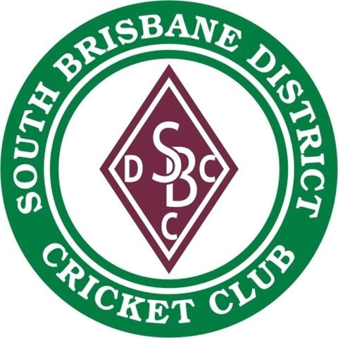
Annual General Meeting – 13 July 2026, 7:00pm
South Brisbane District Cricket Club
SOUTH BRISBANE DISTRICT CRICKET CLUB INC. 1897 – 2022
Associations Incorporations Act 1981 (Registration Number 10374)

NOMINATION FORM

I ………………………………hereby nominate……………………………….for the position of
…………………………………………………of the South Brisbane District Cricket Club
Inc. for the 2026/27 year.
Signature of Nominator: ……….................................
Date:
ACCEPTANCE
I………………………………………..agree to the above nomination and agree to
hold office if elected.
Signature of Nominee: ……….................................
Date:
Nomination form must be received by the Secretary at least ten (10) days (3 July 2026) prior to Annual General Meeting. Email to the below:
Alex Robynson, Secretary, South Brisbane District Cricket Club
Email: alex.robynson@gmail.com
Mobile: 0415 231 197

