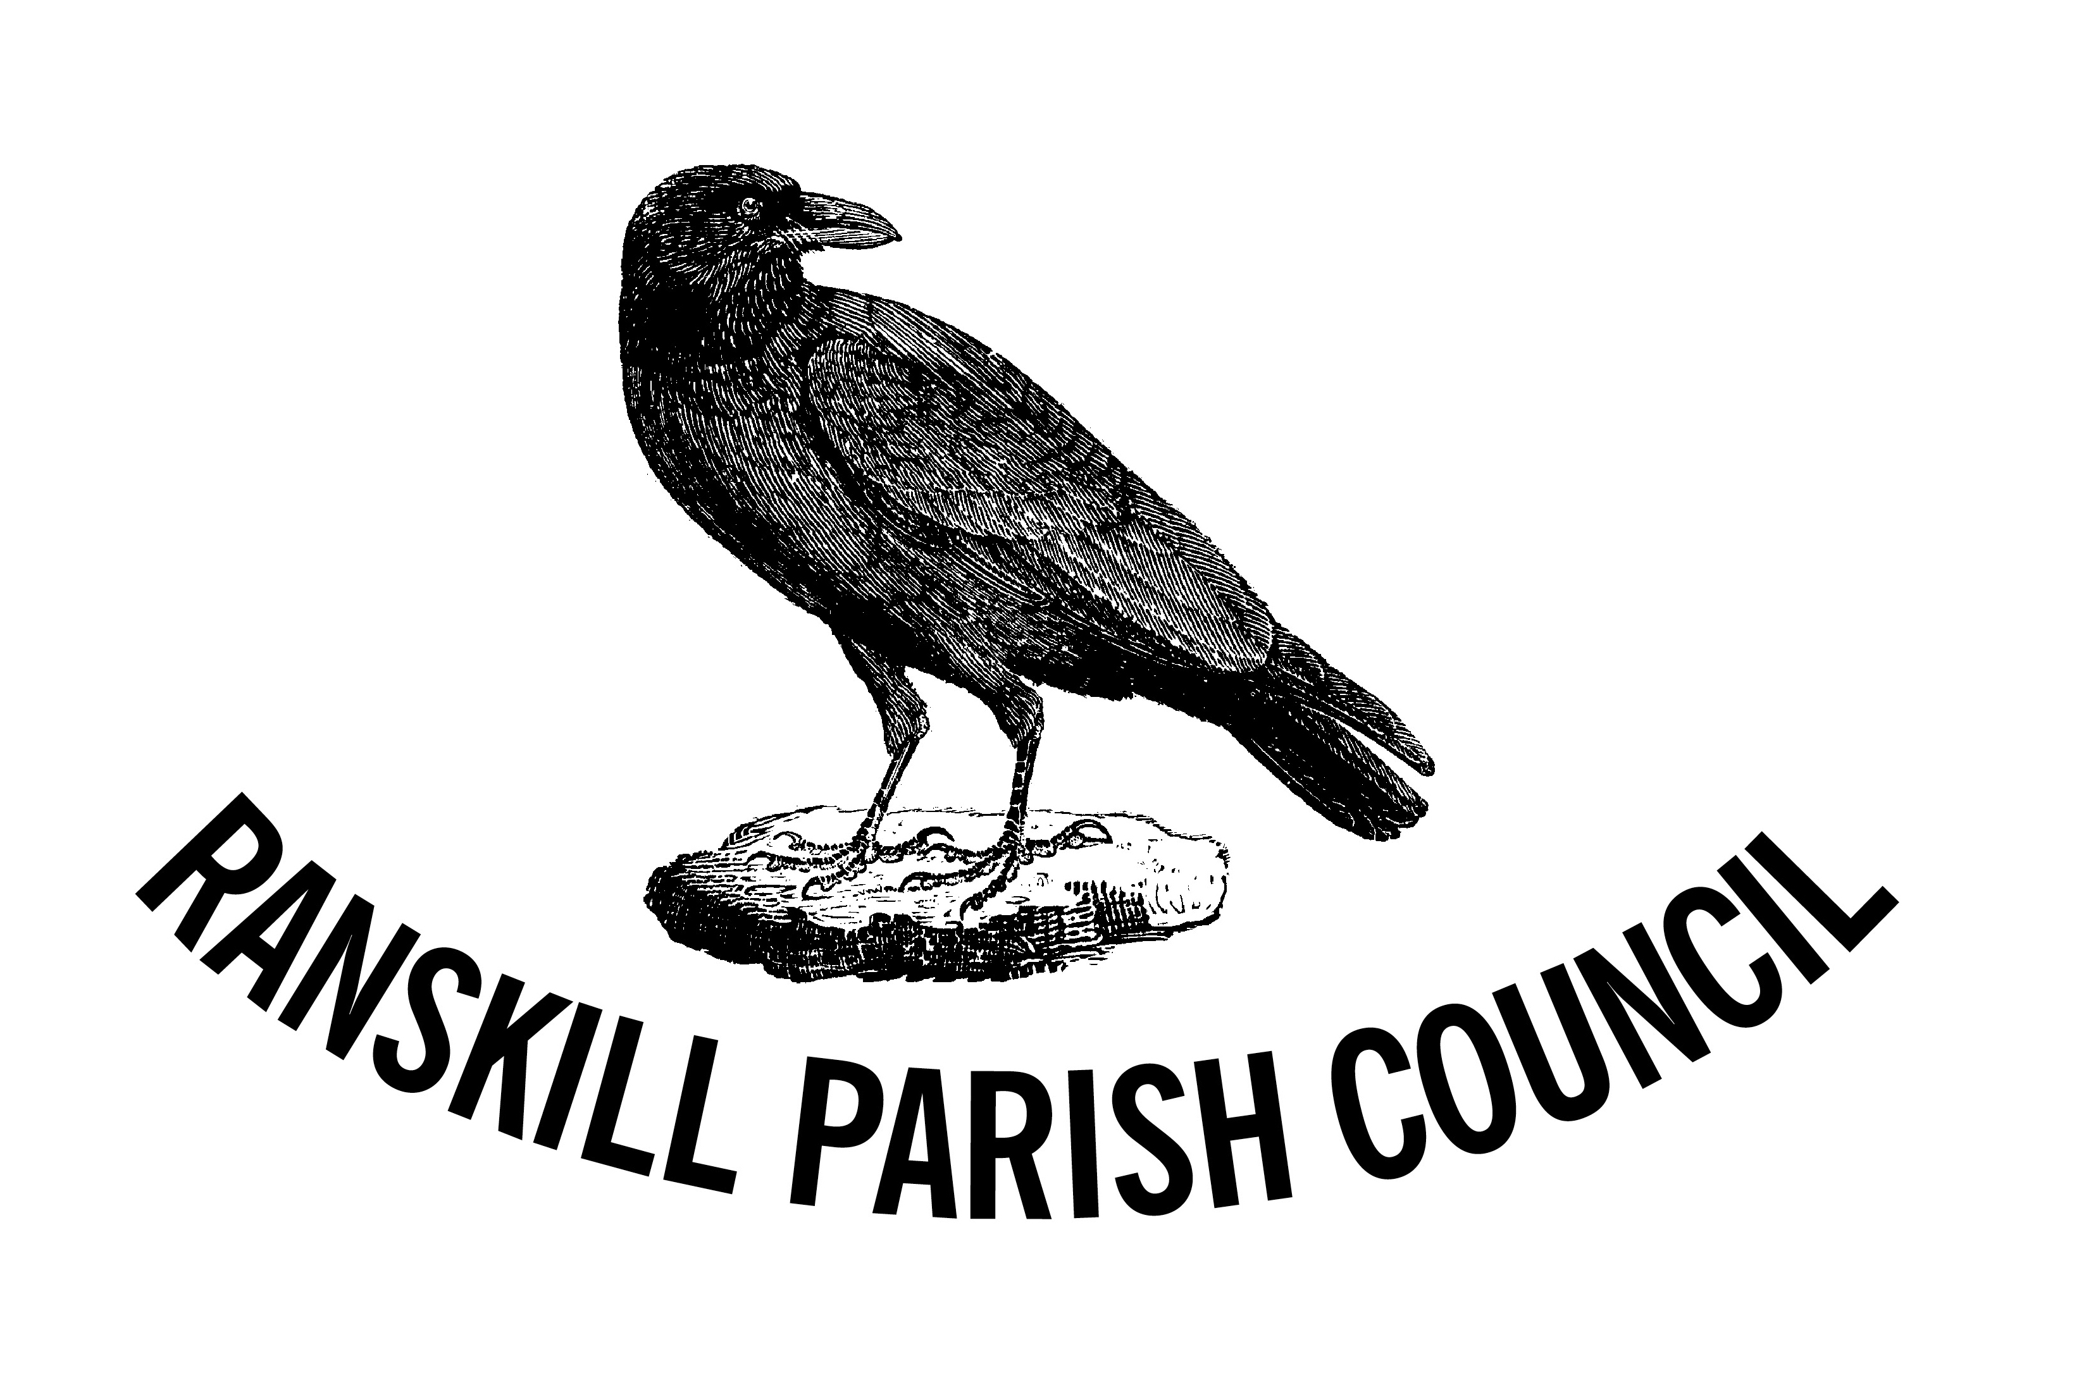
Neighbourhood Plan Steering Group
Fourth Public Consultation
CLOSING DATE : 28th February 202128th ry 20
The Parish Council is seeking your view as to whether you are prepared to accept further housing development on site NP19 in exchange for village owned assets being a village hall and a doctor’s surgery, both identified as long desired assets in prior village surveys. Please see our website for further details: -
www.ranskillplan.co.uk
The Parish Council feels that this decision should be a democratic mandate decided by you, the residents.
This decision will then become incorporated in the Neighbourhood Plan, which will protect the village from any further development.
Planning consent is already granted for up to 32 houses on site NP19. The developer has indicated that they will need a further 79 houses, a total of 111 properties on this site to release sufficient financial headroom to provide the assets for the benefit of the village.
The steering group needs your decision as to whether you prefer:-
Yes: allow limited housing development together with a new community centre and doctor’s surgery
No: no new housing development and no community centre
Please cut out the forms below and post in one of five local houses who have agreed to be used as a drop off point during the voting period to the 28th February 2021: -
- The Chapter House, Great North Road (next to St Barnabas church)
- 8 Witton Close
- Holly Tree Cottage, Station Road
- Raynes, Folly Nook Lane
- Osceola, Mattersey Road (corner of Ravenshill Close)

Should you need any help or have any further queries, please contact: -
Telephone: 07584 169028
Email: parishcouncil@ranskill.org.uk

Ranskill NP Public Consultation February 2021 | YES or NO
I consent to limited housing development on site NP19 to gain a gifted dedicated village assets to include a village hall and a GP surgery
I confirm that I am a permanent resident of Ranskill
Signature | Postcode

Ranskill NP Public Consultation February 2021 | YES or NO
I consent to limited housing development on site NP19 to gain a gifted dedicated village assets to include a village hall and a GP surgery
I confirm that I am a permanent resident of Ranskill
Signature | Postcode

