**WHERE?**

**Advanced Physical Therapy**

**501 Executive Pace**

**Fayetteville, NC 28305**

**WHEN?**

**Sat & Sun**

**November 12 & 13, 2022**

**8am – 4:30pm**

STROKE REHAB:

*The Science & Art of Developing Intentional Interventions*

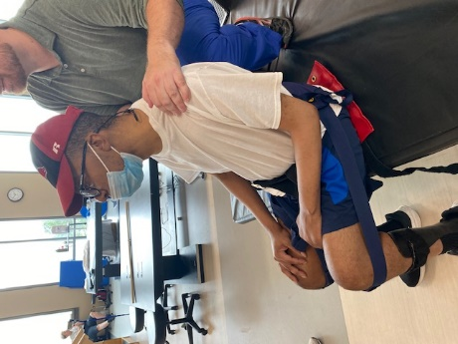

**1.4 CEUS**

**Pre-Approved in NC**

**14.0 Contact Hours**

[Cite your source here.]

To be effective, interventions must be *task specific* and *salient* with intensity and repetition built in. But what does that look like in a busy clinic or home environment where time and equipment are limited? This course will provide a framework for intervention selection based on prioritized activity limitations and impairments identified in the assessment. Current evidence for optimized recovery will be translated into applicable strategies. Then, relevant interventions specifically addressing the demands of transfers, gait, balance, and ADL’s will be discussed, practiced and applied on **real-life patients in a half-day lab experience**. Modifications are provided to ensure application to a wide range of patients.

Come join other rehabilitation professionals and re-energize by learning how to simplify the approach to a successful rehabilitation program for patients with stroke. Depart with actual solutions you can apply on Monday.

**Presenter: *Michelle Green PT, DPT, Board Certified Clinical Neurologic Specialist***Dr.MIchelle Green PT, DPT is a physical therapist with over 25 years of experience in the rehabilitation setting. She has worked with patients who have a variety of neurologic, medical, surgical and traumatic injuries. Dr. Green enjoys working with clinicians to make rehab simple and effective, even with time, staff, and equipment limitations. She works with clinicians to develop a framework of assessment and intervention that directly impacts the patient's progression towards achieving mobility goals: from dressing and performing ADL's, to walking and stairs, to hiking and yoga. This occurs with the support of the research, follows concepts of neuroplasticity and aligns with motor learning and motor control principles. Currently, Dr. Green is an Associate Professor and Assistant Director within the Doctor of Physical Therapy program at Campbell University. She is a 1995 graduate of Ithaca College and resides in Fayetteville, NC with her husband and two sons.

**OBJECTIVES: By the end of this course, participants will be able to:**

1. Develop a revised approach to patient evaluation using the HOAC II (Hypothesis-Oriented Algorithm for Clinicians II), Framework for Temporal Sequence and ICF Model to guide clinical reasoning.
2. Correlate limiting impairments with activity limitations noted during an initial examination.
3. Prioritize impairments identified in an examination for intentional intervention development.
4. Categorize interventions into like groups aimed at specific activity limitations or impairments.
5. Recognize the impact of motor control and learning theories on treatment session development
6. Implement appropriate treatment interventions for identified impairments.
7. Modify treatment interventions to maximize carryover of tasks and movement patterns into functional activities
8. Implement a process of developing interventions and intentionally progressing them toward specific functional goals.
9. Apply principles of neuroplasticity to interventions to improve stroke outcomes
10. Use evidence to guide intervention selection and progression.

**COURSE AGENDA:**

Strategies for Assessment

* Use of ICF and hypothesis-oriented approach to assessment plan
* Use of systems screen and examination to rule in/rule out impairments correlating to activity limitations
* Building a language to describe deficits to guide identification of starting point for interventions and progression
* Logo

  Description automatically generated with medium confidenceCore Set of Outcome Measures for Adults with Neurologic Conditions

The Science of Recovery After Stroke: Principles of Neuroplasticity

* Highlighting principles of specificity, intensity, repetition and salience
* Error Augmentation, Optimal Theory of Motor Learning

Identification of Perceived barriers and strategies for their mitigation

* Hemiplegic UE
* Spasticity & Flaccidity
* Use of AFO’s & FES post-Stroke CPG
* Cognition
* Safety

The Art of Applying the Science for Intentional Progression of Interventions

* Use of motor control/motor learning concepts for optimizing treatment sessions
* Strategic use of positions such as half kneeling, prone, tilt table, standing with endpoint and standing frame
* Strategies for task specific intervention development for transfers, ADL’s, balance reactions and gait
* CPG for Improving Locomotor Function in Chronic Stroke, Incomplete SCI, and TBI
* Implementing High Intensity Step Training
* Cardio Circuits for endurance and functional training for all patient levels

Case Discussion and Live Patient Application of concepts above

**

**REGISTER ONLINE!**

[**www.movement-solutions-for-pt.com**](http://www.movement-solutions-for-pt.com)

**Or call 910-797-5335**

**(Registration open through Wednesday, November 9th. Full refunds through Thursday, November 10th. On-site registration $399)**