|  |
| --- |
| **Propaganda assignment** |

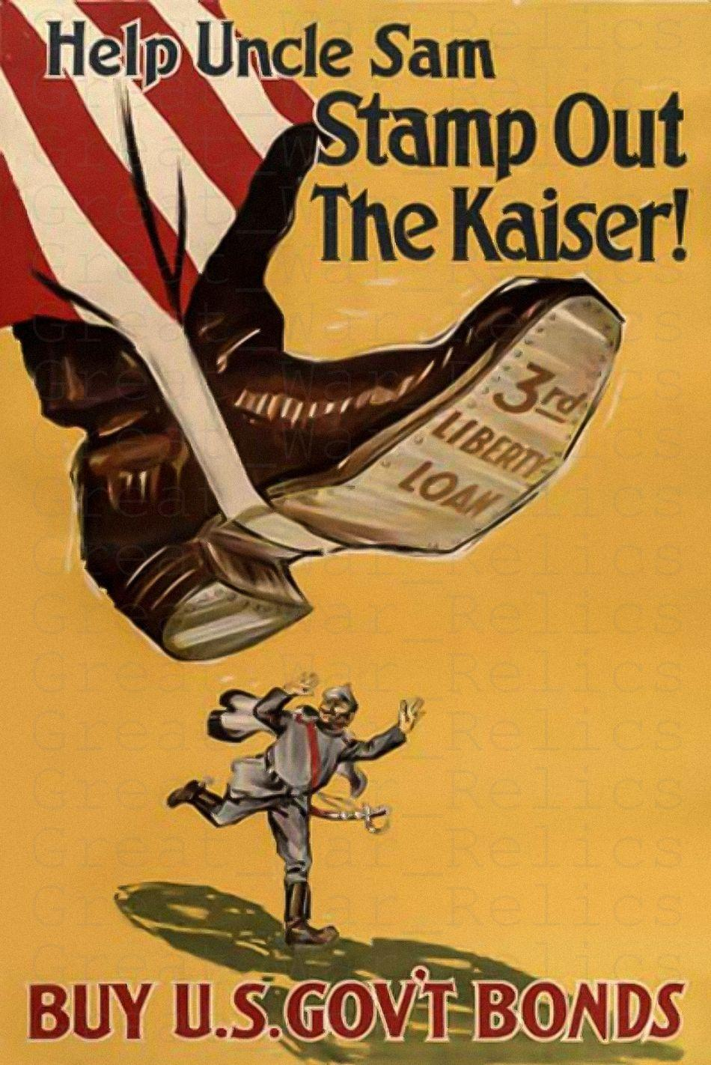

In both the First and the Second World War, all warring parties used propaganda posters. In a number of tasks you will investigate who these propaganda posters were aimed at and what they intended.  
Finally you will create your own propaganda poster.

You will work together with a partner.

|  |
| --- |
| **Before you start; general instructions** |

1. Work with your partner in a shared document. Don’t set up your own page! your teacher will assign a special page to you (shared on classroom). Use this document called ‘answer sheet’ to record all answers.
2. Make sure you follow all instructions carefully and read through the whole assignment before you start. Do not forget to take a long hard look at the rubric on page 7 so that your grade will never come as a surprise.
3. When you are finished, hand in your document on classroom.



|  |
| --- |
| **Index and quick access; just tap to jump!** |

* Jump to assignment 1 Page 2
* Jump to assignment 2 Page 3



* Jump to assignment 3 Page 4
* Jump to Propaganda Analysis Scheme Page 6
* Jump to Rubric Page 7

|  |
| --- |
| Assignment 1: Analysing propaganda posters from World War I |

|  |  |  |
| --- | --- | --- |
|  |  |  |
| Source A, 1916: A British recruitment poster | Source B, 1917, A US recruitment poster featuring Uncle Sam | Source C, 1915: A British recruitment poster |

### 

### To work

1. **Define propaganda**  
   Look up the word ‘propaganda’ on at least three websites and write a definition in your own words.
2. **Make Phase 1 descriptions**  
   Look at the propaganda posters from the First World War above and make Phase 1 descriptions (use schematics to the right to follow the steps). Make sure your description is *detailed* and *elaborate*!
3. **Determine target audience**  
   Now describe for each poster on which persons or groups the propaganda focusses. Be as specific as you can and *explain* which elements in the poster are indicators of the desired target audience.

**\*\*\* END OF ASSIGNMENT 1 \*\*\***

|  |
| --- |
| Assignment 2: Comparing British and American propaganda |

The English and American governments used propaganda posters in the First World War to encourage people to take up service in the army, help produce ammunition or contribute financially to the war effort (buying bonds). To this end, posters appeared everywhere in the country.

Many different propaganda techniques were used, the posters were also created to get an emotional response. When you invoke strong feelings in people, they are more likely to actually do the thing you want them to do.

### To work

1. **Learn about the techniques used in propaganda**  
   Study the Propaganda Poster Analysis Tool on page 6 and make sure you fully understand all the techniques that are described.
2. **Find a poster for every technique mentioned in the Propaganda Poster Analysis Scheme**  
   For every feature of the propaganda poster analysis scheme, find one poster. Copy them in your document and describe for each poster how the technique is being used. Use the PDF files with sources (on classroom). NOTE: the first four pages are UK posters, the last four are US posters.  
   You need to have an example for each of the 7 propaganda techniques.
3. **Analysing British posters**
4. **Technique**  
   Which technique (from the Propaganda Analysis Scheme) did the British government use mostly? Use the sources file (first four pages)  
   Explain in at least 5 sentences which elements in the posters have led you to this conclusion.
5. **Feeling/emotion**  
   Which feeling or emotion did the British posters appeal to the most? Explain in at least 5 sentences which elements in the posters have led you to this conclusion.
6. **Analysing American posters**  
   **A. Technique**  
    Which technique (from the Propaganda Analysis Scheme) did the government of the USA use

mostly? Use the sources file (last four pages)

Explain in at least 5 sentences which elements in the posters have led you to this conclusion.

1. **Feeling/emotion**  
   Which feeling or emotion did the American posters appeal to the most? Explain in at least 5 sentences which elements in the posters have led you to this conclusion.

1. **Concluding Assignment 2**  
   In your search for propaganda posters from World War I you have probably seen certain techniques of propaganda being more used than others. Which features are used the most? *Explain* why you think these are the most used techniques.

**\*\*\* END OF ASSIGNMENT 2 \*\*\***

|  |
| --- |
| Assignment 3: Creating your product |

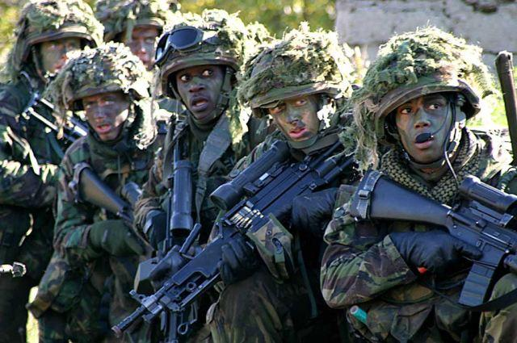

*Dutch soldiers looking frightened during training*

**Imagine yourself in the following situation:**

It is the year NOW and the Third World War is about to break out,

the Netherlands will not be neutral in this war!

Another country is about to declare war on The Netherlands, the first skirmishes have already begun.

The Netherlands has a big problem. The problem is that our country is just not ready for war!

**There are four major problems**

1. **Not enough soldiers**  
   For years now The Netherlands has had an army consisting of volunteers only and this army is way too small to defend our country. The government must therefore call on all able Dutch to help defend the country. 
2. **Not enough ICT experts**  
   War has moved into the realm of ‘cyberspace’ by now. Teams of hackers from the enemy are trying to destabilize our entire defense, financial and communication systems. We also need ICT experts to help develop military drones and weapons with Artificial Intelligence.
3. **Not enough workers to help produce weapons and ammunition**  
   Even with all the high-tech, on the ground, at sea and in the air, war is still fought by people in boats, airplanes and tanks fitted with all kinds of guns. There is a shortage of almost everything and the enemy has more of all this than we do. So we need people to work the machines that produce ammunition and help assemble tanks, aircraft etc.
4. **Not enough money**  
   Of course the government is raising taxes quickly but that will only cover half the cost. They need people to lend money to the government, and fast! People with money in the bank can do that by buying ‘war bonds’ just like in World War I.

The government is planning on using posters to get the Dutch people to go and help with the war effort.

**You and your partner, being experts on propaganda, are hired to help devise a plan for this.**

### 

### To work

1. **Imagine two camps**  
   Decide who is the enemy of the Netherlands in this next war.
2. **Choose two problems to solve**

For at least two of the four problems you need to create a propaganda poster. Those two propaganda posters each have to solve a different problem.

1. **Define your target audience**  
   Decide for each of the two problems you have chosen which audience should be targeted with your propaganda campaign. Explain why you think these people should be targeted in particular. For instance, do you want to convince citizens who are: women/men, young/old, rich /poor, academically educated/ practically educated, physically strong/ mentally strong, etc.?
2. **Choose your propaganda technique**  
   Decide for each of the two problems you have chosen which propaganda technique should be used. Use one or more of the techniques from the Propaganda Poster Analysis Tool on page 6. Don’t forget to *explain* why you think your choices would make for a successful campaign.
3. **Which feelings/emotions will you evoke?**  
   Decide for each of the two problems you have chosen which feelings/emotions will be evoked with your posters. Explain why you think your choices would make for a successful campaign.
4. **Create your posters**  
   For each of the two campaigns you have chosen you need to create a propaganda poster. You have to create it on paper, and it has to be your creation (not generated by AI!!!). You can use pen, markers, colored paper, etc. You may use printed images to paste into your poster, but you are not allowed to make a fully digital poster.

**\*\*\* END OF ASSIGNMENT 3 \*\*\***

|  |
| --- |
| Propaganda Poster Analysis Tool - seven techniques used in propaganda |

|  |  |
| --- | --- |
| **1. Scolding** | The opponent is considered to be bad and ugly. The opponent is depicted as the personification of evil (blackening the opponent). In this list fits the designation of a certain group as a scapegoat that gets blamed everywhere. |
| **2. Generalities** | One invokes (calls on) generally accepted values ​​that can be regarded as positive in themselves, such as faith, hope, love, honor, health, parenting, patriotism. However, these values ​​are used or misused for their own purposes. |
| **3. Transfer** | You try to persuade an institution with a good name (for example the church or the state) to approve your message or program. You connect the authority of the institute or institution to your message / program, which gives it more authority. In this form of propaganda, symbols are often used, such as the cross or the national flag. These symbols often evoke emotions. |
| **4. Witnesses** | Propaganda often uses familiar people or institutions with a great reputation. There is nothing wrong with that, unless you use someone's authority or someone's familiarity in an area where he or she is not competent at all. For example, famous singers or actors advertise presidential candidates in the United States, while there is no reason to believe that they know what is best for the country. |
| **5. The common  man** | You present yourself as being just an ordinary citizen and hope to win the sympathy of people. For example, all US presidents are millionaires lately, but they have all gone to great lengths to show that they are also ordinary people. |
| **6. Group feeling** | You appeal to the fact that people like to belong to a group. If everyone does something then you also want to participate. That is why propaganda makers often rent large venues, time on the radio or TV, they organize large demonstrative parades. They also like to use symbols, colors, music, drama etc. They respond to the fact that people belong to a certain group, people are Catholic or Protestant, they are farmers or teachers, etc. Using all other propaganda techniques they try to reinforce feelings of hatred or fear, prejudice or beliefs that already exist within these groups. |
| **7. Fear** | You appeal to anxiety. Hitler, for example, was a master of the response or fear among the population:  "It's uneasy in the streets. The universities are full of rebellious students. Communists are trying to destroy our country. Russia is threatening us with its power and the republic is in danger. Yes - danger from inside and outside. We need order and law. If that is lacking, our nation can not continue "(1932) |

|  |
| --- |
| RUBRIC |

|  |  |  |  |  |  |  |  |  |  |  |  |  |  |
| --- | --- | --- | --- | --- | --- | --- | --- | --- | --- | --- | --- | --- | --- |
|  | Propaganda assignment tto 3 | | | | | | | | |  | |  | |
|  |  |  |  |  |  |  |  |  |  | |  | |  | |
|  | Name student 1 | |  |  |  |  |  | B | Beginner | |  | |  | |
|  | Name student 2 | |  |  |  |  |  | P | Proficiant | |  | |  | |
|  |  |  |  |  |  |  |  | A | Advanced | |  | |  | |
|  |  |  |  |  |  |  |  |  |  | |  | |  | |
|  | Assignment 1 (research) | | |  |  |  |  | **Overall grade** | |  | |  | |
|  |  |  |  |  |  |  |  |  |  | |  | |  | |
|  | 1. Definition of propaganda | | |  |  |  |  |  |  | |  | |  | |
|  |  |  |  |  |  |  |  |  |  | |  | |  | |
|  | 2. Phase I descriptions | | |  |  |  |  |  |  | |  | |  | |
|  | Source A | |  |  |  |  |  |  |  | |  | |  | |
|  | 1 | First impression | |  |  |  |  |  |  | |  | |  | |
|  | 2 | When was it made? | |  |  |  |  |  |  | |  | |  | |
|  | 3 | Where was it made? | |  |  |  |  |  |  | |  | |  | |
|  | 4 | Who made it? | |  |  |  |  |  |  | |  | |  | |
|  | 5 | Elaborate description | |  |  |  |  |  |  | |  | |  | |
|  |  |  |  |  |  |  |  |  |  | |  | |  | |
|  | Source B | |  |  |  |  |  |  |  | |  | |  | |
|  | 1 | First impression | |  |  |  |  |  |  | |  | |  | |
|  | 2 | When was it made? | |  |  |  |  |  |  | |  | |  | |
|  | 3 | Where was it made? | |  |  |  |  |  |  | |  | |  | |
|  | 4 | Who made it? | |  |  |  |  |  |  | |  | |  | |
|  | 5 | Elaborate description | |  |  |  |  |  |  | |  | |  | |
|  |  |  |  |  |  |  |  |  |  | |  | |  | |
|  | Source C | |  |  |  |  |  |  |  | |  | |  | |
|  | 1 | First impression | |  |  |  |  |  |  | |  | |  | |
|  | 2 | When was it made? | |  |  |  |  |  |  | |  | |  | |
|  | 3 | Where was it made? | |  |  |  |  |  |  | |  | |  | |
|  | 4 | Who made it? | |  |  |  |  |  |  | |  | |  | |
|  | 5 | Elaborate description | |  |  |  |  |  |  | |  | |  | |
|  |  |  |  |  |  |  |  |  |  | |  | |  | |
|  | 3. Finding target audience | | |  |  |  |  |  |  | |  | |  | |
|  | Determine target audience Source A | | |  |  |  |  |  |  | |  | |  | |
|  | Determine target audience Source B | | |  |  |  |  |  |  | |  | |  | |
|  | Determine target audience Source C | | |  |  |  |  |  |  | |  | |  | |
|  |  |  |  |  |  |  |  |  |  | |  | |  | |

|  |  |  |  |  |  |  |  |  |  |  |  |  |  |
| --- | --- | --- | --- | --- | --- | --- | --- | --- | --- | --- | --- | --- | --- |
|  | Assignment 2 (research) | |  |  |  |  |  |  |  |  |  |  | |
|  |  |  | |  |  |  |  |  |  |  |  |  | |
|  | 2. Poster & explanation of the seven techniques | | | | | |  |  |  |  |  |  | |
|  |  | 1. Scolding | |  |  |  |  |  |  |  |  |  | |
|  |  | 2. Generalities | |  |  |  |  |  |  |  |  |  | |
|  |  | 3. Transfer | |  |  |  |  |  |  |  |  |  | |
|  |  | 4. Witnesses | |  |  |  |  |  |  |  |  |  | |
|  |  | 5. The Common Man | | |  |  |  |  |  |  |  |  | |
|  |  | 6. Group Feeling | | |  |  |  |  |  |  |  |  | |
|  |  | 7. Fear | |  |  |  |  |  |  |  |  |  | |
|  |  |  | |  |  |  |  |  |  |  |  |  | |
|  | 3. Analysis British posters | | | |  |  |  |  |  |  |  |  | |
|  |  | A. find most used techniques | | |  |  |  |  |  |  |  |  | |
|  |  | B. find emotion appealed to | | |  |  |  |  |  |  |  |  | |
|  |  |  | |  |  |  |  |  |  |  |  |  | |
|  | 4. Analysis American posters | | | |  |  |  |  |  |  |  |  | |
|  |  | A. find most used techniques | | |  |  |  |  |  |  |  |  | |
|  |  | B. find emotion appealed to | | |  |  |  |  |  |  |  |  | |
|  |  |  | |  |  |  |  |  |  |  |  |  | |
|  | 5. Concluding question | | | |  |  |  |  |  |  |  |  | |
|  |  |  | |  |  |  |  |  |  |  |  |  | |
|  |  |  | |  |  |  |  |  |  |  |  |  | |
|  |  |  | |  |  |  |  |  |  |  |  |  | |
|  |  |  | |  |  |  |  |  |  |  |  |  | |
|  | Assignment 3 (creative) | | | |  |  |  |  |  |  |  |  | |
|  |  |  | |  |  |  |  |  | **Overall grade** |  |  | |
|  | 1. Problem 1 | | |  |  |  |  |  |  |  |  |  | |
|  |  | Target audience | | |  |  |  |  |  |  |  |  | |
|  |  | Propaganda technique effective | | |  |  |  |  |  |  |  |  | |
|  |  | Choice of emotion visible | | |  |  |  |  |  |  |  |  | |
|  |  | End product / design | | |  |  |  |  |  |  |  |  | |
|  |  |  | |  |  |  |  |  |  |  |  |  | |
|  | 2. Problem 2 | | |  |  |  |  |  |  |  |  |  | |
|  |  | Target audience | | |  |  |  |  |  |  |  |  | |
|  |  | Propaganda technique effective | | |  |  |  |  |  |  |  |  | |
|  |  | Choice of emotion visible | | |  |  |  |  |  |  |  |  | |
|  |  | End product / design | | |  |  |  |  |  |  |  |  | |
|  |  |  | |  |  |  |  |  |  |  |  |  | |