Peterborough FASD Support group is run by families with experience of living with Fetal Alcohol Spectrum Disorder (FASD). The group will support people living in any type of family or adults with condition.
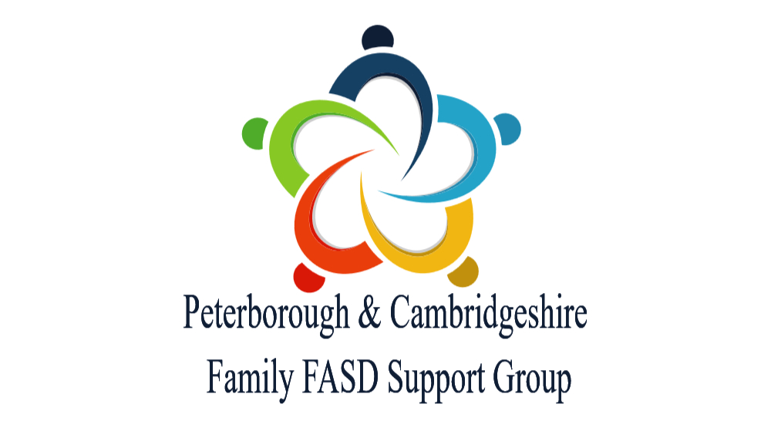
We provide support in a variety of different situations from people who know about living with FASD.
2026 / 2027 Dates

We hold regular face to face meetings starting at 11:00 in Peterborough as follows.

Family get togethers
Sunday June 14th, 2026
Sunday October 18th, 2026
Sunday December 6th, 2026
Sunday February 7th, 2027
Sunday April 25th, 2027
Sunday June 13th, 2027
The Spinney Children’s Centre, Little Miracles, Hartwell Way Peterborough. PE3 7LE

Coffee mornings
Friday July 10th, 2026
Thursday September 17th, 2026
Tuesday November 10th, 2026
Wednesday January 13th, 2027
Thursday March 18th, 2027
Tuesday May 18th, 2027
Wednesday July 14th, 2027
Blue Diamond Garden Centre Café, PE1 4YZ

Please get in touch with us to check that these are running and confirm the venue. There is also a Cambridgeshire monthly support meeting in Papworth Everard on the dates and contact details are shown over the page.

We also provide information advice and guidance to anyone effected by FASD or may be or who has an interest in the condition and will consult with professionals supporting affected families.

We have a closed Facebook page so that members can communicate and discuss issues with each other in confidence. https://www.facebook.com/groups/1320037864718272/
The Peterborough & Cambridgeshire group is part of the FASD UK Alliance and influences developments UK wide. https://fasd-uk.net/

For more information, please contact Brian & Maureen Roberts
fieldofenterprise@gmail.com 01354 669086 / 07906 988992


Peterborough & Cambridgeshire
FASD Support Group
Monthly Saturdays @ 11.30am – 1.00pm
Dates scheduled for 2026:
May 30th
June 27th
July 18^{h}
August 22nd
September 26th
October 24th
November 21st
December 12th
(subject to change)
@ The Printworks
Papworth Everard - CB23 3AY
(opposite Village Hall)
For further info join Peterborough & Cambridgeshire Family FASD Support Group
or contact The Cambridgeshire Virtual School
Fetal Alcohol Spectrum Disorder is a lifelong profound and severe neuro-developmental disorder caused by pre-natal alcohol exposure. Thousands of children were compromised before they were even born. Most recent research (2021) suggests these effects 2% - 4% of the population. Most are undiagnosed. For over 90% of those affected there are no physical characteristics and therefore for the vast majority of those with FASD the disability is hidden. It remains poorly understood, poorly assessed and support mechanisms for those with FASD are almost non-existent in England.
Evening Family support drop-in sessions for 2026 – 2027

As a new development we would like to offer families the opportunity of joining us for an informal drop-in session where you can discuss any issues that you might have or just come for a chat.

These evening sessions will be run in addition to the monthly support groups that have already been advertised in Peterborough and Papworth Everard.

We intend to run the sessions from 7pm to 9pm on the following dates: -

Thursday October 8th,
Tuesday November 24th
Thursday January 28th
Tuesday February 23rd
Thursday March 25th
Tuesday April 13th
Thursday May 27th and
Tuesday June 22nd

We are supported in this exciting development by the Ascent Café in Offord Cluny which will be our venue. More details can be found over the page about the café, which is well worth a visit, even if you can’t get to our drop-in sessions.

As always if you have any burning questions or issues then please get back to me either via email fieldofenterprise@gmail.com or phone 07906 988992.

(Ascent Cafe, Station Lane, Offord Cluny, PE19 5ZA, not far off the A1 between Huntingdon & St Neots)

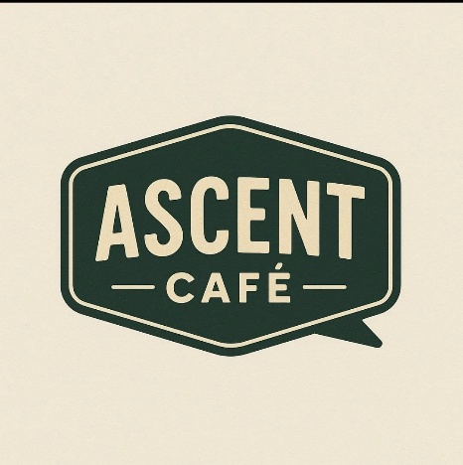
The Ascent Café was opened in November 2025 in Offord Cluny and what was initially supposed to be a family run local community café has already grown into that and so much more, it has become a safe space for SEND children and young people via our SEND opening hours, working in partnership with local SEND Charities – Dream Drops and Little Buds to provide activities and events for the children and the wellbeing of parents.
There is more to in the Autumn term 2026, along with training opportunities for parents and carers, offering free SALT and Occupational Therapy drop ins currently with more drop ins coming from September in a range of themes. All of this on top of lots of events aimed at all that include quizzes, music bingo, vinyl nights, live music event that are for young musicians and bands to give them the opportunity to perform in a venue to a live audience to mention a few.
Day time opening between 9 am and 4 pm weekdays and 9am and 5 pm weekends.
Facebook profile https://www.facebook.com/profile.php?id=61581443589023

Google Map link https://maps.app.goo.gl/s5rf11eozaQCfu6E7

