Peterborough & Cambridgeshire Family FASD Support Group
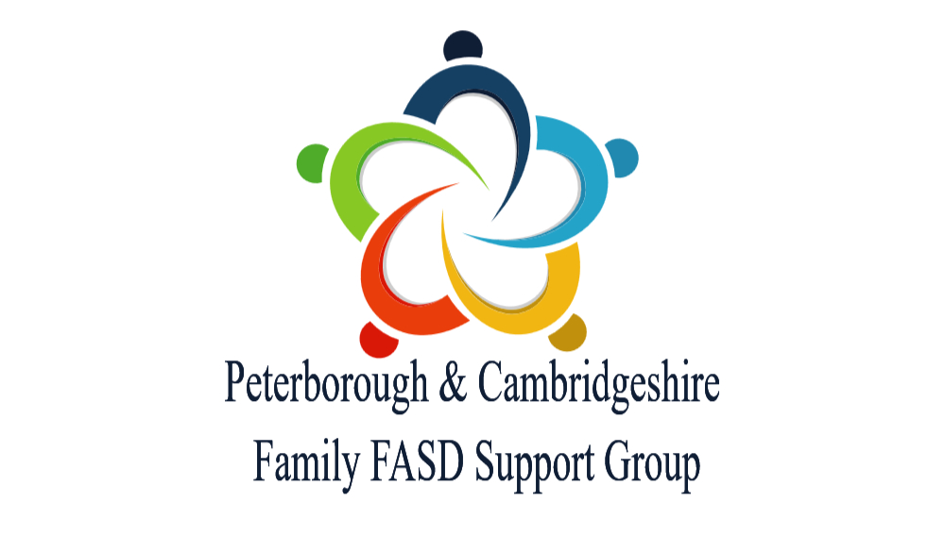
18 Doddington Road, Chatteris. PE16 6UA
01354 669086 / 07906 988992
fieldofenterprise@gmail.com

FASD Awareness Month 2026
FASD Grows Up - A Personal Reflection & Round up
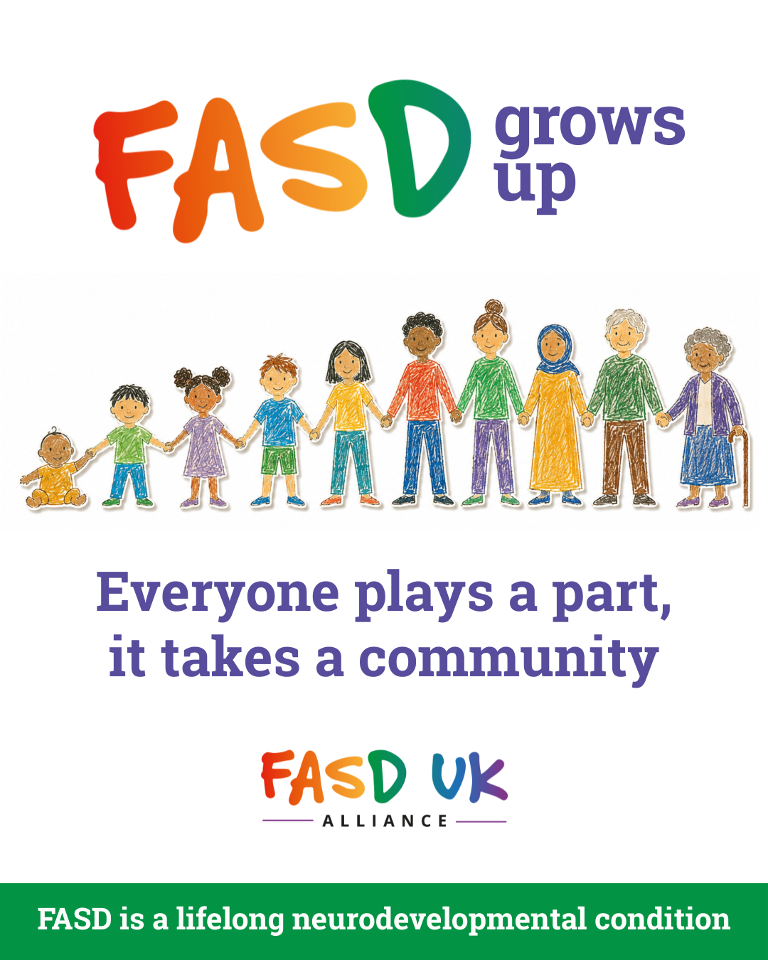

This is a call to action for everyone
Over the course of September 2026, I have posted 12 blogs on various social media platforms that have taken readers through the current state of play in Cambridgeshire & Peterborough as far as identifying people who may have FASD, giving them access to assessment processes and supporting those with FASD and the families that they live with. The blogs can be found here - https://www.fieldofenterprise.org/blog
Cambridgeshire & Peterborough because that is where I have lived and worked for over 17 years and where I co-ordinate the Peterborough & Cambridgeshire Family FASD Support Group.
I focused on the young people turning 18 in the next 12 months as well as painting the wider picture. The rising 18’s because if they are venturing into adulthood unassessed and vulnerable it is at this stage of life that things become even more complex.
I have used published documents from both Councils and local and national research to make the case.
The information has been shared separately with –
Some of the local MP’s (This summary will go to all).
The Mayor of the Cambridgeshire & Peterborough Combined Authority
The Chief Executive Officers and Directors of Children’s Services in both Local Authorities
Central East Integrated Care Board
The local media (none picked it up)
This summary will also go out to all councillors by email in Cambridgeshire & Peterborough.
The key finding has been that the Local Authorities and services have acknowledged the level of FASD in the communities that we live in and yet the services to address the needs of that group of vulnerable citizens are still lacking. In my mind only the input of unfunded volunteers attempting to plug the gap.
It simply isn’t enough to write things in reports and do nothing more. FASD as an issue is too big and currently too costly in financial terms, in mental health terms, in terms of wasted potential and emotional stress.
In blog 4, I established that the current Joint Strategic Needs Assessment for Children & Young People in Cambridgeshire & Peterborough (JSNA) accepts that –
3% of all under 18’s has FASD.
That is 6,200 young people.
You will find them in every school & college, on every GP’s list, in every Parliamentary constituency and Council ward, in our youth services and community activities and sports clubs and also not being able to access the services that most of us take for granted.
In Blog 6, I discussed that as things currently stand as there is no pathway –
Over 90% will never be diagnosed and most won’t understand why their brain works differently to others.
Blog 8, considered the nationally acclaimed research undertaken in Peterborough that recorded that –
27% of Children in Care had FASD
Blog 9 went on to look at figures. In the two local authorities in 2025 this amounted to-
288 children
This is a key group as the Local Authorities have taken the very serious decision to remove these children from their families and take over the parenting responsibilities for them. I would suggest that –
Corporate parents should be doing far better than they currently are with regard to FASD.
Their lead would be a catalyst for others. In the same way a commitment by the Integrated Care Board and health bodies to implement the NICE Quality Standard 204 (FASD) would be a signal of intent that would generate the environment for major change.
The same research in Peterborough indicated that -
75% of children adopted were exposed to alcohol in the womb
This doesn’t mean that every one of these children will have FASD, but Adoption UK suggests that 35% of adopted children do have it.
FASD will be disproportionately represented in vulnerable cohorts
Those in Kinship Care, those with Special Educational Needs and in Special Schools and sadly those in secure children’s settings and involved in the criminal justice system.

However, the Councils should be doing this already
Cambridgeshire Children's Services aims ‘to ensure that every child and young person across the county is given the best possible start in life, remains safe and well, and is effectively supported through early years, education, and into adult life.’
Peterborough City Council Children’s Services aims ‘to ensure every child grows up safe, healthy, happy, and able to reach their full potential.’
Therefore, it is difficult to see how they will achieve these aims if they don’t fully understand 3% of the children and young people who live in their area and for whom they provide essential services. Children and young people with FASD should not be further marginalised and made even more vulnerable.
All of our children and young people will grow up into adults with FASD. In most of the Blogs, but especially number 3, we focused on our single cohort of 18-year-olds.
In total 449 18-year-olds have FASD
The failure to identify FASD and provide children, young people and adults with appropriate informed support is costly. Huge savings could well be made if a small investment was made in order to allow people with FASD to thrive.
National FASD's 2026 report The Cost of Inaction on FASD puts the lifetime societal cost of a single FASD case at £359,835 when diagnosed and £431,802 when undiagnosed. This is discussed in the paper produced that can be found here https://www.fieldofenterprise.org/blog/the-cost-of-inaction-in-peterborough-cambridgeshire-2026-relating-to-fasd
The local lifetime costs for that cohort of 18-year-olds is-
£190 million of which £62 million still to be spent
Blog 1o, on commissioning services further dives into the figures indicating where I expect the costs to be incurred
The lifetime costs for all of our children are staggering –
£3.3 billion will be committed if there is no action taken
There is plenty of savings that can be made, but more importantly we would be addressing key local vulnerabilities.
FASD is a lifelong pervasive and a severe neurodevelopmental impairment

If we calculate 3% of the Cambridgeshire & Peterborough population based on the 2021 census this is –
26,836 citizens who may have FASD
This is a huge issue that impacts every part of our communities and therefore it demands a community approach from everyone to make inroads into improving the wellbeing of those with FASD, the families and partners that they live with and everyone who supports them in whatever role they have.
The call to action a challenge
Blog 11, makes suggestions of what the initial actions could be –
1. A named FASD lead in each council and in the ICB.
2. An accessible local diagnostic and post-diagnosis pathway, built on NICE Quality Standard QS204 (2022) and SIGN 156 (2019), whose approach NICE has accepted.
3. FASD awareness training in the offer for schools, social care, kinship carers, midwifery and anyone else who works with vulnerable children, young people and adults.
4. Routine enquiry about, and recording of, prenatal alcohol exposure in health assessments, care plans and pathway plans — which paragraph 44 of the looked-after children statutory guidance already expects.
5. A guarantee that FASD will be taken into consideration as our vulnerable children transition into adult life with the support that they need and are entitled to.
6. A commitment to embed FASD Awareness in policy and practice across the area so that there is a lasting legacy that doesn’t just fizzle out when staff move on or retire.
This is as well as the national call for action from the National Organisation for FASD discussed in Blog 3. Basically, the national ask is for 0.25% of the tax gain from alcohol duty to be used to inform society about the risks posed by alcohol in pregnancy, assess those who might have FASD and support those who do. That 0.25%, around £31 million a year would support national initiatives and local grass roots work. It seems like a no brainer, and financially something that saves literally billions.
Freedom of Information Questions
I have not been able to shake the fact that after 17 years working on FASD locally no one had told me that FASD has been accepted as part of the JSNA and that they level assumed is higher than any other condition. Therefore, I have written to the following individuals and organisations to ask how they are using this information in practice.
  - Public Health, Peterborough City Council,
  - Public Health, Cambridgeshire County Council.
  - The joint Public Health Intelligence Team
  - The joint Cambridgeshire and Peterborough Health and Wellbeing Board,
  - Cambridgeshire Lead Member for Health and Wellbeing Cambridgeshire County Council
  - Peterborough Cabinet Member for Public Health, Homelessness and Poverty
  - Cambridgeshire and Peterborough Combined Authority (CPCA)
  - Cambridgeshire Police and the
  - Cambridgeshire & Peterborough Local Safeguarding Children Board
At the end of October 2026, I intend to share with everyone their answers.
Everyone plays a part, it takes a community
There is a big job to do. Everyone has a role to play throughout all parts of our communities. Local families and people with FASD cannot do this themselves. Currently, without informed support that understands the needs, families have too much to do, whether they know about FASD or not.
That means that we need professionals to step up and help to build a critical mass of local expertise to support those with FASD and their families as well as embedding best practice in policy and what is oden in both Council areas. This cannot only sit in the heads of and be driven by keen and informed members of departments, agencies and organisations. Policy and practice must be in place that means that everyone is informed and empowered to make a difference, even when personnel changs.
As families and people with lived FASD experience we stand ready to support these efforts. We need a seat that the table when decisions are being made and structures are being developed. Peterborough and Cambridgeshire have a unique level of experience in identifying and supporting people with FASD. I cover this is Blog 3, and yet it isn’t coordinated or joined up.
FASD can and does affect all sectors of society
If there are any questions, thoughts, observations or you just want a chat, reach out and members of the Peterborough & Cambridgeshire Family FASD Support Group are here for you. I cover what we do in Blog 5 or see here for support group venues and dates https://www.fieldofenterprise.org/blog/peterborough-cambridgeshire-family-fasd-support-groups-dates-2026-27

Brian Roberts
Co-ordinator Peterborough & Cambridgeshire Family FASD Support Group

The Peterborough & Cambridgeshire Family FASD Support Group has been operating as a regional source of FASD support, information, advice and guidance for people with, or who may have FASD, and those who live with them for well over 15 years. We operate regionally with in the north of East Anglia and in the East Midlands. The support is not limited to the County and City, as other groups providing FASD support are still few and far between. However, our core membership lives within the two local authorities. The group was founded by parents and carers of young people with FASD. We are an independent organisation with no formal connections to any local government or health organisations. We are members of the FASD UK Alliance and also work closely with the Hertfordshire FASD Support Group. In addition to the support, information, advice and guidance, we also raise awareness of the risk of prenatal alcohol exposure and the implications of having FASD. This can extend to individual support for families navigating the local systems. We will work with all organisations to improve the life changes of those with FASD, the quality of life for any type of families affected and to reduce the prevalence of FASD. We work closely with Cambridgeshire Pinpoint, Both the Virtual schools in Cambridgeshire & Peterborough, the Regional Adoption Agency and local SEND advocacy groups. We are proud to have members who have FASD, who are birth parents, kinship carers, foster carers, special guardians and adopters.
The current diagnostic criteria for FASD are outlined in the SIGN 156 Guidance that is now applicable in England & Wales as well as Scotland since the publication of the NICE Quality Standard 204 for FASD in March 2022. https://www.sign.ac.uk/sign-156-children-and-young-people-exposed-prenatally-to-alcohol This states that - A diagnosis/descriptor of FASD is made only when there is evidence of pervasive and long-standing brain dysfunction, which is defined by severe impairment (a global score or a major subdomain score on a standardised neurodevelopmental measure that is ≥2 SDs below the mean, with appropriate allowance for test error) in three of more of the following neurodevelopmental areas of assessment: - motor skills - neuroanatomy/neurophysiology - cognition - language - academic achievement - memory - attention - executive function, including impulse control and hyperactivity - affect regulation, and - adaptive behaviour, social skills or social communication. Therefore, any assessments / reassessment of need as far as someone with FASD would expect to find impairments in three or more of these areas. In a recent reassessment of need in Cambridgeshire for my son’s EHCP the EP used this as a framework and found that there were 7 areas impacted. My argument is that as professionals these assessments are being made every day in both Authorities. So, with knowledge and co-ordination Cambridgeshire, Peterborough or any other LA/ ICB can make assessments of FASD.

