Peterborough & Cambridgeshire Family FASD Support Group
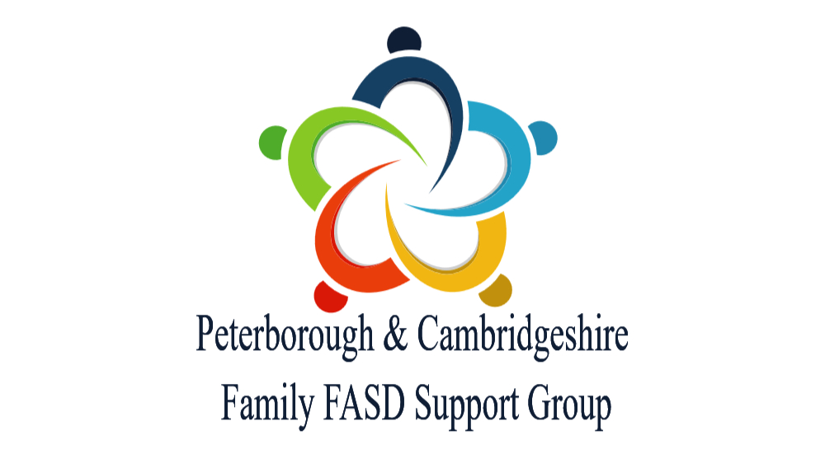
The Peterborough & Cambridgeshire Family FASD Support Group has been operating as a regional source of FASD support, information, advice and guidance for people with, or who may have FASD, and those who live with them for well over 15 years. We operate regionally with in the north of East Anglia and in the East Midlands. The support is not limited to the County and City, as other groups providing FASD support are still few and far between.
The group was founded by parents and carers of young people with FASD. We are an independent organisation with no formal connections to any local government or health organisations. We are members of the FASD UK Alliance and also work closely with the Hertfordshire FASD Support Group.
In addition to the support, information, advice and guidance, we also raise awareness of the risk of prenatal alcohol exposure and the implications of having FASD. This can extend to individual support for families navigating the local systems.
We will work with all organisations to improve the life changes of those with FASD, the quality of life for any type of families affected and to reduce the prevalence of FASD. We work closely with Cambridgeshire Pinpoint, Both the Virtual schools in Cambridgeshire & Peterborough, the Regional Adoption Agency and local SEND advocacy groups.
We are proud to have members who have FASD, who are birth parents, kinship carers, foster carers, special guardians and adopters.
Support Groups-
Our support groups are run specifically for those who live with children & young people who have or may have FASD. They are informal groups for anyone seeking mutual support, for people to get to know each other, build friendships, reduce isolation, ask questions, problem solve and share experiences in a supportive and non-judgemental environment.
Of course, many of our members have numerous roles, some being employed in local government or health bodies, but their attendance at support groups should be specifically as a person who lives with someone who has or who may have FASD.
Our monthly face-to-face support groups currently operate three locations Peterborough, Papworth Everard & Offord Cluny, but members can seek support remotely via the Facebook Page or by messaging us. Please see the fliers for each support group.
Facebook –
We run a private Facebook page which allows approved members to connect with over 140 local people with lived experience of FASD. Membership of the group is by application and like the support group should be supportive and non-judgemental.
A membership application can be found here – https://www.facebook.com/groups/1320037864718272/
Information, advice, guidance and support-
FASD is a confusing condition that many professionals still don’t understand. This can make getting the best for people with FASD quite difficult. Therefore, we will offer advice and guidance to individuals and families whenever the need arises. This can be either via remote meetings on the internet or in person. This also includes consolation with organisations around local children and people who have or may have FASD.
FASD UK Alliance-
We are a member of the FASD UK Alliance, a national closed group of independent FASD organisations with over 5,000 members in the UK. Again, the Alliance exists to support people with FASD, and families affected
An application for membership can be found here- https://fasd-uk.net/
Support for practitioners / lobbying organisations-
We will work with all organisations to raise awareness of FASD, promote best practice in supporting those with FASD and challenge where understanding and support falls short. It is therefore vital that we remain independent and every member feels they can express their views without fear of any repercussions.
We have worked with local MP’s (including the Health Secretary), the County & City Councils, the Virtual Schools, the Integrated Care Board, Pinpoint and Family Voice.
More recently training in education and social care and Cambridgeshire is undertaken by the Virtual Schools https://www.cambslearntogether.co.uk/cambridgeshire-school-improvement/cambridgeshire-virtual-school/training-and-resources
We can also provide nationally acclaimed training featuring local lived experience that is informed by the ‘Best Practice in FASD Training’ guidance for other organisations and for educational and social care organisations outside the County & City, who wish to find out more.
More information please contact –
Brian Roberts 07906 988992 fieldofenterprise@gmail.com
August 2026

