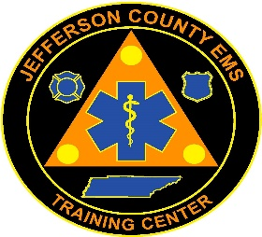
Jefferson County EMS Training Center
581 W. Old AJ Hwy
New Market, TN 37820
Telephone 865-471-9001
Fax 865-475-9458

Jefferson County EMS Training Center, in collaboration with Jefferson County EMS, will be hosting an Basic-Emergency Medical Technician (EMT) course. The EMT course will begin January 23, 2025. Classes will be held on Monday and Thursday evenings from 5:30 pm until 10 pm. Interested candidates should hold a current BLS certification.

Application packets can be found at www.jeffersoncountyemstc.com. Application packets include a lot of information and instructions, so please read the packet carefully and complete all documents as required. Completed application packets, including provided Medical Statements and Vaccination Records, should be returned in person to Rodney Satterfield at Jefferson County EMS Station 1, 581 W. Old AJ Hwy, New Market, TN 37820 no later than November 30, 2024, at 4 pm.

Once applications are processed, candidates will be required to take a written pre-test and participate in an advisory board interview, as well as pass a drug screen and background check. Interviews will be held on December 16, 2024, at the JCEMS address listed above and times will be scheduled once the applications are reviewed. Please make arrangements now to be available to attend the interview session, as it is mandatory for admission into the program.

Should you have any questions, feel free to contact Rodney Satterfield at rsatterfield@jeffersoncountytn.gov or by calling 865-471-9001.

Sincerely,

Rodney Satterfield, AAS, EMT-P IC
Education Program Director

