Exhibit 36
Geoff Blanche Masters by Research Experimental and Theoretical Electricity Physics
Objective
10/1/2020
The objective of the Masters Paper is to:
- Define the endothermic charge of an electric field as already observed in NASA experiment,
- Describe the total behaviour of the charge of the electric field,
- Write the equation for the endothermic electric effect field reaction
- Describe how this can be used to our advantage for renewable energy electricity generation.
Possible Project Title
- Investigation of the Endothermic Charge Characteristics of an Electric Field for Renewable Energy Generation experimenting with a Lithium Battery and inductor circuit.
- Using the endothermic charge region of an electric field as a renewable electricity energy Generator, by investigating how the charge characteristics of an electric field using a Lithium Battery and inductor circuit can be integrated in generation.
- Analysing the Endothermic Electric Effect of the Electric Field and how this can be used as a renewable energy source.

Theory
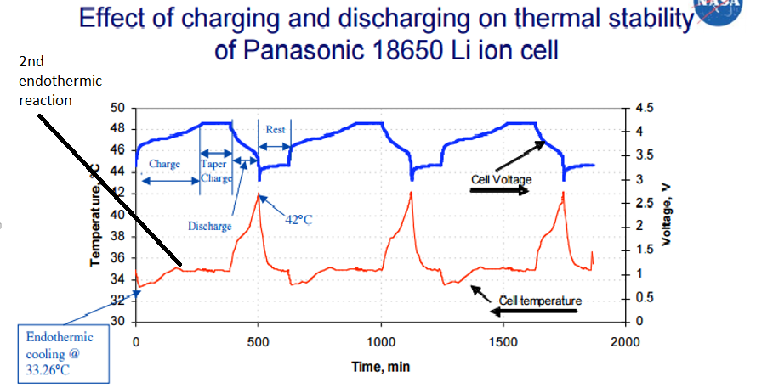
IMPORTANT NOTE TO READER
Just like the photoelectric effect, the endothermic reaction is a physical reaction that is seen in an electric field charge, and is parameter based. Although there CAN BE a chemical content in a battery, the ionisation of an atom is a physical reaction where, the electron leaves the metal atom to form the positive and negative electric field. Another point you can refer to is: on the NASA graph there is a 2nd endothermic reaction in the charge of the battery approximately 200minutes into the charge.
If it was a chemical reaction causing the endothermic reaction, this would take place when the activation force is placed on the system at the beginning of the charge and would then finish when all reactants are used up, and COULD NOT happen again further on in the charge AS SEEN IN GRAPH.
Lithium Batteries have an ionic voltage at room temperature even in the regarded discharged state, this is due to the photoelectric effect.
The investigation will be done by performing 2 experiments and researching available literature:
- Charging a lithium battery
- Building a circuit that remains endothermic during cycling by employing certain parameters.

Experiment 1

- Lithium Battery charger circuit For Gif 9800mAh 3.7 volt Lithium-ion Battery

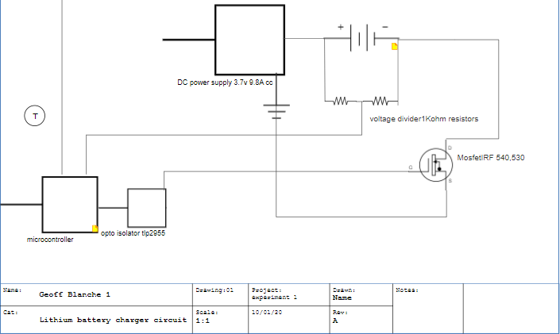

Circuit Parts
Mosfet 540 or 530
Microcontroller uno
Opto isolator TLP 2955
VDC Power Supply
Lithium Battery 3.7v 9800mAh
2 of 1Kohm resistors
Temperature sensors

Sample Arduino Code
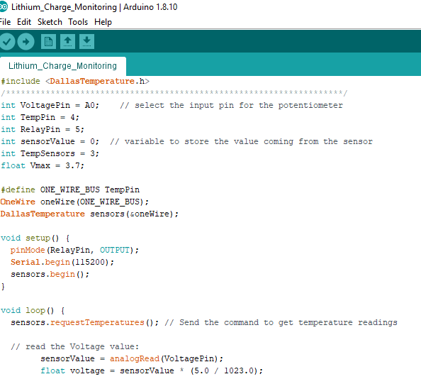

Requirements
- Lithium ion Battery 9800 mAh, constant current of 1C, C/2, constant voltage of 3.7V
- Data sheets required for Battery and Power Supply
- Build a circuit which includes a voltage divider, input to microcontroller to read rising voltage and measure temperature of battery during charge.
- Data collecting in a controlled environment for analysis of results.

Experiment 2

- Endothermic Electricity Circuit.
Aim of experiment is to distinguish between endothermic and exothermic reaction in the system. Physically observe reaction by sight, sound and temperature
Circuit Diagram
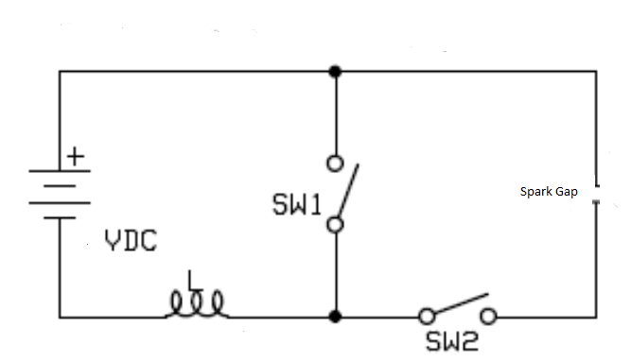

Circuit Parts
Mosfets 710,720 500v
Microcontroller uno
Opto isolator TLP 2955
VDC Power Supply
inductor
Temperature sensors

- Suitable switching Gear- Mosfets
- Microcontroller, software programmer, Adjustable frequency-milli to micro seconds
- Adjustable dc voltage and current supply to circuit
- Adjustable Spark Gap
- Large length of medium voltage coil 20,000 metres
Time Scale
 | January | February | March | April | May | June | July | August
Actions | Order circuit parts , Study data sheets | Assemble experiments circuitry and write program software | Undertake experiments | Collate data into results analysis | Conclusions | Write up masters to final draft. Proof Read.

