Dear Sir /Madam,
I see the University is strongly recommending to myself and my fellow students to enter into an experimental drug trial. There is no long-term safety data to this experimental drug but there is now short-term data of around 10 months since the rollout of this experimental drug by the Welsh Government and UK Government. You are now trying to coerce me and my fellow students with false claims. You are claiming this experimental drug is ‘SAFE AND EFFECTIVE. You are not reporting the facts and there is now data available for everyone to see (links below) This drug is dangerous, causing harm and death. In my opinion this is now academic misconduct, coercion to murder, and harassment. You are coercing students to enter into an unsafe experimental trial whilst claiming it is ‘SAFE AND EFFECTIVE’, which is a false claim. I strongly advise you actually give students the facts that are reported by the yellow card scheme immediately. This data should be shown on your website’s frontpage immediately. This will give my fellow students an informed choice on whether to enter into, or not to enter into this experimental drug trial. If you fail to do this, I will have no alternative but to report this crime and take direct action.
Source data:
www.gov.uk/government/publications/coronavirus-covid-19-vaccine-adverse-reactions/coronavirus-vaccine-summary-of-yellow-card-reporting#annex-1-vaccine-analysis-profile

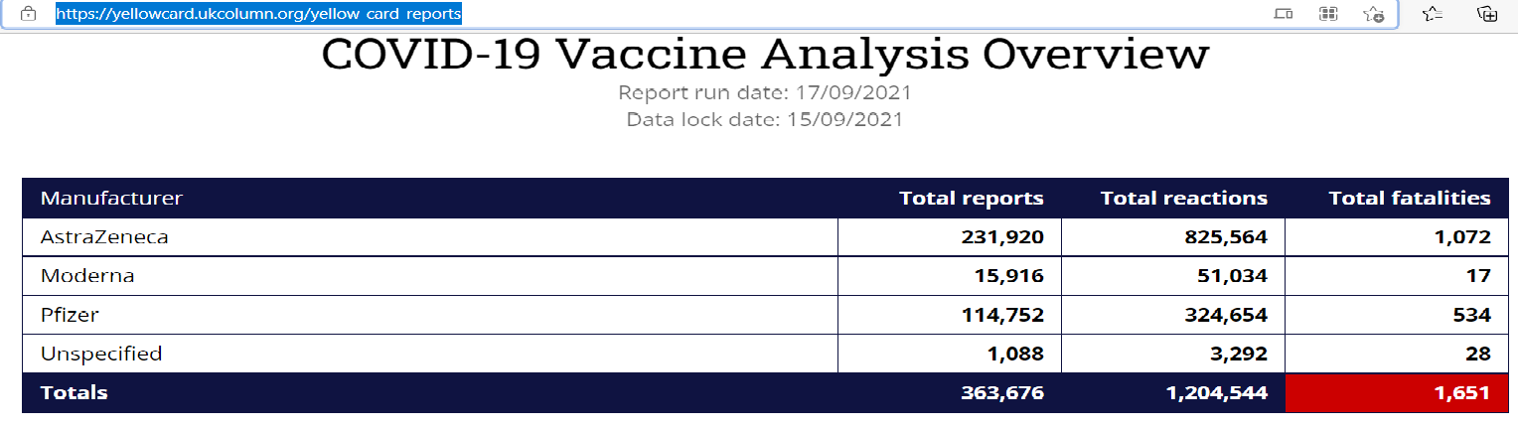
Regards
student 946484

