**REACH Project Narrative Summary Report**

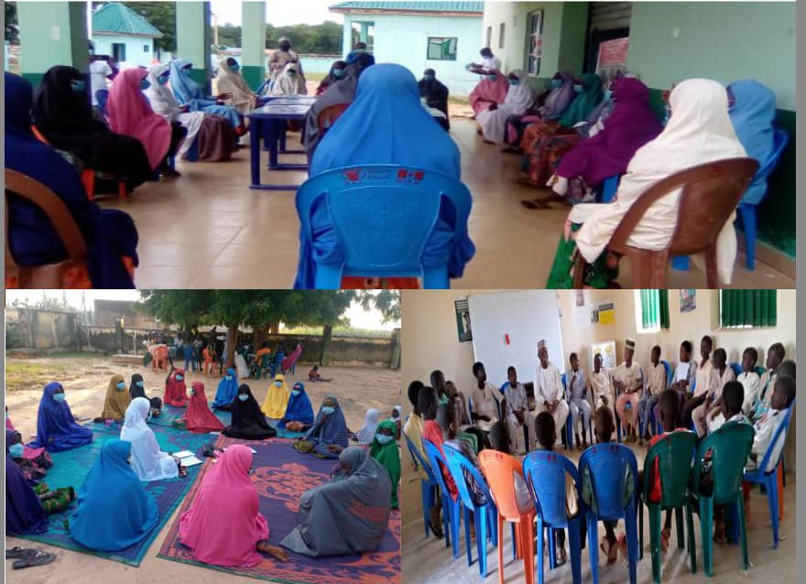

REACH Project:

Reaching and Empowering Adolescent to Make Informed Choices about their Health. October 2018 to August 2021

**ADOLESCENT SEXUAL REPRODUCTIVE HEALTH AND RIGHT ASRHR title as: REACH Project: Reaching and Empowering Adolescent to Make Informed Choices about their Health. October 2018 to August 2021**

**SMACI in partnership with Save the Children International Successfully Implemented a three years project Funded by Global affairs Canada REACH project, Reaching and empowering Adolescent to make inform choice about their health** the project targeted 22,400 adolescent 10-19years of age both male and female (married and unmarried) in the rural and hard to reach communities in Talata Mafara LGA of Zamfara state and **the following** **result: is achieved**

* Successfully completed and Delivered 22,863 targeted beneficiaries on choices and ASRH and life skills curriculum.
* Increase confidence of adolescent girls in delaying marriage till the age of 18 form 69% to 85%.
* Reduced early child marriage before the age of 15 from 41% to 54%.
* Increased the knowledge of adolescent girls for the importance of pregnancy safe spacing from 51% to 82%.
* Increase willingness of couple on joint decision making about SRH from 35% to 64%.
* Enrolled and retained 703 adolescents into school, 467 Girls and 236 boys.

REACH project use socio-ecological model and SEED model a holistic approach design for implementation of gender sensitive Sexual and reproductive health program. Aimed to Improved sexual and reproductive health of adolescent girls and boys (aged 10-19) in Gombe, Katsina and Zamfara states in Nigeria through the following objective:

* Improved access to high quality, gender-responsive and adolescent-friendly SRH services by unmarried and married adolescent girls and boys
* Improved decision making of married and unmarried adolescent girls to make inform decisions about their own SRH rights
* Improved integration of civil society contribution and evidence based best practices by local and international stakeholders in ASRHR policy design and implementation

The Key activities of REACH project included recruitment and training of facilitators, service providers, facilities health gender responsive infrastructure need assessment, consultation with adolescent, provision of equipment and sporting equipment, social norms exploitation survey, and weekly safe space sessions for Very Young and Older Adolescents for Married and Unmarried (10-19 years), community mobilization events, Quarterly Review Meetings, Advocacy visits, VOICES viewing sessions, PROMISES poster placing and unveiling, celebration of international days, coaching and mentoring of health workers, outreaches and outreach supervisions, feedback meeting with facilitators and adolescents, supportive supervisions, distribution of safe space materials and Technical Working Groups (TWG) meetings. So also some of the REACH Project core activities include Orientation of Facilitators on COVID-19 Preventive Measures and creation of awareness on COVID-19 to Adolescents and Community members, election, inauguration and training of children parliament, training of Change Agent, training of Religious and traditional leaders, Dissemination of REACH Mid Term review, training of CBOs on SGBV, REACH Close out event at LGAs, State and national level.

However, the project implementation comes with many challenges due to COVID-19 pandemic. This lead to reduction of adolescents in safe space group from 25 to 20, similarly, safe space session were suspended in some communities such as Gwaram, Ruwan Gizo, etc due to insecurity. The above mention activities were conducted for the progress of the project throughout the implementation period.

Despite the security challenges in some of the project communities and COVID-19 pandemic in year three of the project, the project has recorded a tremendous success with regards to number of adolescents enrolled and graduated from CHOICES and ASRH safe space. Cumulatively, from the project inception May, 2019 to August, 2021. Zamfara state established a total of **2,092** groups for both Choices and ASRH safe spaces **M: 936 F: 1156**). However, Zamfara state has so far graduated **45,120** adolescents (M: 20,470 F: 24,650)

**Beneficiaries**

The project direct and indirectly reached a total of 43,011 beneficiaries 33,500 adolescents and **9,511** adults – the detailed breakdown is as below.

|  |  |  |  |  |  |  |  |
| --- | --- | --- | --- | --- | --- | --- | --- |
| **Beneficiaries** | **Age Group 1 (Adolescent)** | | | **Age Group 2 (Adult)** | | | **Grand Total** |
|  | F | M | Total | F | M | Total |
| Unmarried girls and boys safe space sessions | 4,735 | 3,805 | 8,540 |  |  |  | 8,540 |
| Married Adolescents girls safe space sessions | 3,615 |  | 3,615 |  |  |  | 3,615 |
| Sessions conducted with partners of married Adolescent girls |  |  |  |  | 6,215 | 6,215 | 6,215 |
| Training of HWs on providers bias |  |  |  | 28 | 16 | 44 | 44 |
| Training of PPMVs on providers bias |  |  |  | 10 | 12 | 22 | 22 |
| Community mobilization event | 5,750 | 3,360 | 9,110 | 1270 | 1300 | 2,570 | 11,680 |
| Advocacy to village heads and religious leaders |  |  | 0 |  | 148 | 148 | 148 |
| Advocacy to other community members |  |  | 0 |  | 186 | 186 | 186 |
| Adolescent participants at community meetings | 450 | 550 | 1,000 |  |  |  | 1,000 |
| Adolescent consultation meeting | 180 | 120 | 300 |  | 20 | 20 | 320 |
| Adolescents that participated in the CHOICES activity | 6,300 | 4,475 | 10,775 |  |  |  | 10,775 |
| Training of Religious and Traditional leaders on Gender Norms and Equality |  |  | 0 | 126 | 60 | 186 | 186 |
| Training provided to change agent, religious and traditional leaders | 92 | 68 | 160 | 126 | 60 | 186 | 346 |
| **Total Beneficiaries** | **21,122** | **12,378** | 33,500 | **1,522** | **7,989** | **9,511** | 43,011 |

**Lessons learnt**

Below are some of the lessons learnt during REACH Project implementation in Zamfara State

1. Adolescents' participation in the safe spaces significantly improved their understanding of gender equality, equitable relationship, negotiation skills, sexual reproductive health, saving goals etc. The boys and girls who are engaged with the project now speak out against discriminations and confidently express their future hopes and aspirations to their parents as well as built their capacity on complaint and feedback mechanism (CRM).
2. Engagement of traditional and religious leaders to support and ensure effective community mobilization activities in various communities in the LGAs lead to a successful project implementation and sustainability. Stakeholder assured Save the Children international and CSO’s implementation partners of their commitment in project continuity after the closure.
3. Organizing sports competitions among adolescents promotes greater participation of girls in sports activities and increased joint event planning among boys and girls. Communities are also giving support to girls to express their abilities and realize their dreams.
4. Organizing sports competitions among adolescents promotes greater participation of girls in sports activities and increased joint event planning among boys and girls. Communities are also giving support to girls to express their abilities and realize their dreams
5. Engagement of Married Girls and their spouse on Gender equitable relationship will lead signicant increase the couple joint decision making around Social issues, Sexual Reproductive Health including the Use of contraceptive
6. Provision of gender responsive sexual reproductive services will significantly increase access and utilization of reproductive health services by adolescent.

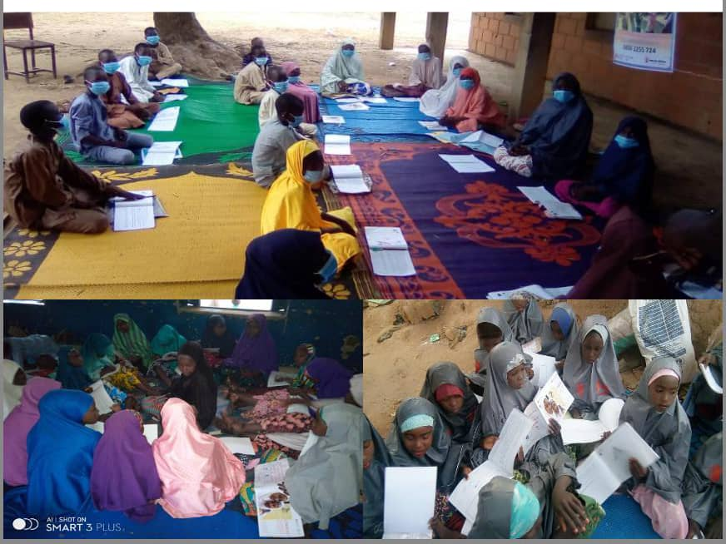

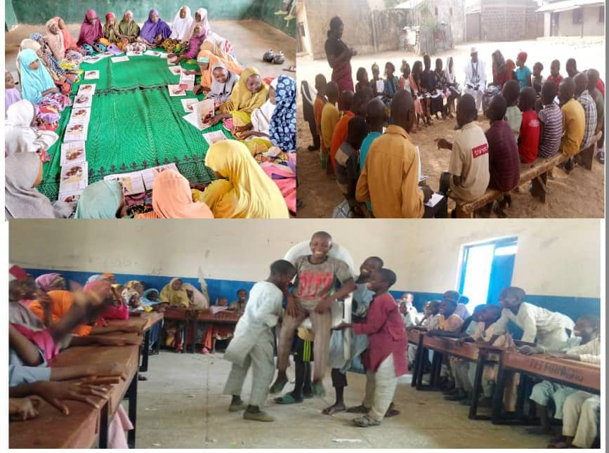

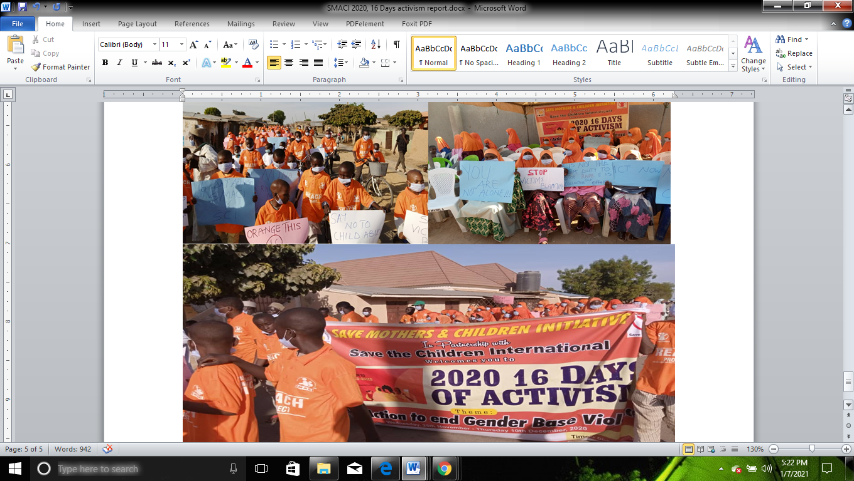

|  |  |
| --- | --- |
| **Implementer’s name and contact Information** | Save the Children International and Save Mothers and Children Initiative SMACI  No 26 Gura Filing Station, Gada Biyu Sokoto Road, Gusau Zamfara state |

**Program Managers** Name, Murtala Bellpo and Aminu Shehu

**Gratee Signature**  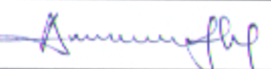

**Total Project Budget: 478.743** CAD (**148,410.340** NGN)

**Project start and end date: October 2018 to August 2021**

**State/Country** Zamfara Sate Nigeria

**Date Submitted**: 01-09-2021