4/11/2020

|  |
| --- |
| Overview and Practice | EJWoolaston |

|  |  |
| --- | --- |
| EXT | **FOUR APPROACHES To Reading Practices** |

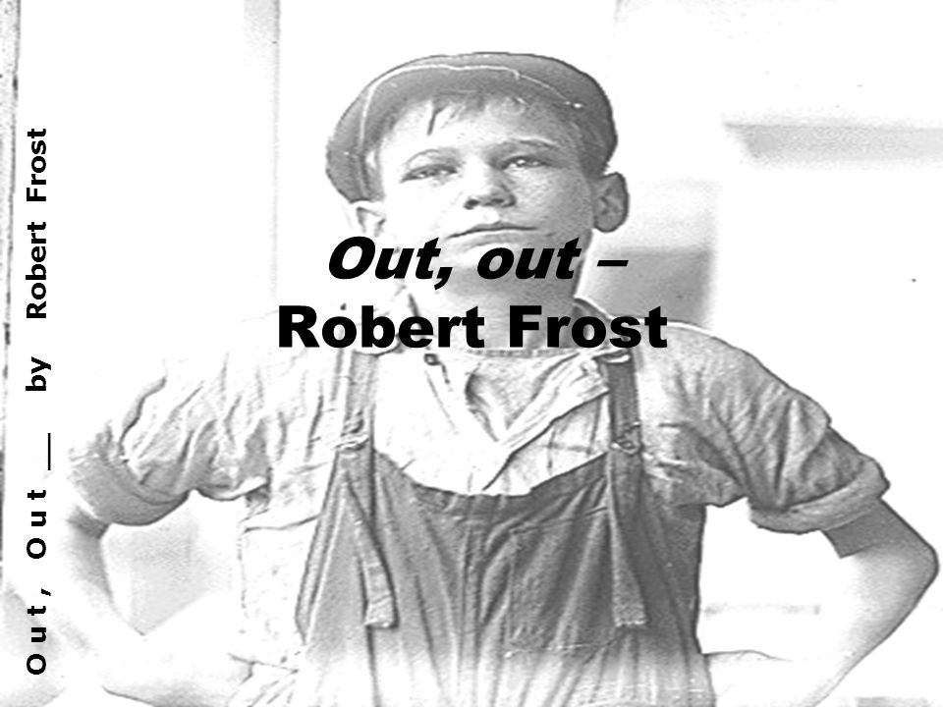

**Applying Elements of the Four Approaches to**

**Possible author-centred approaches**

Readers may consider possible influences on the author e.g.:

1. biographical details
2. news story
3. intertextuality: Macbeth’s famous soliloquy

**Relevant terms**

implied author

discourse

**Relevant theorist**

Foucault

**“Out, Out” by Robert Frost**

THE BUZZ-SAW snarled and rattled in the yard

And made dust and dropped stove-length sticks of wood,

Sweet-scented stuff when the breeze drew across it.

And from there those that lifted eyes could count

Five mountain ranges one behind the other *5*

Under the sunset far into Vermont.

And the saw snarled and rattled, snarled and rattled,

As it ran light, or had to bear a load.

And nothing happened: day was all but done.

Call it a day, I wish they might have said *10*

To please the boy by giving him the half hour

That a boy counts so much when saved from work.

His sister stood beside them in her apron

To tell them “Supper.” At the word, the saw,

As if to prove saws knew what supper meant, *15*

Leaped out at the boy’s hand, or seemed to leap—

He must have given the hand. However it was,

Neither refused the meeting. But the hand!

The boy’s first outcry was a rueful laugh,

As he swung toward them holding up the hand *20*

Half in appeal, but half as if to keep

The life from spilling. Then the boy saw all—

Since he was old enough to know, big boy

Doing a man’s work, though a child at heart—

He saw all spoiled. “Don’t let him cut my hand off— *25*

The doctor, when he comes. Don’t let him, sister!”

So. But the hand was gone already.

The doctor put him in the dark of ether.

He lay and puffed his lips out with his breath.

And then—the watcher at his pulse took fright. *30*

No one believed. They listened at his heart.

Little—less—nothing!—and that ended it.

No more to build on there. And they, since they

Were not the one dead, turned to their affairs.

**Robert Frost**

**Context**

Robert Lee Frost was born in San Francisco, and after his father’s death in 1885, he moved with his family to Lawrence, Massachusetts, where he became interested in reading and writing poetry while in high school. Frost attended Dartmouth College and Harvard University, but never received a degree. He was a jack of all trades, and had many different occupations after leaving school, including a teacher, a cobbler, and an editor of the local newspaper, the "Lawrence Sentinel". His first published poem was "My Butterfly: An Elegy" in the New York literary journal "The Independent" in 1894. A year later he married Elinor Miriam White, with whom he shared valedictorian honours with at his Massachusetts High School.

In the following years, he operated a farm in Derry, New Hampshire, and taught at Derry's Pinkerton Academy. In 1912, he sold his farm and moved his family to England, where he could devote himself entirely to his writing. His efforts to establish himself in England were immediately successful, and in 1913 he published "A Boy's Will", followed a year later by "North of Boston". It was in England where he met and was influenced by such poets at Rupert Brooke and Robert Graves, and where he established his life-long friendship with Ezra Pound, who helped to promote and publish his work.

Frost returned to the United States in 1915, and by the 1920's, he was the most celebrated poet in North America, and was granted four Pulitzer Prizes. Robert Frost lived and taught for many years in Massachusetts and Vermont, and died on January 29, 1963 in Boston.

**Newspaper article: LANCASTER NOV 18 -**

John R. Adams, 15, son of Mr and Mrs James Adams, Route 3, Riverton, died last Saturday evening as a result of injuries he received while operating a power saw on his parents’ farm.

The accident happened late Saturday afternoon while young Adams, his brother Stephen 12, and his father were sawing logs. Apparently the boy was momentarily distracted while feeding a piece of wood into the blade, which caught his hand and amputated it.

The youth’s sister, Mud, 17, was witness to the accident. She said that her mother had sent her to call her father and brothers to supper. The accident occurred, she said, just as she called out to them.

Mr Adams immediately drove to nearby Riverton for a doctor. He finally located Dr E.L. White and drove him back to the farm.

Dr White said that when he arrived the boy was already in shock from loss of blood and that it was impossible to save him. The cause of death was listed by the coroner as accidental.

Funeral services on Tuesday were held in Riverton Congregational Church, and internment was in Good Hope Cemetery.

**Intertextual connection**

The title of the poem is presented as a quotation. Many critics have suggested that the title comes from Shakespeare’s play *Macbeth*. Towards the end of the play, just as he is about to face his enemies in combat, Macbeth hears the news that his wife, the Queen, has been killed. The following is Macbeth’s response.

**Seyton:**

*The Queen, my lord, is dead.*

**MacBeth:**

*She should have died hereafter:*

*There would have been a time for such a word.*

*Tomorrow, and tomorrow and tomorrow*

*Creeps on this petty pace from day to day*

*To the last syllable of recorded time,*

*And all our yesterdays have lighted fools*

*The way to dusty death. Out, out, brief candle!*

*Life’s but a walking shadow, a poor player*

*That struts and frets his hour upon the stage*

*And then is heard no more. It is a tale*

*Told by an idiot, full of sound and fury*

*Signifying nothing.*

The last six linesof Macbeth’s speech contain a series of metaphors about life. Macbeth compares life to: a candle that burns out;a shadow; a poor actor who makes one brief appearance; and a pointless story, full of sound but without meaning.

**But we mustn’t forget the intentional fallacy and the ‘death of the author’. Texts take on a life of their own…**

**Possible Text Centred Approaches**

**Historical Text Centred Reading**

1. In what way is the malevolence of the buzz saw emphasised through Frost’s foregrounding of onomatopoeia, personification and alliteration? Provide examples of each.
2. In what way does the saw’s capacity to reduce forest trees to ‘sticks’ and ‘stuff’ foreshadow the events of the poem and contribute to a sense of foreboding? What other elements of the poem foreshadow the tragedy that is about to unfold?
3. Why does Frost contrast the noise of the buzz saw to the tranquillity of the mountain scenery?
4. “*And nothing happened: day was all but done*.” Are these words ominous or reassuring? Is a growing sense of foreboding now permeating the poem? What is the importance of the speaker’s use of ‘*but’* in “*day was all but done*”?
5. How has ‘meal imagery’ been used in the poem?
6. How is the repetition of the word ‘boy’ employed to position the reader to view the unfolding events?
7. In what way do the short sentences used to capture the boy’s death contribute to the drama of the poem?
8. What might the following symbolise: the setting sun, the buzz saw, the ‘five mountain ranges’, the boy.
9. Consider the binary oppositions at work in the poem, which assist in the production of an invited reading. E.g. life/death, work/leisure, cycles/a single event, nature/technology, permanence/impermanence. Others?

**Text – centred reading: arriving at the invited reading, becoming the implied reader**

1. Rank the following thematic possibilities (cross those out don’t apply at all):

* + The dangerous relationship between humans and machines
  + The hard work required of rural folk
  + Life’s cruelties, the pointlessness but inevitability of human suffering
  + The importance of moving on after catastrophic events
  + The indifference of most individuals to the suffering and death of others
  + The promise and optimism of youth
  + Humankind’s intellectual and emotional avoidance of confrontation with mortality
  + The unpredictability of life and of death
  + The role of fate and chance in our lives

**Possible Invited Reading**

|  |  |
| --- | --- |
| **Topic Sentence**  **Expand/explain**  **Substantiate**  **Quote**  **Analyse**  **Conclude** | ***The main idea privileged by Robert Frost in the poem “Out. Out…” is that in the midst of life, human beings must be willing to accept the inevitability of suffering and death and the need to “move on”.*** *Frost chooses the tragic death of a boy in a farm accident to demonstrate the unexpectedness of death. He sets the unfolding events against images of timeless nature, “five mountain ranges …. under the sunset”, in order to emphasise the fact that while human beings come and go, humanity itself lives on as part of nature. The mountainous setting symbolizes the permanence of nature, with its vast periods of time. This is contrasted to the brevity of the life of the boy who had “No more to build on there”. Those who are still living return to the affairs of the living. Rather than being callous, Frost represents these simple rural folk as pragmatic realists who recognize the necessity of overcoming adversity by ‘getting on with their lives”.* |

**Text–centred: An alternate reading of “Out, Out….” – as an exercise in horror/terror**

Robert Frost well deserves the epithet “poet of terror” as this poem privileges the idea that there are malevolent forces in the cosmos, which seek out a means of self-expression by disrupting human existence when least expected. The poem is an exercise in pure horror portraying the bleeding to death of a boy after a buzz-saw accident. It is based on the real life horror of the death of a young man who died of shock after lacerating his hand in a mechanical wood saw. The title refers both to the gushing of the victim’s life-blood from his injured hand and to the extinguishing of his life. The buzz saw is alive and rejoicing in its own malevolence from the very first line of the poem when it ‘snarled and rattled’. These onomatopoeic words both define the saw’s monstrous personality and it insatiable appetite. The implied metaphor of a vicious animal eating its fill is completed by the description of stove-length wood sticks of its excreta. The relatively calm atmosphere created through the description of the five mountain ranges only serves to intensify the enormity of what is to come.

Frost continues to develop horror conventions through the remainder of the poem. The tragic event occurs at day’s end, which may also symbolise the end of a life. In defiance of the fading light, the saw continues to devour the wood fed to it. The repetition of the onomatopoeic verbs ‘snarled’ and ‘rattled’ with their harsh ‘r’, ‘s’ and ‘t’ sounds add an additional sense of foreboding to the scene. This is further enhanced through the ominous “And nothing happened: day was all but done” with its foregrounding of the word ‘but’, signalling a false sense of relief. At the sister’s announcement of supper, the use of ‘meal imagery’ and the increasing personification of the saw, which “knew what supper meant”, suggest that the saw has reacted with instinctive and deliberate malice. It “leaped out at the boy’s hand” in a kind of supernatural, malicious act. The boy’s hysterical reaction further privileges the idea that the behaviour of the saw has been devilish and undeserved, with the repetition of the noun ‘boy’ increasing the direness of the event for the reader.

The reader continues to be held in thrall by the inexplicable and incomprehensible tragedy as the boy’s horror is replaced by disbelief. He saw “all spoiled” with the loss of a hand just as he is about to enter manhood. He cries out as a child might for adult help, “ Don’t let him cut my hand off –“ The word ‘so’ is powerful in its isolation and simplicity, heralding as it does the inevitability of what is to follow. The darkness of ether is ominous, foreshadowing the death to come. The boy presents a pitiful figure on his death-bed, a grotesque parody of the energetic young man he presumably once was. The ‘puffed’ lips are particularly ugly and the realisation of his passing comes with the stilted syntax and interrupted metre of “Little – less – nothing!” The last two lines have their own horror as the boy’s corpse is accorded little attention, “And they, since they were not the one dead, turned to their affairs”. Sawing, suppers, sunsets and life go on. Frost’s grizzly story about wood sawing well deserves a place in the horror genre.

(Adapted from Matthews, Frances Russell, Robert Frost, Pheonix Senior English Guides, Pheonix Education, Albert Park, 1999, p 59 ff.)

**A Reader-Centred Approach**

**Implied author**: The "author" that is inferred from or implied by the text, as distinct from the real person/author.

**Ideal reader**: Collaborates with the author in engaging with the text; accepts the values, beliefs and attitudes that are presented to create meaning.

1. Who is the implied author of the text?
2. Who is the implied or ideal reader of the text?
3. How has the point of view encouraged me to take up some characters perspectives more than others?
4. Do I identify with the characters?
5. Can I visualise images and symbols in the text?
6. Can I relate my own personal experiences to those in the text?
7. How does my present mood impact on my reading of this text?

**You could also read the poem resistantly from, say, a Marxist or a feminist perspective.**

**A World-Context Centred Approach**

**Marxism: A resistant reading of “Out, out…”**

Marxist criticism examines the role played by literature in maintaining values and beliefs, which support the ruling classes in society. Class refers to social divisions between groups of people. Populations may be divided on the basis of their birth, wealth, occupations, influence, values and so on. Class divisions are related to the beliefs and values of specific groups of people.

The German philosopher Karl Marx argues that the way people think and behave in any society is determined by basic economic factors. In his view, those groups of people who owned and controlled the major industries could exploit the rest of the population, first through conditions of employment, and second by forcing their own values and beliefs onto other social groups. Marxist criticism applies these arguments to the study of literary texts.

Marxist criticism might explore the way different classes of people are represented in texts in order to challenge oppressive beliefs and values which might be promoted. (See Moon, Brian, Literary Terms: A Practical Glossary, Chalkface Press, 2001, p82 ff.)

According to one Marxist critic, the characters in this poem are the victims of a society in which work is seen as being of the utmost importance. They are motivated chiefly by economic necessity. The poem suggests that there is a power structure in society, that there are those who are forced to work relentlessly for a living and those who do not. Some have time to enjoy the scenery, such as the narrating poet who observes the scene.

For others there is a clear division of labour – the boy who works past ‘knock off’ time, the ‘they’ who determine that the boy must keep working, the sister who inhabits the domestic sphere, the passive watcher at the deathbed, and the doctor who inspires fear in the boy. The family situation seems at first harmonious but it is then distorted by the demands of working and surviving a capitalist society.

**Reading resistantly**

1. Underline then write out all the lines in the poem which privilege the idea that work is important, that it dominates the lives of these working class people (identifying a sub-text). Provide your own explanation of each line.
2. Why is the loss of the boy’s hand ironic, given the dominance of the work ethic? What does the boy fear? What is your understanding of “no more to build on there”?
3. Is the doctor a symbol for the capitalist owner who has the boy at his mercy?
4. What evidence is there that this is a hierarchical society? How is labour divided? Who holds the most power? Who holds the least power?
5. How would you describe the family in the poem in terms of their social position?
6. Why do the characters turn so quickly to their affairs? What does the word ‘turned’ suggest? Are they callous and uncaring?
7. What might these people hope for from life? What do they fear?
8. In what way are the harsh socio-economic conditions of the 1930’s reflected in the poem?
9. Construct you own Marxist reading of “Out, out…” in a PEEL paragraph, using the information and questions above as a guide. Answer the question: *In what ways does the poem alert society to its neglected members?* in your paragraph.

**Four Approaches to Reading**

|  |  |  |  |
| --- | --- | --- | --- |
| **Author-centred** | **Text-centred** | **Reader-centred** | **World-context centred** |
| **author god** generates text: *auctores*, custodians of knowledge | New Criticism 1930s-1960s | **role of reader** in meaning making acknowledged 1960s | Whose **interests** are served by representations of the world in texts? |
| **name** guarantees quality, originality, individualism, creativity e.g. 19C Romantic movement | meaning found in **words on the page**, text autonomous | readers **relate to others’ experiences**, expand horizons | **Marxism\*** emphasises structural class-based inequalities |
| **gifted individual**, themes related to life, transcends culture, best moral values, aesthetic skills | text **stable** with ‘true’ meaning, disciplined, objective reading | led to growth pedagogy 1970s, 1980s | **Feminism\*** focuses on issues related to gender |
| **biographical information** assists interpretation - text reflects life and times of author | **closely examine** language and structure | encouraged **empathy** | **LATER**  post-colonial theory* and queer theory* |
| particular **language choices** may be typical of author | **focus on** figurative language including symbolism | **meaning not fixed** | **cultural materialism\***  **new historicism\*** both grew out of Marxist theory |
| **textual features** may reflect author’s intentions/visions,  author interprets their world and times | **lit to resolve** moral, psychological and spiritual dilemmas e.g. dualities: love/hate, thought/feeling, | **LATER**  recognize cultural experience reader brings to text | feminists develop different emphases e.g. **French*, Anglo-American*, black, queer\***… |
| **LATER**  **intentional fallacy** – author’s stated purpose cannot determine all legitimate readings, one reading among others | all parts of text work together to create **harmonious whole** | meaning **continually renegotiated** | common assumption is that societies are profoundly **inequitable** as a result of structural inequalities |
| **biographies**etc. open to interpretation, partial, biased etc.  not possible to read author’s life directly off text – trace instead trace competing **discourses** | **Structuralism\*** another historical approach, **Saussure*, genre studies*, intertextuality*, narratology\***: explore recurrent patterns and motifs, ‘universal’ narrative structures. | texts are received differently by readers at different historical moments - **horizon of expectations**\* (Jauss 1982) | In any society particular **social groups and their values may prevail** at a particular time |
| **implied author** – imagined figure, different to historical writer | **semiotic analysis\*** – system of signs | **Implied reader, invited reading, alternative reading, resistant reading\*** | readers either **negotiate with or resist\*** discourses and ideologies in texts. |
| **death of author** (Barthes 1978) – multiple readings possible | **LATER - poststructuralists\***  incoherences, contradictions, disunities in texts | readers fill **gaps\*** drawing on prior knowledge | all texts are partial - biased |
|  | **‘harass’ the text** to make it conceal what it tries to conceal | multiple readings | **silences\*** |
|  | **gaps, silences, contradictions, binary oppositions\*** (privileged half, not dualism), **semiotics** – used as social/political activity | **interpretive communities**\* Fish 1980 | **political consequences** to accepting particular views of the world as being natural |
|  | no single, fixed meaning;  **discourse, ideology** important |  | **close analysis of texts:** **gaps*, silences*, binary oppositions*, myth*, semiotics\*** etc. |

**Theorists pose question of texts, develop terms and concepts and apply a myriad of reading strategies. There is a high degree of overlap between theories and the strategies employed.**