**IA 2 Complex Transformation and Defence: Introductory Lessons**

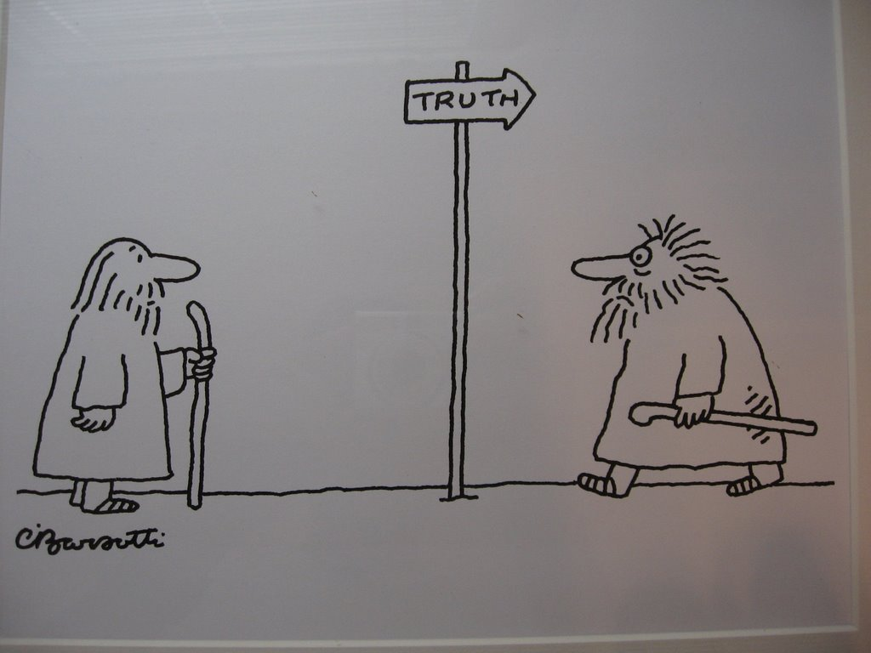

**The problem: All texts are deliberate constructions……. composed in a par**

**ticular cultural, social and historical context …… they will reflect a certain world view or version of reality, conveying a particular set of assumptions, attitudes, and messages which may be understood as the ideology of the text …….**

**What kinds of literary texts might now be deemed to be socially unjust in terms of race, gender and class which were previously viewed as realistic, unproblematic depictions of social interactions, as being ‘*just the way things* are’?**

**What if you find yourself disagreeing with the invited reading of the text because you have noticed that the ideology underpinning the text is racist, sexist or classist? What could you do to rectify the perceived injustice? How could you re-write the text in order to position your reader differently?**

**What text have you chosen to transform? Why? How did you transform it? Why? What problems did you encounter? What was the result? Was the end result socially just?TEXTUAL INTERVENTION**

**Pre-reading:** Hourihan, M (1997) *Deconstructing the Hero*, Routledge, London. Introduction, Chapters 1 and 2, 5

What if?

**TEXT 1**: View **the beginning** of a brief video of a peak hour rush at a busy city railway station at <http://www.youtube.com/watch?v=7EYAUazLI9k>

1. What do you think is happening, where and to whom?
2. What is your ‘preferred way of seeing’ or ‘invited reading’ of this text?
   * Who or what is the focal point of the text?

**Text-centred**

**approaches to reading**

* + How do the human participants relate to the viewer and to one another?
  + How do facial expression, dress and body language help construct meaning?
  + How do the symbolic objects help construct meaning/s?
  + How does the setting help construct meaning/s?

Discourse: A form of language that is related to particular social institutions and practices. (See Moon for further information.)

Ideologies: Systems of thought and action: world views, beliefs, values, attitudes.

See Moon p71-72.

* + How do camera angle and shot type contribute to the meaning making process?
  + What **kinds of dominant discourse/s** are mobilised in the text?
  + What values/attitudes/**ideologies** underpin these discourses?
  + Whose interests does this text support?
  + **How might you change the discourse in order to read the text resistantly and to reposition readers?**

1. Watch as the discourses operating in the text change as the entertainment begins. Reconsider the questions above.
2. What is the alternative **discourse,** which is present by the end of the video? What values/attitudes/**ideologies** underpin this discourse? Whose interests does this text support?
3. How might the discourses have been further altered to cause change for the better? Think in terms of race, class or gender.

**Introductory Activity: Textual Intervention – Visual Text 2 (See below)**

John Bracks

*“Collins Street”*

John Bracks

*“Collins Street”*

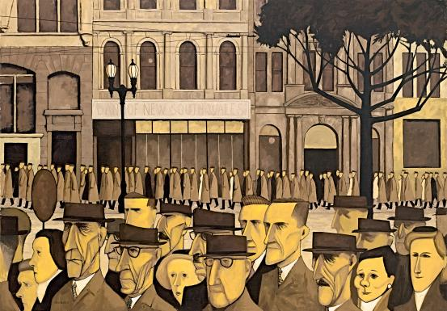

What if?

1. What do you think is happening, where and to whom?
2. What is your ‘preferred way of seeing’ or ‘invited reading’ of this text?
   1. Who or what is the focal point of the text?

Text-centred

approaches to reading….

* 1. How does the human participant relate to the viewer?
  2. How do facial expression, dress and body language help construct meaning?
  3. How do the symbolic objects help construct meaning/s?
  4. How does the setting help construct meaning/s?

Discourse: A form of language that is related to particular social institutions and practices. (See Moon for further information.)

Ideologies: Systems of thought and action: world views, beliefs, values, attitudes.

See Moon p71-72.

* 1. How do camera angle and shot type contribute to the meaning making process?
  2. What kinds of discourse/s are mobilised in the text?
  3. Where would you expect to find this visual?
  4. Can the text be categorised according to genre?

1. Add a heading/title or caption to the visual, which enhances your invited reading of it. Explain why you chose those particular word choices.
2. What kinds of values and attitudes are reflected in your word choices?
3. Now add a heading/title or caption which is more outrageous and/or playful.

Reading across and against the text…

* What is your reading of the text now?
* How has it changed from the previous invited reading?
* Has the function/genre/purpose of the text changed?
* Have the values and attitudes underpinning the text changed?
* Have you constructed an alternate or resistant reading of the base text?

1. What kind of subtle change could you make to the visual in order to enhance or alter meaning?
2. How might a more outrageous intervention change meaning?
3. Are you able to alter elements of the text to achieve a discursive shift or shifts? I.e. Change the discourse operating in the text?

**TEXTUAL INTERVENTION**

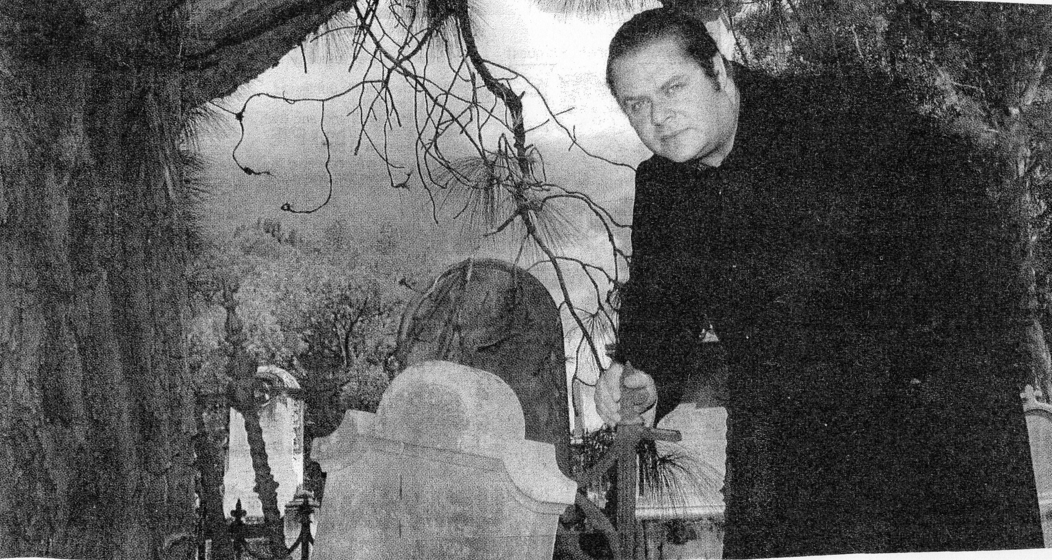

**View ppt Introtransformations.**

**Key Questions:** What is a complex transformation of text and how do you defend a complex transformation?

Discourse: A form of language that is related to particular social institutions and practices. (See Moon for further information.)

Ideologies: Systems of thought and action: world views, beliefs, values, attitudes.

See Moon p71-72.

STEPS in inventing a more socially just text and then defending your complex transformation:

1. Read the text using appropriate reading practices that help to produce an invited reading (reading with the text). Construct an invited reading in about ten (10) lines of writing.
2. Identify the range of discourses and ideologies that are promoted in the text, and consider any you might wish to challenge or oppose. Choose a theoretical position from which to oppose this ideology. E.g. feminist or Marxist or post-colonial theory or eco-critical theory.
3. Consider what resistant reading you might want your transformed text to invite. This decision will be informed by your choice of theoretical stance. What aspects of the base text will be the ‘launching pad’ for the complex transformation?
4. Intervene in the form of a complex transformation to produce this new invited reading of the text. Discursive shifts are brought about in part by changes to the structural and textual features of the focal text. For example, you will need to make decisions about changing or retaining some of the following, depending on the reading you want your transformed text to invite.

*Genre *Subject matter *Roles and relationships *Point of view *Structure/s *Mode and medium

1. Explain how you applied the theoretical approaches in the intervention in the text, or part of the text.
2. Evaluate how the rewritten text offers readers an alternative position.

**Key concepts:**

1. **Re-positioning:** The re-writer (you) opposes and re-writes the base text so that readers of the base text are *re-positioned* by the transformed text to make an oppositional reading of the base text. E.g. when you viewed the flash mob singing and dancing in the railway station you were almost unconsciously repositioned to critique the economic discourses and capitalistic ideology of the base text and to embrace the joyous spontaneity of the musical text and its underpinning values.
2. **Reading resistantly or against the grain of the text.** (It is not good enough to produce an alternative reading. Go for a ‘Full Monty’ resistant reading!)

You need to recognize the **invited reading** of the base text before you can uncover the **gaps,** **incoherencies** and **silences** and then read against the text.

1. **Binary oppositions** have a critical role in highlighting contested discursive positions (injustices mainly pertaining to race, class and gender) in the text. E.g. the *passivity* of the princess who lives *inside* a castleis in opposition to the *activity* of the prince who operates *outside*. Feminists would object to the gender stereotypes and erroneous assumptions inherent in these representations. A useful starting point when deconstructing a text is to look for the patterns of binary oppositions in the text in order to determine which aspect of the binary is dominant/privileged and which is marginalised. The opposing binaries are woven into the structural, literary and sometimes visual elements of the text and support one ideology more strongly than another.

Suggested texts:

* Kubla Khan
* Rime of Ancient Mariner
* Superhero comic
* Enid Blyton story
* Blinky Bill
* Dot and the Kangaroo

1. **Subversion is not inversion -** A simple privileging of the other side of the binary is known as a ‘flip’ or inversion. This is where the positions of the marginalised and privileged parts of the pairing are simply reversed. E.g. the princess becomes brave and daring whilst the prince is a duffer. Here the female takes on the attributes of the male and so is empowered at the expense of the male. The original qualities of the binary or dualism are the same; it’s just that a different group is in a position of power. The basis for power remains unquestioned and unchallenged; it is actually reinforced. The discourse remains the same thus there is NO DISCURSIVE SHIFT. You need to **subvert** the ideology of the base text by CHANGING THE DISCOURSE. These inversions retain the same binaries but shift the locus of power; the cultural assumptions regarding the basis of power remain uncontested and they are both simplistic and **not socially responsible nor just**.
2. **Textual ideology –** This is the world view, cultural assumptions, beliefs and values that the text as a whole promotes and invites the reader to endorse. E.g. Fairy tales present a simple beauty/ugly binary which invites the reader to unproblematically endorse the sexist assumption that only those who are beautiful are deserving of a man’s love.
3. **Discourses –** These are ways of being (thinking, valuing, speaking, behaving) mobilized by the characters within particular contexts. E.g. You could think in terms of race, class and gender discourses or more broadly of religious, economic, political, environmental, educational, legal, business, family, medical ……. discourses. You will need to completely change the discourse in your base text (discursive shift). For instance, a romantic fairy tale in which gender/romantic discourses dominate could become a psychiatrist’s report (medical discourse) or a political speech (political discourse).

**Draw up a Frayer Model in order to consolidate your understanding of each of these key terms: discourse, ideology and subversion.**

|  |  |
| --- | --- |
| **Definition** | **Characteristics/further information** |
| **Example** | **Non-example** |

**Visual Text**

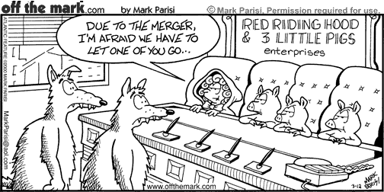

**“*The Three Little Pigs*” – to consider:**

**Tell the story of the “Three Little Pigs” – each student contributes one element of narrative structure**

* Discourses mobilized in original tale?
* Ideology underpinning original tale?
* Is discourse/ideology in each cartoon different from that in original tale?
* In which transformed text have the binaries (and therefore the power structure) simply been switched?
* Is each transformed text more socially just than the base or initialising text?

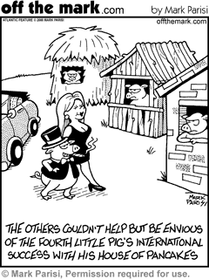

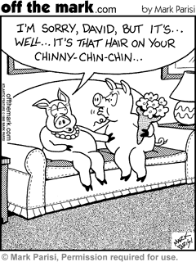



**Visual Text**  Corporate Slogan reads: *The lion goes from strength to strength; Logo is a lion.*

*Also: Peugot 205. Love It.*

Woman and car both in bright red; field light yellow; sky vivid blue.

**Textual Intervention:**

1. What is the purpose of this text? Who is the intended audience?

**Text-centred**

**approaches to reading**

1. What is the invited reading of this text?
2. What discourses are mobilised in the text?
3. What language features and visual elements contributed to you construction of this invited meaning? For example, what is the meaning and effect of the camera, body language, the landscape, the colours, the logo, the slogan, the camera angle and shot type?
4. What values and attitudes underpin the text?
5. What if the text were different? Intervene in the text in some way so as to ‘recentre it’, thereby deflecting and redirecting its ‘dominant’ ways of saying. Aim to make two interventions: one subtle; the other outrageous. Deliberately put it ‘off balance’ and alter its emphasis. Do not be afraid to experiment.
6. Why did you make that particular intervention? What preferences does it imply or assert? What other options did you consider but then reject? Why did you reject alternative interventions?
7. Consider what light these changes throw on the structures, meanings, values/ideology and functions of the base text.
8. Discuss and compare the changes you generated with those generated by other people. Be prepared to recognise other ‘points of entry’ and other points of view.

**HOMEWORK:** Read Pope, Rob (2004) *Textual Intervention: Critical and Creative Strategies for Literary Studies*, Routledge, London. P 1-14

and

Johnson, Greer “Understanding textual intervention: from reading to writing practices” English in Australia 132

**View Pope and Johnson Textual Intervention PowerPoints.**