# MYTH: Ideology is closely allied to the concept of myth. Roland Barthes used this term in *Mythologies* to describe the way certain stories and images function to shape our perception of reality. For Barthes, myths are omnipresent signs, which impose upon us the belief that something simply ‘goes without saying’; they create a perception of the falsely obvious. (Hourihan p 12)

# In modern literary and cultural study, myth refers to a shared way of understanding the world that is activated through representations in texts. This kind of myth is related to the signs and categories through which a community view the world, so that knowing the myth is part of what it means to be a member of the culture.

# Many aspects of cultural life are understood through myth. Motherhood, for example, is a powerfully mythologised cultural role. Representations of motherhood in texts often activate ideas to do with nurturing, self-sacrifice, gentleness, femininity, purity, domesticity and more. So powerful is the myth that many mothers suffer badly in comparison with the mythic representation; they fell pressured to live up to the myth, as if the myth itself were some kind of truth or standard, rather than being a cultural construction. The same can be true for myths of fatherhood, myths of boys and girls, myths of the city and country, myths of work and so on. How do little girls live up to the beauty myth perpetuated by representations of princesses in fairy tales? How do they react to myths about what it means to be feminine, which is to be passive and subordinate to the masculine?

A myth is a textual representation of a shared understanding about the world. The mythic level of meaning in a text is not a single idea or topic; it is a pre-packaged set of beliefs and practices that seem natural and obvious to members of a culture. Texts use combinations of signs (words or images taken from the culture) to invite readers to ‘activate or recognize the myth. For example, “Once there was a dear little girl whom every one loved” activates myths of childhood and girls – innocence, virtue, honesty, love, and beauty. Angela Carter deconstructs this myth of innocence and virtue when she has her girl willingly sleep with the wolf.

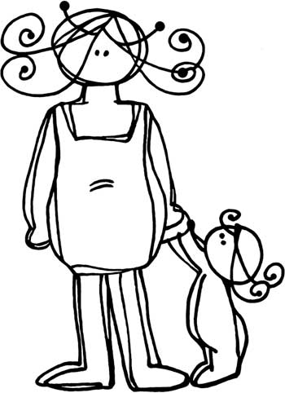 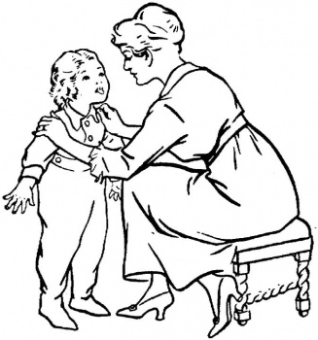 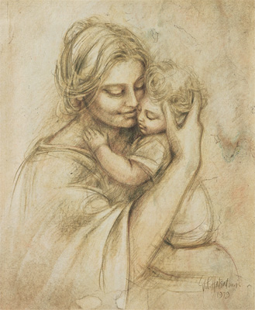 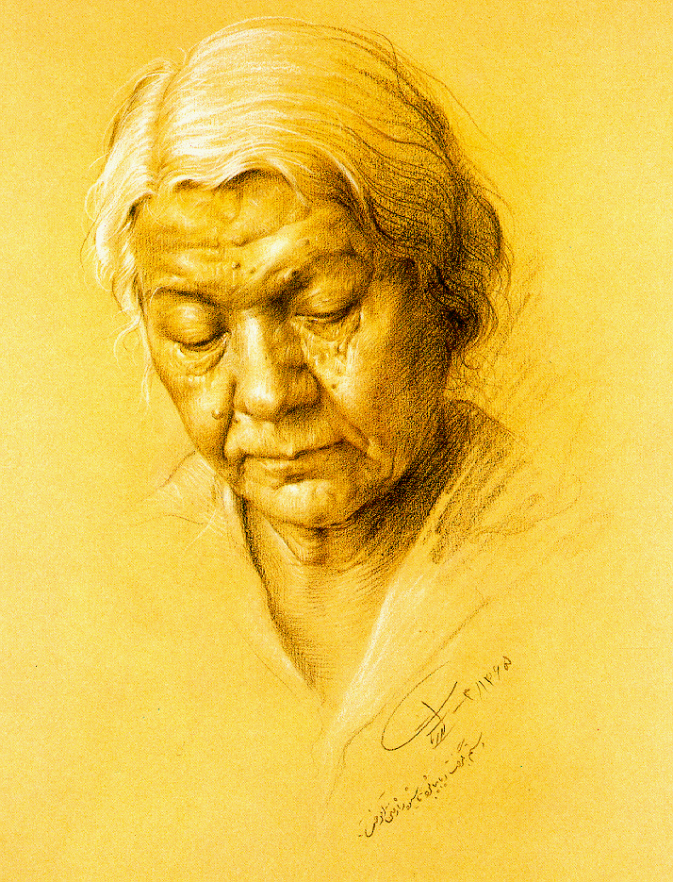

**SIGNIFIER AND SIGNIFIED:** To explain how myth works Barthes uses the linguist Saussure’s concept of the sign. Saussure calls a written symbol (e.g. wolf) a signifier; the signifier evokes a concept, the signified (the reader’s mental idea of a wolf). Therefore, the word, or sign, consists of the signifier and the signified. The crucial point is that the signifier (wolf) does not relate to anything in the physical world (any actual animal); it relates to a mental concept which may involve any number of emotional associations. In the case of the ‘wolf’ these associations might include ‘dangerous’, ‘slavering’, ‘predatory’, ‘shaggy’, “huge fangs’, ‘blood-thirsty’ and so on – all the ascriptions which have led to the persecution and extermination of the wolf in many parts of the world, despite the extreme rarity of actual wolf attacks on humans. What kinds of associations do we have for signifiers such as dragon, witch, princess, ogre, servant etc? What cultural roles does each fulfill? What kinds of ideas are activated through their representations in fairy tales?

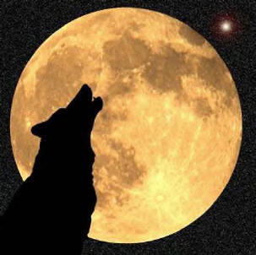 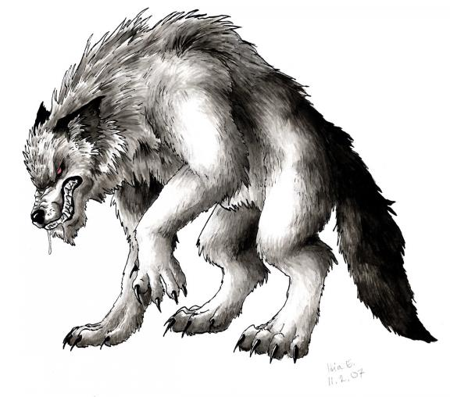  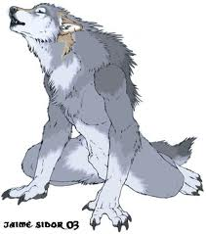

# 

# From: Hourihan, Margery, 1997, *Deconstructing the Hero*, Routledge, London

# For more detail on myth see Moon, B (2001) *Literary Terms*, Chalkface Press, Cottesloe p. 87.

**INTERNET** **SOURCES:**

Myth: Barthes argues that the orders of signification called denotation and connotation combine to produce ideology in the form of myth …… myths operate through codes and serve the ideological function of naturalization.

(Comment: e.g. myth of motherhood, of childhood, of crocodile, of the noble savage, of hunting and gathering)

At: <http://www.aber.ac.uk/media/Documents/S4B/sem-gloss.html#M>

The myth of the Noble Savage is anthropology’s oldest and most successful hoax, still widely believed today, almost a century and a half since its creation. As it is commonly understood, the myth makes the false claim that savages are noble, a misrepresentation arising from Rousseau’s invention of the Noble Savage concept in the mid-18th century as a romantic glorification of savage life.

At <http://faculty.washington.edu/ellingsn/Noble_Savage.html>

The Noble Savage is not a person, but an idea. It is cultural primitivism, the belief of people living in complex and evolved societies that the simple and primitive life is better. The Noble Savage is the myth that man can live in harmony with nature, that technology is destructive and that we would all be happier in a more primitive state.

Before Christ lived, the Noble Savage was known to the Hebrews as the Garden of Eden. The Greeks called it the lost Golden Age. In all the ages of the world, otherwise intelligent and learned persons have fallen swoon to the strange appeal of cultural primitivism. In the 16th century, French writer Michel de Montaigne described Americans Indians as so morally pure they had no words in their languages for lying, treachery, avarice and envy. And Montaigne portrayed the primitive life as so idyllic that American Indians did not have to work, but could spend the whole day dancing.

In 1755, Jean-Jacques Rousseau argued that what appeared to be human progress was in fact decay. The best condition for human beings to live in, according to Rousseau, was the “pure state of nature” in which savages existed. When men lived as hunters and gatherers, they were “free, healthy, honest and happy.” The downfall of man occurred when people started to live in cities, acquire private property and practice agriculture and metallurgy. The acquisition of private property resulted in inequality, aroused the vice of envy and led to perpetual conflict and unceasing warfare.

According to Rousseau, civilization itself was the scourge of humanity. Rousseau went so far as to make the astonishing claim that the source of all human misery was what he termed our “faculty of improvement,” or the use of our minds to improve the human condition.

Since Rousseau wrote, more than 250 years of archeological and ethnographic research have shown that most of the imaginative conceptions associated with the Noble Savage are simply wrong.

<http://www.edmondsun.com/opinion/local_story_333222711.html?keyword=topstory>

**The Concept of Myth**

Myths confer a "common significance or unconscious formulations which are the work of minds, societies and civilizations" .

……'myth' as recurring themes, icons and stereotypes which claim common recognition within a cultural group with a shared ideology……………. Ideology we define as the grid of significations which organises myths in the legitimation of particular social, economic and political relations.

Barthes argues that what makes myth definitive is its formal characteristics. Myth is an utterance without an utterer. The absence of the person who speaks gives the myth the quality of a statement of eternal fact, truth, obviousness, naturalness, common sense, rightness, reasonableness, already-thereness -- it just needs to be named ... by anyone, hence the apparent `objectivity' of myth….

………..The successful operation of myth lies in its apparent lack of construction -- its innocence.

At: <http://ccms.ukzn.ac.za/index.php?option=com_content&task=view&id=625&Itemid=72>

**Signification.** For Saussure, the relationship of a sign or sign system to its referential reality. Barthes makes much more of the concept, and uses it to refer to the way that signs work in a culture: he adds the dimension of cultural values to Saussure's use of the tern. Barthes identifies two orders of signification: the first is that of denotation (which is what Saussure calls 'signification'), the second is that of connotation and myth and occurs when the first order meanings of the sign meet the values and established discourses of the culture.

The **first order of signification: denotation**. This refers to the simple or literal relationship of a sign to its referent. It assumes that this relationship is objective and value-free—for all their differences, the words 'horse', 'steed' and 'nag' all denote the same animal. The mechanical/chemical action of a camera in producing an image of what it is pointed at is denotation. The concept is generally of use only for analytical purposes; in practice there is no such thing as an objective, value-free order of signification except in such highly specialized languages as that of mathematics: 4 + 8 = 12 is a purely denotative statement.

The **second order of signification: connotation**. This occurs when the denotative meaning of the sign is made to stand for the value-system of the culture or the person using it. It then produces associative, expressive, attitudinal or evaluative shades of meaning.

The second order of signification: myth. Barthes's rather specialized use of the term myth refers to a chain of concepts widely accepted throughout a culture, by which its members conceptualize or understand a particular topic or part of their social experience. Thus our myth of the countryside, for example, consists of a chain of concepts such as it is good, it is natural, it is spiritually refreshing, it is peaceful, it is beautiful, it is a place for leisure and recuperation. Conversely, our myth of the city contains concepts such as unnaturalness, constriction, work, tension, stress. These myths are arbitrary with respect to their referents, and culture-specific. In the eighteenth century, for example, the city was mythologized as good, civllized, urbane, polite; the countryside as bad, uncivilized, rude. A typical twentieth-century advertisement shows a happy family picnicking in a meadow beside a stream, with their car parked in the background. The mother is preparing the meal, the father and son are kicking a football, and the daughter is picking flowers. The ad acts as a trigger to activate our myths of countryside, family, sex roles, work-and-leisure, and so on. To understand this ad we must bring to it our 'ways of conceptualizing' these topics (or our myths): if we do not have these myths, the ad will mean something different to us, or may not mean very much at all. The term myth, then, is not to be used in the layperson's sense of a 'false belief', but in the anthropological sense of a culture's way of conceptualizing an abstract topic'. Myths are conceptual and operate on the plane of the signified; connotations are evaluative, emotive and operate on the plane of the signifier.

**Signification and ideology:** the third order. Fiske and Hartley (1978) suggest that the connotations and myths of a culture are the manifest signs of its ideology. The way that the varied connotations and myths fit together to form a coherent pattern or sense of wholeness, that is, the way they 'make sense', is evidence of an underlying invisible, organizing principle—ideology.