**Part 1 – Planning the Reading (kindly provided by Tony Cuppit BGGS)**

I have decided on a reader-centred reading and defence, because I think that will be easier to write, will have more theoretical material to draw from, and is closer in style and tone to other work that I have written in English. In short, I’d be mad to choose the other option.

I have selected the iconic MCU (that’s the Marvel Cinematic Universe, for any philistines who did not already know this) film *Black Panther* (2018) for several reasons, mostly related to aspects of reader-response theories:

1. While I have seen the film before, it is some time since I last watched it. Therefore, I am prepared for my responses to have changed
2. Having seen the film when it was first released, it is now part of my store of experiences. So too, are the many events associated with the Black Lives Matter movement, since the release of this film
3. I am a fan of the MCU, and collected Marvel comics when I was much younger. There is a possibility to explore the film as part of this interpretive community
4. I can refer to both the technical aspects of the film and my personal responses to the film (efferent and aesthetic readings, respectively)
5. I have watched the film several times, so I can talk about the way my expectations shifted from one viewing to the next (horizon of expectations)
6. The tragic passing of Chadwick Boseman is still raw. I expect a strong emotional response when I sit down to watch the film again. I can explore both my response, and my expectation of it, through reader-response theory

There is potential to refer to Rosenblatt, Iser, Jauss, Fish, Bleich and Holland in my defence. I must be careful not to refer to any theories or theorists in the reading. I am doing this planning now, because I know I will need to include things in my reading, which I can refer to in my defence. In other words, I needs to produce a **theoretically defensible reading**, by ensuring the relevant theoretical approaches are at the forefront of my thinking as I construct my reading.

It is the lens through which I am watching the film; when I use this interpretive lens, I describe the film, not the lens.

**Reading** = produce valid interpretations

**Defence** = demonstrate understanding of how theory was applied (including similarities and differences); evaluate the effectiveness of these theories in explaining my interpretations

So my reading will be all about the feels. It is a reader-centred reading, so I am referring explicitly to the film, but I am using it to talk about myself; at the same time, I am using myself to talk about the film. This produces my own personal and unique response. This is obviously going to be in first person.

Then, in my defence, I imagine the troop of reader-response theorists (Rosenblatt, Iser, Jauss, Fish, Bleich and Holland) sitting around a table, discussing my reading. They are arguing about how to explain my reading. This may be in first or third person.

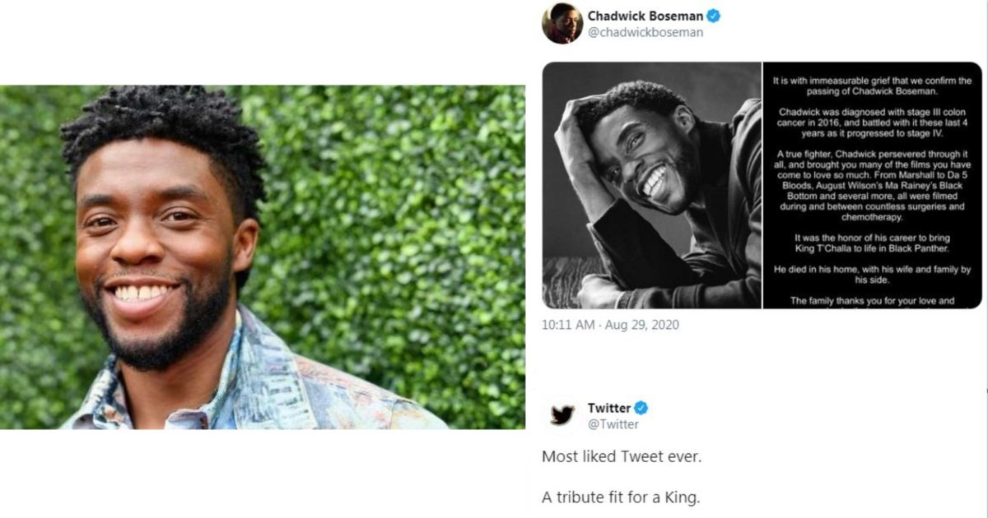

**Part 2 – Draft Reading (801 words)**

The tragic passing of Chadwick Boseman prompted me to return to Wakanda, and his breakout role as the eponymous *Black Panther* (2018). I will readily admit that – as much as I enjoyed it – I was not enamored of the film when it was first released. Having critically studied the Blaxploitation films of the 1970s, I saw too many of the tropes reminiscent of that genre of American film-making, which relied on an urbanized exoticism in its representation of African-Americans, while somehow managing to represent both heroes and villains as subversive threats to the social order. Perhaps, as a white middle-class man, this made me uncomfortable. Perhaps I was supposed to be uncomfortable. I nevertheless liked the movie, as I had most installments of the Marvel Cinematic Universe (MCU), but I did not love it.

This time around, I loved the film. I suspect this has something to do with the growth of the #BlackLivesMatter [BLM] movement which, while it was around when the film premiered, has become a cultural phenomenon in its own right. I remember feeling uncomfortable, when it premiered, with the film’s depiction of Wakanda through tribal imagery; the five tribes coming together in a colourful festival of song and dance to coronate their King. The spears and clubs, the shamanistic use of animal totems, and even the sight of one character riding a rhino in the climactic battle, all grated on me. As a film student, I was aware of Hollywood’s history of Blaxploitation; films like *Shaft* and *Blacula*. This era of film-making in the 1970s perpetuated racial stereotypes while claiming to make films for an African-American audience. I didn’t trust this film when I first watched it. Now I see *Black Panther* through lens of BLM, as a celebration of African cultures not as relics of the past, but as living cultures that thrive and evolve, so that Wakanda fuses tradition with modernity. This is beautifully portrayed through set design, costuming, and even the characterisation. T’Challa’s sister Shuri (Letitia Wright) is a standout. Shuri is initially criticized by a conservative tribal patriarch purely on the basis of her age and gender, and consistently represents the voice of an emerging generation of young people demanding change, creating a more caring and inclusive world, and using their incredible talents to make that world a reality.

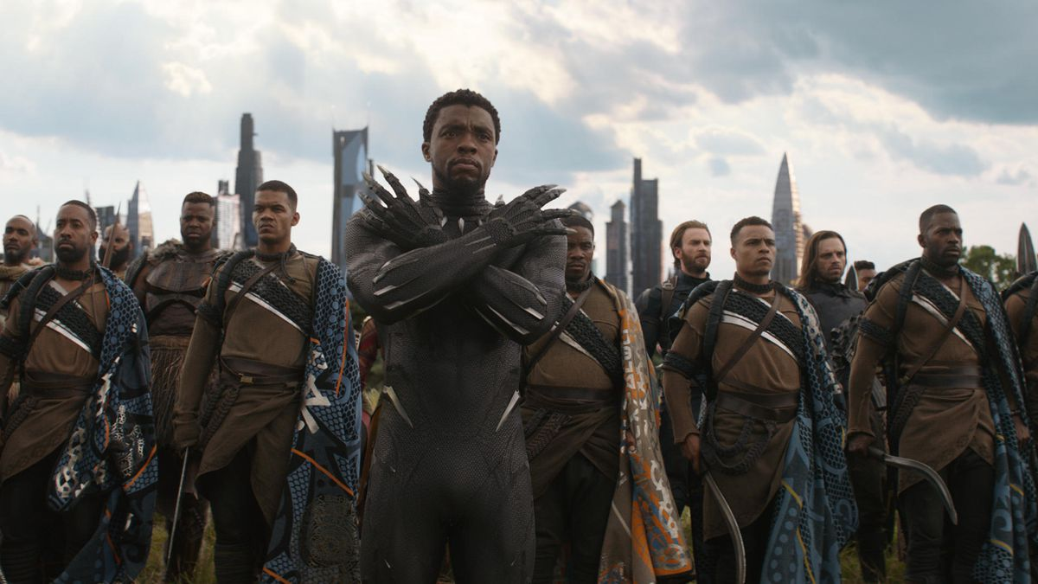

Just as I was when I first saw it in the cinemas, I was aware of my own identity as a white man, and struggled with my response to the film’s didactic. White characters were conspicuous by their rarity, with Martin Freeman’s well-meaning CIA agent Everett Ross and Andy Serkis’ villainous Ulysses Klaue the only white characters of note. Both are shallow stereotypes, with Ross the likeable sidekick often portrayed by Freeman, and Serkis a stereotype of Afrikaner racism, exploiting the natural resources of the continent and caring little for its people. He is a morally bankrupt maniac. My initial emotional response to this was to cynically reject these representations. Over time, these sharp feelings have softened, and I have become more aware of my own white privilege. As a white man, I am used to seeing ‘my people’ represented in complex and diverse ways in film. *Black Panther* forced me to consider the perspective of a misrepresented, unrepresented, and under-represented groups in Hollywood film. It is still common for characters of colour to be reduced to broad – and offensive – stereotypes. Klaue, laughing manically through his rotten teeth, is a vocal reminder of this institutionalized white privilege, just as T’Challa and his family offer a refreshing alternative to Hollywood’s racial tropes.

This brings me back to T’Challa himself. Chadwick Boseman. What a magnificent performance by a magnificent human being. When I saw a video on YouTube, where Boseman tells the story of how Denzel Washington paid his college tuition, and how understood the opportunities his position provided him, to support young men of colour, I cried. It brought the ending of *Black Panther* into sharper focus, with T’Challa finally agreeing that Wakanda would use its advantages to support those who lacked the same opportunities. Knowing that he was receiving treatment, during filming, for the cancer that would take his life, leads me to wonder how much input Boseman had into this element of the narrative. Just as T’Challa ensures Wakanda’s legacy is positive and empowering, Boseman’s legacy takes a similar path. The only question that remains – who will take the eponymous role in the next installment of the franchise? My money is on Shuri, the younger sister who, during her brother’s coronation, raises her hand, as if to challenge him, but instead shows her predilection for breaking tradition. Smart, sassy, and a smasher of conventions, Shuri taking the mantle of Black Panther would be a jewel in the crown of Boseman’s legacy.

Wakanda Forever!

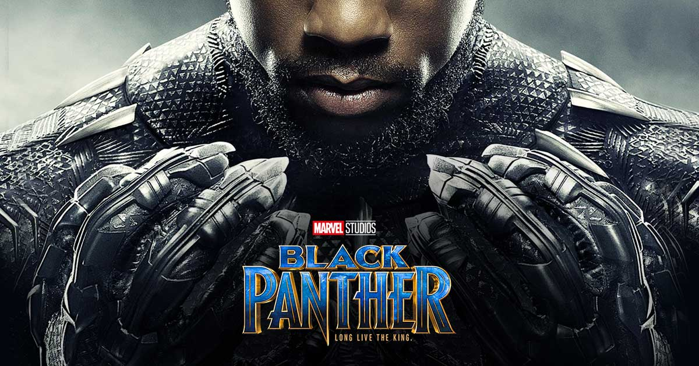

**Part 3 – Defence Planning**

Before getting into the ‘meat’ of my defence, I need a brief introductory paragraph. The purpose of this paragraph is to provide some socio-historical context to reader-response theory. Don’t overthink the structure (rather than a BTP introduction, this is all B).

When I am planning my defence, I need to go through my reading and consider how I could use different theorists and theories to explain what I have done. Then I will look for patterns than can be synthesized into a coherent defence. This is what I can see in my reading of *Black Panther*:

* The first paragraph of the reading establishes expectations. I refer to my experiences with different films, including having watched this film before. There is opportunity to talk about my **Iserian store of experiences**, as well as my membership of an **interpretive community**, as I talk about watching it as a white middle-class man, and can describe the specific strategies I deploy as a member of this community.
* The topic sentence of the second paragraph indicates an overall response that could be described as **plaisir**. There is an opportunity to talk about a changing **horizon of expectations** to account for my differing responses. My initial lack of **plaisir** could be explained by membership of an **interpretive community** (being a film student) or a particular **store of experiences** in combination with **response-inviting structures**. The same **response-inviting structures** provoked a different response when I more recently watched it, due to a different (having grown) **store of experiences**.
* The third paragraph begins by identifying my response to the film’s message, and basing this on my membership of an **interpretive community**. I’m seeing a pattern here; now I’m sure that I will need to talk about **interpretive communities** at some point in my defence. I will probably even talk about them twice, which will be a neat way of demonstrating that one can belong to, and move between, **interpretive communities**. In this paragraph, I can explain my discomfort as **horizonal discord** (this is not how I am used to seeing white people represented) based on my **interpretive community**.
* The fourth paragraph is about Chadwick Boseman, but it does not have a clear topic sentence. I make my response (respect/awe/adoration) clear but it is not explicit. That shouldn’t be a problem, but I may need to re-edit to ensure I’m not lapsing too far into the conversational register. There is an opportunity to explain the first part of this paragraph through my **Iserian store of experiences**. As I watch and re-watch the film, I look for deeper meanings and reveal an aspect of my **identity theme** through the **Fantasy/Transformation** component of **DEFTing**.

I do not need to account for every aspect of my Reading in my Defence. Looking at this set of dot points, I can see that the theorizing of the first paragraph has significant overlaps elsewhere. So I think I will go straight to some interpretive community paragraphs. I think I can get two good body paragraphs out of explorations of different interpretive communities in combination with different second – or even third – approaches. I plan to write a third body paragraph, exploring the FT of DEFTing at the end, together with Iser … but this is something I may cut if there is no space. I know I have about 1200 words to play with for my Defence.

Throughout my defence, I will need to be careful with my language choices. Holland, Iser, and the other theorists do not explain my reading. It is unlikely that they are familiar with my work (some of them are even dead, and their zombies are unlikely to have written about my reading of this film). This is an important point of epistemology – you are using Holland et al to explain elements of your writing.

GOOD: This can be explained through Holland’s notion of DEFTing; or

Iser’s notion of a store of experiences could be used to explain how I …

BAD: Holland described this part of my reading as …; or

According to Iser, I am drawing on my own store of experiences …

[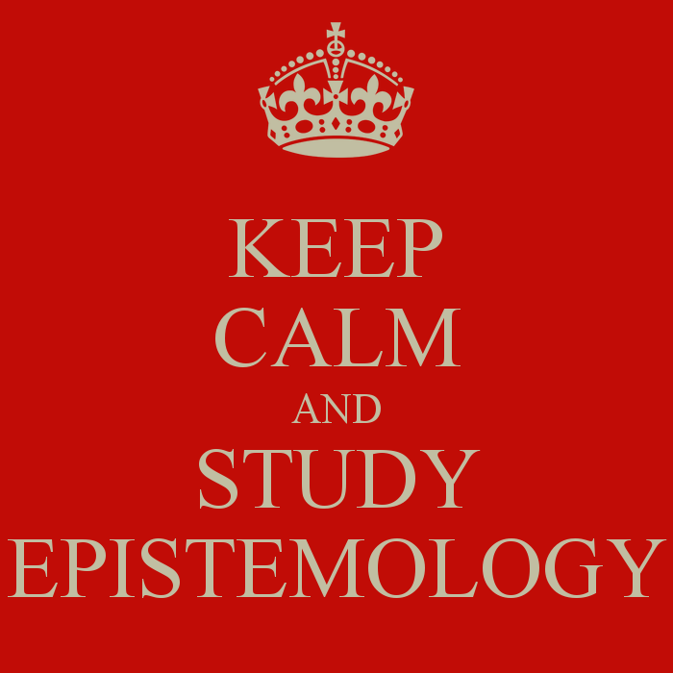](https://www.google.com.au/url?sa=i&rct=j&q=&esrc=s&source=images&cd=&cad=rja&uact=8&ved=0ahUKEwjeo4WP6pzQAhXBi5QKHQcNCjYQjRwIBw&url=https://howtobeastoic.wordpress.com/2015/04/29/stoic-epistemology/&psig=AFQjCNEXK1cae3SNAGFCI6p12p7R0k2Drw&ust=1478820557758798)Can you see the difference between these two ways of thinking about your own thinking? I hope so.

**Part 4 – Draft Defence (1238 words)**

The decision to embark on a reader-response, rather than an authorial, reading of *Black Panther* (2018) was a pragmatic decision. Given my range of emotional responses to the film and to Chadwick Boseman’s performance in the titular role, a range of reader-response theories is potentially suitable in explaining my transaction with the film. These theories first emerged in the 1920s, when Louise Rosenblatt proposed a transactional theory of reading. This reaction against the orthodoxy of New Criticism only came to prominence in the 1960s and 70s, when reader-response theorists such as Wolfgang Iser, Stanley Fish, and Norman Holland, all proposed different forms of transactional and psychoanalytic frameworks to explain the reading process. These theories can be used to explain my unique response to *Black Panther.*

My changing response to the film, which I attribute to the growth of the #BlackLivesMatter [BLM] movement, can be attributed to the filter of my growing store of experiences. Wolfgang Iser describes a synchronic reading process, in which a text is composed of response-inviting structures. Each is a “potential structure which is ‘concretised’ by the reader in relation to his or her extra-literary norms, values and experience” (Selden et al, 2005:50). The meaning of the text is generated through a transaction between these structures, and each reader’s unique store of experiences, allowing the reader “to act as co-creator of the work by supplying that portion of it which is not written but only implied” (Tompkins, 1980:xv). I describe my own store of experiences when I say I was “aware of Hollywood’s history of Blaxploitation; films like *Shaft* and *Blacula*” (Cupitt, 2020: lines 18-19[1]) when I first watched it. The synchronic nature of this reading process, according to Iser, means that “the text ceases to be treated as a static object and becomes a changing ‘gestalt’” (Selden, 1989:124-5). This means that, as my store of experiences grows between viewings, my gestalt reading may also change. This change is evident in my opinion of the film “as a celebration of African cultures not as relics of the past, but as living cultures that thrive and evolve” (lines 21-22). While my initial interpretation can be explained by my store of experiences, there is nothing in my Reading to identify any change to my store of experiences – other than having already seen the film – to account for this changed gestalt. Instead, it can be explained by the interpretive community to which I identify myself as belonging. Stanley Fish describes interpretive communities as “different groups of readers who adopt particular kinds of reading strategies” which “determine the entire process of reading – the stylistic facts of the text and the experience of reading them” (Selden et al, 2005: 56). When I identify myself as a film student who is “aware of Hollywood’s history of Blaxploitation” (line 18) I deploy a particular set of strategies related to film history. I compare the representation of race in the film to representations in other films. My awareness of Hollywood’s checkered racial history leads both to my initial negative response as the film unfolded before me, in which I felt uncomfortable (line 14) and, having had time to consider the film as a whole, my new appreciation for it. This specific interpretive community, as part of my store of experiences, works with the film’s response-inviting structures to generate my changing responses between viewings.

Fish’s theory of interpretive communities can also explain my struggle with the film’s message. While my knowledge as a film student explained by previous response, my I describe my identity as a white man, and the reading strategies that follow from this identity, as responsible for this struggle. According to Fish “readers can belong, consciously or unconsciously, to more than one community at the same time, or they can change from one community to another at different times in their lives” (Tyson, 1999:171). I refer to “the only white characters of note” being constructed as “shallow stereotypes” (line 34). Furthermore, I note that as “a white man, I am used to seeing ‘my people’ represented in complex and diverse ways in film” (lines 39-40). Here, it is obvious that I am accustomed to some psychological realism in the portrayal of white characters; I do not have to specifically look for this because it is the default, which I am used to passively accepting. When I watch a film that does not conform to this pattern of characterisation, my “emotional response to this was to cynically reject these representations” (lines 37-38). This cynicism, and my initial struggle with the film’s racial representation, can be understood as what Hans-Robert Jauss describes as horizonal discord. This occurs “when a literary work with an unusual aesthetic form can shatter the expectations of its reader and at the same time confront him with a question which cannot be answered by religiously or publicly sanctioned morals” (Jauss and Benzinger, 1970: 36). This ‘unusual aesthetic form’ could be a Brechtian breaking of the ‘fourth wall’ or any other response-inviting structure that defies narrative or generic conventions. In this case, the reversal of the typical Hollywood hierarchy of racial representations confronted me with questions that cut to the core of my interpretive community. The film “forced me to consider the perspective of a misrepresented, unrepresented, and under-represented groups in Hollywood film” (lines 40-41), confronting me with questions about my own white privilege (line 39) and the reading strategies – that previously seemed so natural to me – that follow from this interpretive community. My unconscious membership of this community contributes to my horizonal discord when I am confronted by stereotypical representations of my own racial group.

While my membership of different interpretive communities explains my various responses to the film as a whole, it is my identity theme, based on my store of experiences, that explains my emotional response to Chadwick Boseman’s performance as T’Challa. I describe myself crying at “a magnificent performance by a magnificent human being” (lines 47-48), in the knowledge that Boseman had been receiving treatment for cancer during filming. This knowledge was part of my store of experiences during my recent viewing of the film, but not my original viewing. I started to interpret the film differently, as the actor’s legacy. In doing so, I projected what Norman Holland would call a “characteristic pattern of defense” (Tompkins, 1980) onto the film. This pattern of defense, in which I protect my psychological equilibrium by looking for deeper meanings in any aspect of a text that prompts a strong emotional response – in this case, my tears – reveals an aspect of my identity theme. Holland describes identity themes as each reader’s own personal coping strategy that “reveals the psychology of the reader” (Tyson, 1999:169). This transactional reader-response theory begins with a defense mode, in which “our psychological defenses are raised by the text” (Tyson, 1999:170), but is also revealed by a fantasy mode in which “we find a way to interpret the text that will tranquilize those defenses and thus fulfill our desire to be protected from threats” (Tyson, 1999: 170). This is exactly what I do when I focus on “who will take the eponymous role in the next installment of the franchise” (line 56), constructing a ‘what if’ story to stymie my tears of sadness and tell myself they are actually tears of hope.

The strategies and practices I applied—whether consciously or not—in my reading spanned the gamut of reader-response theory, from the objectivity of the film’s response-inviting structures to the extreme subjectivity of Holland’s psychoanalytically-based approach. This self-reflexive analysis and evaluation of the reader-centred theoretical underpinnings of my reading of *Black Panther* reveals not only the distinctions and complexities of the various positions I took up in the reading, but also the useful interstices and complementarities between them.

**Bibliography [not included in the word count]**

Bertens, Hans (2014) *Literary Theory: The basics*, Routledge: London and New York.

**[even though I have not referred to the textbook in this reading or defence, I am including it in my bibliography, as it was important in informing my understanding of the literary theories that I have referred to. That is the difference between a bibliography and a list of references]**

Coogler, Ryan (dir.) (2018) *Black Panther.*

**[don’t forget to include the film in your bibliography]**

Jauss, Hans Robert, and Benzinger, Elizabeth (1970) “Literary History as a Challenge to Literary Theory” in *New Literary History* 2(1) pp 7-37.

Selden, Widdowson, and Brooker (2005) *A Reader’s Guide to Contemporary Literary Theory*, Pearson Longman.

Tompkins, Jane P. (1980) *Reader-Response Criticism: From Formalism to Post-Structuralism*, JHU Press

Tyson, Lois (1999) *Critical Theory: A User-Friendly Guide*, Garland: New York.

**[For these three readings, all sourced from the book of readings or available through the Minerva Unit Page, I have written the reference just as it appears in the book of readings. Don’t list the book or readings itself, or any class handouts, in your bibliography. Just list anything from the book of readings that you used – the purpose of the bibliography is to allow others to look up the same source material]**

1. All subsequent references to Cupitt, 2020 will be by line number only