**Excerpt from *Great Expectations* by Charles Dickens (Due Friday 24th August) FEEDBACK SHEET**

**Miss Havisham (Predict/Define/Question/Summarize)**

*But prominent in it was a draped table with a gilded looking-glass, and that I made out at first sight to be a fine lady's dressing-table.*

*Whether I should have made out this object so soon, if there had been no fine lady sitting at it, I cannot say. In an arm-chair, with an elbow resting on the table and her head leaning on that hand, sat the strangest lady I have ever seen, or shall ever see.*

*She was dressed in rich materials - satins, and lace, and silks - all of white. Her shoes were white. And she had a long white veil dependent from her hair, and she had bridal flowers in her hair, but her hair was white. Some bright jewels sparkled on her neck and on her hands, and some other jewels lay sparkling on the table. Dresses, less splendid than the dress she wore, and half-packed trunks, were scattered about. She had not quite finished dressing, for she had but one shoe on - the other was on the table near her hand - her veil was but half arranged, her watch and chain were not put on, and some lace for her bosom lay with those trinkets, and with her handkerchief, and gloves, and some flowers, and a prayer-book, all confusedly heaped about the looking-glass.*

*It was not in the first few moments that I saw all these things, though I saw more of them in the first moments than might be supposed. But, I saw that everything within my view which ought to be white, had been white long ago, and had lost its lustre, and was faded and yellow. I saw that the bride within the bridal dress had withered like the dress, and like the flowers, and had no brightness left but the brightness of her sunken eyes. I saw that the dress had been put upon the rounded figure of a young woman, and that the figure upon which it now hung loose, had shrunk to skin and bone. Once, I had been taken to see some ghastly waxwork at the Fair, representing I know not what impossible personage lying in state. Once, I had been taken to one of our old marsh churches to see a skeleton in the ashes of a rich dress that had been dug out of a vault under the church pavement. Now, waxwork and skeleton seemed to have dark eyes that moved and looked at me. I should have cried out, if I could.*

*"Who is it?" said the lady at the table.*

*"Pip, ma'am."*

<http://www.online-literature.com/dickens/greatexpectations/8/>

**Construct a fishbone diagram using the diagram on the next page as your model.**

**Text-centred reading**: Genre? Binaries? Narration? Symbol and metaphor? Stylistic features and literary techniques (dialogue, imagery and figurative devices, characterisation, rhetorical devices, text structures)

**World-context-centred reading**

**• representations —** How does the text construct representations of people, groups, places or ideas?

**• ideology —** What cultural beliefs, values and attitudes that reinforce **particular power structures in society** underpin the text? How does the text challenge or reinforce dominant worldviews?

**• cultural ideas —** Consider how the text upholds or resists prevalent cultural ideas related to topics such as – race, gender, **class,** sexuality, **age**, the environment.

What concepts and issues are explored? What ideas are conveyed about those issues and ideas?

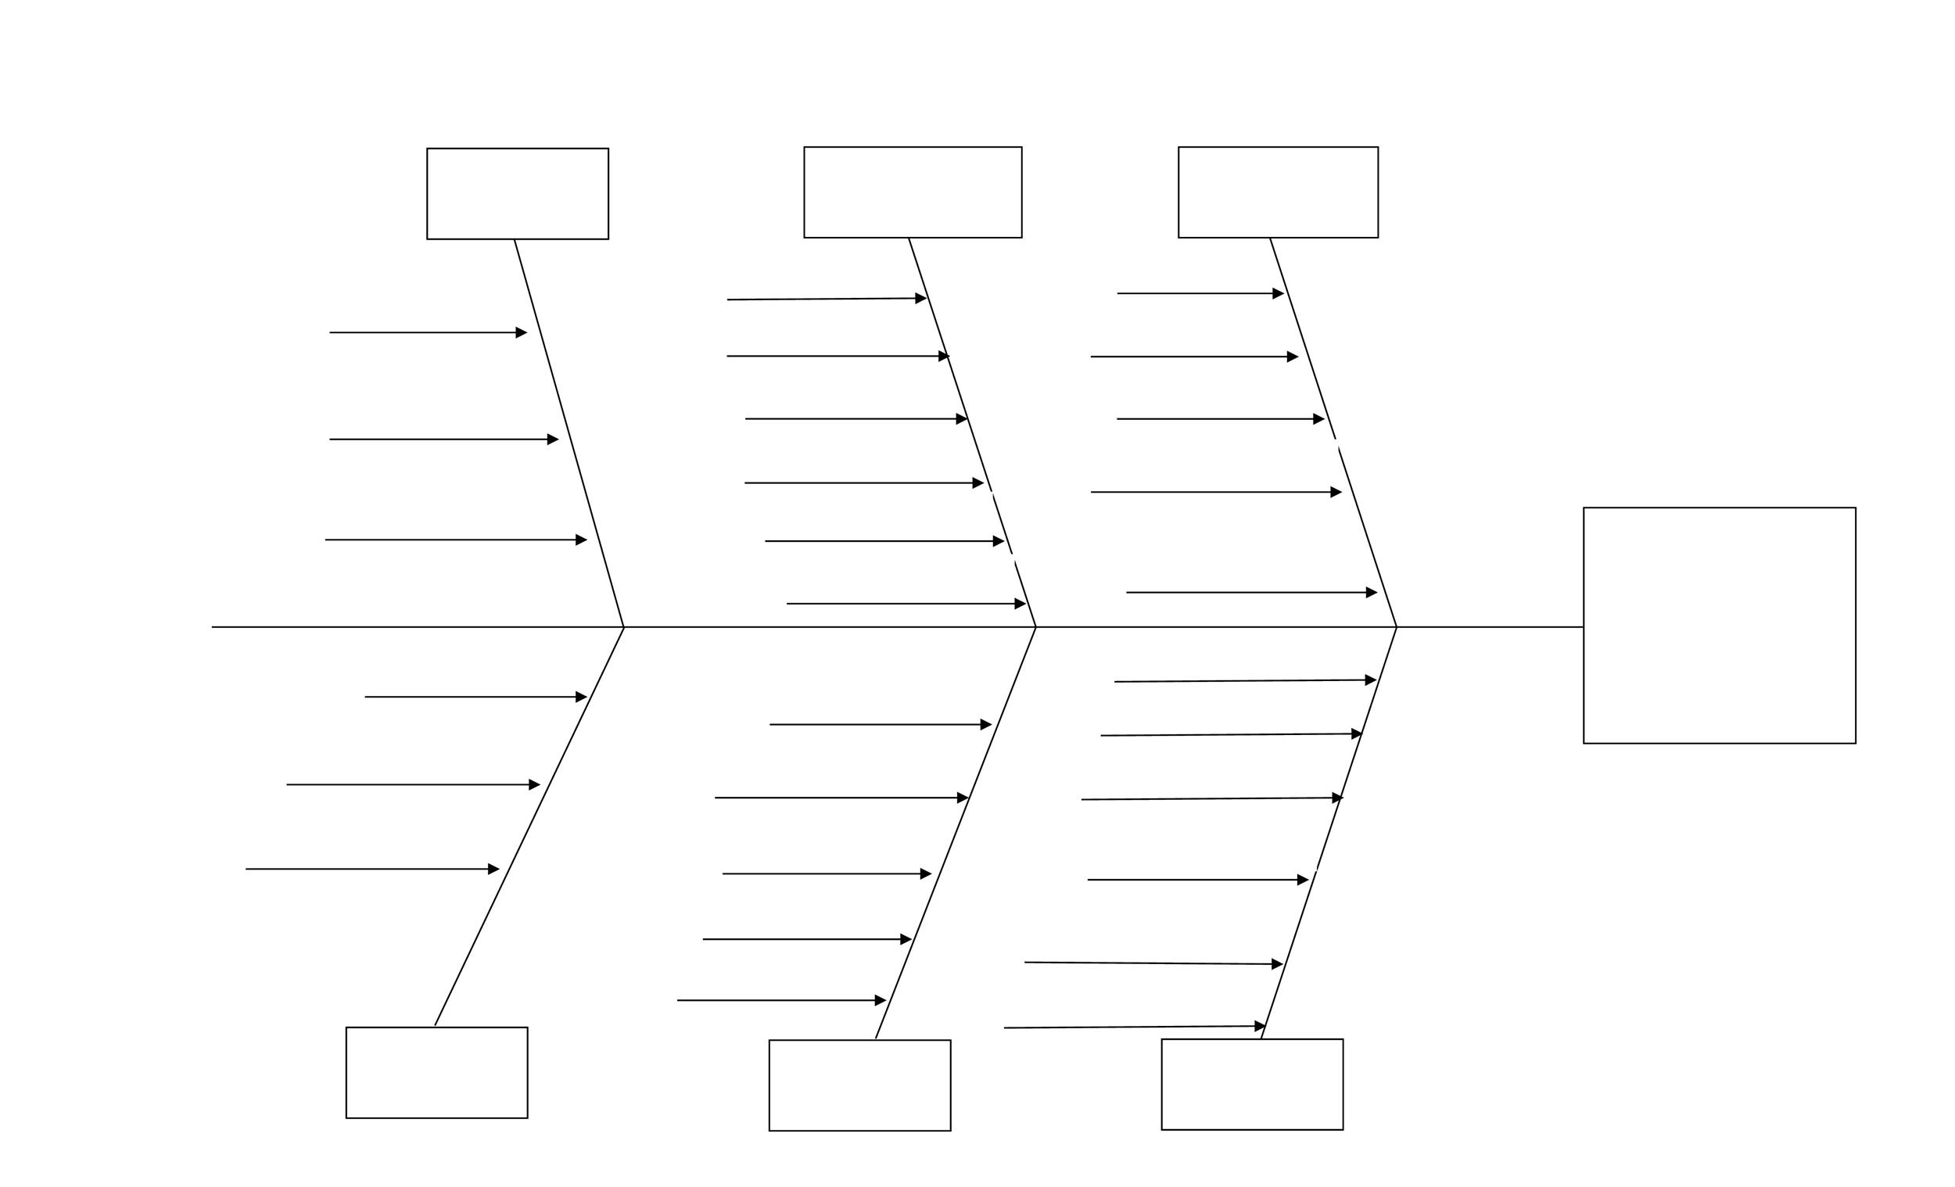

Cultural ideas? A woman has been betrayed by a man (gender), class differences and hegemony, ageism

Ideology? Wealth and power do not guarantee happiness

Concepts and issues: marriage, betrayal, delusion, insanity, wealth, power

Symbolism: jewels, yellow, white, withered flowers, bridal dress

Metaphor: “waxwork and skeleton*”*

*Visual imagery in descriptive paragraph constructs representation of ‘fine’ yet ‘strange’ lady*

Narration?

First person, focalized on woman

Binaries: wealth/poverty, youth/age, sanity/delusion, power/lowliness, past/present

Genre: realistic fiction, highly descriptive, verisimilitude, representation of character

Genre?

Binaries?

Symbolism?

Metaphor?

Stylistic features?

Representation

Of lady

Thesis statement?

The excerpt from the novel, *Great Expectations,* by Charles Dickens conveys the ideas that wealth does not always mean happiness and that the power that comes with wealth may be misused.

Ideas conveyed?

Concepts and issues?

**Possible Introductory paragraph**

|  |  |
| --- | --- |
| **Intro: Text name, author name, genre, universal thesis statement** | The excerpt from the novel *Great Expectations* by Charles Dickens suggests that wealth and power do not always provide contentment for yourself or happiness for others. |
| **Content, concepts** | In keeping with the novel genre, the excerpt describes the aged personal appearance of wealthy Miss Havisham through the eyes of Pip, who seems to be youthful. This ‘*strange*’ yet ‘*fine*’ lady is dressed in what appears to be a bridal gown, despite her great age and withered figure, suggesting that she has been jilted in her youth. |
| **Reiteration of theme statement but with detail.** | Despite the show of wealth that surrounds Miss Havisham, the representation of her character suggests that she is not only unhappy and deluded but that she also misuses her authority over others. |
| **P1: Topic sentence relates to thesis statement** | The **binary oppositions** youth/age, power/weakness and sane/deluded suggest that Miss Havisham is a pitiable yet powerful creature who maintains control over others because of her wealth, despite the fact that her behaviour appears to be quite deranged. |
|  | Evidence of age |
|  | Evidence of power |
|  | Evidence of delusion |
| **Conclude link** | The **ideology** underpinning the **binaries** seems to implicitly critique the perversion of wealth and power for selfish personal reasons. The mitigating factor is Miss Havisham’s almost hallucinatory state of mind. |
| **P2: Topic sentence relates to thesis statement** | The narrative excerpt, written from Pip’s **first person point of view, focalises** on Miss Havisham in order to **represent** her as being dominating, delusional and even fearful. |
| **Expand/explain** | The reader can only observe what Pip observes; we are not privy to Miss Havisham’s thoughts and feelings. This closeness to Pip’s **reliable** observations **positions the reader** to identify with Pip rather than with Miss Havisham. He observesthat although she is a “*fine lady*” she is also “*the strangest lady I have ever seen*”. |
| **Evidence** | Dickens employs **symbolism** in the form of jewels to signify her wealth and power; withered flowers and the colour yellow to symbolize her age and the bridal dress to suggest her impending marriage and subsequent jilting by her fiancé. The latter event seems to have unhinged her. There is a high degree of **verisimilitude i**n the detailed descriptive paragraph; nothing is left to the reader’s imagination. “*She had not quite finished dressing, for she had but one shoe on - the other was on the table near her hand”.* This description of an obviously disturbed mind is followed up by Pip’s **metaphorical evaluation** of Miss Havisham as “*waxwork and skeleton*”. Her appearance strikes fear in Pip; her “*dark eyes moved and looked at me*”. Pip would have “*cried out*” in fear if he “*could*”. |
| **Conclude link** | It seems Miss Havishammisuses her great wealth to inspire fear in those she considers to be socially inferior. |
| **P3: Topic sentence relates to thesis statement** | The excerpt therefore critiques **class-based power structures** in society as it seems that the wealthy and powerful may misuse their authority. It seems that Pip is in a subordinate role as he is both younger and, it is inferred, in awe of Miss Havisham’s display of wealth: “*bright jewels sparkled on her neck and on her hands”* and “*other jewels*” which lay “*sparking on the table”*. In remaining within the frozen moment of her jilting, it is suggested that Miss Havisham has failed to use her wealth purposefully, for the betterment of others. Her imperious “*Who is it*?” implies a lack of polite consideration in the context of this uneven social interaction. Wealth and authority are not necessarily to be admired for their own sake, particularly as these ‘assets’ may pervert the endowed person’s better nature. |