 ***SARATH DEVAPPRIYA***

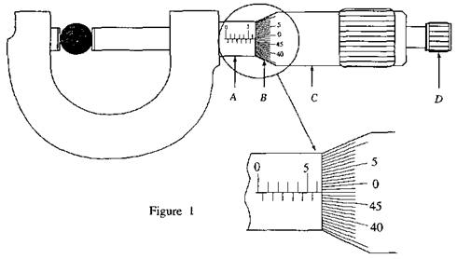

**(01) (a) Name the parts of the micrometer screw gauge labelled as A, B, C and Din figure I.**

(i) A ……………………………………………….. (ii) B ……………………….. ……………….

(iii) C ………..…………………………………….. (iv) D ………………………………...........

b.(i) What is the least count of the above micrometer screw gauge in mm? ………………………….. mm

(ii) Write down the scale reading for the diameter of the ball shown in figure 1 in mm …………………….mm

(iii) figure 2 shows a situation in which the micrometer screw gauge is adjusted to determine the zero

error. State the correct value for the diameter of the ball in mm …………………………… mm

(iv) Write down the fractional error of the measurement for the diameter of the ball (numerical

simplification is not necessary)

………………………………………………………………………………………………………………………………………………………………

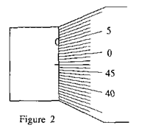 (v) What is the precaution taken in the micrometer screw gauge to avoid over-pressing the object?

…………………………………………………………………………………………………………………………………………………………………………………………………………………………………………………………………………………………………………………………………….

( c) A wire of circular cross section (length *l ≈* 55 cm and diameter

d1 ≈ 4 mm) is fixed to a disk (diameter d2 ≈ *5 cm* and thickness

t ≈3 mm) as shown in figure 3. Magnitudes given in parentheses are

approximate values.

(i) Of the measuring instruments, metre rule, spherometer, vernier

callipers, and the micrometer screw gauge, write down the most

suitable instrument for the measurement of each of the above

quantities.

Measurement Instrument

*l* …………………………………………

d1 ………………………………………….

d2 …………………………………………

t ………………………………………….

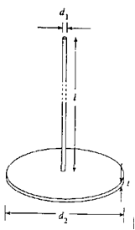(ii) What experimental procedure would you follow to obtain a better value for

the thickness of the disk?

…………………………………………………………………………………………………………………………………………………………………

(d)The thickness of a certain type of polythene sheet is much smaller than the least

count of a micrometer screw gauge. Propose a method to estimate the

thickness of a sheet using a micrometer screw gauge.

………………………………………………………………………………………………………………………………………………………………………………………………………………………………………………………………………………………………………………………………………………………………………………………………………………………………………………………………………………………………………

**[A/L 2004]**

**(02) The diagram below shows a Vernier Calliper. figure 3**

(a) What are the other parts other than the Main scale and the Vernier scale that should made use of in

doing the following measurements?

i. External diameter of a test tube. …………………………………………………………………………………………………………….

ii. The length of a test lube. …………………………………………………………………………………………………………………………

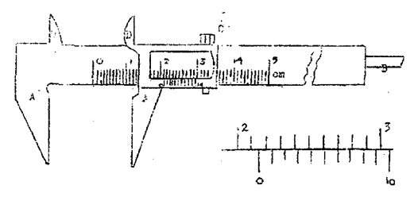

(b) If 10 divisions of the Vernier coincides with 9 divisions of the main scale, what will be the least count?

……………………………………………………..................................................................................................................

(c ) What is the reading of the Vernier Calliper shown in the diagram?

………………………………………………………………………………………………………………………………………………………………...

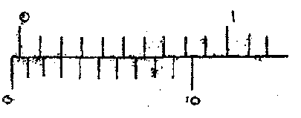

(d) When the jaws of this is fully closed the zero of the Vernier does not coincide with the zero of the Main Scale. The zero of the Vernier is behind the zero of the main scale. This is a zero error.  
i . What is the value of this zero error? ………………………………………………………………………………………………………

ii. What is the correct reading in the Calliper (shown in the diagram) if this zero error exists?

……………………………………………………………………………………………………………………………………………………………………….

(e) From the following readings which one can be a correct reading taken by a Vernier Calliper?

I . 0.15mm ii. 0.30mm iii. 0.255mm

(f) In the Vernier scale of a travelling microscope 100 Vernier divisions correspond to 99mm 2

i. What is the least count of the instrument?

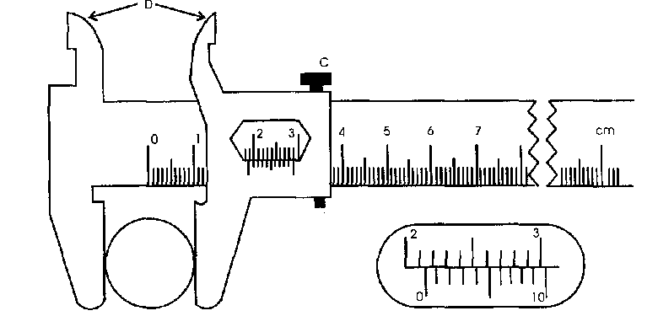………………………………………………………………………………………………………………………………………………………………………

ii. State one difficulty that will arise in taking a reading from such a scale

…………………………………………………………………………………………………………………………………………………………………….

**[Colombo District Exam 1987]**

**(03) The diagram shows a Vernier Calliper adjusted to measure the diameter of a metal cylinder. Enlarged** diagram of the vernier is given separately.

(a) If 10 divisions of this Vernier coincides with 9 (mm), what is the reading that you will obtain as the diameter of the cylinder.

………………………………………………………………………………………………………………………………………………………………………

(b) If in a more accurate (different type) of a measuring instrument 50 Vernier divisions coincide with 99

½mm divisions of the main scale. What is the least count of the instrument?

………………………………………………………………………………………………………………………………………………………………….……………………………………………………………………………………………………………………………………………………………………………

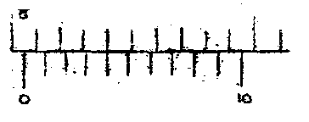(c) After removing the cylinder from the Vernier calliper shown in the diagram, It’s jaws were completely closed. It was found that the zero of the Vernier does not coincide with the zero of the main scale. This is shown in the adjacent diagram and it is considered that a zero error exists in this instrument. What is the value of this zero error? What is the correct value of the diameter when this zero error is taken into account?

……………………………………………………………………………………………………………………………………………………………………………..……………………………………………………………………………………………………………………………………………………………...

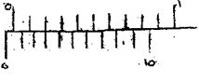(d) In some instruments a zero error occurs when the zero of the Vernier stands behind the zero of the main scale. Such an instant is shown in the diagram. Read the zero error of this Calliper.

………………………………………………………………………………………………………………………………………………………………………………………………………………………………

(e) What is the purpose served by the nut C of the Calliper?

………………………………………………………………………………………………………………………………………………………………………………………………………………………………………………………………………………………

(f) What is the purpose served by the internal jaws (D) of the Calliper?

…………………………………………………………………………………………………………………………………………………………………. 3

(g)In the manufactures handbook the diameter of a wire is given as 0.18mm, it is not possible to use the Calliper shown in the main diagram to check the correctness of this value. Give reasons for this

…………………………………………………………………………………………………………………………………………………………………………………………………………………………………………………………………………………………………………………………………………………………………………………………………………………………………………………………………………………………………… **[AL 1984]**

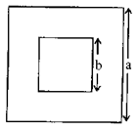**(04) Figure shows a thin, uniform square metal sheet of side with a square hole** ofside b in it. a and b are of the order of a few centimetres. a. b. thickness (t) and the mass (m). of the sheet are to be measured as accurately as possible.  
(a) What is the best laboratory measuring instrument that can be used to measure t?

……………………………………………………………………………………………………………………………

(b)An important check has to be made before raking it measurement using the above instrument. What is it?

……………………………………………………………………………………………………………………………………………………………………….

( c ) You are given a Vernier calliper to measure a and b. Which part of the calliper would be utilize to

(i) determine a : …………………………………………………………………………………………………………………………………

(ii) determine b : …………………………………………………………………………………………………………………………………

(d) What is the most suitable laboratory measuring .instrument that can be used to measure m?

……………………………………………………………………………………………………………………………………………………………………….

(e) Write down an expression for the density of the metal in-terms of m, a. b and t.

……………………………………………………………………………………………………………………………………………………………………….

(f)The thickness t was measured at five different places of the sheet and the values obtained are given

below. 1.10 mm 1.11mm 1.12 mm 1.12 mm 1.11 mm

(i) What is the least count of the instrument used?

……………………………………………………………………………………………………………………………………………………………………….

(ii) Calculate the mean thickness of the sheet

………………………………………………………………………………………………………………………………………………………………………………………………………………………………………………………………………………………………………………………………………………

(iii) Up to how many decimal places would you give the answer calculated above? …………………………………..

***Explain***why? ..…………….………………………………………………………………………………………………………………………………………………………………………………………………………………………………………………………………………………………………………………………………………………………………………………………………………………………………………………………………………………………………………

(g) To determine thevolume of the sheet a student suggests to immerse the sheet of metal in water and

measure the volume of water displaced. State why this is not so accurate as compared to the value

calculated using a. b and t ……………………………………………………………………………………………………………………………………………………………………………………………………………………………………………………………………………………………………………………………**[ AL 1995]**

**Ex.** 1.20 mm 1.26mm 1.42mm 1.44mm 1.56mm 1.78mm

The above readings are taken from a vernier calliper. What is the least count of it? ……………………….. 4

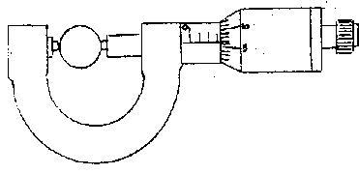**(05) The diagram shows a Micrometer Screw Gauge that can be** used to measure small thicknesses and diameters. A thin wire is placed between its jaws.

(a) If the collar is divided into 100 equal parts and the barrel in marked in mm. what is the least count of the instrument? The pitch of the screw is 1 mm.

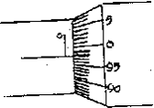……………………………………………………………………………………………….

(b) What is the reading in the position shown in the diagram?

………………………………………………………………………………………………

(c) When the jaws are fully closed after removing the wire the zero of the circular scale does not coincide with the zero of the linear scale. This is considered as a zero error .The adjoining diagram shows such an arrangement. Estimate the zero error.

………………………………………………………………………………………………………………………………………………………………………

If the error is taken into account what is the correct measurement of the wire? …………………………………………

(d) In another screw gauge having the same least count, when jaws are fully closed, the collar goes beyond the zero of the linear scale. To make the zero of the circular scale to coincide with the datum line, circular scale has to be totaled back (reverse direction) through 6 divisions. This is also a zero error. What is the magnitude of this error?

………………………………………………………………………………………………………………………………………………………………………

In measuring the diameter of a wire.

(i)Two readings are taken at two perpendicular positions at the same point.

(ii)Measurements are taken at several points.

Give reasons for each of the above

(1)………………………………………………………………………………………………………………………………………………………………………………………………………………………….……………………………………………………………………………………………………………… (ii)…………………………………………………………………………………………………………………………………………………………………………………………………………………………………………………………………………………………………………………………………………

What is the purpose served by the head H of the screw gauge?

………………………………………………………………………………………………………………………………………………………………………

A student used this instrument to measure the diameter of a wire. Measurements were taken at 3 different points and two perpendicular positions at every point. The readings that obtained for the diameter in mm are 2.10, 2.12, 2.08, 2.13. 2.09, and 2.10. He estimated the diameter as 2.1033.

Write your-comments about this result.

………………………………………………………………………………………………………………………………………………………………………………………………………………………………………………………………………………………………………………………………………………………………………………………………………………………………………………………………………………………………………………………

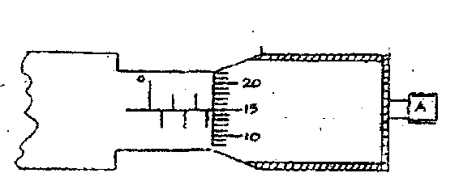 **(06)**

**Figure shows section of a micrometer** screw gauge. It has 50 divisions on the thimble scale and when the thimble is rotated one complete turn it moves through one division ( 0.5 mm ) on the sleeve scale.

(a) What is the least count of the instrument? ……………………………………………………………………………………..

(b) When taking a measurement, the component marked A (the ratchet) serves an important function.

(i) What is it?..........................................................................................................................................

……………………………………………………………………………………………………………………………………………………………………

(b) How do you make sure that the ratchet has been utilized correctly In performing the function mentioned in (b)? ………………………………………………………………………………………………………………………………………………………………………………………………………………………………………………………………………………………………………………………………………………………………………………………………………………………………………………………………………………………………………………………  
(c ) How do you determine the zero error, if any, of the screw gauge? ………………………………………………………………………………………………………………………………………………………………………………………………………………………………………………………………………………………………………………………………………………

(d)The screw gauge is used to measure the diameter of a steel ball and reading obtained is shown in the diagram given at the beginning of the question. If there is no zero error in the instrument, what is the diameter of the bail? ……………………………………………………………………………………………………………………………….

(e ) For measuring the diameter of a thin wire the Micrometer Screw Gauge is more suitable than a Vernier Calliper. Give the main reason.

………………………………………………………………………………………………………………………………………………………………………………………………………………………………………………………………………………………………………………………………………………………………………………………………………………………………………………………………………………………………………………………

(f) Using a Micrometer Screw Gauge how would you obtain a better value for the diameter of a Sonometer wire?.................................................................................................................................................................................................................................................................................................................................................(g) Name two other measurements, which could be performed with Vernier Calliper but not with Micrometer Screw Gauge. …………………………………………………………………………………………………………………………………………………………………………………………………………………………………………………………………………………………………………………………………………………………………………………………………………………………………………………………………………………**[AL/N&E 1990 SPECIAL]**

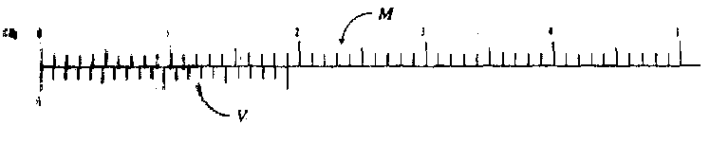**(07) Figure shows a part of the main scale *(M)* and vernier scale *(V)* of a certain vernier calliper when** their respective zero marks coincide. (Note that the figure is enlarged.)

(i)What is the length of a vernier division in mm?

……………………………………………………………………………………………………………………………………………………………..

(ii) Hence or otherwise determine the least count of the instrument.

………………………………………………………………………………………………………………………………………………………………

(iii) According to the above figure, what is the least distance (in mm) of the vernier scale that has to be moved in order to make a vernier scale mark coincide once again with a main scale mark?

…………………………………………………………………………………………………………………………………..

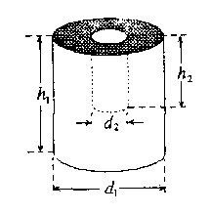A cylindrical metal piece has a cylindrical hole as shown in the figure.

In order to determine accurate values of the following measurements which part of the vernier

calliper (out of external jaws, internal jaws and depth bar) would you use?

(i) For the measurement of *d1*

(ii) For the measurement of *h1*

(iii) For the measurement of *d2 …………………………………………………………………………..*

(iv) For the measurement of *h2 ……………………………………………………………………………*

(c) Write down an expression for the volume *V* of the metal in terms of *d1 ,h1* , *d2* and *h2*

……………………………………………………………………………………………………………………………………………………………………

*(d)* (i) When *d2* was measured using the vernier calliper mentioned above, the position of the vernier scale obtained relative to the main scale is shown below. What is the value of *d2*

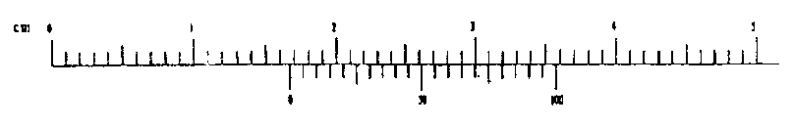……………………………………………………………………………………………………………………………………………………………………….

(ii) What is the fractional error of this *d2* measurement? (Simplification is **not** expected.)

……………………………………………………………………………………………………………………………………………………………………….

**(08)For determination of density of the material of a twenty-five cent coin a student measured the** thickness t, diameter d and the mass m of the coin. His measured values were t = 1.77 mm. d = 18.01 mm and m = 3.12 g.

(a) (i) What is me least count of the instrument used to measure d in mm?

(ii) List the laboratory measuring instruments, which can be used m order to obtain the same accuracy as above in respect of the measurements of the thickness t and the diameter d.

(1) Thickness t ………………………………………………………………………………………………………………………………………………………………………………………………………………………………………………………………………………………………………………………………………………

(2) Diameter d …………………………………………………………………………………………………………………………………………………………………………………………………………………………………………….

1. Write down an expression for the density p of the material of the coin in terms of t, d ,and m.

……………………………………………………………………………………………………………………………………………………………….......

(C)(1) If you are given a large number of coins and a meter ruler as the measuring instrument, explain how you would obtain a value for the average thickness t of a coin. with the same accuracy of I/100 of a mm as above……………………………………………………………………………………………………………………………………………………………………………………………………………………………………………………………………………………………………………………………………………………………………………………………………………………………………………………………………………………………………………

(2) What is the minimum number of coins you would need for this measurement?

………………………………………………………………………………………………………………………………………………………………………..

(d)(1) One of the coins was hung from a thread connected to one end of a vertical sensitive spring and the extension of the spring was observed using a metre ruler. When the coin was in air the extension was X, and when it wascompletely immersed in water the extension was X.t. Find the relative density of the material of the coin.

………………………………………………………………………………………………………………………………………………………………………………………………………………………………………………………………………………………………………………………………………………………………………………………………………………………………………………………………………………………………………………………

(2) When the features of the coins are considered the immersion method would be Better than the method used in (b) for determining the volume of the coin. Explain why?

………………………………………………………………………………………………………………………………………………………………………………………………………………………………………………………………………………………………………………………………………………

(e) Coins are made of an alloy containing two metals A and B. The relative density of the alloy is 8 and the relative densities of metals A and B are 3 and 9 respectively. Find the mass ratio of metals A and B in the alloy.

……………………………………………………………………………………………………………………………………………………………………………………………………………………………………………………………………………………………………………………………………………………………………………………………………………………………………………………… mA /mB =