STUDYLINK- Dev Physics Centre

**PAPER CLASS REFRESHING TEST 1HOUR & 30MINUTES**

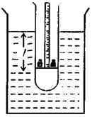**01.The figure shows a weighted thin walled test tube that can be used in the laboratory to**

measure the density of a liquid. A paper millimetre scale is pasted vertically on the inner wall

of the tube. The bottom portion of the tube is filled with sand and the rest of the tube has a uniform cross-section of area A.

(a) Why is the initial weighting with sand necessary?

………………………………………………………………………………………………………………………

(b) The volume of the sand filled portion of the tube is V, and the mass of the test tube with sand is M. When an additional mass m is dropped into the tube the reading of the liquid level on the scale is *l*. If the density of the liquid is ρ , write down an expression which show a relationship between I and m.

……………………………………………………………………………………………………………………..

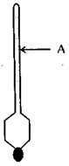(c)(i) Rearrange the equation obtained in (b) to plot a graph to determine p of the liquid,

………………………………………………………………………………………………………………………………………………….

………………………………………………………………………………………………………………………………………………….

………………………………………………………………………………………………………………………………………………….

(ii) What additional measurement is required to obtain the density of the liquid from the graph,

………………………………………………………………………………………………………………………………………………….

(iii) What is the instrument you would use to obtain this measurement?

………………………………………………………………………………………………………………………………………………….

(d)The hydrometer, a device used to determine the density of liquids, works on the principle illustrated above. If consists of a large bulb with a calibrated narrow stem, as shown in the figure.

(i) Why does the hydrometer have a large bulb at the bottom?

…………………………………………………………………………………………………………………………….

…………………………………………………………………………………………………………………………….

(ii) What is the advantage of having a narrow stem?

…………………………………………………………………………………………………………………………….

(e)When floated in pure water this hydrometer is immersed up to the mark A. When successively immersed in a concentrated salt solution and in coconut oil it floats up to the points B and C respectively. Mark the points B and C on the diagram given in (d).

**02. In an experiment to find the density of coconut oil you are provided with the following :**

(1) U-tube mounted on to a vertical frame with appropriate scales

(2) Water and sufficient amount of coconut oil (3) Funnels.

(a)(i) Draw a labelled diagram of the experimental setup, clearly showing the levels of water and coconut oil columns and their common interface.

(ii) On the diagram drawn above mark, as h1 ; and h2 the two measurements that you have to take.

(b)If the densities of coconut oil and water are given by d1 and d2  respectively,

write down an expression for d1; in terms of d2, h1 and h2

………………………………………………………………………………………………………………………..

(i)Select the correct procedure out of the following in order to draw a graph in

Determining (1)Adding more water to the respective arm.

(2)Adding more coconut oil to the respective arm.

……………………………………………………………………………………………………………………………………………………………………………………….

(ii) Give the correct reason for not selecting the other procedure.

……………………………………………………………………………………………………………………………………………………………………………………….

………………………………………………………………………………………………………………………………………………………………………………………

(iii) In such a graph the gradient is found to be 0.87. Determine the density of coconut oil (density of water = 103 kg m-3)

………………………………………………………………………………………………………………………………………………………………………………………………………………………………………………………………………………………………………………………………………………………………………………………………

(d)In this experiment which liquid should be poured into the U-tube first. Give reasons for your a answer.

………………………………………………………………………………………………………………………………………………………………………………………………………………………………………………………………………………………………………………………………………………………………………………………………

(e)If you want to determine the density of coconut oil with a fractional error of 0.1, what should be the minimum height possessed by a liquid column? Assume that the height of a liquid column can be measured with an accuracy of 1 mm.

[ Hint: Fractional error of density ( ∆d /d )=2 x fractional error of height of a liquid column ( ∆h /h )]

………………………………………………………………………………………………………………………………………………………………………………………………………………………………………………………………………………………………………………………………………………………………………………………………..

(f) What is the experimental disadvantage of using mercury instead of water in this experiment?

………………………………………………………………………………………………………………………………………………………………………………………………

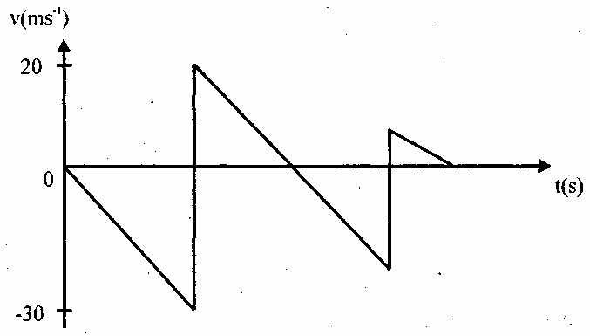**03. A small ball of mass 0.1 kg is dropped from rest at**

t = 0 onto a horizontal floor. The ball was initially at a height H from the floor, and it bounces back vertically after each and every col­lision. Figure shows a portion of the velocity (v) - time (t) graph of the ball, (i) Neglecting air resistance and the upthrust, calculate the following for the ball.

(a) The initial height H.

(b) The change in momentum of the ball, and the , momentum transferred to the floor at the first collision.

(c) The value of t at which the second collision occurs.

(ii) If the collision between the ball and the floor is perfectly elastic, draw the v - t graph for this motion.

(iii) A particle of mass 6 x 10-26kg in an empty cubical box of side length 1 m is made to move back and forth, while making collisions with two opposite walls of the box normally. The collisions between the particle and the walls are perfectly elastic, and the speed of the particle is 2 x 103 m/s (Assume that the gravitational force on the particle is negligible.)

(a)Calculate the rate at which the particle collides with one of the two walls.(b) What is the rate at which the particle transfers momentum to that wall? (c) Suppose that the box contains 2 x 1023 such particles performing the same motion mentioned above. Assume also that these particles do not make collisions among them­ selves, and that the collisions are uniformly distributed over the entire area of the wall. Calculate the pressure exerted by the particles on one of the two walls**.**

04.**(a) In an open space wind is blowing along a horizontal direction at a constant velocity V. A Considering that the density** of air is ρ find the kinetic energy per unit volume of moving column of air. (b) The kinetic energy of the wind can be used to rotate the blades of a windmill and the energy thus extracted from the wind can be converted to electricity. Consider a situation where the wind blowing normal to the plane of rotation of the blades in a windmill. The area swept by a rotating blade is A. Assuming that all the kinetic energy of the wind blowing through a cross sectional area A could be extracted by the blades, show that the rate at which the wind energy is transferred to the windmill is ½ρAV3.

(c) If A = 50 m2, V = 10 ms-1, ρ = 1.2 kgm-3 and the windmill converts its mechanical energy to electricity with an efficiency of 20 %. find the power output of the windmill. Hence find the minimum number of windmills of the above capacity that would be required to generate electrical power equivalent to the power output of the Kotmale hydro power station. The generators at Kotmale power station produce approximately 135 MW of electrical power. (d) If the mechanical energy produced by the windmill mentioned in (c) is directly used to drive a mechanical water pump with 60% efficiency, what is the maximum volume of water that can be pumped per hour to a height of 100 m? Assume that the speed of the wind is constant during the period. [Density of water 1000 kgm-3 .