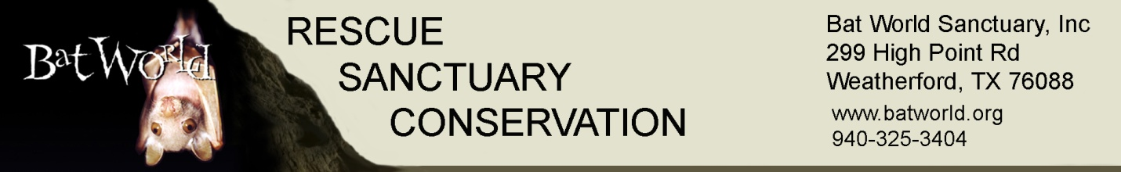

Custom Bat Rehabilitation Workshop Request
Please read the sample proposal on our National Workshops page for planning guidance and host responsibilities. Please note we require at least six months lead time to schedule a custom workshop.
Name of Hosting Organization: ___________________________________________________
Contact Name: ________________________________________________________________
Contact Phone: ________________________________________________________________
Contact email: _________________________________________________________________
Location: _____________________________________________________________________
Location Address: ______________________________________________________________
Desired Date(s): __________________ ____________________ ____________________
(Please provide three date options for your workshop)
Based on the planning guide, confirm you are able to provide:
Minimum of 12 attendees (maximum 24). _____
Meeting room. ______
Cadavers (minimum one per attendee plus 2 for instructor). ______________________________________________________________________________

Live bats, if available. ____________________________________________________________

Instructor fees and shipping costs as outlined in the planning guide. ______________________

