Power Hour

**Prayer Guide**

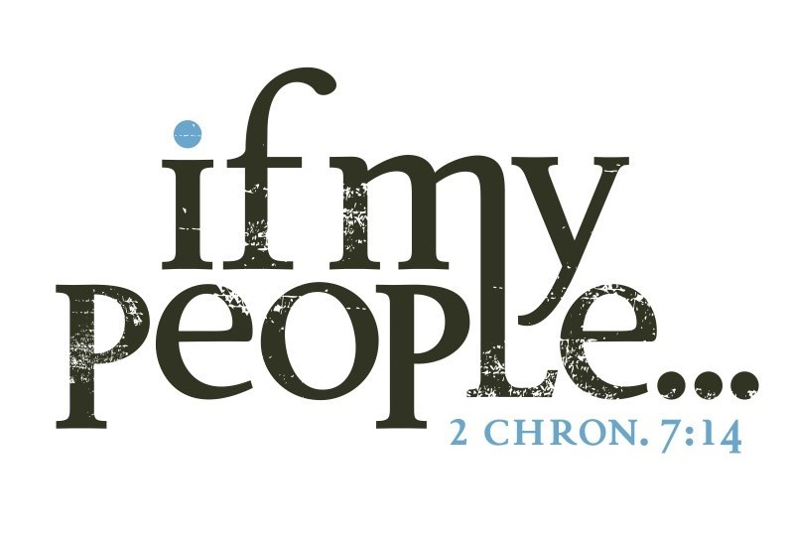**Healing**

**October 2021**

# Praying through each day

Prayer works! Prayer changes lives, changes situations, changes things; prayer is powerful.

E. M. Bounds, the great prayer warrior and intercessor said,

“Four things let us ever keep in mind:

God hears prayer, God heeds prayer,

God answers prayer, and God delivers by prayer.”

So let me encourage you as you use these pages, these Bible verses, pray with faith, believe for the impossible and trust God to keep to his promises.

To help you prayer why don’t you try to following?

1. Spend a few moments in thanksgiving and praise, focusing on Jesus and the goodness of God.
2. Ask Jesus to fill you with his Holy Spirit
3. Open your Bible and

 Read the texts out loud.

 Spend sometime thinking about the text.

 Pray the text back to God and what he has shown you.  Wait on God to hear what he will say to you.

1. Finish with thanksgiving or maybe finish by saying the Lord’s Prayer.

Be blessed and let’s believe together, pray together, expect together and rejoice together as we see God answer prayers and bring breakthrough, blessing and His Glory.

Pastor Ian

# Friday

**“Prayer breaks all bars, dissolves all chains, opens all prisons, and widens all straits by which God’s saints have**

## been held.” E. M. Bounds

**Matthew 4:23, 24** 23 Jesus went throughout Galilee, teaching in their

synagogues, proclaiming the good news of the kingdom, and healing every disease and sickness among the people. 24 News about him

spread all over Syria, and people brought to him all who were ill with various diseases, those suffering severe pain, the demonpossessed, those having seizures, and the paralyzed; and he healed them.

**Matthew 8:16, 17** 16

When evening came, many who were demon-possessed were brought to him, and he drove out the spirits with a word and healed all the sick. 17 This was to fulfil what was spoken through the prophet Isaiah:

“He took up our infirmities and bore our diseases.”

…………………………………………………………………………………………………….

…………………………………………………………………………………………………….

…………………………………………………………………………………………………….

…………………………………………………………………………………………………….

…………………………………………………………………………………………………….

*Jesus heals all. Jesus delivers all.*

# Thursday

**“The possibilities of prayer run parallel with the promises of God.”**

## E. M. Bounds

**Lamentations 3:19—26** 19 I remember my affliction and my wandering, the bitterness and the gall. 20I well remember them, and my soul is downcast within me. 21 22

Yet this I call to mind and therefore I have hope: Because of the Lord’s great love we are not consumed, for his compassions

never fail. 23They are new every morning; great is your faithfulness.

24 I say to myself, “The Lord is my portion; therefore I will wait for him.” 25The Lord is good to those whose hope is in him, to the one who seeks him; 26it is good to wait quietly for the salvation of the Lord.

…………………………………………………………………………………………………….

…………………………………………………………………………………………………….

…………………………………………………………………………………………………….

…………………………………………………………………………………………………….

…………………………………………………………………………………………………….

…………………………………………………………………………………………………….

…………………………………………………………………………………………………….

…………………………………………………………………………………………………….

*God is faithful, loving, and compassionate.*

# Monday

**“The secret of prayer and its success lie in its urgency.**

## We must press our prayers upon God.” E. M. Bounds

**Isaiah 53: 2– 6** 2

… He had no beauty or majesty to attract us to him nothing in his

appearance that we should desire him. 3 He was despised and

rejected by mankind, a man of suffering, and familiar with pain. Like one from whom people hide their faces he was despised, and we

held him in low esteem. 4 Surely he took up our pain and bore our

suffering, yet we considered him punished by God, stricken by him,

and afflicted. 5 But he was pierced for our transgressions, he was crushed for our iniquities; the punishment that brought us

peace was on him, and by his wounds we are healed. 6 We all, like

sheep, have gone astray, each of us has turned to our own way; and the Lord has laid on him the iniquity of us all.

…………………………………………………………………………………………………….

…………………………………………………………………………………………………….

…………………………………………………………………………………………………….

…………………………………………………………………………………………………….

……………………………………………………………………………………………………. ……………………………………………………………………………………………………. …………………………………………………………………………………………………….

*Jesus carried all our sins, sorrows, and sickness.*

# Tuesday

**The Church is looking for better methods; God is looking for better men. The Holy Ghost does not flow through methods, but through men. He does not come on**

**machinery, but on men. He does not anoint plans, but men…Men of prayer.**

## E. M. Bounds

**Mark 1:32-34** 232 That evening after sunset the people brought to Jesus all the sick and demon-possessed. 33The whole town gathered at the door, 34and

Jesus healed many who had various diseases. He also drove out many demons, but he would not let the demons speak because they knew who he was.”

## Acts 10:38

“how God anointed Jesus of Nazareth with the Holy Spirit and power, and how he went around doing good and healing all who were under the power of the devil, because God was with him.”

…………………………………………………………………………………………………….

…………………………………………………………………………………………………….

…………………………………………………………………………………………………….

…………………………………………………………………………………………………….

…………………………………………………………………………………………………….

…………………………………………………………………………………………………….

*Jesus is our healer and deliver by the power of Spirit.*

# Wednesday

**Prayer succeeds when all else fails.**

## E. M. Bounds

**Jeremiah 32:17, 26, 27** 17 “Ah, Sovereign Lord, you have made the heavens and the earth by your great power and outstretched arm. Nothing is too hard for you.

...26Then the word of the Lord came to Jeremiah: 27 “I am the Lord, the God of all mankind. Is anything too hard for me?”

…………………………………………………………………………………………………….

…………………………………………………………………………………………………….

…………………………………………………………………………………………………….

…………………………………………………………………………………………………….

……………………………………………………………………………………………………. ……………………………………………………………………………………………………. …………………………………………………………………………………………………….

…………………………………………………………………………………………………….

…………………………………………………………………………………………………….

…………………………………………………………………………………………………….

……………………………………………………………………………………………………. ……………………………………………………………………………………………………. …………………………………………………………………………………………………….

…………………………………………………………………………………………………….

*Nothing is to hard for God!*