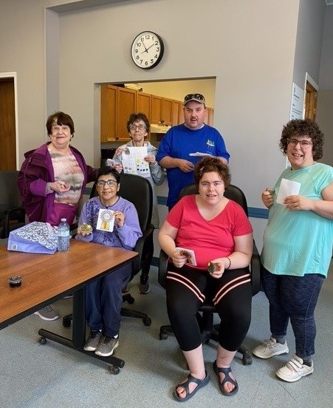  2023 - 2024  34th  Annual report  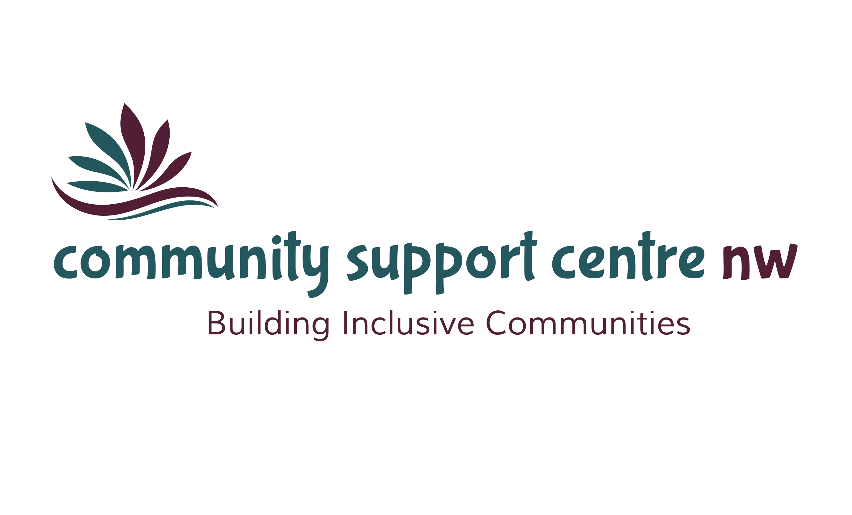 | Mission  Providing quality, innovative, client-centered programs and services to enrich the lives of the individuals and families we support.  Vision  Where everyone feels valued, connected, included and empowered.  Land Acknowledgement  Community Support Centre-NW operates on the original lands and territories of Treaty 3, the traditional land of the Anishinaabeg people. We also recognize our Meti Nation that shares the spiritual history of this land.  We acknowledge and appreciate the aboriginal peoples who have been stewards of this land and as guests, we commit to honour our responsibilities and uphold the Treaties that were signed here.  ──── Volunteerism  Education  Respect  Integration  Inclusive Community  Accountability  Progressive, Proactive and Forward Thinking  Advocacy

Board of Directors

2023 - 2024

Kim Douglas Chairperson
Carlynne Bell Vice Chairperson
Heather Corner Secretary
Shannon Wogenstahl Treasurer
Heather Cranney Director
Staff

Executive Director: Debbie Dokuchie
Financial Administrator: Margaret (Peggy) Howard
Community Programs Supervisor: Nikki Zajarny
Supervised Access Program Coordinator: Karyn Haney
Supervised Access Team Leader: Joni Alexander
Administrative Assistant: Denelle Riives
Office Cleaner: Kurissa Langner
Community Connectors: Charlie Barton Kandi Strand Joanne Lupien
Heather Ames Joylyn Forsythe Brenna Reimer
Kim Korolenko Elisha Thompson Megan Warren

Supervised Access Workers: Heather Madussi Denelle Riives Lori Clendenning
Jessica Alcock Elaine Kaiser Jackeline Cansick
Calie Clendenning Donna Dryden Emma Ankney
Lesley Norman Paige Sidney

Executive Director / Board Chair Report

As a multi-service organization, our past year was a blend of both successes and challenges. While funding and recruitment presented some challenges, the services we provided were successful, meaningful and met the needs of the individuals and families we serve.
In July 2023, the Agency and UNIFOR Local 324-18 agreed upon a three-year contract which will be in effect until July, 2026. Unionized employees in Dryden, Kenora and Fort Frances voted one hundred percent in favour of the contract. Negotiating was a positive and congenial process as we continue to strive to provide fair compensation within our budget constraints.
The Ministry of Children, Community and Social Services announced its long-term vision for developmental services reform. Entitled “Journey to Belonging - Choice and Inclusion”, the plan will be phased in over the next several years. Much work is needed to prepare for the anticipated changes necessary to meet the key elements of the plan, which will include a new funding model based on people’s assessed needs.
The Agency continues to host the Inter-Agency Committee. Meetings are well attended by service providers from various sectors, which provides an opportunity to share information and build solid relationships with our service partners.
Christmas Cheer 2023 had another successful season. Every year we are amazed by the generosity of our community members. We received positive feedback from both the donors and recipients regarding the change from food and toys to gift cards enabling the recipients to purchase the items that they need. We provided support to 322 families and 236 children in Dryden and the surrounding area.
The staff are the heart and soul of the Community Support Centre-Northwest. They are a source of talent, ideas and energy and are always committed to providing the best possible service. We thank them for all that they do.
Thank you to our Board of Directors who continue to provide invaluable guidance. Each member brings a unique perspective, and we are grateful for their support.
As we look toward the future, we recognize that for the Community Support Centre-Northwest, change is and will continue to be constant. Despite this, we look forward to the coming year of on-going success and accomplishments.
Respectfully,
Kim Douglas Debbie Dokuchie
Board Chairperson Executive Director

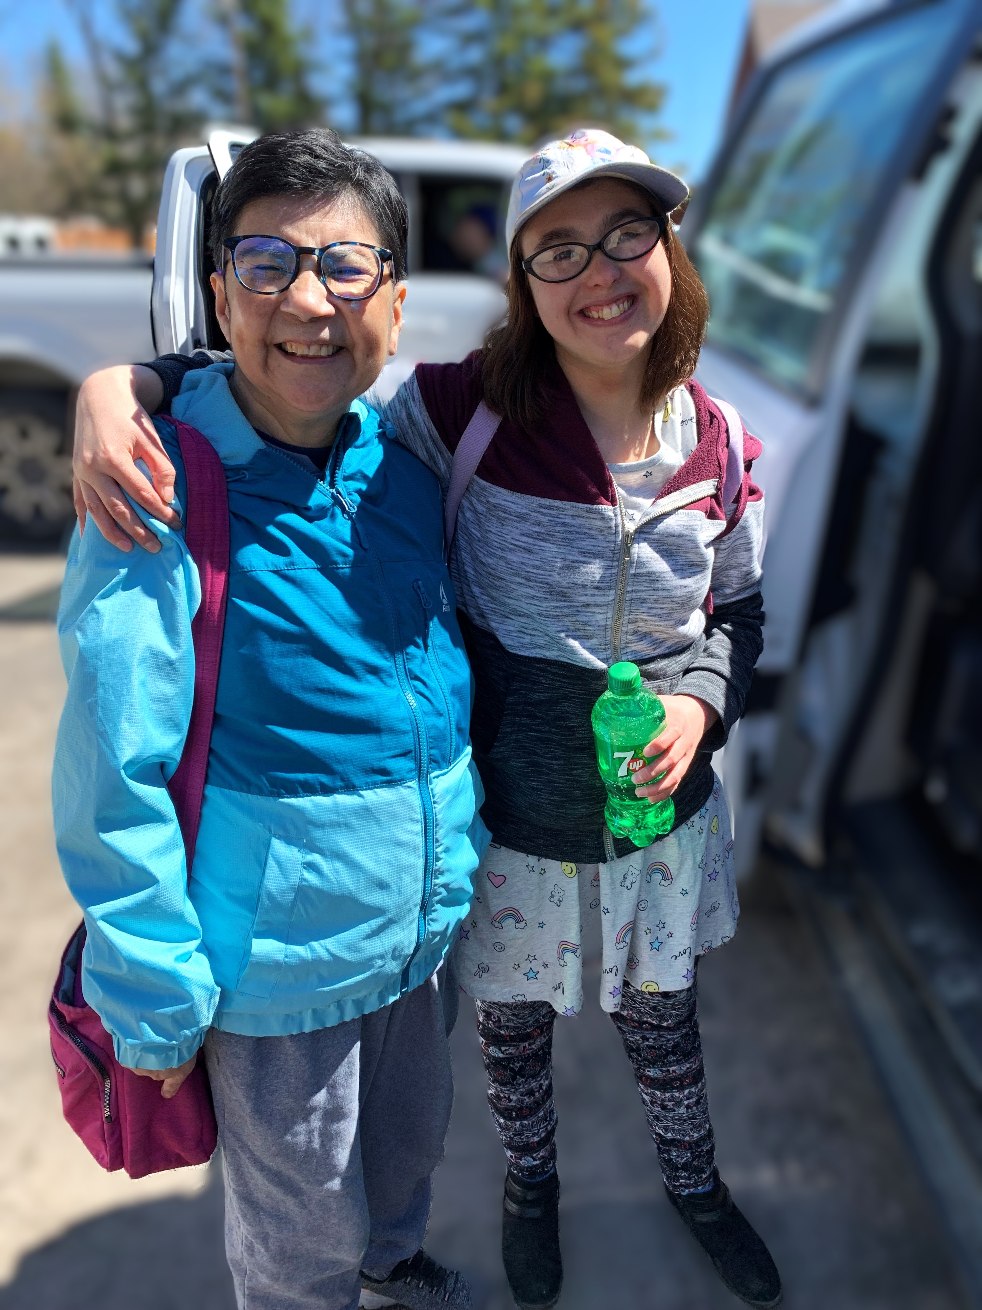

Passport Program
Passport is a funding program to help adults with a developmental disability to live more independently. Families and individuals can choose to purchase services from the Agency with their Passport funding.
We work closely with individuals to provide services and supports tailored to their interests and needs.
Community Support Centre-NW provides administrative and brokerage services for all or part of Passport funding.
15 Individuals Served
2346 Service Hours

Community Participation and Supports
The Community Participation and Supports program connects adults with a developmental disability to their community through recreation, leisure and skill building activities. Supports are provided to allow individuals to participate in a wide variety of opportunities. Access to the program is through Developmental Services Ontario – Northern Region.
55 Individuals Served 7612 Service Hours

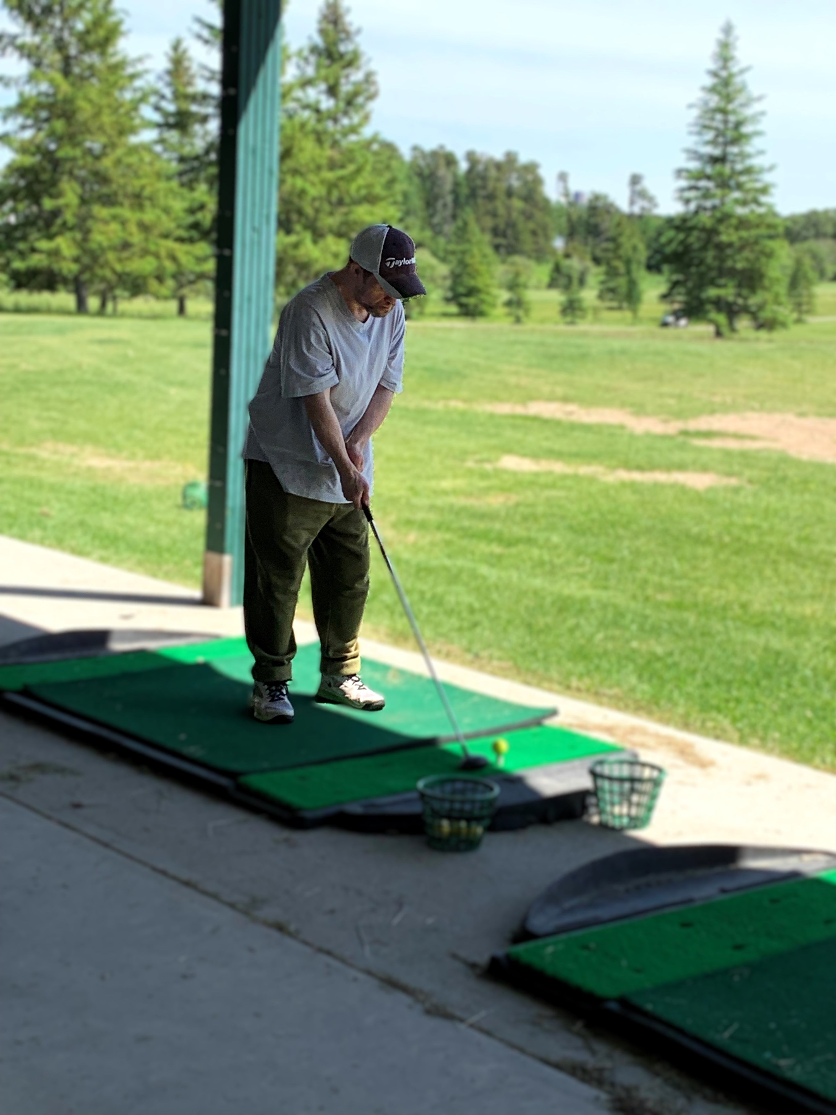

Specialized Respite Services
Specialized Respite is a fee-for-service program for children and youth. We provide respite services to families and foster caregivers. Fees can be paid by the family or another involved service provider such as child welfare agencies, children’s mental health or government funded programs.


87 In-Person Visits
110 Virtual Visits
79 Exchanges

Christmas Cheer
Assisting families in need of assistance due to limited finances. Christmas Cheer is a holiday distribution program accomplished through a coordinated effort of charities, businesses, service clubs, community members and volunteers.
322 Families 236 Children

12 Individuals Served
3046 Service Hours

Supervised Access Program
The Supervised Access Programs helps children and their families through difficult periods following a separation or divorce. We provide a safe, child-focused, neutral environment for visits or exchanges to take place between children and their visiting parents or relatives under the supervision of trained staff. We ensure that the situation is safe and comfortable for all participants. Visiting sites are located in Dryden, Kenora and Fort Frances.


Financials
Year Ending March 31, 2024

Revenue
Ministry of Community & Social Services 658,209
Fee for Service & Other Revenue 139,174
Fee for Service – Passport 83,161
Fundraising – Donation 100
Fundraising – Cheer 67,538
Miscellaneous 973
949,156

Expenses
Bad Debts 1,115
Salaries and Benefits 738,563
Supplies/Equipment 88,856
Building Occupancy/Maintenance 47,716
Training 10,184
Travel 49,849
Other Program Expenditures* 22,249
958,532
Deficiency of revenue over expenses (9,376)

*includes audit costs

 OUR SERVICE PRINCIPLES

Respect
We believe that every individual has the right to their own values, beliefs and individual choices.

Inclusion
We believe that every individual should be accepted and treated equally as a valued member of the community and are entitled to participate fully and enjoy the same quality of life as all community members.

Collaboration
We believe in the importance of working collaboratively with our service partners to achieve the best outcomes for the people we support.

Accountability
We believe in being fiscally responsible and demonstrating transparency and ethical decision-making.

Innovation
We believe in developing an organizational culture that supports opportunities for learning, growth and development and values the contributions of the individuals we support, their families, the staff and the broader community.

53 Arthur Street
Dryden, ON
P8N 1J7
Phone: 807-223-5995
Fax: 807-223-8370

1422 Highway 17 East, Unit #7
Kenora, ON
P9N 1M2
Phone: 807-468-6021

525 Mowat Avenue
Fort Frances, ON
P9A 1Z1
Phone: 807-274-0110

Toll Free: 1-844-523-8825

Website: www.communitysupportcentre.com



