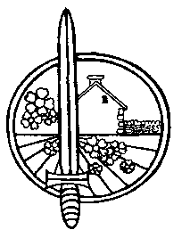
Letham Feuars committee, 15 The Square, Letham, DD8 2PZ lethamfeuars@gmail.com
SC003197

COMMITTEE NOMINATION FORM
For election of member/trustee of Letham Feuars committee *See below

Candidate name

Home address (within the original boundaries of Letham)

Contact details
Tel: Email:

I confirm that I am aware of the duties and responsibilities of becoming a trustee of the Letham Feuars committee, a registered charity (SC003197), and that I will always act in the interests of the charity.
Signature:

Proposer:

Seconder:

Personal statement

As a committee member/trustee of Letham Feuars committee, you could take part in any or all of the following activities. Please detail which of the following skills/qualities you possess, or have experience of, which may benefit the charity if you were to be elected as a trustee.

- Website/social media administration
- Archiving/record keeping
- Funding applications and associated research
- Organisation of community events
- Practical skills such as Xmas lights, repairs, decoration, catering etc.

A personal statement is not an absolute requirement to become elected as a committee member/trustee, however if you wish please include below a short paragraph or two outlining the qualities, skills, knowledge or experience you would be able to bring to the charity.

Date protection: Data will not be stored electronically and will only be used for the purposes of election of a committee member/trustee.

