The Effects of Sea-Level Rise on Barrier Island Systems Along the East Coast

of the US and Community Resiliency to Adapt

Britton Hartzok M01091692

ESCI 579

Dr. Vaillencourt

Millersville University

November 30th, 2020

I. Interpretation
Dating back to early civilizations, humans have congregated near lowland regions, river deltas, and estuaries because of their abundance of food, water, and resources (Stanley & Warne, 1997). Later, easy access to sea routes allowed for developed societies to explore, trade, and prosper. In these past 3000 years, sea levels have remained relatively stable which have allowed modern communities to colonize further into the continental shelf than ever before (Williams, 2013). However with the advent of the Industrial Revolution, global sea levels began rising at a rate of 1.7 mm/year (Fig.1) (Williams, 2013). As of 2013, the average global rate of SLR was around 3.1 mm/year (Williams, 2013). By the end of the 21st century, various model projections estimate global sea levels will increase by about 1 meter (Fig. 2). This prediction is especially discomforting considering 10% of the world’s population lives within 10 meters of sea level (McGranahan, et al., 2007).
The two primary causes of rising global sea level (GSL) are melting continental ice deposits and thermal expansion - heat transfer from the atmosphere to ocean surface waters (IPCC, 2007). Contributions from each are shown in Table 1. Eustatic or absolute mean sea level are used interchangeably to describe global SLR and don’t reflect changes observed at the local level. Coastal planners and municipal engineers address community resiliency to SLR and require a very precise measurement of sea-level rise in their area. In this case, it is more appropriate to measure local relative sea level (LRSL) - determined by studying tidal gauge records and the smaller-scale geophysical processes specific to that coastal system (Williams, 2013).
LRSL is affected by coastal land subsidence (settling/compaction of organic sediments, displacement caused by groundwater withdrawals from continental aquifers), sediment losses (riverine entrapment from dams or loss to other systems), and erosion from wave and tidal energy (Eggleston & Pope, 2013). LRSL differences are widely distributed and highly variable (Fig. 3). While the Pacific Coast of the US has seen a decrease in LRSL, the East Coast and Gulf communities are increasingly vulnerable to SLR because of their low relief, shallow river deltas, and long barrier island chains (Williams, 2013). For example, ocean levels in the Outer Banks (NC) have risen at a rate of 3 to 3.3 mm/year over the 20th century - 1 mm/year of background rise at the global level plus 2.2 mm/year of abrupt change beginning with the Industrial Revolution (Kemp, et al., 2009). Fig. 4 highlights future vulnerability of the Outer Banks and its low coastal wetlands.
Thanks to global warming, we now live in a world of extremes. Due to natural and anthropogenic changes to global temperature, coastal regions are at greater risk of flooding from extreme tides and storm surges caused by increased frequencies of high energy weather events (FitzGerald, et al., 2008). When appraising the impacts of SLR, it is best not to misrepresent SLR as only coastal inundation, but as a reduction in our resiliency to withstand major episodic weather events. As a result of SLR, storms of any magnitude will reach higher elevations, penetrating deeper inland (FitzGerald, et al., 2008). Even in areas that only see the occasional tropical storm, warmer ocean surface temperatures will exacerbate storm strength leaving many locales woefully underprepared (Webster, et al., 2005). As sea levels rise, coastal protection barriers already in place will be less effective and in greater risk of failure. Levees will breach, storm walls will be topped, and our precious barrier islands will continue to shrink. Consider Fig. 5 which highlights coastal vulnerabilities to SLR under 3 different projections.
Barrier islands make up around 15% of the world’s coastlines and can be found on every continent (except Antarctica), in every geological setting, and in any climates (Davis, 1994). Their ideal environment is a submerging coastline in the low to middle latitudes in areas within the microtidal (<2m) to mesotidal (2-4m) range (Hayes, 1979). Often running parallel to the coastline as one chain or groups of chains, the longest barriers in the world correspond to Amero-trailing coastlines - such as the Atlantic and Gulf coasts of the US (FitzGerald, et al., 2008). Miles Hayes (1979) classified barrier islands based on their wave energy and tidal range:
a) Wave dominated, which are a result of wave generated sediment transport. They consist of long chains of island with sparse tidal inlets that guard large lagoons or bays - such as the Outer Banks or northern New Jersey (Hayes, 1979).
b). Mixed-energy, which were formed and are shaped by wave and tidal processes. These barrier islands are more segmented, have many tidal inlets, and backbarrier regions are made up of tidal marshes and creeks - such as the coasts of South Carolina, Georgia, and Virginia (Hayes, 1979).
From various views, Fig. 6 illustrates the features of the barrier island system including the tidal inlet, dune complex, and backbarrier. Tidal inlets are openings within the barrier chain that allow mixing of ocean water with the lower salinity waters of the backbarrier system - bays, lagoons, tidal creeks, and marshlands (FitzGerald, et al., 2008). Fig. 6 also depicts the physical mechanisms that threaten barrier island chains. It is these processes that cause the landward retreat of barriers and threaten the estuarine ecosystem it protects. Three major forces of barrier island morphology are:
a) Washovers - During storm surges and extreme tidal events, the beach face and nearshore regions of the dune erode. Seen in Fig. 7, ocean water carries sediment over and through the dune complex where it deposits into overwash fans and terraces (McGowen & Scott, 1975). This process is the primary driver of barrier-island sediment budgets (Donnelly, et al., 2006). In the backbarrier, if sand accumulates faster than the vertical accretion rate of plant life, estuaries and marshland become impaired or disappear altogether (FitzGerald, et al., 2008). Through aerial analysis and core sample inspection, Conery, et al. found that Hurricane Isabel (2003) had overwashed 9% of Ocracoke island at an average thickness of 0.24 meters (Conery, et al., 2018). In addition, they believe this one event is linked to 23% of the net change to the shoreline seen since then (Conery, et al., 2018).
b) Breaching - often a direct result of hurricanes, the barrier will breach creating a tidal inlet which facilitates net transport of sediments from the shoreside of the dune to the backbarrier (Leatherman, 1979). Barrier breaching and tidal inlet formation exacerbate barrier segmentation which widens inlets overtime and contributes to the formation of tidal deltas and shoals (FitzGerald & Montello, 1993). Fig. 8 highlights the different stages of barrier decline as a result of sea level rise.
c) Wind Transport - loose, dry sediment is blown over the barrier by sea-land and land-sea breezes causing migration or morphing of the entire dune system (Jones & Cameron, 1977).
For decades, scientists have worked to condense these processes into one predictive model. Although much more complicated models are available today, Dean & Maurmeyer (1983) modified the original Bruun Rule (1962) to include barrier systems. They generalized Bruun’s observations into an equation that not only considers erosion but also accretion (Eq.1 and Fig. 9). Progress in the area of barrier modelling has greatly helped to inform local municipalities of future local risk. However, models are only accurate with a consistent supply of sand. Today, many sediment banks are net negative or have been lost to other systems. Dam construction entraps sediment and prevents flow to river deltas, engineered shoreline structures prevent a natural exchange of erosion and accretion, and sand deposits aren’t being transported onshore from the continental shelf (Pilkey & Cooper, 2007).
Today, scientists have widely acknowledged the influence of SLR on barrier island chains. Shao et al. (1998) defined shoreline migration as a function of four variables: sea-level rise, sediment supply (mostly as a result of long-shore transport), wave energy (tidal and storm events), and human intervention such as shore protection structures and beach renourishment projects (Eq. 2). Shoreline migration as a consequence of rising oceans was further supported by recent research conducted along the eastern shore of Virginia where the majority of barrier island erosion was correlated to storm events and sea-level rise (Hamilton, et al., 2017).
As sea levels change and barrier islands move landward, estuaries and marshlands begin to disappear either through submersion or the intrusion of salt water (Deaton, et al., 2017). Coupled with beachfront erosion, this scenario is worrisome because it means that land is being lost on both sides of the island (Deaton, et al., 2017). As marshes begin to disappear and are replaced by open water, tidal inlets widen and lead to increased sand sequestration to tidal deltas and shoals, while at the same time leading to segmenting and narrowing of nearby shorelines (FitzGerald, et al., 2008). In time, some barrier islands will drown resulting in their reclassification as subaqueous sand shoals (Williams, 2013). Warning signs of barrier island regression (Gutierrez, et al., 2007):
-Increased rate of landward migration
-Decreased width and relief. Smaller dunes are more susceptible storm erosion (Houser, 2018).
-Greater frequency and intensity of overwashing
-Greater incidences of breaching and widening of inlets
-Chain has become more segmented

II. Analysis
Environmental/Economic Argument for Barrier Preservation
Barrier islands are of supreme ecological importance. Dune complexes provide breeding ground for wildlife such as sea turtles and coastal birds. Under the protection of barrier islands, estuaries and marshes of intracoastal systems are extremely productive and efficient ecosystems. By absorbing kinetic energy, they prevent erosion and stabilize sediments (Epanchin-Niell, 2016). They act as a sink to carbon and other pollutants, provide valuable foraging and breeding grounds for various organisms, and offer resting habitat for migratory birds (Epanchin-Niell, 2016). Increased inundation of oceanwater to these areas will result in higher salinity in rivers and bays forcing free-moving creatures to adapt or migrate and non-motile life to die-off (Scavia, 2002). These areas only exist because of the protection provided by barrier islands. As this protection decays, so too does the ability of this ecosystem to perform its fundamental functions - which humans rely heavily on.
As sea level rise threatens our coastal ecosystems, it also threatens the livelihood of those that work in marine and tourism industries. Coastal systems, such as the barrier islands off the eastern shore of Virginia, provide a robust habitat for commercial fishing and aquaculture (Rood, 2012) and prop up a tourism and recreation industry that benefits the state of Virginia and greater Mid-Atlantic region (Kirley, 1997).
Historically, barrier islands have acted as natural breakwaters, buffering the mainland from coastal Atlantic storm systems. They act as levees preventing or softening the effects of tidal surges while absorbing high energy wave action. On the East Coast of the US alone, total property values are estimated to be over $3 trillion (Evans, 2004). By monetizing the annual storm protection value offered by coastal wetlands, barrier islands and their estuaries are worth $8,235/hectare (Epanchin-Niell, 2016). At the local level, a 2017 study found that future sea level rise projections for Assateague Island (VA) would result in $141,894,898 in damages to infrastructure and cultural assets (Deros, 2017).
Arguments for Natural vs. Human Altered Barrier Islands
Paris & Mitasova (2018) published a study on barrier island morphology at Ocracoke Island and Core Banks, both located in North Carolina’s lower Outer Banks (Fig. 10). Ocracoke was used to represent a human-altered island with a small community and engineered protective dune system. Core Banks was considered a specimen barrier islands, relatively intact in its natural state. They came up with three findings. First, geomorphology around the tidal inlets is driven by the sedimentary process of the inlet and mostly behaves independently of the dune protection systems at Ocracoke (Paris & Mitasova, 2018). Two, common to the narrower Core Banks, there appears to be a critical point in island width below which overwashing and erosion begin to deteriorate the dune complex (Paris & Mitasova, 2018). Lastly, since the protective dune system was installed in the 1950s, shoreline erosion and the counterclockwise migration of Ocracoke Island has been reduced by 40% (Paris & Mitasova, 2018).
Conversely, there is evidence that human manipulation of barrier island systems (either through development or engineered shoreline defenses) have significantly influenced coastal morphology and in some cases are counterproductive to coastal management strategies (Pilkey & Neal, 2002). Over centuries, barrier islands have naturally eroded, drifted, shifted, and replenished themselves. Human influence has interrupted these natural processes which otherwise work towards a state of equilibrium with the wind, water, and land (Riggs, et al., 2004). Pilkey & Neal (2002) concluded that coastal development necessitates the introduction of shoreline defenses at the expense of disrupting natural geomorphic processes. Man-made solutions, whether permanently engineered barriers (jetties, seawalls, breakwaters) or periodic beach renourishment projects, are costly and don’t offer a viable permanent solution (Valverde, et al., 1999). Under rising sea levels, a jetty that functions as intended today may offer little protection in the future while still impeding subaqueous sedimentation.
By studying LIDAR surveys, Meredith, et al. (1999) discovered that regions north of the Ocracoke Inlet experienced the most severe erosion losses in the aftermath of Hurricane Bonnie. However, barrier regions south of the Ocracoke Inlet were impacted the least. This is significant because areas north of the inlet were fortified by artificially created foredunes - Ocracoke and Hatteras Islands . Areas south of the inlet were naturally maintained - Core Banks. In addition, Core Banks was actually closer to Bonnie’s landfall.
It has been asserted that protective dune systems found in Hatteras and Ocracoke act more like ‘fort walls’ - promoting continued development of coastal communities while diminishing the natural geomorphic processes (Riggs, et al., 2008). At Core Banks, where there are minimal human influences, the sediment exchange system adapts to sea level and storm events through a slow-paced migration landward while at the same time growing in width and elevation (Ames & Riggs, 2009). Sand dunes, like any living creature, adapt to changes in their environment by defensively preserving their themselves. Further north in Cape Hatteras, storm events routinely wash out the main artery of the southern Outer Banks - NC Highway 12. Continuous efforts to keep the road open, while correcting one vulnerability, have created another by narrowing other nearby stretches of beach (Smith, et al., 2008).
To accommodate infrastructure and high-rise oceanfront buildings, the most heavily developed barrier islands (such as Ocean City, MD) have been constructed on a lower relief. However, because they haven’t been engineered to support a community, undeveloped beaches are naturally higher in elevation (Dinan, 2017). Therefore, with increasing sea levels, high value properties in developed beach towns are under risk of flooding during high tides and storm surges. Over time, undeveloped beaches are better postured to evolve with a changing climate.

III. Inference:
Though once conserving mass, barrier island systems in the eastern US are out of equilibrium and experiencing a net loss in their sediment supply. This change has been brought about by accelerated eustatic and local sea-level rise as well as increased coastal human development. Losses of barrier island systems will result in a loss of estuaries and marshland which are of extreme economic and ecological value to humankind.
IV. Evaluation
Sources for these arguments were all published in either peer-reviewed journals, university libraries, conference presentations, or government reports. These researchers have upheld a level of ethics and due-diligence expected within the scientific community.
Although some of the presented findings contradicted the conclusions found in other studies, this could be attributed to the different temporal and spatial scales in which the research was conducted. Meaning, conclusions drawn about barrier islands in the Outer Banks might have been different than findings from Assateague because:
-Assateague is a mixed-energy system whereas the Outer Banks are wave dominated
-They exist at different latitudes and have a unique local geomorphology
-Single hurricane events have been known to dramatically and permanently change the characteristic behavior of a barrier system. Over time, each location has been influenced by different storms
-Each is of different width and pitch and has been developed to varying degrees
Conversely, although some studies were performed in nearby locations, their methodology varied greatly. One research project (Paris & Mitasova, 2018) examined overwash from a single hurricane by analyzing dune core samples in various locations around Ocracoke Island. With such a relatively small sample size, it’s hard to draw a practical conclusion. However, another publishment (Conery, et al., 2018) surveyed this region from the air by studying changes over time in LIDAR images - a much more conclusive, rigorous methodology for measuring overwash.

V. Explanation
Sea level rise has been heavily documented for over a century. Although historically measured through tidal gauges, scientists are now able to study global SLR more accurately and on a greater scale through satellite altimetry- although LRSL research still relies heavily on local tidal changes. Coastal cities and beaches are susceptible to the gradual effects of SLR, as well as the acute threat of devasting tropical storm systems. The urgency to protect barrier island systems is should be measured in decades (not centuries). In a best case scenario, undeveloped barrier islands will begin a slow migration landward. In more extreme situations, developed barrier communities will experience higher rates of erosion than can be naturally replenished - leading to large scale property losses (Fig. 11). Beach renourishment is only a short-term solution, and with sediment banks becoming increasingly scarce, this makes dredging increasingly and prohibitively expensive. Engineered shore protections might provide defense from coastal erosion in the short term, however these practices have only encouraged the rate of beach front development to unsustainable levels. In reality, these measures only really guard against inundation, tidal flooding, and moderate storm surges. The future schema, in our warming climate, includes high frequency, high energy coastal storms resulting in major losses of life and property.

VI. Self-regulation:
I did a good job of summarizing the findings of many other researchers and strived to accurately interpret and report their results. To improve, I would find data that is more up-to-date. Some of the journals were a decade old. Although there is a strong consensus on the topic and science is always evolving, I do know that new SLR models are haven introduced and projections have changed. Because of my basic understanding of coastal engineering or oceanography, a number of the publications were beyond my level of comprehension. I really had to boil down the results of each journal to get to the crux of the issue. In most cases, my sources were highly respected and heavily cited within this field. However, I did come across a published master’s thesis from Gettysburg College. Although I avoided quoting the authors directly, I did use their work to mine for secondary resources.
Overall, I think my investigation has its strong suits, but I feel there was some redundancy in my argument. In addition, I’d like to better support the impact of SLR on barrier islands rather than simply emphasize their morphological behavior. Also, when I set out on this investigation, I decided to narrow my focus primarily on the Atlantic coast. Upon reviewing the literature and other articles on the topic, I think I could have nicely tied in some research from the Gulf coast as well. I found many similarities there with East Coast barriers.

VII. Summary and Conclusions.
The East Coast of the US is home to some of the longest stretches of barrier islands in the world. Over millennia, these islands have experienced a delicate cycle of erosion and accretion, which relies heavily on sediment availability and the energy of its transport system. However, owing in some cases to their narrow width and low relief, barrier islands are especially susceptible to sea level rise - as a result of natural and human-induced climate change. Due to specific geophysical and oceanographic characteristics, the impacts of sea level rise are expected to be severe on the East Coast of the US. In addition, the extreme pressure of human development here has made it increasingly difficult for community planners to protect infrastructure. Figure 5 highlights just how dire the situation is. Future implementation of coastal engineering structures and beach renourishment projects, if well planned and executed, will provide some protection from SLR associated island erosion in the short-term. However, the best long-run strategy would be to pursue policies and practices that discourage further development. The National Flood Insurance Program (NFIP) could be amended so that insurance companies aren’t salivating over the federal payout they’ll receive with the next catastrophe. Individual insurance premiums could reflect the actual risk of a property’s location. In addition, the federal government could stop awarding tax incentives for second homes built in highly vulnerable areas. Finally, local and municipal planners can pursue sustainable coastal defenses projects that are practical and realistic and don’t inadvertently encourage more beach-front development.

VIII. Figures and Tables
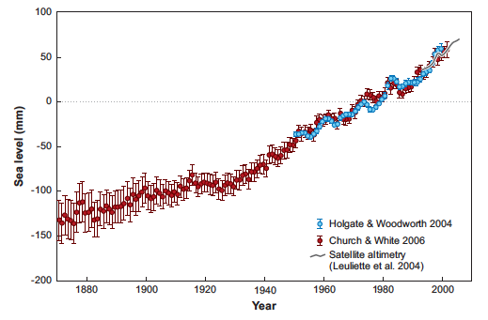
Figure 1: Annual averages of global mean sea level dating back to the early 1800s. Error bars represent 90% confidence intervals and gray curve represents satellite altimetry deviation from Church & White (FitzGerald, et al., 2008).

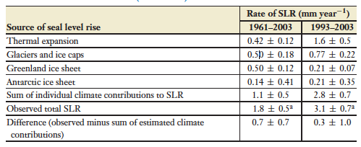
Table 1: Source contributions to global SLR. Data from 1993 onward are a result of satellite altimetry while the left column represents readings from tidal gauges from 1961-2003 (FitzGerald, et al., 2008).

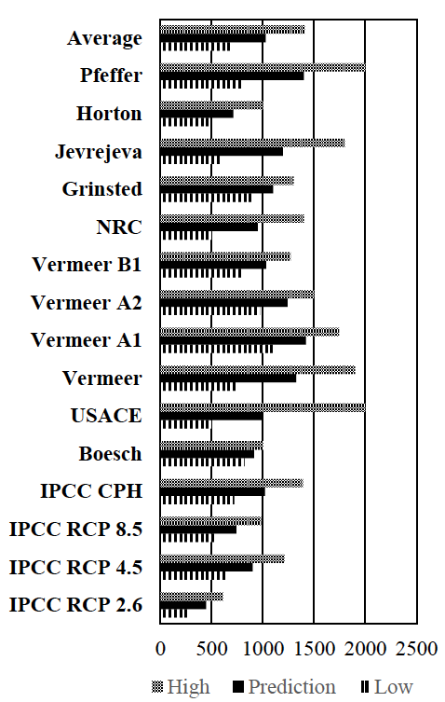
Figure 2: Various model projections for the year 2100 in millimeters (Hamilton, et al., 2017).
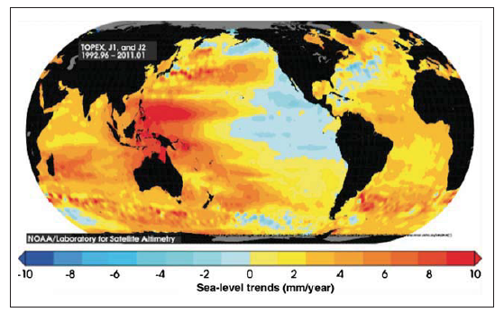
Figure 3: Spatial view of the highly variable rates of SLR globally from 1992-2011 measured through satellite altimetry (CSIRO, 2012).
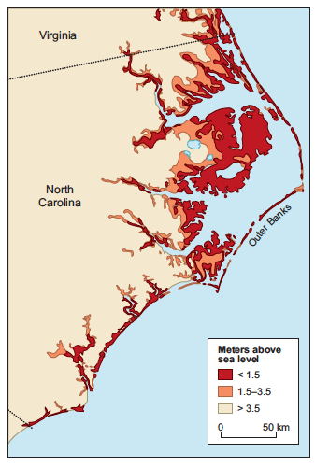
Figure 4: Barrier islands of the Outer Banks and their low-lying coastal wetlands showing vulnerability of its communities (FitzGerald, et al., 2008).
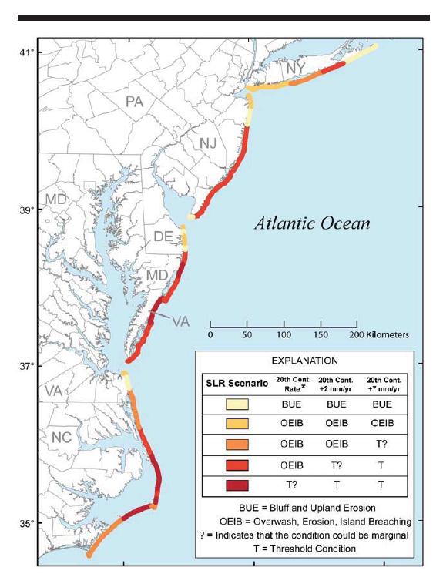
Figure 5: Potential sea-level rises responses along the Mid-Atlantic coastline under three different rise scenarios (USCCSP, 2009).

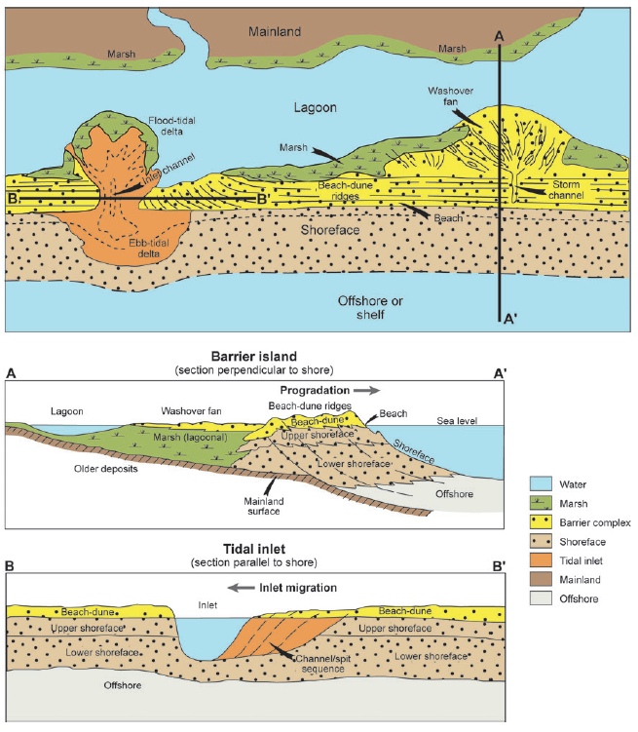
Figure 6: Overhead, parallel-cross-sectional, and perpendicular views of the entire barrier island system showing various erosion and accretion processes (FitzGerald, et al., 2008).

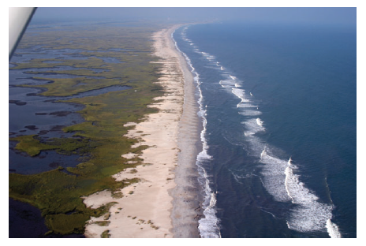
Figure 7: Aerial photo of Masonboro Island, NC highlighting washover fans from the foredune into the backbarrier marshland (FitzGerald, et al., 2008).

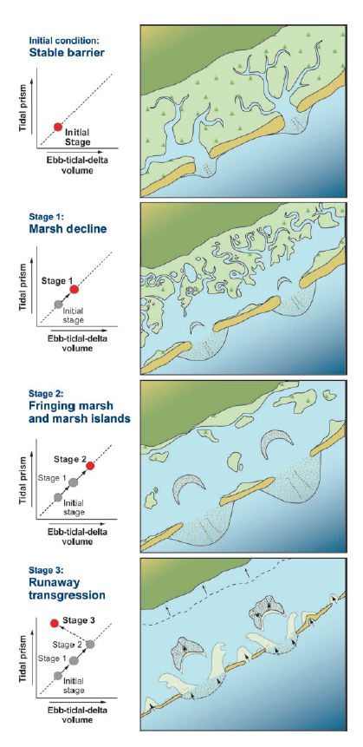
Figure 8: Evolutionary model of a barrier island’s progression from stable to severely impaired under the influence of accelerated SLR (FitzGerald, et al., 2008).

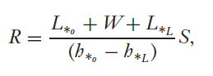
Equation 1: Generalized Bruun rule - Dean & Maurmeyer (1983). Variables explained in Figure 9.

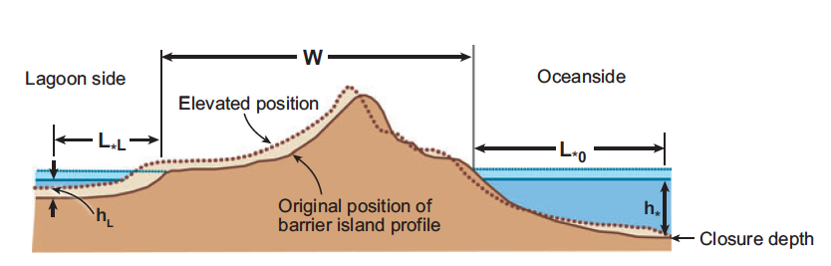
Figure 9: Graphical explanation of the Generalized Bruun rule as expanded by Dean & Maurmeyer (1983) to incorporate the effects of landward migration of barrier islands under the influence of sea-level rise. Here both the fore and back facing regions of the system are considered (FitzGerald, et al., 2008).

SM = $f \left\{ SLR \right| SS \left| WE \right| HI \}$
Equation 2: Shoreline migration as a function of sea-level rise (SLR), sediment supply (SS), wave energy (WE), and human interventions (HI) (Shao, et al., 1998).

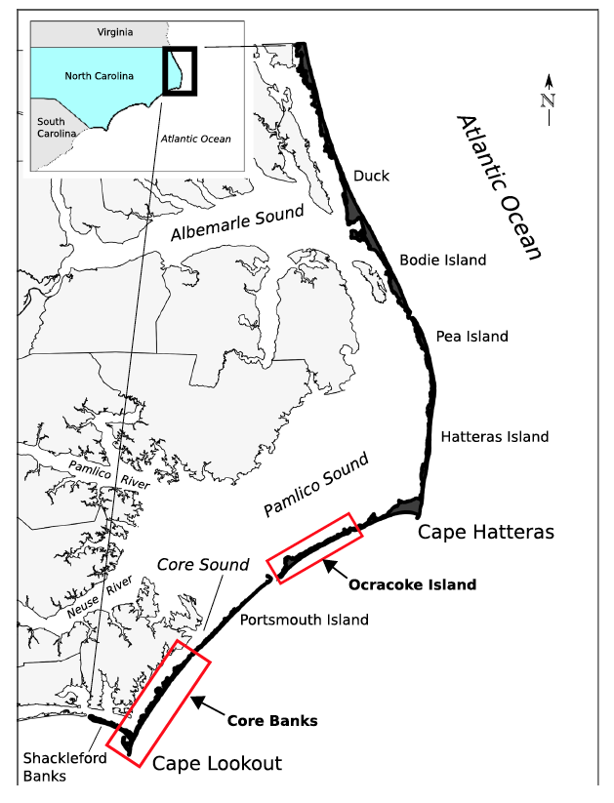
Figure 10: Map of the Outer Banks for spatial reference (Paris & Mitasova, 2018).
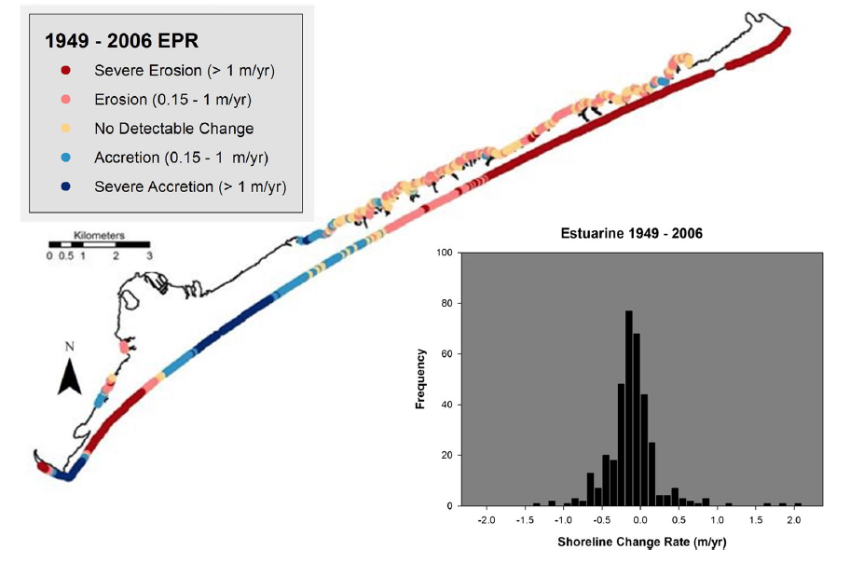
Figure 11: Findings from Conery, et al. (2018) exhibiting long term shortline changes for various intersects at Ocracoke Island. Notice narrow, ocean-facing dunes exhibited greater degrees of erosion while sound-side backbarrier and wider regions of the island experienced far less erosion and in some cases accretion.

Bibliography

Ames, D. V. & Riggs, S. R., 2009. Barrier Island Response to Sea-Level Rise, Storm Dynamics, and Human Intervention Based Upon Time-Slice Analysis and Geomorphic Mapping, North Carolina Outer Banks. Southeastern Section - Geological Society of America - 58th Annual Meeting.
Conery, I., Walsh, J. P. & Corbett, D. R., 2018. Hurricane Overwash and Decadal-Scale Evolution of a Narrowing Barrier Islands, Ocracoke Island, NC. Estuaries and Coasts, 15 March, Volume 41, pp. 1626-1642.
CSIRO (Commonwealth Scientific and Industrial Research Organisation), 2012. Sea-level rise: Understanding the Past-Improving Projections for the Future. [Online]
Available at: http://www.cmar.csiro.au/sealevel/
Davis, R. A., 1994. Geology of Holocene Barrier Island Systems.
Dean, R. G. & Maurmeyer, E. M., 1983. Models for Beach Profile Responses, s.l.: s.n.
Deaton, C. D., Hein, C. J. & Kirwan, M. L., 2017. Barrier Island Migration Dominates Ecogeomorphic Feedbacks and Drive Salt Marsh Loss Along the Virginia Atlantic Coast USA. Geology, 45(2), pp. 123-126.
Deros, e. a., 2017. Getting that Sinking Feeling: Analysis and Impacts of Sea Level Rise on the National Parks Along the East Coast, USA. The Cupola Scholarship - Gettysburg College, pp. 1-34.
Dinan, T., 2017. Projected Increases in Hurricane Damage in the United States: the Role of Climate Change and Coastal Development. Ecological Economies, Volume 138, pp. 186-198.
Donnelly, C., Kraus, N. & Larson, M., 2006. State of Knowledge on Measurement and Modelling of Coastal Overwash. Journal of Coastal Research, 22(4), pp. 965-991.
Eggleston, J. & Pope, J., 2013. Land Subsidence and Relative Sea-Level Rise in the Southern Chesapeake Bay Region, Reston, VA: U.S. Geological Survey.
Epanchin-Niell, R. e. a., 2016. Threatened Protection: Sea Level Rise and Coastal Protected Lands of the Eastern United States. Ocean and Coastal Management, Volume 137, pp. 118-130.
Evans, R. L., 2004. Pinning Down the Moving Shoreline. Oceanus, Volume 42, pp. 1-6.
FitzGerald, D. M., Fenster, M. S., Argow, B. A. & Buynevich, I. V., 2008. Coastal Impacts Due to Sea-Level Rise. Annual Review of Earth and Planetary Sciences, 4 February, Volume 36, pp. 601-647.
FitzGerald, D. M. et al., 2006. Impacts of Rising Sea Level to Backbarrier Wetlands, Tidal Inlets, and Barriers: Barataria Coast, Louisiana. Coastal Sediments, Conf. Proc..
FitzGerald, D. M. & Montello, T. M., 1993. Backbarrier and Inlet Sediment Response to Breaching of Nauset Spit and Fortmation of New Inlet, Cape Cod, MA. Formation and Evolution of Multiple Tidal Inlet Systems, pp. 158-185.
Gutierrez, B. T., Williams, S. J. & Thieler, E. R., 2007. Potential for Shoreline Changes Due to Sea-Level Rise Along the U.S. Mid-Atlantic Region. [Online]
Available at: http://pubs.usgs.gov/of/2007/1278
Hamilton, S. E. et al., 2017. On Borrowed Time: The Past, Present, and Future of Virginia's Barrier Islands Under the Differing Sea-Level Rise Scenarios.
Hayes, M. O., 1979. Barrier Island Morphology as a Function of Tidal and Wave Regime. Barrier Islands, pp. 1-28.
Houser, C. e. a., 2018. Role of the Foredune Controlling Barrier Island Response to Sea Level Rise. Barrier Dynamics and Response to Climate Change, pp. 175-207.
IPCC, 2007. Climate Change 2007: The Physical Science Basis, Summary for Policymakers. Contrib. Work. Group I Fourth Assess. Rep. .
Jones, J. R. & Cameron, B., 1977. Landward Migration of Barrier Island Sands Under Stable Sea Level Conditions. Journal of Sedimentary Research, Volume 47, pp. 1475-1483.
Kemp, A. C. et al., 2009. Timing and Magnitude of Recent Accelerated Sea-Level Rise (North Carolina, United States). Geology, November, 37(11), pp. 1035-1038.
Kirley, J. E., 1997. Virginia's Commericial Fishing Industry: Its Economic Performance and Contributions. [Online]
Available at: https://doi.org/10.21220/V5JS55
Leatherman, S. P., 1979. Migration of Assateague Island, Maryland, by Inlet and Overwash Processes. Geology, Volume 7, pp. 104-107.
McGowen, J. H. & Scott, A. J., 1975. Hurricanes as Geologic Agents on the Texas Coast. Estuarine Research, Volume Volume III, pp. 23-46.
McGranahan, D. A., Balk, D. & Anderson, B., 2007. The Rising Tide: Assessing the Risks of Climate Change and Human Settlments in Low Elevation Coastal Zones. Environment and Urbanization, Volume 19, pp. 17-39.
Meredith, A., Eslinger, D. & Aurin, D., 1999. An Evaluation of Hurricane-Induced Erosion Along the North Carolina Coast Using Airborne LIDAR Surveys, s.l.: NOAA Coastal Services Center.
Paris, P. J. & Mitasova, H., 2018. Geospatials Contrasts Between Natural and Human-Altered Barrier Island Systems: Core Banks and Ocracoke Island, North Carolina, USA. Journal of Coastal Conservation, Volume 22, pp. 679-694.
Pilkey, O. H. & Cooper, J. A., 2007. Lifting Up the Flap on Why Quantitative Beach Behaviour Predictive Modeling Can't Work. Jouranl of Coastal Research Special Issue, Volume 50, pp. 585-587.
Pilkey, O. H. & Neal, W. J., 2002. Engineered Barrier Islands: Lifeless Piles of Sand. Abstract Program - Geological Society of America, 34(6), p. 446.
Riggs, S. R. et al., 2004. Geomorphic, Time-Slicing Mapping of Dynamic Barrier Islands, North Carolina's Outer Banks; a Basis for Prudent Management. Abstracts with Programs - Geological Society of America, 36(5), p. 123.
Riggs, S. R. et al., 2008. Barrier Islands in the Eye of a Human Hurricane; Economic Development vs Climate Change, Sea-Level Rise, and Storms. Abstracts = Congres Geologique International, Resumes, Volume 33.
Rood, S. A., 2012. Addressing Eastern Shore and Chesapeake Bay Environmental Issues and Economic Development. University Research and Education.
Scavia, D., 2002. Climate Change Impacts on U.S. Coastal and Marine Ecosystems. Estuaries and Coasts, 25(2), pp. 149-164.
Shao, G., Young, D. R., Porter, J. H. & Hayden, B. P., 1998. An Integration of Remote Sensing and GIS to Examine the Response of Shrub Thicket Distributions to Shoreline Changes on Virginia Barrier Islands. Journal of Coastal Research, 14(1), pp. 299-307.
Smith, C. G. et al., 2008. Geospatial Analysis of Barrier Island Width of Two Segments of the Outer Banks North Carolina, USA: Anthropogenic Curtailment of Natural Self-Sustaining Processes. Journal of Coastal Research, 24(1), pp. 70-83.
Stanley, D. J. & Warne, A. G., 1997. Holocene Sea-Level Change and Early Human Utilization of Deltas. Geological Society of America Today, Volume 7, pp. 1-7.
USCCSP (U.S. Climate Change Science Program), 2009. Coastal Sensitivity to Sea-Level Rise: a Focus on the Mid-Atlantic Region, Washington, DC: U.S. Environmental Protection Agency.
Valverde, H. R., Trembanis, C. & Pilkey, O. H., 1999. Summary of Beach Renourishment Episodes on the U.S. East Coast Barrier Islands. Journal of Coastal Research, Volume 15, pp. 1100-1118.
Webster, P. J., Holland, G. J., Curry, J. A. & Chang, H.-R., 2005. A Beach Profile Model for Barred Coasts - Case Study from Sand Key, West-Central Florida. Science, Volume 309, pp. 1844-1846.
Williams, S. J., 2013. Sea-Level Rise Implications for Coastal Regions. Journal of Coastal Research, Volume 63, pp. 184-196.

