

**Summer 24 Parishes Bulletin (46)**

Welcome to this latest Parishes Bulletin

**Multi-agency exercise tackles Peak District wildfire scenario**

Firefighters have joined forces with Peak District National Park rangers and moorland managers in a training exercise to prepare for a wildfire scenario.

The exercise, at Stanage Edge, between Hathersage and Sheffield, on the National Park Authority’s Stanage-North Lees estate, tested how specialist equipment would be used in a real-life emergency and how teams would work together to tackle a moorland fire.

It was organised by Derbyshire Fire & Rescue Service (DFRS) and supported by partners in the Fire Operations Group (FOG).

Read the full story.

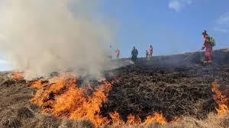

**RSN Rural Funding Digest & Government Consultations**

Information for anyone looking for funding. The Funding Digest includes many sources of grant funding that some may not be aware of.

The Government Consultation section may include a draft response to relevant rural consultations and also highlights other consultations relevant to rural areas which you may be interested in responding to.

The April 2024 edition of the Rural Funding Digest can be found **here**

The April 2024 edition of the Rural Funding Digest can be  found **here**

The April 2024 edition of current Government Consultations can be found **here**

|  |
| --- |
| **The Rural Services Network** encompasses a wide range of partners and organisations who all work together to help provide a voice for rural communities. Over 20,000 members belong to the network. We represent over 500 organisations across the public, private and voluntary sectors including leading national bodies, local authorities, utility companies, health trusts, housing associations, grass root community organisations and more. The Rural Services Network is a membership organisation and includes different types of membership depending on the kind of organisation you belong to. For further details click here |

**Have you listened to Voices from the Peak?**

*Voices from the Peak* is a series of six creative audios about aspects of the Peak District’s cultural heritage, nature and ways of life. They present an informative, sometimes beautiful, sometimes thought-provoking way of engaging with the National Park’s special qualities.

Created by poet Mark Gwynne Jones, each audio draws on lived experiences and intriguing encounters, he explains: “The Peak District speaks though our stories. There is poetry in everyday speech, in spontaneous expressions about nature or places, and our connection to the land.”

Hear Mark’s creative interpretation in words, sound and music online via www.peakdistrict.gov.uk/voicesfromthepeak or www.markgwynnejones.com.

Extracts of the first three audios released in 2021, are still available online. *Burning Drake, Snow!* and *Kinder Scout* – feature lead mining heritage, extreme winters, and the right to roam.

The latest three audios, released in 2023: *Nine Ladies, The Blessing of Water* and *Raven Tor* are free to listen to in full online – each is about 20 minutes long – and cover topics from the cultural heritage of stone circles to the ancient art of welldressings, wildlife and more.

Mark is currently touring *Voices from the Peak – Live* at venues in and around the Peak District and is happy to bring the show to rural communities. Details of how to book performances are online.

*Voices from the Peak* is funded by Arts Council England and supported by the Peak District National Park Authority and Derbyshire County Council.

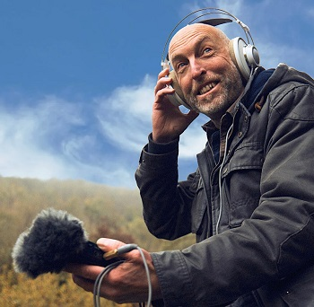

**Celebrating 70 years of National Park Rangers**

*Report from engagement ranger team leader Jessica Coatesworth*

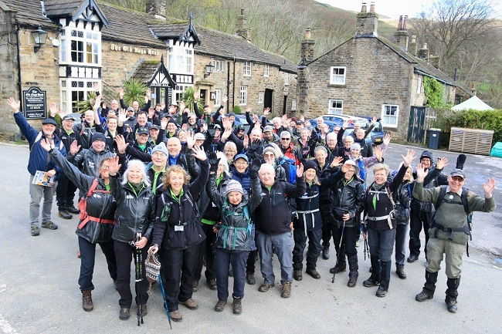

On Tuesday 16 April 2024, the Peak District National Park Ranger Service celebrated its 70th anniversary. The warden service, as it was previously known, recruited the first full-time paid ranger in the country in1954, three years after the Peak District was founded, and the volunteer warden service officially started the same year on Good Friday (see photo below). The volunteer rangers today are an essential part of Peak District ranger team, and we couldn’t do our work without them. The 70th anniversary of the ranger service gave us a great opportunity to get together, share stories and catch-up, but most importantly celebrate the first ranger service in the first UK National Park.  
   
Current rangers still do some of the same things as the first wardens, but with more visitors to the Peak District than ever the rangers are supported by a big volunteer team. Volunteer rangers can often be seen on busy footpaths at the weekend, talking to visitors and helping people find their way, or helping with practical improvements in the week. The National Park rangers also run Guided Walks throughout the year in various locations. The volunteer team has a broad range of experience too; some of the volunteer rangers having been involved for over 50 years, while others are just at the start of an exciting career. Several of our Area / Engagement Rangers over the years started with us as volunteer rangers, and it has been and still is a great way to get experience and discover if it is a role for you.  
   
No doubt the ranger role will continue to evolve, especially as the planet faces more uncertain weather and changes to the climate, but hopefully it will continue to be a role that challenges people in positive ways and still has good job satisfaction, while also engaging with communities and the public to love and care for our protected landscapes. As Ted Talbot says, 'we all need to be a bit more ranger'!

|  |
| --- |
|  |

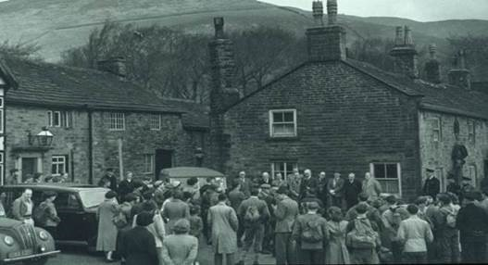

**A date for your diary**

Parishes day this year is on the 12th October at 10am in the Boardroom of Aldern House, Bakewell. The draft agenda theme this year will be on the review of the Local Plan. Invitations to be sent out later in the year.

**Community Small Grant supports Hartington’s book receipt**

|  |  |  |
| --- | --- | --- |
| |  | | --- | | https://mcusercontent.com/dbe69275983808f875843c493/images/9002732d-c3aa-9abb-49ca-f0d6debcf84e.jpg |  |  | | --- | | ***Report from community policy planner Clare Wilkins***  The Community Small Grant fund has given £575 to Hartington Community Group to pay for half the cost of a reprint of a popular local history book.  Liz Broomhead from Hartington Community Group said: "*Alcock’s Lamp* is a social history of Hartington over the past 150 years written by Ron Riley. | |

"Ron was a resident whose family went back many generations. He was highly respected and ensured much of the history of the village was recorded in an interesting and very readable and relevant form. The booklet was first printed in 1994, as a fund raiser for the Church.  
   
"There have been two reprints, the last where Hartington Community Group supported the Church with funding. There is considerable demand for a reprint from both visitors and new people who have moved into the village and surrounding area. To this end we have researched another print run 500, confident that with Community Small Grant and the financial support of the Hartington Community Group and St Giles Church Parochial Church Council we will be able to recoup costs and provide surplus to be used to support the community and enhance the understanding of the importance of the Peak District National Park."  
  
Photo: Chris Roberts, of Hartington Cheese Shop, with the book which he sells for the group.

**Work is underway to restore wildfire scarred landscape**

***Report from senior communications officer Robbie Carnegie***  
When a campfire in 2018 started a wildfire that raged across 61 hectares (equivalent to 85 football pitches) of moorland near Leek, 20% of the precious peatland landscape of the Roaches was devastated. Moors for the Future Partnership scientific research of the aftermath revealed that 11,000 tonnes of carbon dioxide was released back into the atmosphere as a direct result of the fire, the equivalent carbon loss to running 1,426 homes for a year.  
  
The Partnership has begun extensive works on this scarred landscape. These works include the blocking of gullies eroded by water using stone, and coir log dams made from coconut fibre, and stabilising and revegetating remaining bare peat from the 2018 fire.  
  
The local community, visitors and moorland enthusiasts can get involved in hands-on restoration work in the Partnership’s volunteer sphagnum moss planting scheme. Sphagnum moss is an essential carbon store, accumulating over time to create new layers of peat. It is able to absorb up to 20 times its own weight in water, protecting and maintaining the wetness of the peat underneath and holding peak water flow on the hills. This small moss will help to return this once bleak landscape back to life, providing a home for a rich selection of moorland species of plants, insects, birds and mammals.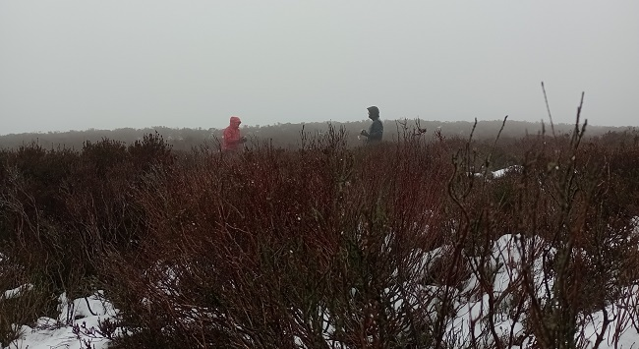  
  
Photo: volunteers planted sphagnum moss at the Roaches, despite the snow



**CEO roadshows are proving useful**

Phil's 'Meet the CEO' events continue with residents most recently sharing their views in person in Bakewell Quakers Main Hall at the end of May.

Among the topics discussed at the sessions were the role of the National Park Authority, work with partners and the guiding, coordinating purpose of the National Park Management Plan, and the organisation’s own responsibilities and powers. Moorland restoration, support for farmers in national parks, nature recovery, rewilding, grouse moor management, and wildlife crime were also raised by those in attendance.

**On line enforcement enquiry form**

A new way for people to report potential breaches of planning controls is being introduced by the Peak District National Park Authority.

The new online enquiry form makes it easier and quicker to provide relevant information and for Authority officers to carry out an effective investigation. The form includes an interactive map which can show the precise location of the property in question and photographs can also be uploaded.

Breaches of planning control occur when someone carries out development, such as building works or a change of use, without first obtaining planning permission.

Read the full story.

If you have any queries please contact Andrew Cook, Principal Enforcement Planner on  
01629 816304 or Andrew.Cook@peakdistrict.gov.uk

For any queries about this bulletin, please email sandra.harrop@peakdistrict.gov.uk