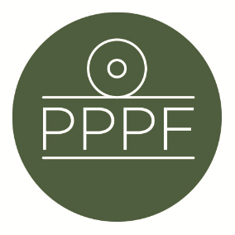

**Peak Park Parishes Forum**

**Working for, and on behalf of, Local Councils within the Peak District National Park**

Secretary: Peter Leppard, Sickleholme Cottage, Saltergate Lane, Bamford, Hope Valley, S33 0BE

Tel. 07860 624453 e-mail: secpppf@gmail.com

Meeting of the Management Committee to be held at 2pm on Tuesday 9 July 2024 at Aldern House, Baslow Rd, Bakewell, DE45 1AE

**AGENDA**

1. To receive apologies for absence

.

1. To accept the minutes of the meeting of 12 March
2. To receive an update on the setting-up of Planning training for Parishes
3. PDNPA Local Plan

**a.** To receive an update on the Plan’s development

**b.** To develop a mechanism whereby PPPF’s consultation response can be drafted

and agreed

1. To consider topics for discussion at the 2024 Parishes Day
2. Secretary’s report

1. Finance
2. To note the Forum’s FY2023/24 unaudited accounts
3. To approve any payments
4. To confirm date of next meeting

***Peter Leppard***

Secretary, Peak Park Parishes Forum 2 July 2024