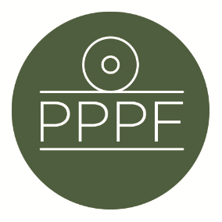

**Peak Park Parishes Forum**

**Working for, and on behalf of, Local Councils within the Peak District National Park**

Secretary: Peter Leppard, Sickleholme Cottage, Saltergate Lane, Bamford, Hope Valley, S33 0BE

Tel. 07860 624453 e-mail: secpppf@gmail.com

Meeting of the Management Committee to be held at 10am on Tuesday 13 August 2024 at Aldern House, Baslow Rd, Bakewell, DE45 1AE

**AGENDA**

1. To receive apologies for absence

.

1. To accept the minutes of the meeting of 9 July
2. To consider a suggestion from a Parish that PPPF becomes involved in the issue of perceived poor responsiveness of DCC’s PRoW section
3. 2024 Parishes Day: To consider any outstanding issues re the planning of this
4. PDNPA Local Plan: To consider the latest position, and decide next steps
5. Secretary’s report

1. Finance
2. To note the Forum’s financial position year-to-date
3. To approve any payments
4. To confirm date of next meeting

***Peter Leppard***

Secretary, Peak Park Parishes Forum 6 August 2024