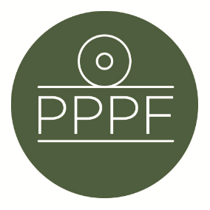

**Peak Park Parishes Forum**

**Working for, and on behalf of, Local Councils within the Peak District National Park**

Secretary: Peter Leppard, Sickleholme Cottage, Saltergate Lane, Bamford, Hope Valley, S33 0BE

Tel. 07860 624453 e-mail: secpppf@gmail.com

Meeting of the Management Committee to be held at 2pm on Tuesday 11 March 2025 at Aldern House, Baslow Rd, Bakewell, DE45 1AE

**AGENDA**

1. To receive apologies for absence

.

1. To accept the minutes of the meeting of 21 January
2. To consider the PDNPA Nature Recovery Plan <https://reports.peakdistrict.gov.uk/naturerecovery>
3. To note the University of Sheffield project *Promoting fair and effective stakeholder engagement with environmental policy and decision-making in National Parks*
4. To review recent press, p-r and other activity seeking to address visitor behaviour in the Peak District
5. To review the current position re PDNPA’s governance-reform recommendations to DEFRA
6. To consider the Committee’s next steps re the emerging new PDNPA Local Plan
7. Secretary’s report
8. Finance
9. To note the Forum’s financial position year-to-date
10. To approve any payments
11. To confirm date of next meeting
12. To decide next steps re recruitment of a new Secretary to the Forum

***Peter Leppard***

Secretary, Peak Park Parishes Forum 5 March 2025