**01.The line graph below shows the percentage of tourists to England who visited four different attractions in Brighton.**

**Summarise the information by selecting and reporting the main features, and make comparisons where relevant.**

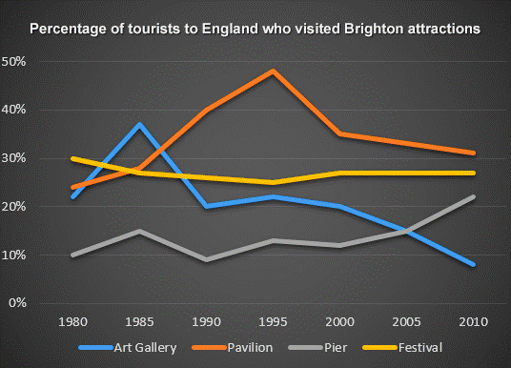

The line graph ……………….the …………………. of ………………………………who visited ……………………………………between……………………………….. It can be………….. that in ………………………..the favourite attractions were the pavilion and the festival. ……………………………..attraction ……………..the pier but in ……………………………………and the ………………………..the …………………. popular.

During the …………………………..there was a …………………………in visitors to the ……………………………………….and then the ……………………………………went down…………………………. The trend for ……………………………………..similar…………………………. Visitors increased rapidly ………………………………………….1980 to 1985 ……………………………………to less than ………………………….the next ………………………….years. The number of tourists ……………………………………………….fluctuated slightly but in general remained…………………………………………………. Visitors to the pier also fluctuated from ………………………………….then ………………………………………..from ………………………….between ……………………………………….. .