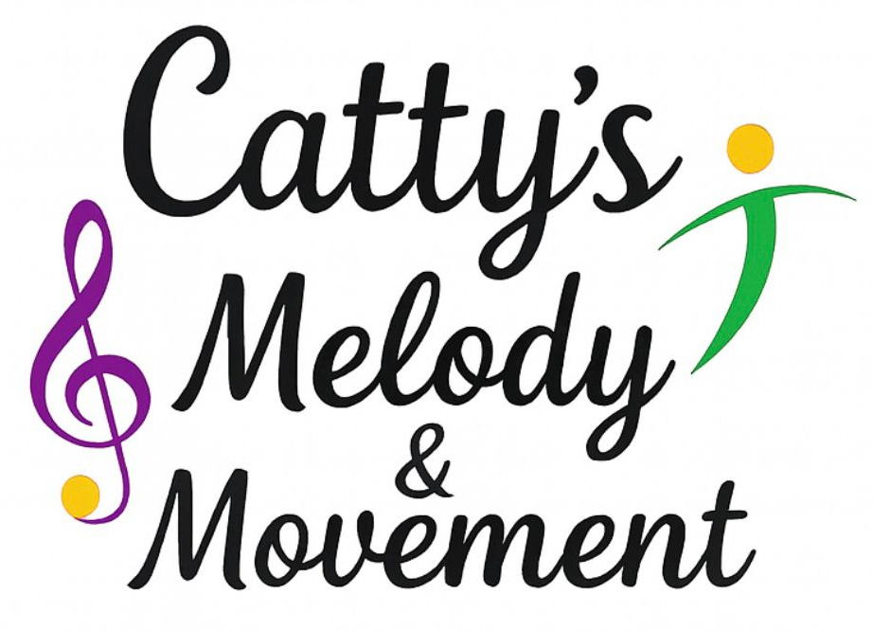
Safeguarding & Child Protection Policy

Organisation: Catty’s Melody and Movement
Policy applies to: All staff, volunteers, sessional workers, cover staff, students and anyone working on behalf of Catty’s Melody and Movement.
Scope: This policy applies to all activities delivered by Catty’s Melody and Movement in schools, early years settings, community venues and other performance or teaching environments.

1. Statement of Intent
Catty’s Melody and Movement is committed to safeguarding and promoting the welfare of all children and young people. We recognise our responsibility to take all reasonable steps to ensure that children are protected from harm and can participate in our activities in a safe, positive and supportive environment.
Safeguarding and promoting the welfare of children means:
- Protecting children from maltreatment;
- Preventing impairment of children’s health or development;
- Ensuring that children grow up in circumstances consistent with the provision of safe and effective care; and
- Taking action to enable all children to have the best outcomes.

This policy is informed by UK statutory guidance including Working Together to Safeguard Children and relevant children’s legislation.

2. Our Beliefs
We believe that:
- children and young people should never experience abuse of any kind;
- everyone has a responsibility to promote the welfare of children and young people, keep them safe and practise in a way that protects them.

We recognise that:
- the welfare of the child is paramount in all the work we do and in all decisions we take;
- working in partnership with children, young people, parents, carers, schools and other agencies is essential in promoting children’s welfare;
- all children, regardless of age, disability, gender reassignment, race, religion or belief, sex or sexual orientation, have an equal right to protection from all types of harm or abuse;
- some children are additionally vulnerable due to previous experiences, disability, communication needs or other factors;
- Extra safeguards may be required to keep children who are additionally vulnerable safe from abuse.

3. How We Keep Children Safe
Catty’s Melody and Movement seeks to keep children and young people safe by:
- Valuing, listening to and respecting them.
- Appointing a Designated Safeguarding Lead (DSL) and, where appropriate, a Deputy DSL.
- Adopting safeguarding and child protection best practice through clear policies, procedures and a staff code of conduct;
- Ensuring staff and volunteers receive appropriate safeguarding training and supervision;
- Recruiting staff and volunteers safely, including:
  - enhanced DBS checks (or non-UK equivalent where applicable);
  - appropriate safeguarding and child protection training;
  - first aid training relevant to the role;
  - risk assessments for activities and venues;
- Recording, storing and sharing information securely and professionally in line with data protection legislation;
- Seeking written parental consent before taking photographs or videos and being clear about how images will be used;
- Making safeguarding information available to parents and carers;
- Ensuring children, young people and families know how to raise concerns or make a complaint;
- Following clear procedures for responding to concerns, disclosures and allegations;
- Maintaining an anti-bullying approach and responding effectively to any bullying;
- Having whistleblowing procedures in place;
- Providing a safe physical environment through robust health and safety practices;
- Fostering a safeguarding culture where concerns can be shared openly and respectfully;
- Reporting concerns of abuse or neglect to the appropriate safeguarding agencies;
- Reviewing this policy regularly.

4. Types of Abuse and Neglect
Abuse and neglect are forms of maltreatment of a child. A child may be abused or neglected by an adult or by another child.
Physical Abuse
Deliberately causing physical harm to a child, including hitting, shaking, burning, poisoning, drowning, suffocating or inducing illness.
Emotional Abuse
Persistent emotional maltreatment that adversely affects a child’s emotional development, including humiliation, intimidation, isolation, serious bullying (including online bullying) or preventing normal social interaction.
Sexual Abuse
Forcing or enticing a child to take part in sexual activities, whether physical or non-contact, including online abuse and grooming. Sexual abuse can be committed by adults or other children.
Neglect
Persistent failure to meet a child’s basic physical or psychological needs, including failure to provide adequate food, clothing, shelter, supervision, medical care or emotional support.

5. Risk Assessment & Health and Safety
We actively promote good health and safety practice by:
- maintaining safe and healthy working conditions;
- identifying and managing risks in all venues and activities;
- welcoming feedback from staff, schools, venues, parents and students;
- ensuring staff are suitably qualified, trained and competent;
- sharing relevant safety information with staff and participants.
Risk assessments are available on request.

6. First Aid & Accidents
- All staff hold up-to-date first aid certificates appropriate to their role.
- First aid kits and ice packs are available during sessions.
- All accidents or injuries are recorded on an Accident Report Form and shared with parents, carers or school staff as appropriate.
- Reasonable steps will be taken to prevent reoccurrence.
- In the event of a serious incident or emergency, emergency services will be contacted on 999.

7. Appropriate Physical Contact in Performing Arts
Physical contact may sometimes be required in dance and performing arts to demonstrate or correct posture or movement. This may include adjusting arms, legs, feet, posture or positioning.
When physical contact is necessary, staff will:
- explain clearly what they are doing and why;
- seek verbal consent where appropriate;
- remain sensitive to the child’s wishes;
- ensure contact is appropriate, minimal and in the child’s best interests;
- encourage children to report any discomfort or concerns.

8. Roles & Responsibilities
Designated Safeguarding Lead (DSL)
The DSL is responsible for:
- receiving and responding to safeguarding concerns;
- liaising with local safeguarding partners and children’s services;
- making referrals where necessary;
- ensuring staff understand safeguarding procedures;
- ensuring safeguarding training is completed;
- reviewing and updating this policy.
All safeguarding concerns must be recorded in writing and passed immediately to the DSL.

9. Responding to Disclosures & Whistleblowing
If a child discloses abuse or neglect, staff must:
- stay calm and listen carefully;
- reassure the child and take them seriously;
- avoid asking leading questions;
- never promise confidentiality;
- explain what will happen next;
- record the disclosure as soon as possible, using the child’s own words;
- sign and date the record;
- report the concern immediately to the DSL;
- seek support as needed.

Whistleblowing concerns about staff conduct must be reported to the DSL or, if necessary, to an appropriate external body.

10. Reporting Concerns – Warwickshire
If there are concerns that a child is suffering abuse or neglect:
- Warwickshire Children & Families Front Door: 01926 414144
(Mon–Thu 8.30am–5.30pm, Fri 8.30am–5.00pm)
- Emergency Duty Team (out of hours): 01926 886922
- Immediate danger: Call 999

11. Key Contacts
Designated Safeguarding Lead (DSL):
Name: Catherine Giles
Phone: 07828128212
Email: info@cattysmelodyandmovement.com

12. Policy Review
This policy will be reviewed annually or sooner if there are changes in legislation, guidance or organisational practice.
Policy owner: Catty’s Melody & Movement
Last reviewed: February 2026
Next review due: February 2027

