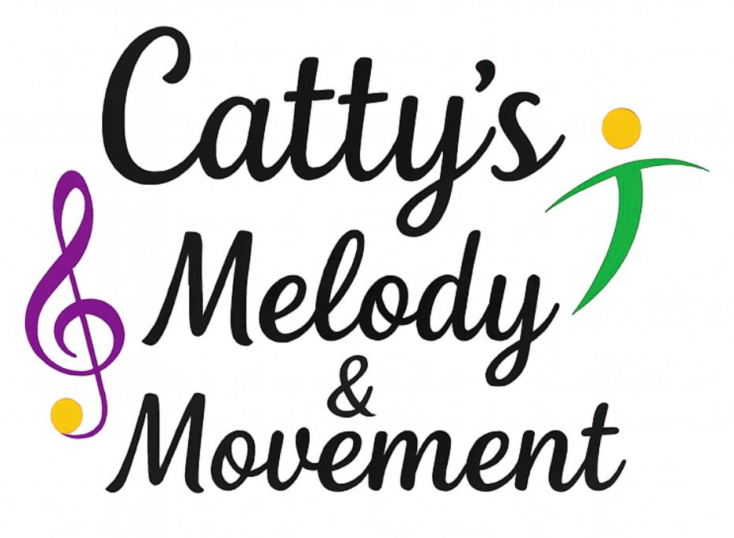
Health and Safety Policy

Statement of Intent
Catty’s Melody and Movement is committed to safeguarding the health, safety and welfare of all children, staff, school personnel and visitors during sessions delivered within school settings. We aim to work in full partnership with schools to ensure a safe, positive and well-managed learning environment at all times.
We comply with the Health and Safety at Work Act 1974, the Workplace (Health, Safety and Welfare) Regulations 1992, and all relevant health and safety legislation, guidance and school-specific policies.
Catty’s Melody and Movement holds appropriate Public Liability Insurance, Evidence of insurance is available to schools upon request.

- Responsibilities of All Staff
All Catty’s Melody and Movement staff are responsible for:
- Maintaining a safe and healthy environment within school premises
- Taking reasonable care for the health and safety of themselves and others
- Working in accordance with this policy and the host school’s health and safety procedures
- Reporting all accidents, incidents or near misses to both Catty’s Melody and Movement management and the designated school contact
- Undertaking relevant health and safety and safeguarding training as required

Failure to follow safety instructions or recognised safe practices may result in disciplinary action.

- Responsibilities of the Registered Person / Business Owner
The registered person holds overall responsibility for the safe delivery of Catty’s Melody and Movement sessions in schools and will ensure that:
- Health and safety responsibilities are clearly communicated to all staff
- Appropriate risk assessments are completed for school-based activities
- Staff are suitably trained and competent to deliver sessions safely
- This policy is reviewed regularly and updated as required
- Effective communication is maintained with schools regarding safety arrangements
- All accidents, incidents and dangerous occurrences are recorded and reported in line with school and statutory requirements
- Incidents are reviewed to reduce risks and prevent recurrence

- Working in Partnership with Schools
When operating on school premises, Catty’s Melody and Movement will:
- Follow the host school’s health and safety, safeguarding, fire safety and emergency procedures
- Sign in and out in accordance with school visitor procedures
- Liaise with the school regarding evacuation routes, assembly points and emergency contacts
- Respect all school site rules and supervision expectations
The school retains responsibility for the general safety of the premises, while Catty’s Melody and Movement is responsible for the safe delivery of its activities.

- Responsibilities During Sessions
Staff ensure that:
- Activity spaces provided by the school are suitable for movement-based sessions
- Floors are clear, dry and free from hazards
- Equipment and props are safe, age-appropriate and fit for purpose
- Any unsafe conditions are reported immediately to the school
- Children remain under appropriate supervision at all times
- A working mobile phone is available for emergencies
- Cleaning products or hazardous substances are not accessible to children

- Security and Supervision
- Children remain under the supervision of Catty’s Melody and Movement staff and/or school staff at all times, as agreed with the school
- Children do not leave the session area unless accompanied by authorised staff
- Collection and dismissal procedures follow the school’s established systems
- Visitors are never left alone with children

- Equipment and Resources
- All equipment, instruments and resources are maintained in a clean and safe condition
- Equipment is checked before use and removed if unsafe
- Risk assessments are completed for new activities or equipment
- Flammable or specialist equipment is stored safely and used appropriately

- Hygiene and Infection Control
- Staff model and promote good hygiene practices
- Hands are cleaned before and after activities where appropriate
- Any cuts or abrasions are covered with suitable dressings
- Staff follow school infection control procedures

- Dealing with Body Fluids
- Any incidents involving body fluids are managed promptly and safely
- Appropriate protective equipment is used
- Incidents are reported in line with school procedures

- Accidents, Incidents and First Aid

- All accidents and incidents are recorded using the school’s accident reporting system
- The school’s first aid procedures are followed at all times
- Parents/carers are informed by the school in line with their policies

- Staffing Levels and Ratios
- Staffing levels are appropriate to the age, needs and number of children
- Additional support is provided where required
- Children are supervised at all times during sessions

- Related Policies
This policy should be read alongside:
- Risk Assessment Policy
- Safeguarding and Child Protection Policy
- First Aid Policy
- Accident and Incident Reporting Policy

Policy Owner: Catty’s Melody & Movement
Review date: February 2026
Review Date: February 2027

Written in accordance with the Statutory Framework for the Early Years Foundation Stage (2024): Safeguarding and Welfare Requirements – Safety and suitability of premises, environment and equipment (Sections 3.63–3.69).

