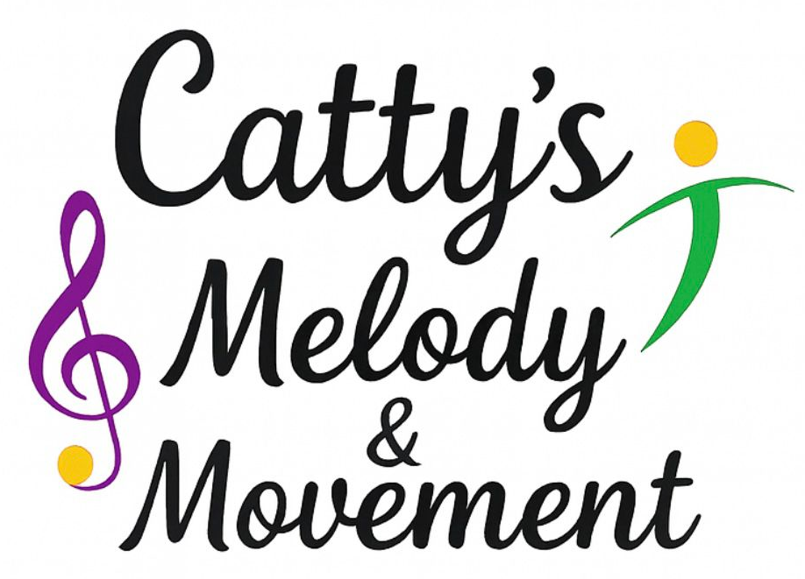
Behaviour Policy
Policy Statement
Catty’s Melody and Movement is committed to providing a safe, inclusive, positive, and engaging learning environment for all children. We believe that children learn best when they feel respected, valued, and supported. This behaviour policy outlines the expectations, strategies, and procedures used to promote positive behaviour during all sessions delivered in schools.
This policy aligns with school behaviour policies and statutory guidance and is designed to complement, not replace, the school’s own procedures.

1. Aims
- To create a safe, welcoming, and inclusive environment for all participants
- To promote positive behaviour, mutual respect, and cooperation
- To encourage children to develop confidence, self-discipline, and social skills through music and movement
- To ensure consistency and fairness in managing behaviour
- To work in partnership with schools, staff, parents/carers, and pupils

2. Expectations of Children
All children attending Catty’s Melody and Movement sessions are encouraged to:
- Treat others with kindness, respect, and consideration
- Listen to instructions and follow session rules
- Take care of equipment and the learning environment
- Participate positively and try their best
- Use kind words and safe actions at all times

Session rules will be shared in a child-friendly way, often using music, movement cues, and visual reminders.

3. Positive Behaviour Strategies
We focus on positive reinforcement and encouragement, including:
- Verbal praise and positive feedback
- Encouraging teamwork and cooperation
- Modelling positive behaviour
- Reward systems such as stickers, stamps, or verbal recognition (where appropriate and in line with school policy)
- Using music, movement, and structured activities to maintain engagement

4. Managing Challenging Behaviour
We understand that children may sometimes display challenging behaviour. Any behaviour management will be handled calmly, respectfully, and appropriately for the child’s age and needs.
Strategies may include:
- Gentle reminders of expectations
- Redirecting behaviour to a positive alternative
- Time to calm down within the session space (never isolation)
- Clear, age-appropriate explanations of why behaviour is unacceptable

Physical punishment, humiliation, or shouting is never used.

5. Serious or Ongoing Behaviour Concerns
If behaviour:
- Poses a risk to the child or others
- Causes persistent disruption
- Involves bullying, aggression, or unsafe actions

The following steps will be taken:
- Inform school staff immediately
- Record concerns where appropriate
- Follow the school’s behaviour and safeguarding procedures
- Work collaboratively with school staff to support the child

Catty’s Melody and Movement staff will not administer sanctions such as exclusion or detention; these remain the responsibility of the school.

6. Special Educational Needs and Inclusion
We recognise that some children may have additional needs that affect behaviour. Sessions are inclusive and adaptable, and reasonable adjustments will be made where possible.
We will:
- Work closely with school staff to understand individual needs
- Use differentiated approaches and flexible activities
- Promote understanding and inclusion among all participants

7. Role of Staff
Catty’s Melody and Movement staff will:
- Act as positive role models at all times
- Apply this policy consistently and fairly
- Maintain clear communication with school staff
- Uphold safeguarding and health & safety procedures

8. Partnership with Schools
This policy works alongside the school’s own behaviour policy. In all cases:
- School behaviour procedures take precedence
- School staff remain responsible for overall discipline
- Open communication is encouraged to ensure consistency

9. Review and Monitoring
This policy will be reviewed annually or sooner if required due to changes in legislation or practice.

Policy Type: Behaviour Policy (Schools)
Policy Owner: Catty’s Melody & Movement
Review date: February 2026
Review Date: February 2027

