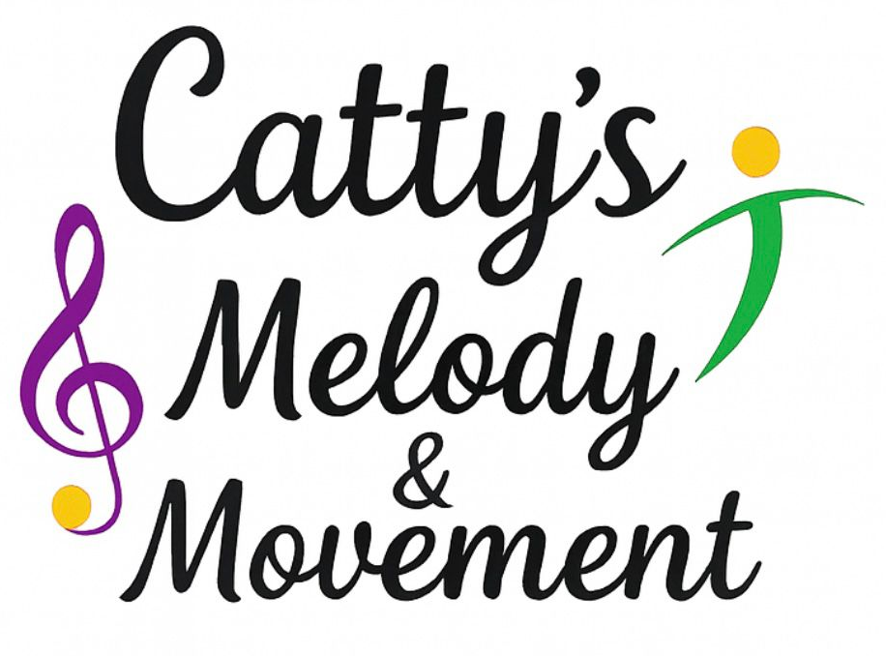
Inclusion & SEND Policy
Catty’s Melody and Movement is committed to providing an inclusive, supportive and nurturing environment where every child can access, enjoy and benefit from our sessions. We celebrate diversity and believe that all children, regardless of ability, background or individual need, have the right to participate fully in music and movement activities.
This policy applies to all staff, freelancers, volunteers and anyone working on behalf of Catty’s Melody and Movement.

1. Aims of the Policy
We aim to:
- Promote equality, inclusion and respect for all children.
- Ensure children with Special Educational Needs and/or Disabilities (SEND) are supported to access our sessions.
- Work in partnership with parents/carers, schools, nurseries and other professionals.
- Remove barriers to participation wherever reasonably possible.
- Ensure all children feel safe, valued and confident.

2. Definition of SEND
A child is considered to have Special Educational Needs and/or Disabilities if they:
- Have a learning difficulty or disability which requires special educational provision to be made.
- Have significantly greater difficulty in learning than the majority of children of the same age.
- Have a disability that prevents or hinders them from making use of facilities generally provided for children of the same age.

SEND may include, but is not limited to:
- Communication and interaction needs (e.g. Autism Spectrum Condition, speech and language difficulties)
- Cognition and learning needs
- Social, emotional and mental health needs
- Sensory and/or physical needs

3. Our Inclusive Practice
Catty’s Melody and Movement is committed to inclusive practice by:
- Adapting activities to meet a range of abilities and learning styles.
- Using visual aids, repetition, music, movement and sensory resources to support engagement.
- Offering alternative ways to participate where needed (e.g. seated movement, simplified actions).
- Encouraging positive behaviour through praise, encouragement and clear routines.
- Creating a welcoming, calm and supportive atmosphere.
We recognise that every child is unique and support is tailored to individual needs wherever possible.

4. Identification and Information Sharing
- Parents/carers and settings are encouraged to share relevant information about a child’s needs prior to sessions.
- This may include details from Individual Education Plans (IEPs), EHCPs, or professional guidance.
- All information is treated confidentially and in line with our Data Protection and GDPR policies.
- Staff will use this information to plan inclusive and supportive sessions.

5. Working in Partnership
We believe strong partnerships are key to supporting children with SEND.
We will:
- Communicate openly with parents/carers and settings.
- Take guidance from teachers, SENCOs and other professionals where appropriate.
- Share positive progress and any concerns in a sensitive and professional manner.
- Encourage feedback to help us continually improve our inclusive practice.

6. Reasonable Adjustments
Catty’s Melody and Movement will make reasonable adjustments to ensure inclusion, which may include:
- Adjusting session structure or pace.
- Modifying activities or equipment.
- Providing additional visual or sensory support.
- Allowing flexibility in participation.

If a child’s needs cannot be safely or reasonably met within our sessions, this will be discussed openly and sensitively with parents/carers and the setting.

7. Behaviour and Emotional Support
We recognise that some children with SEND may communicate through behaviour.
Staff will:
- Use positive behaviour strategies.
- Maintain clear, consistent routines.
- Offer reassurance, calm responses and emotional support.
- Follow our Behaviour Policy at all times.

Any significant concerns will be shared with the school/nursery and parents/carers in line with safeguarding procedures.

8. Staff Training and Responsibilities
- All staff are expected to uphold this policy and promote inclusive practice.
- Staff will receive appropriate guidance and training to support children with SEND.
- Staff will work within the limits of their role and seek advice when additional support is needed.

9. Safeguarding and Health & Safety
- The welfare and safety of all children is paramount.
- This policy should be read alongside our Safeguarding, Health & Safety, Behaviour and Equality policies.
- Any safeguarding concerns will be reported immediately in line with our Safeguarding Policy.

10. Monitoring and Review
This policy will be:
- Reviewed annually or sooner if legislation or guidance changes.
- Updated to reflect best practice and feedback from parents, settings and staff.

Policy Owner: Catty’s Melody & Movement
Review date: February 2026
Review Date: February 2027

Catty’s Melody and Movement is proud to create joyful, inclusive musical experiences where every child can shine.

