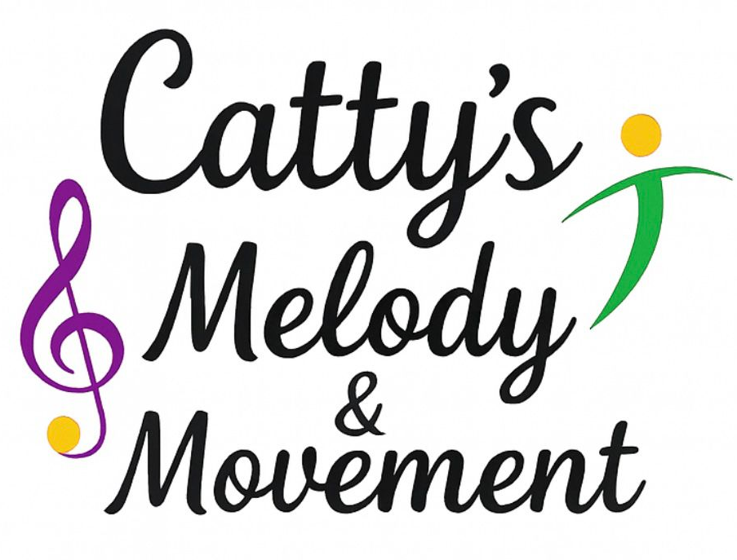
Equality & Diversity Policy
Catty’s Melody and Movement is committed to promoting equality, celebrating diversity and creating an inclusive environment where all children, families, staff and partners are treated with fairness, dignity and respect.
We believe that diversity enriches our music and movement sessions and that every individual has the right to feel valued, included and supported regardless of background or personal characteristics.
This policy applies to all staff, freelancers, volunteers and anyone working on behalf of Catty’s Melody and Movement.

1. Aims of the Policy
We aim to:
- Promote equality of opportunity for all children and adults.
- Eliminate discrimination, harassment and victimisation.
- Foster positive attitudes towards diversity and inclusion.
- Ensure our sessions are accessible, welcoming and inclusive.
- Comply with relevant equality legislation and best practice.

2. Legal Framework
This policy is informed by the Equality Act 2010, which protects individuals from discrimination based on the following protected characteristics:
- Age
- Disability
- Gender reassignment
- Marriage and civil partnership
- Pregnancy and maternity
- Race (including colour, nationality and ethnic or national origin)
- Religion or belief
- Sex
- Sexual orientation

Catty’s Melody and Movement is committed to upholding the principles of this legislation at all times.

3. Our Commitment to Equality and Diversity
We are committed to:
- Treating all children and adults fairly and with respect.
- Valuing individual differences and cultural backgrounds.
- Providing inclusive activities that reflect a diverse society.
- Challenging discrimination, stereotyping or prejudice where it arises.
- Ensuring no individual is disadvantaged when accessing our services.

4. Inclusive Practice in Our Sessions
Catty’s Melody and Movement promotes equality and diversity by:
- Offering inclusive music and movement activities suitable for a wide range of abilities.
- Adapting sessions to meet individual needs, including SEND.
- Using positive language, imagery and resources that reflect diversity.
- Encouraging cooperation, kindness and mutual respect.
- Creating a safe and welcoming environment for all participants.

5. Children with SEND and Additional Needs
We are committed to ensuring children with Special Educational Needs and/or Disabilities (SEND) are fully included.
- Reasonable adjustments will be made to support participation.
- Activities will be adapted where possible to meet individual needs.
- We work in partnership with parents/carers and settings to support children effectively.
This policy should be read alongside our Inclusion & SEND Policy.

6. Staff Responsibilities
All staff, freelancers and volunteers are expected to:
- Uphold this Equality & Diversity Policy at all times.
- Treat all children, families and colleagues with respect.
- Challenge discriminatory behaviour or language appropriately.
- Promote inclusive values through their conduct and teaching.
- Report any concerns to the appropriate person.

7. Dealing with Discrimination and Complaints
- Any form of discrimination, bullying or harassment will not be tolerated.
- Concerns or complaints will be taken seriously and addressed promptly.
- Issues will be managed fairly, sensitively and in line with our Complaints and Safeguarding procedures.

9. Monitoring and Review
This policy will be:
- Reviewed annually or sooner if legislation or guidance changes.
- Updated to reflect best practice and feedback from staff, parents and partner settings.

Policy Owner: Catty’s Melody & Movement
Review date: February 2026
Review Date: February 2027

Catty’s Melody and Movement celebrates diversity and is proud to create inclusive musical experiences where everyone feels they belong.

