cape Moreton - Gunumbah:

Archaeological and Aboriginal meanings at a quarry site on Moreton Island, southeast Queensland

By ANNIE ROSS, BOB ANDERSON AND CLIFF CAMPBELL, published 19 November 2013[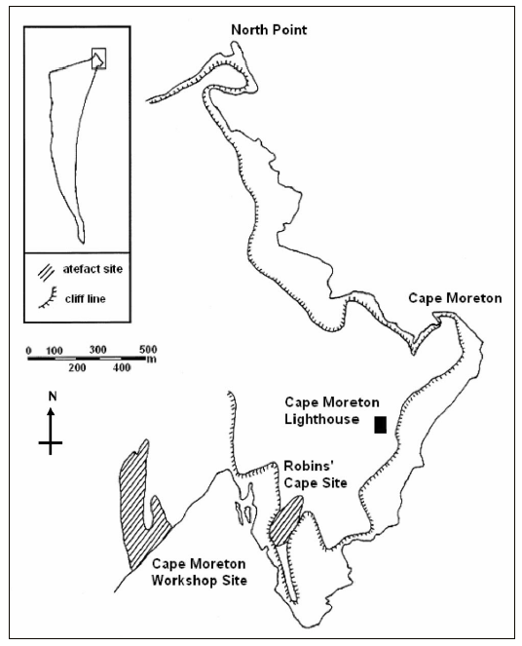](https://australianarchaeologicalassociation.com.au/wp-content/uploads/2013/11/Ross-et-al-Fig2-p78.png)

Northeastern portion of Moreton Island (published in *Australian Archaeology* 57:78). [/caption] Cape Moreton - Gunumbah - on Moreton Island, Queensland, is an area of high cultural value to the Ngugi traditional owners, and has considerable archaeological significance. The extensive area of stone outcrops is the largest raw material source for stone artefact manufacture in Moreton Bay, yet there is no evidence for extraction activities or stone working associated directly with the outcrops. Stone working is only visible at two nearby workshop sites. Furthermore, the area is made up of multiple outcrops of different raw material types. Each quarry is owned by a particular family, and the quarries were a major focus for trade on Moreton Island. Significant places close to the quarries imposed restrictions on access to the stone and obliged visitors to behave in accordance with Ngugi Law. Although several archaeologists have analysed the Cape Moreton stone outcrops, the full meaning of Gunumbah can only be determined by including Aboriginal knowledge of the entire place.