Joel Fostin Student I.D. 1072921

Task 3

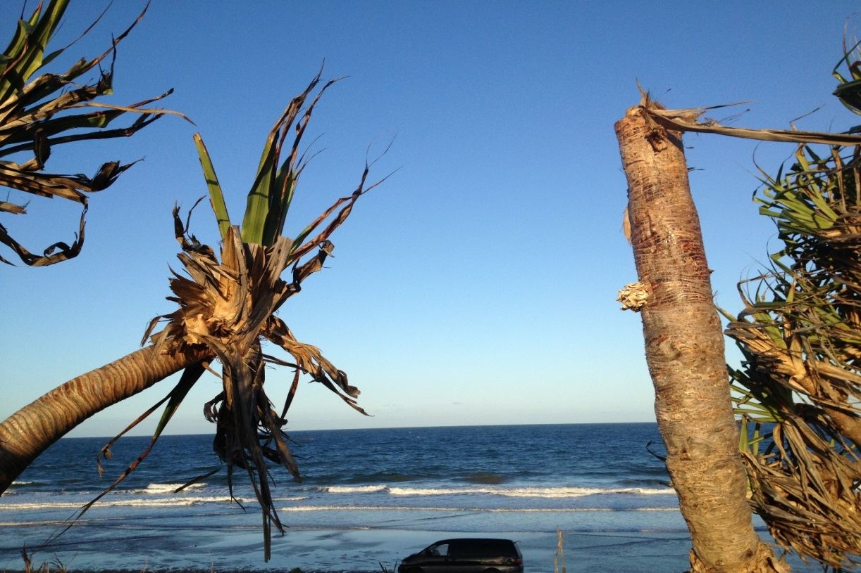University of the Sunshine Coast

**Management plan for early detection and mitigation of Jamella australiae (Pandanus Leafhopper) causing Pandanus dieback in Pandanus tectorius populations of Queensland May 2015**

**Table of Contents**

**Introduction** 1

**Background of Pandanus Dieback** 2

**The Pest *(Jamella australiae)*** 2

**Biological Control (*Aphanomerus pusillus*)** 3

**Current Distribution of *J. australiae* and *A. pusillus*** 3

**Managing Pandanus Dieback** 6

Physical control 6

Chemical control 6

biological control 7

**Early Detection/ Monitoring** 7

**How to recognise Jamella induced dieback in *Pandanus*** 7

Identification of *J. australiae*: 8

Identification of the egg parasitoid wasp *A. pusillus* 10

**End Note 11**

**References 12**

**Appendices 14**

Appendix 1 Pandanus Dieback Detection Survey 14

Appendix 2 *Aphanomerus pusillus* host specificity 15

# **Introduction**

The pandanus palm (*Pandanus tectorius*) is native plant found in high conservation value coastal dunes, headlands and islands throughout the Pacific Islands, parts of South East Asia and Australia (Stone 1978). The geographic extent of *Pandanus tectorius* in Australia stretches from coastal areas and islands in northern Queensland south to Port Macquarie in New South Wales (Williams 1979). It is commonly found within the eastern edge of littoral rainforests that are listed as an endangered ecological community under the Threatened Species Conservation Act 1995. (Bridestone 2015, Department of Environment and Climate Change (DECC) 2007).

*Pandanus tectorius* play an integral role in coastal ecosystems providing food and habitat for a diverse range of vertebrates and invertebrates. They are also a key species for dune stabilisation and wind protection for other littoral (coastal) plant species. They have a high cultural value for indigenous people and traditionally were used as an important resource for food, clothing, fishing and decoration (Thompson et. al 2011). In recent times pandanus palms have become highly valued and used as an ornamental and landscape plant across eastern Australia. The resulting intra-state transport of pandanus has facilitated the spread of a pest insect species that has, and continues to cause high mortality rates in wild pandanus populations, a condition commonly termed “Pandanus Dieback” (DECC 2007,NSW Environment and heritage 2015, Smith & Smith 2000).

# **Background of Pandanus Dieback**

Pandanus dieback was first recorded on the Gold Coast in 1993 and on the Sunshine Coast in 1995 (Management Plan-Noosa National Park 1999). Research began in 1995 to determine the cause of the dieback. Leaf and trunk samples were examined for the presence of virus, viroids and mycroplasma transmission. Soil and roots were also examined for the presence of phytophthora and nematodes. None of these pathogens were found responsible for the dieback (Smith 1998, Smith 2012, State of Queensland department of Environment (SQDE) 1997). The primary cause of dieback was linked to the presence of a leaf hopper (*Jamella australiae*) (DECC 2007, Smith 1998). Alarmingly high mortality rates were observed of up to 45% within less than two years of initial infestation (Smith & Smith 2000), with many more suffering a continual decline. It was found that when heavy infestations of *J. australiae* occur (due to absence of predators), large quantities of sugary honeydew is produced by the pest and concentrates at the base of the tightly packed leaf sheaths. During wet periods this honeydew leads to sooty mould and proliferation of fungal pathogens. This fungal rot spreads within the tightly packed crowns, causing live tissue damage to leaves, and the subsequent attrition of each growth head, ultimately leading to plant death (NSW Environment and Heritage 2015, DECC 2012, Smith 2012).

In 1995-1998 multiple government agencies conducted collaborative research into the leaf hoppers origins, potential predators and management options in order to create a management strategy to control leaf hopper numbers. Research into suitable insecticidal controls revealed that the systemic poison imidacloprid (confidor®) was effective in controlling leaf hopper numbers (Smith 1998). Stem injection of imidacloprid was then carried out In Noosa National Park and Burleigh Heads National Park as an interim measure to protect the surviving Pandanus palms (Noosa National Park Management Plan (NNPMP) 1999, Smith 2012).

# **The Pest *(Jamella australiae)***

Further research revealed *J. australiae* were found on *Pandanus spiralis*, endemic to Northern Australia (above the dry belt north of Townsville), first desdcibed by Kirkaldy in 1906 (Kirkaldy 1906). It belongs to the order Hemiptera and the Flatidae family and as such has a piercing mouth part that is designed to extract the sap from plant tissue. Adult planthoppers grow to approximately 8mm to 10mm long and are mottled brown/grey (Smith, 1998). The female adult planthopper lays white ovate, disc-like egg rafts within tightly bunched pandanus leaves. Each egg raft can contain between 50-80 eggs (Smith, 1998). There are five juvenile nymph stages (instars) ranging from 2-8mm long, juveniles are white and have a waxy fluff extending from the posterior. Early instars do not have fully formed mouth parts and feed on the sugary honey dew excreted by later stage instars and adults (Medler 1989).

No evidence of *J. australiae* related pandanus dieback was observed in the insect’s natural range. This was attributed to the presence of natural insect predators that control *J. australiae* numbers (Smith 2012).

# **Biological Control (*Aphanomerus pusillus*)**

Two species of egg parsitoid wasps *Aphanomerus pusillus* and *Ooencytus sp*. were identified and collected from northern Australia by CSRIO and contained in DPI laboratories on the sunshine Coast (Smith 2012). Both insects belong to the Hymenoptera family and are true egg parasitoids, the females seek out their host’s egg rafts and lay their eggs within the host’s eggs. The larvae of the parasitoid then feed on the egg/larvae of the host and after metamorphosis emerge from the egg case as an adult (Van Driesche et. al. 2010).

In1998 approval was given, and both wasp species were released in small numbers at Noosa National Park and Burleigh Heads National Park. *Ooencytus sp*. did not establish and successfully control planthopper numbers. *A. pusillus* believed to be host specific (see Appendix 2 for more information of host specificity), established well, and became successful at controlling leafhopper numbers (Smith & Smith 2000, Sunshine Coast Regional council (SCRC) 2012).

In areas where *A. pusillus* has established sustainable populations, the use of chemical control has been almost completely discontinued (SCRC 2012, Smith 2012). The Sunshine and Gold Coasts are testament to dynamic population shifts between predator and prey, with pandanus mortality primarily occurring on pandanus suffering from other environmental stresses (Smith 2012). Although cold winter temperatures, particularly in the southern areas were believed to adversely affect the resilience and potentially effectiveness of the tropical wasp species, effective biological control has still been observed (Brideson 2015). The wasp has followed the localised spread and migration of the planthopper (including south into Northern NSW) (Brideson 2015).

# **Current Distribution of *J. australiae* and *A. pusillus***

Due to the extensive horticultural use and subsequent transport of pandanus palms, there have been multiple *J. australiae* outbreaks across Queensland and New South Wales. For example a single *Pandanus spiralis* specimen planted in a private estate on a coastal headland was responsible for the northern most known outbreak in Agnes Water Queensland, this infested tree most likely originated from a Cairns base nursery. Likewise the southernmost infestation was found at Yamba on a recently landscaped private property. This infested mature tree was bought from a Tweed Head’s based nursery (Brideson 2015). Many more outbreaks have similarly occurred and will continue to occur as infested pandanus are transported to unaffected coastal areas.

Populations of *J. australiae* have been found in Tin Can Bay, Rainbow Beach, Moreton Island, North Stradbroke Island, Fraser Island, Bargara (near Bundaberg), Kingscliff, Casuarina Beach, Bogangar, Byron Bay, Broken head, Ballina and most likely many more locations that may have not yet been diagnosed. It should be noted that in most cases where both predator and prey are present, a gradual localised migration of both insects occurs, *J. australiae* populations are contained and pandanus die back is minimal (SCRC 2012, Smith 2012). This may well be the case with future planthopper outbreaks originating from areas with established populations of *A. pusillus*. However to date, almost all outbreaks of *J. australiae* have not been accompanied by the parasitoid wasp, thus highlighting the need for awareness, monitoring and early detection.

The ‘Pandanus Planthopper Working Group’ was established in NSW in November 2004 for this purpose. Acting as an inter-agency group, working cooperatively with local and state government and the community for a coordinated control and prevention of *J. australiae* in northern New South Wales (Brideson 2015). No such organisation exits in Queenslandand official scientific and pest distribution data is currently unavailable due to the lack of research being carried out.

No official museum distribution records of either insect exist (Fostin 2015). A distribution map (see figure 1) of both prey and predator has however has been produced based on media information of council stem injections been carried out and communications with community groups, Council staff and Parks officers. This is a preliminary map produced for education purposes, until official distribution data has been collected and collated.

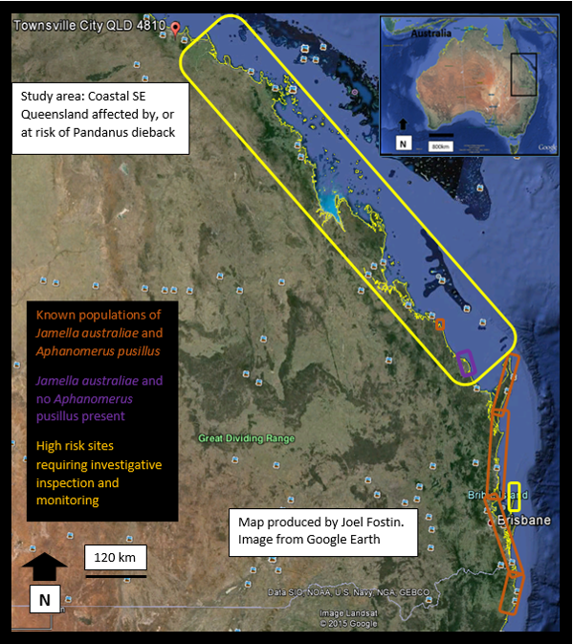

**Figure-1.** Map of South Eastern Queensland showing coastal sites with known populations of *J. australiae* and *A. pusillus* in orange, sites with populations of *J. australiae* and no *A. pusillus* populations in purple, and high risk sites requiring monitoring in yellow.

*Since the production of this map the presence of *J. australiae* has been confirmed on Moreton island (circled in yellow north of Brisbane), North Stradbroke Island and Tin Can Bay. The presence of *A. pusillus* in these locations is currently unknown. The presence of *A. pusillus* on Fraser Island has also yet to be confirmed.

# **Managing Pandanus Dieback**

Three methods have been used to control *J. australiae* infestations: **physical**, **chemical** and **biological.** The physical and chemical controls both have merit for implementation in given circumstances, however the introduction and monitoring of self-sustaining populations of the egg parasitoid *A. pusillus* should be considered as the primary pandanus dieback management strategy (SCRC 2012, Smith 2012, Smith & Smith 2000).

**Physical control** involves highly labour intensive stripping and disposal of affected leaves, this removes significant numbers of the leaf hopper from the plant and eliminates much of the fungal rot and restores vascular function. This is an effective control method that can keep infested trees alive without the use of insecticide (Smith 2012). It is however logistically impractical for large scale management, and also raises safety concern for workers due to steep and unstable nature of much of the coastal environment where Pandanus are found.

**Chemical control** is done via foliar spray of smaller individuals, or stem injection into multiple stems of mature pandanus, with imidacloprid (Confidor®). Confidor is a non-specific systemic poison acting as a neurotoxin to all sap, pollenand nectar feeding insects, when injected into the stem it can remain within pandanus palms vascular system for up to 2 years (SCRC 2012, Smith 2012). The stem injection method is usually done with a specialised tool (side winder), and involves drilling a 5mm hole and injecting 5ml of the class 4 chemical at a 1:1 rate then plugging the hole to prevent pathogen entry points. This is a costly, time consuming and labour intensive method that has and still is being employed by councils and national parks in almost all outbreak sites from Ballina to Agnes Water (except where *A. pusillus* has been naturalised). This management method in itself poses a risk to the plant, as the hole drilled disrupts vascular connectivity and provides a potential entry point for fungal invasion, and therefore is not suitable as a long term control method. (Brideson 2015, Smith 2000).

Foliar application of Confidor can be performed on small pandanus (lacking a trunk), and is also the preferred method for severely affected mature pandanus with low transpiration rates due to decreased foliage. It is effective at a rate of 5ml:1L water (Smith 2012). With this method the insecticide does not remain in the plant tissue as long as the stem injection method.

Apart from the environmental concerns of introducing a non-specific pesticide with to coastal ecosystems, another disadvantage of the continued use of Confidor is the likelihood that with continued use the target insect will develop a chemical resistance (Miyata, 1989). Studies conducted by Cheng et. al. have also suggested that the use of imidacloprid turn off some genes that some rice varieties use to produce defensive chemicals, thus increasing the plants susceptibility to planthopper infestation and attacks (Cheng et. al. 2012). As pandanus also belong to the monocotyledon clade, the use of imidacloprid may have a similar negative effect on pandanus palms.

Whilst the use of Confidor is not sustainable in the long term, it has merit to protect feature plants in parks and gardens, or where dieback has progressed to a critical point (e.g. late detection of advanced dieback cases).

The **biological control** egg parasitoid *A. pusillus* has been successful at controlling *J. australiae* populations. Where *A. pusillus* has naturalised a predator prey balance exists and physical and chemical control is rarely required (SCRC 2012, Smith 2012). The wasp is considered as ‘naturalised’ in Queensland and no restrictions are placed on the translocation (Van Driesche et. al. 2010).

Translocation of *A. pusillus* is relatively simple, involving the collection of fresh *J. australiae* egg cases from sites with high parasitism levels. The collected egg rafts are stored in a suitable container until adult wasps emerge. The adult wasps are then released within the foliage of pandanus palms with high leafhopper numbers. An even simpler method of placing parasitised egg rafts at the base of pandanus with low *A. pusillus* numbers is used by some Sunshine Coast council parks staff to boost parasitism levels on pandanus with high rates of planthopper infestation and low rates of paratism (this should be carefully considered due to the risks of spreading the numerous insect species, arachnids and fungal/bacterial pathogens found on Pandanus plants).

# **Early Detection/ Monitoring**

The most beneficial management tool for prevention of pandanus dieback is the **early detection** of *J. australiae* in new outbreak sites. In the absence of significant biological predators or chemical controls, irreversible damage is caused to the vascular pathways of individual pandanus lowering the plants metabolic function. After this damage has occurred, and even when control methods are introduced, plant health often progressively declines resulting in eventual mortality.

In order to achieve early detection of *J. australiae* a simple monitoring program should be introduced in unaffected areas. The three primary objectives of this monitoring program is to establish plant health, secondly to ascertain the presence of *J. australiae*, and thirdly to ascertain the presence of *A. pusillus*.

A simple survey has been produced to assist in the collection of this preliminary data (Appendix 1). It is recommended that this survey be undertaken at least annually by a nominated person/people. The accompanying photos can be printed and used as identification tools. Pandanus populations adjacent to suburban areas, estates etc., should be the primary focus, as the most likely outbreaks will continue to occur as infested pandanus are transported to unaffected coastal areas. If the presence of *A. pusillus* has been confirmed, a site specific management plan can be constructed based on the level of infestation and the range of spread.

# **How to recognise Jamella induced dieback in *Pandanus***

Signs of *J. australiae* induced dieback can often be observed from a distance. Large amounts of dead leaf around the base of the leaf heads is normal and can often be observed on unaffected pandanus. Affected trees however, have increased amounts of dead leaves sporadically throughout live growth heads, and often the centre is completely dead. Black sooty mould, caused by the insect’s sugary secretions, can usually be seen on the leaves and trunks of badly infested trees. Leaf dieback often begins on the northern (warmer) side of the tree or in trees on the northern edge of tree clumps (Bridestone 2015).

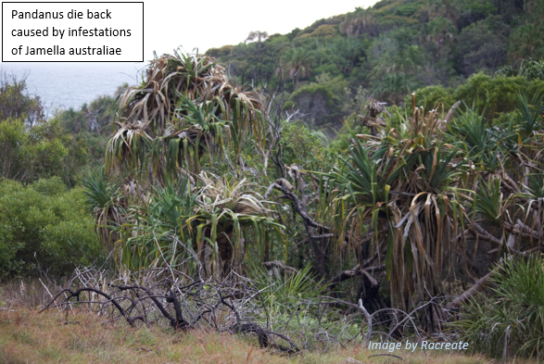

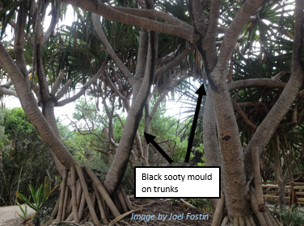

**Identification of *J. australiae*:** A close inspection of individual leaf sheaths will reveal *J. australiae* egg rafts between both live and dead leaf sheaths (the most common/obvious sign of infestation). Nymphs at various growth stages and their exoskeletons and mature adults can also be observed.

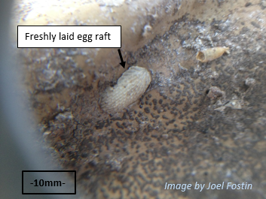

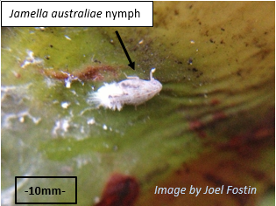

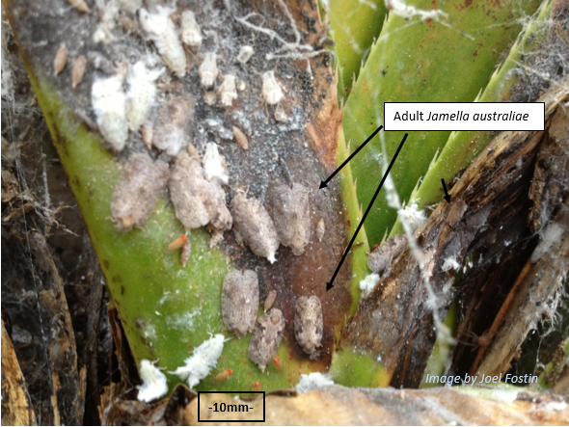

**Identification of the egg parasitoid wasp *A. pusillus*:** The adult wasp is rarely seen as it measures less than two mm long.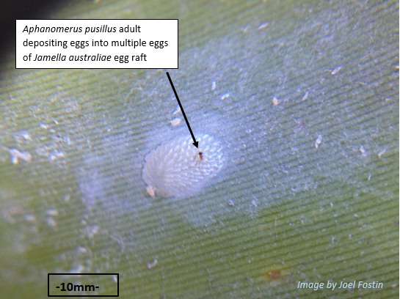 The most distinguishing sign of the presence of *A. pusillus* is the emergent holes made in the eggs of *J. australiae* egg rafts.

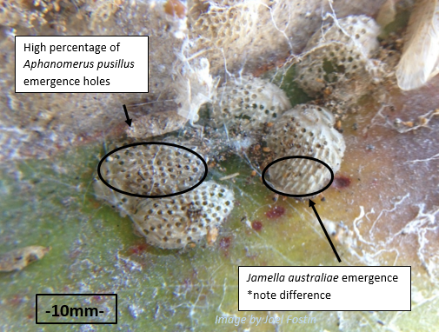

# **End Note**

This report and attached survey (see Appendix 1) has been produced to facilitate the early detection of pandanus dieback and contribute to data collection and comprehensive mapping of the distribution of *J. australiae* and *A. pusillus.*  With proactive monitoring and the subsequent prompt translocation of *A. pusillus*, localised and wide spread dieback of *Pandanus tectorius* can be prevented or minimalized. Frailty of the data and potential for inaccuracy is acknowledged, which emphasises the need for more thorough field research and monitoring, and an inter-organisational collaborative approach to the management of pandanus dieback.

If either *Jamella australiae* or *Aphanomerus pusillus* are identified in any area not indicated on the above map or for more information and to email completed surveys, contact Joel Fostin at: [pandanusdieback@outlook.com](mailto:pandanusdieback@outlook.com)

Mobile: 0434537272

**Acknowledgements**

I would like to thank Nat Smith for his time and advice (author of most of the research that is available), Chris Burwell senior curator from The Queensland Museum entomology department, John Olds principle conservation officer from NPRSR Rockhampton for his sage advice, Saranne Giudice Healthy Habitats Project Officer from Burnett Mary Regional Group for her assistance, Julie O’connor from Discovery planet, Rachell Anning From Racreate for her photography and awesomeness, and countless other national parks officers, council workers and coast care members for their kind assistance and contact referrals.

# **References**

Anon, Parasitoid Wasp Genomes. (2010). *Science*, 327(5963), pp.247-247

Brideson, J. (2015). *PROTECTING PANDANUS TREES FROM THE PANDANUS PLANTHOPPER*. 1st ed. [ebook] Ballina NSW: Northern Rivers and Mid North Coast Pandanus Planthopper Working Groups. Available at: http://www.coastalconference.com/.../Protecting%20Pandanus%20trees%20from [Accessed 12 Apr. 2015].

Cheng, Yao; Shi, Zhao-Peng, Jiang, Li-Ben, Ge, Lin-Quan, Wu, Jin-Cai, Jahn, Gary C. (2012). "Possible connection between imidacloprid-induced changes in rice gene transcription profiles and susceptibility to the brown plant hopper Nilaparvata lugens Stål (Hemiptera: Delphacidae)". *Pesticide Biochemistry and Physiology* **102** (3): 213–219. doi:10.1016/j,[accessed 12 May 2015]

Environment.nsw.gov.au, (2015). *Pandanus trees and the threat of dieback - Publication | NSW Environment & Heritage*. http://www.environment.nsw.gov.au/vegetation/pandanusdieback.htm [Accessed 20 Mar. 2015].

Fostin, J. (2015). *Jamella australiae and Aphanomerus pusillus official distribution records*. [email].

Noosa National park, *Management plan*. (1999). Brisbane, p.8. Available at: http://www.nprsr.qld.gov.au/managing/plans-strategies/pdf/noosa-national-park-1999.pdf [Accessed 20 Mar. 2015].

Department of Environment and Climate Change NSW, 2007, Management Strategy 2008-2011. DECC, Sydney, NSW http://www.environment.nsw.gov.au/resources/pestsweeds/RegionalPestStrategyNRR.pdf [Accessed 21 Mar. 2015].

Medler, J. (1989). Review of Jamella Kirkaldy and Malleja , gen. nov. in Australia and New Guinea, with descriptions of new species (Homoptera : Flatidae). *Invertebrate Systematics*, 3(7), p.995. [Accessed 20 Mar. 2015].

Miyata, T 1989, 'Problems in the control of insecticide-resistant rice plant- and leafhoppers', *Pesticide Science*, vol. 26, no. 3, pp. 261-269. Available from: 10.1002/ps.2780260306. [11 May 2015].

Pemberton, C. E. (1964). *Highlights In The History OF Entomology In Hawaii 1778-1963*, Bishop Museum. [Accessed 20 April 2015] http://hbs.bishopmuseum.org/fiji/pdf/pemberton1964.pdf.

Smith, N. (1998). *Pandanus dieback*. Brisbane: Qld. Dept. of Environment and Heritage and Qld. Dept of Primary Industries. [Accessed 20 April 2015]

Smith, N.J., Smith, D., (2000). Studies on the flatid Jamella australiae Kirkaldy causing dieback in Pandanus tectorius var. pedunculatus (A.Br.) Domin on the Sunshine and Gold Coasts in Southeast Queensland. General and Applied Entomology 29, 11–20.

Smith, N. (2012). *Management of Jamella australiae (pandanus leafhopper) in Pandanus tectorius populations*. Bundaberg Regional Council.

State of Queensland, Department of Environment. (1997). Pandanus Dieback. *Wildlife Information.* State of Queensland, Department of Environment.

Stone, B. (1978). A review of the Australian species of Pandanus, sectico Semikeura (Pandanaceae). *Nuytsia* 2:236-253. [Accessed 20 April 2015]

Sunshine Coast Regional Council, (2012). *Sunshine Coast Local Government Area Pest Management Plan*. The Sunshine Coast QLD: Sunshine Coast Regional Council, pp.Section 3 p33. [Accessed 21 March] http://www.sunshinecoast.qld.gov.au/addfiles/documents/environment/pmp_fward_exec_summ_intro.pdf

Thompson, L., Englberger, L., Guarino, L., Thaman, R. and Elevitch, C. (2011). *Species Profiles for Pacific Island Agroforestry*. [online] www.traditionaltree.org. Available at: http://www.agroforestry.net/images/pdfs/P.tectorius-pandanus.pdf [Accessed 11 May 2015].

Williams, K. (1979). *Native plants of Queensland*, Ipswich, Australia: K.A.W. Williams.

Van Driesche, R.G., Carruthers, R.I., Center, T., Hoddle, M.S., Hough-Goldstein, J., Morin, L., Smith, L., Wagner, D.L., Blossey, B., Brancatini, V., Casagrande, R., Causton, C.E., Coetzee, J.A., Cuda, J., Ding, J., Fowler, S.V., Frank, J.H., Fuester, R., Goolsby, J., Grodowitz, M., Heard, T.A., Hill, M.P., Hoffmann, J.H., Huber, J., Julien, M., Kairo, M.T.K., Kenis, M., Mason, P., Medal, J., Messing, R., Miller, R., Moore, A., Neuenschwander, P., Newman, R., Norambuena, H., Palmer, W.A., Pemberton, R., Perez Panduro, A., Pratt, P.D., Rayamajhi, M., Salom, S., Sands, D., Schooler, S., Sheppard, A., Shaw, R., Schwarzländer, M., Tipping, P.W., van Klinken, R.D., Classical Biological Control for the Protection of Natural Ecosystems*,* *Biological Control* (2010), doi: 10.1016/j.biocontrol.2010.03.003 [accessed 10 May 2015]

# 

# **Appendices**

## **Appendix 1 Pandanus Dieback Detection Survey**

|  |  |  |  |  |  |  |  |  |
| --- | --- | --- | --- | --- | --- | --- | --- | --- |
| Pandanus tectorius Dieback detection survey | | | | | | | | |
|  | **Department/organisation** | |  | | | | | |
|  | **Researcher name/s** | |  | | | | | |
|  | **Date** | |  | | | | | |
|  | **Location name/ (GPS coordinates if available)** | |  | | | | | |
|  | **Number of individual Pandanus plants per 200 metres of coast or cluster population \*** | |  | | | | | |
|  | **Health condition* of Pandanus per 200 metres of coast or per cluster population** | | **Healthy** | | **Poor** | | **Very Poor** | |
| **Approximate number:** | | **Approximate number:** | | **Approximate number:** | |
| **Examination of five Pandanus in the poorest condition** | | | | **Plant 1** | **Plant 2** | **Plant 3** | **Plant 4** | **Plant 5** |
| **Approximate height of palm** | | | |  |  |  |  |  |
| **Approximate number of leaf heads** | | | |  |  |  |  |  |
| **Percentage of unhealthy leaf heads** | | | |  |  |  |  |  |
| **Number of leaf heads examined for Jamella egg rafts \*** | | | |  |  |  |  |  |
| **Number of egg rafts sighted (If any) \*** | | | |  |  |  |  |  |
| **Percentage of egg raft parasitised*(If any)** | | | |  |  |  |  |  |
| **Other notes:**  **(Indication of other pests or disease, observed evidence of fire, habitat type, soil type, nutrient levels, etc.).**  **\*Photograph any anomaly** | |  | | | | | | |
| **\*Definition of cluster population** | | **A group or community of pandanus positioned/grouped or occurring closely together** | | | | | | |
| **\*Definition of healthy Pandanus** | | **Plants in a normal state of health >80% of leaves green and healthy** | | | | | | |
| **\*Definition of Pandanus in poor health** | | **Plants clearly suffering 30-50% of leaves yellow or dead** | | | | | | |
| **\*Definition of pandanus in very poor health** | | **Plants severely suffering >50% of leaves are yellow or dead** | | | | | | |
| **\*Number of leaf heads to examine** | | **Inspect at least 5 leaves on each of 10 separate leaf heads, (leafhopper egg rafts, nymphs, and adults usually occur at base of leaf sheaths)** | | | | | | |
| **\*Jamella egg rafts** | | **See description and photos in attached report** | | | | | | |
| **\*Parasitised egg rafts** | | **See description and photos in attached report** | | | | | | |

**Email completed survey and photos/queries to Joel Fostin:** [**pandanusdieback@outlook.com**](mailto:pandanusdieback@outlook.com)

## **Appendix 2 *Aphanomerus pusillus* host specificity**

Although it is outside the scope of this report, attempts were made to access the data collected by CSRIO and the DPI, pertaining to the host specificity of *A. pusillus* prior to its release. Online information accessed regarding this was conflicting and insufficient.

The authors current understanding is that *A. pusillus* is an egg parasitoid that does prey on other Flatidae genus and species. It should be noted that in previous research the parasitoid wasp is referred to as *Aphanomerus nr. Pusillus*, indicating notable morphological/behavioural differences.

The use of *A. pusillus* as a biological control of flatid species has been known since at least 1904, when it was introduced to Hawaii (and soon thereafter to New Zealand) to control the Australian originated pest species “Torpedo Bug” (*Siphanta acuta*). *S. acuta* is an agricultural pest feeding on a diverse range of plant species, and in the early 1990’s also decimated local forests of some of the Hawaiian Islands (Pemberton 1964). Considerable scientific research has been conducted in the Hawaiian Islands into the effectiveness and parasitism rates of *A. pusillus* on *S. acuta*, with parasitism rates matching that as found on in Australia on *J. australiae* of >80% (Van Driesche et. al. 2010).

A. Pusillus is considered naturalised in south east Queensland and no restrictions are placed on the distribution and translocation of the predator.

Although *A. pusillus* is now naturalised in NSW, initial concerns of it preying on other flatid species prevented the issuing of a license under the National Parks and Wildlife Act 1974 to collect and release *A. pusillus* there. Although these concerns seem justified like many cases of environmental management, the compromise is often made by choosing the ‘lesser of two evils’.

Whilst high population levels of *A. pusillus* may potentially have a spill over effect and prey on other leafhoppper species found in the littoral zone, the use of imidacloprid and the associated time, costs, damage to pandanus vascular system, and the death of all insects which feed and forage for nectar and pollen on pandanus would have far greater negative effects.