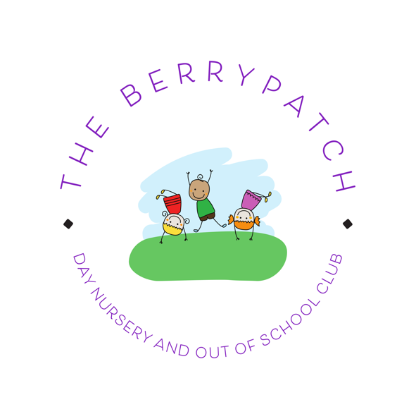

Finedon Community Centre , 71 Wellingborough Road Finedon NN9 5LG
Tel: 07597557861 email:berrypatchfinedon@gmail.com
www.theberrypatchfinedon.com

Nursery Fees and Funding

Non-Funded Under 2 years
- Full Day (7:30 AM - 6:00 PM): £79 per day
- Morning Session (7:30 AM - 1 PM): £42 per session
- Afternoon Session (1:00 PM - 6:00 PM): £38 per session

Non-Funded 2 years and over
- Full Day (7:30 AM - 6:00 PM): £72 per day
- Morning Session (7:30 AM - 1 PM): £38 per session
- Afternoon Session (1:00 PM - 6:00 PM): £35 per session

15/30hr Fully Funded Hours Term Time Only 38 weeks a year.
- Full Day (9:00AM - 3:00PM)
- Morning Session (9:00AM - 12PM):
- Afternoon Session (12:00PM - 3:00PM)

12/24hr Funded Hours over the full year.
- Full Day (9:00AM - 3:00PM)
- Morning Session (9:00AM - 12PM):
- Afternoon Session (12:00PM - 3:00PM)

Fees for additional hours on top of funding
- Under 2 £7.50 per hour
- 2 and over £6.80 per hour

How the funding can be used
North Northamptonshire council offers funding for eligible children in 2 different ways
- Term time only – Funding can be used over the terms of a school year -38 weeks of the year (see term time dates below)
- Stretched – Funding can be used all year when we are open-47 and a half weeks a year
If you are eligible for 15 hours a week funding – this equates to 12 hours a week when it is ‘stretched’ over the year
If you are eligible 30 hours a week funding - this equates to 24 hours a week when it is stretched over the year.

Funding -Eligibility
Please note the information below is correct as of 1st September 2025 and not all funding listed was available before this date.
For funding purposes terms are defined as :
Autumn term 1st September – 31st December
Spring Term – 1st January – 31st March
Summer Term- 1st April – 31st August
Working parent/parents
Known as ’30 Hours funding’- Is available for children from the term after they turn 9 months old ( See above for term dates) from September 2025.
If you are a single working parent or a 2 parent family and both of you work you may be eligible if 1 parent ( single parent family) or both parents ( 2 parent family):
• Expect to earn the equivalent of 16 hours a week at the National Minimum or Living Wage
• May be on maternity, paternity or adoption leave
• May be eligible if unable to work due to being disabled or have caring responsibilities.
You are unable to claim the funding if either parent individually expects to earn £100,000 adjusted net income or more a year.
The funding must be applied for by the parent/carer via ‘Childcare choices website. https://www.childcarechoices.gov.uk/
You will be given a code if you are eligible and you must give this code to us alongside your national insurance number, child’s name and date of birth. We will then verify the code and will confirm with you when you can use the funding.

Examples of when you can use the funding.
Your child turns 9 months on 26th February - They are eligible to use the funding from the next term which would be 1st April.
Your child turns 2 years old on 5th August - They are eligible to use the funding from the next term which would be 1st September.
Your child turns 3 years old on 14th September. They are eligible to use the funding from the next term which would be January 1^{st.}
You must apply for the funding by the following dates :
To use from September -apply by 31st August
To use from January – Apply by 31st December
To use form April- Apply by 31st March

Non working parents
2-year-olds can also get 15 hours a week funded childcare, the term after their 2nd birthday , if you receive one of the following:
• Income Support
• Jobseeker’s Allowance (JSA) based on income.
• Employment and Support Allowance (ESA) related to income.
• Universal Credit
• Tax credits and you have an annual income of under £16,190 before tax
•The guaranteed element of State Pension Credit
• Support through part 6 of the Immigration and Asylum Act
• The Working Tax Credit 4-week run on (the payment you get when you stop qualifying for Working Tax Credit)
•You receive Disability Living Allowance for your child
This funding must be applied for via North Northants County Council https://www.northnorthants.gov.uk/get-help-paying-childcare/free-early-education-and-childcare-2-year-olds
If eligible you will receive a code that you must give to us along with your child’s name and date of birth
All parents of 3 and 4 year-olds can claim 15 hours a week funding from the term after their child’s 3rd birthday, regardless of whether their parents work or any benefits they receive. This does not need to be applied for, but you will need to fill in a declaration form that we will give you before your child’s starts.
How the funding can be used

We offer both term time sessions and all year round.
Examples- Term time only
You are eligible to 15 hours week
You wish your child to attend Monday to Friday 9am-12 mid-day – ( 15 hours a week ) Term time only . There would be no charge.
You are eligible to 30 hours week
You wish your child to attend Monday to Friday 9am-3pm (30 hours a week) – Term time only. There would be no charge.
Examples- All year round
You are eligible to 12 hours a week ( stretched funding)
You wish your child to attend Monday to Friday 9am-12 mid-day ( 15 hours a week) all year round . You can use 12 hours a week funding and would be charged for the remaining 3 hours a week.
You are eligible to 24 hours a week ( stretched funding)
You wish your child to attend Monday to Friday 9am-3pm ( 30 hours a week) -all year round . You can use 24 hours a week funding and would be charged for the remaining 6 hours a week.

Full time place, all year round – Using 24 hours stretched funding .
You wish your child to attend from 7.30am – 6pm – Monday to Friday – All year round. This would be 52 and a half hours a week – You can use 24 hours a week funding and would be charged for the remaining 28 and a half hours.
If you have any questions with regard to funding please do not hesitate to ask.
If you are not eligible to any funding, full fees will apply .
If you would like your child to start attending before they are eligible for funding, full fees will apply.
We offer a 10% discount for siblings.
Fees are invoiced monthly, on the 15th of each month, in advance , to be paid within 14 days.
Snacks for children are included in the fees but your child will need to be supplied with a packed lunch (or something that can be reheated for their lunch).
Where applicable Nappies, Wipes, Creams and formula milk/Breast milk will need to be supplied

We are open Monday to Friday 7.30am - 6pm for 47.5 weeks of the year .
Children can attend either term time or all year.

Term time dates :
2025-2026
Term 1
Open -Wednesday 3rd September 2025
Close- Friday 24th October 2025
Term 2
Open – Tuesday 4th November 2025
Close- Friday 19th December 2025
Term 3
Open – Tuesday 6th January 2026
Close Friday 13th February 2026
Term 4
Open-Monday 23rd February 2026
Close- Friday 27th March 2026
Term 5
Open Monday 13th April 2026
Monday May 4th Bank Holiday-Closed
Term 6
Open Tuesday 2nd June 2026
Close Friday 17th July 2026

We are closed fully for all children on the following dates:
Close at 1pm on Tuesday 23rd December 2025 and re open on Monday 5th January 2026 – Christmas break.
Closed all day Friday 6th February 2026 – Staff training
Close at 6pm on Thursday 2nd April 2026 and reopen on Monay 13th April – Easter break.
Closed all day Monday 4th May 2026 – Bank Holiday
Closed all day Monday 25th May 2026 -Bank Holiday
Close at 6pm on Friday 21st August 2026 and reopen on Tuesday 1st September 2026 ( Monday 31st August- Bank Holiday)

