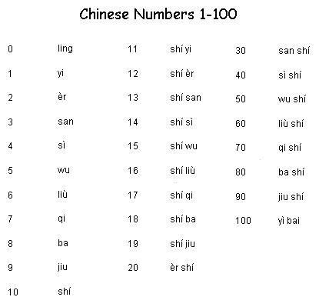

Games:

Counting circle 7, 13

Card adding subtracting games 25, 54

Minimum or maximum non-repeating numbers

Webpage number songs

<https://www.youtube.com/watch?v=2eLP3FuuEVs&t=12s>