

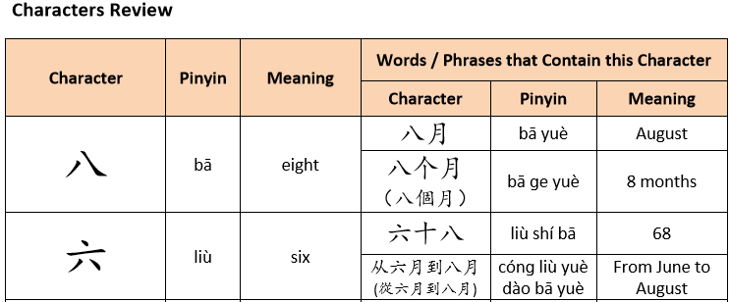

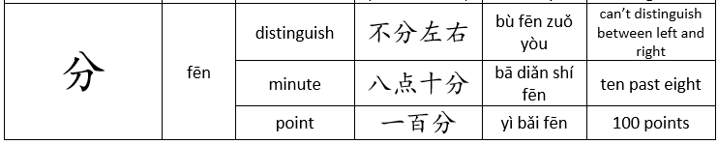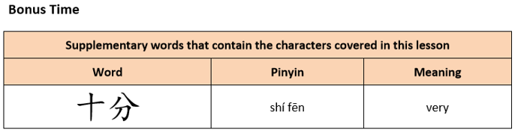

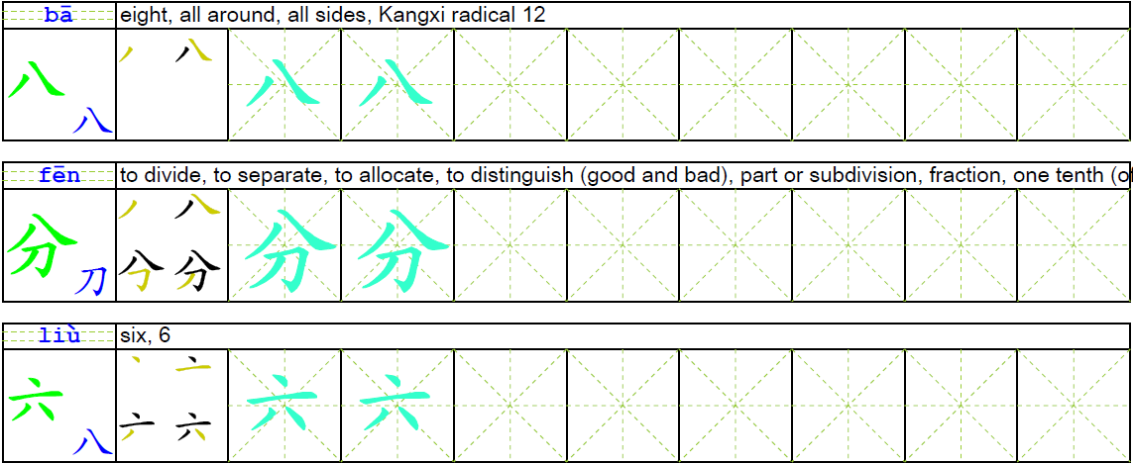



Real life reading practice. Look at the picture and circle or write down the character(s) you recognize. Write down the character’s Pinyin above it.

Picture 1:

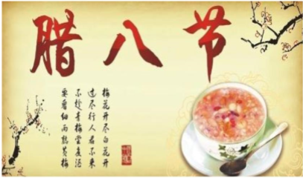

Picture 2:



Picture 3:

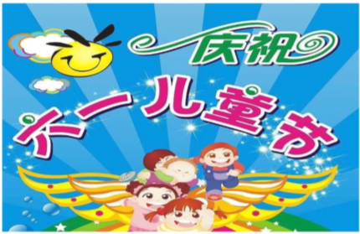

Identify following 20 characters you learned and write down pinyin, characters and English meanings on the space of this page.

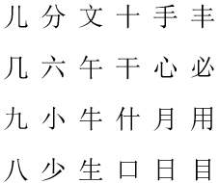

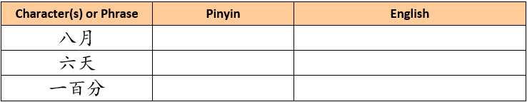





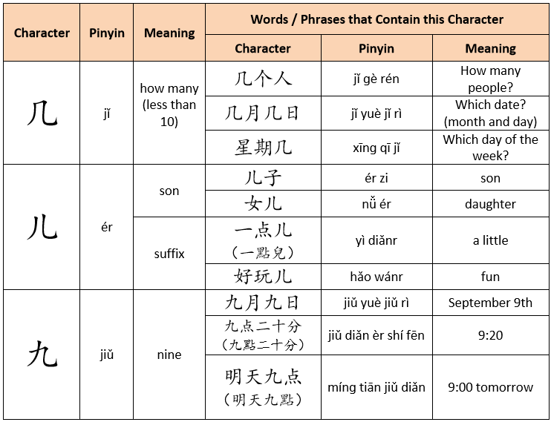

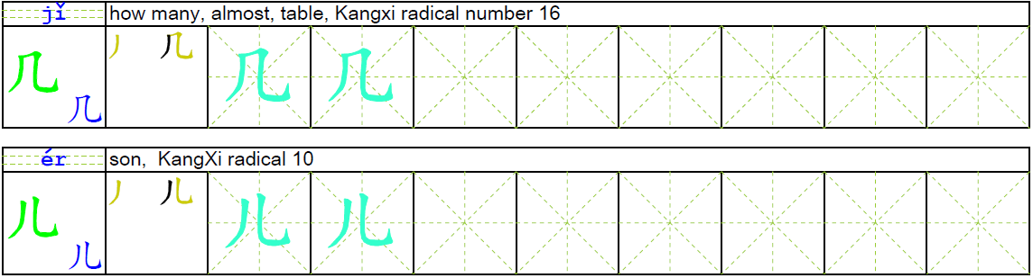

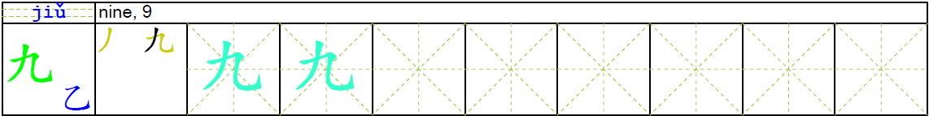

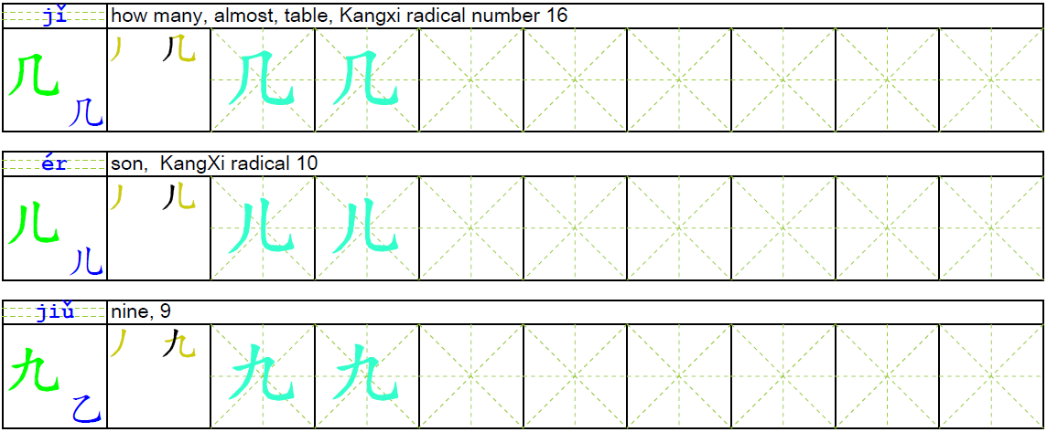

Real life reading practice. Look at the picture and circle or write down the character(s) you recognize. Write down the character’s Pinyin above it.

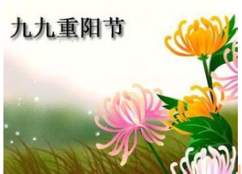

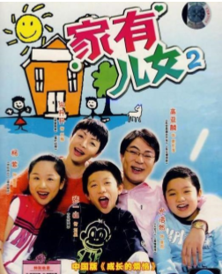

Identify following 23 characters you learned and write down pinyin, characters and English meanings on the space of this page.

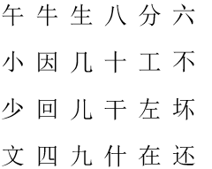

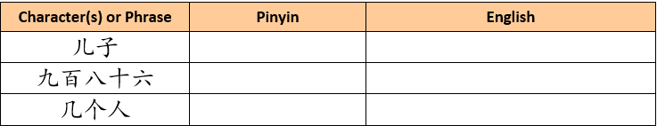



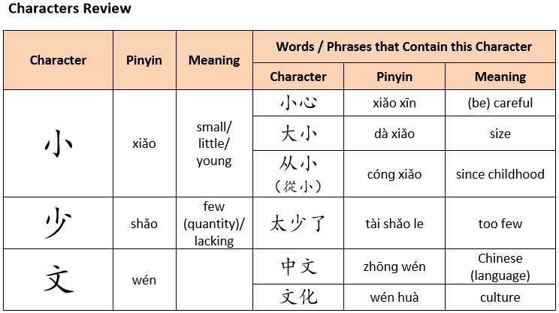

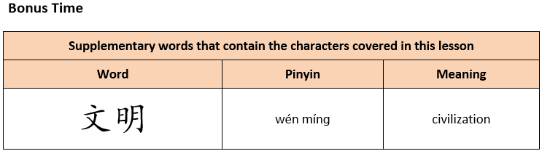

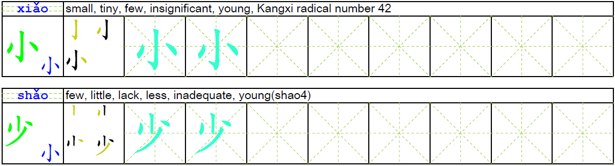

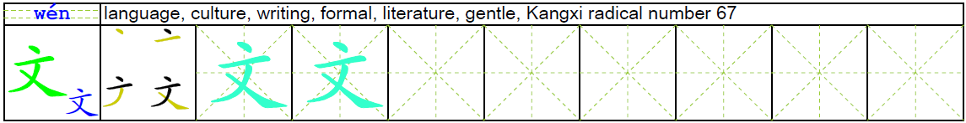

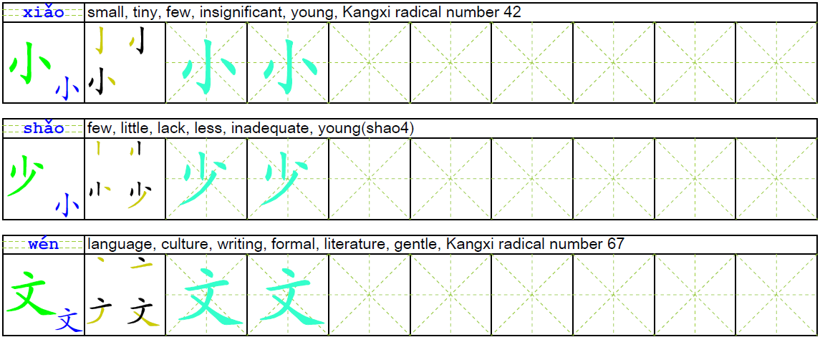

Real life reading practice. Look at the picture and circle or write down the character(s) you recognize. Write down the character’s Pinyin above it.

Picture 1:

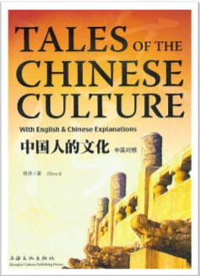

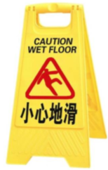

Picture 3:



Identify following 15 characters you learned and write down pinyin, characters and English meanings on the space of this page.

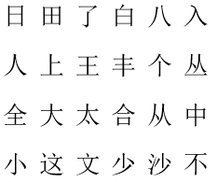

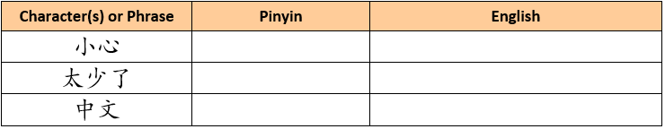



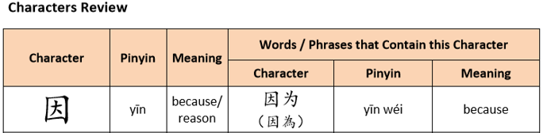

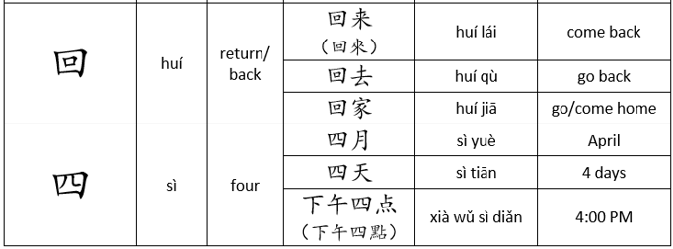

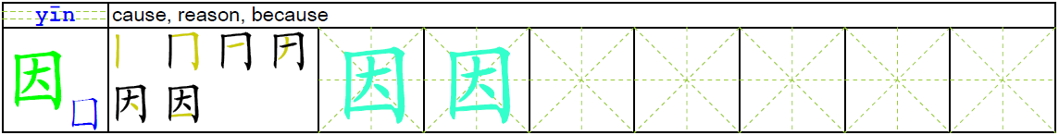

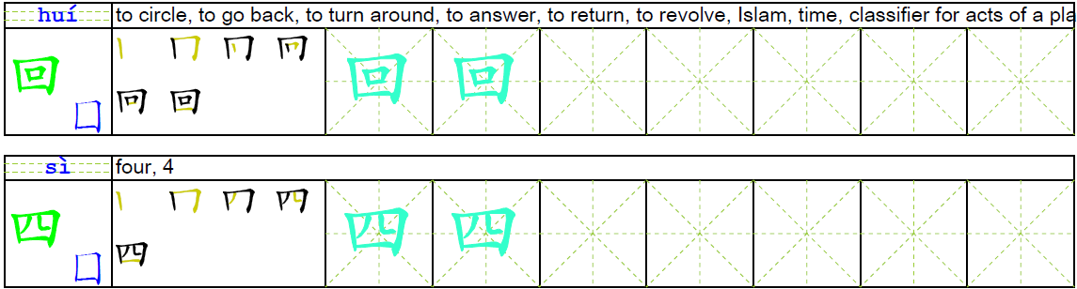

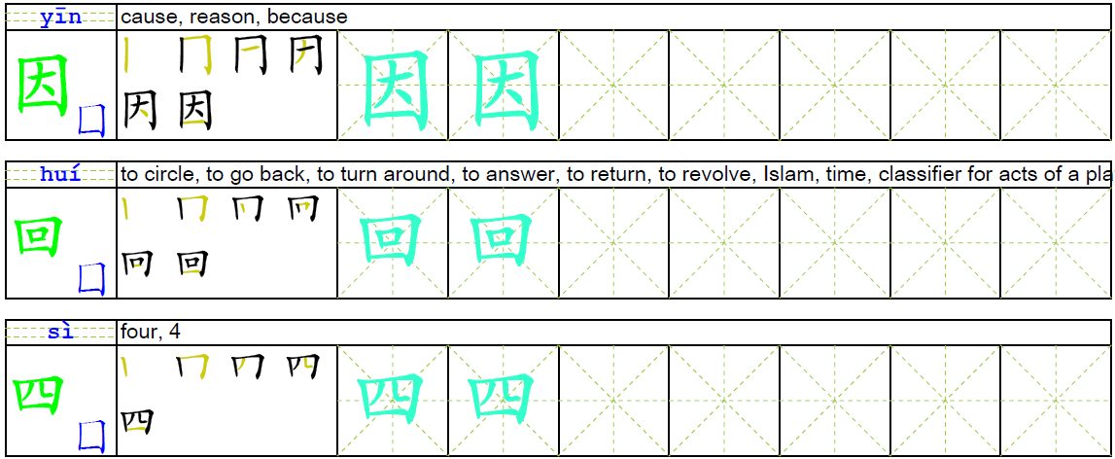

Real life reading practice. Look at the picture and circle or write down the character(s) you recognize. Write down the character’s Pinyin above it.

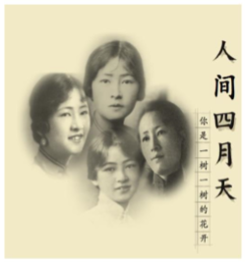

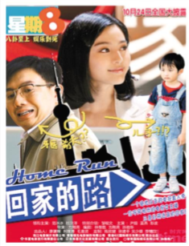

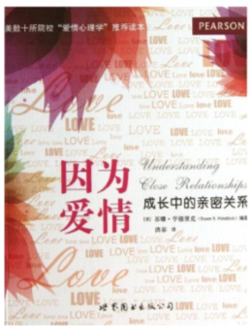

Identify following 20 characters you learned and write down pinyin, characters and English meanings on the space of this page.

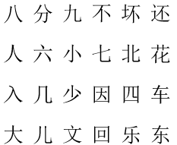

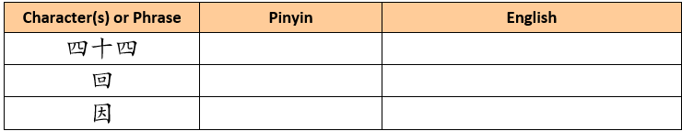



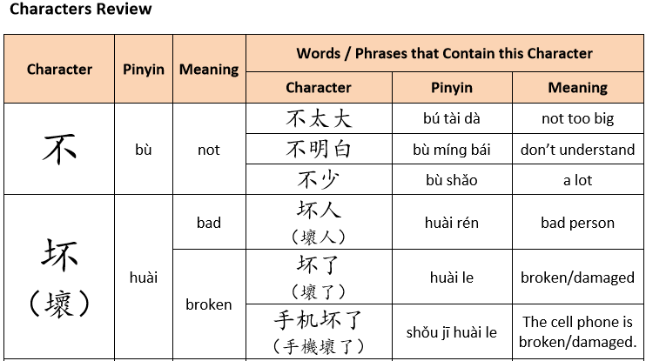

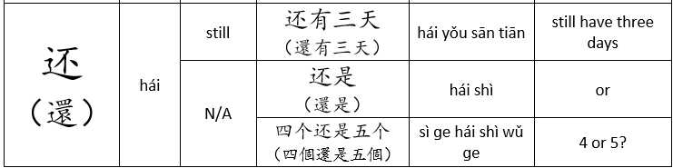

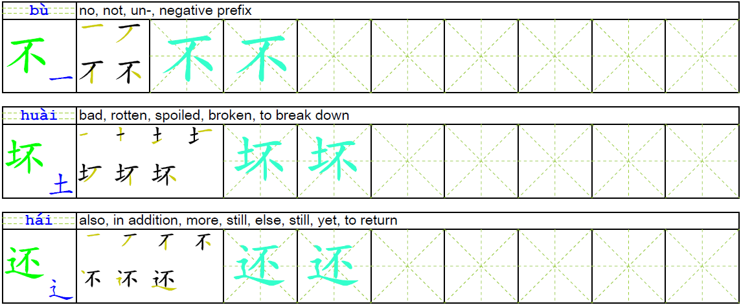



Real life reading practice. Look at the picture and circle or write down the character(s) you recognize. Write down the character’s Pinyin above it.



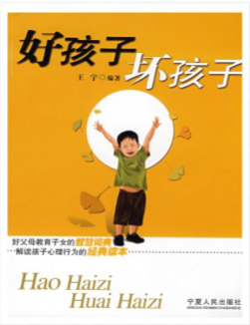

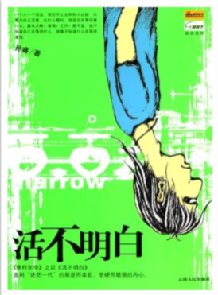

Identify following 20 characters you learned and write down pinyin, characters and English meanings on the space of this page.

