**Chapter 1: Linear relations**

**Revision A (32 marks)**

Name: ___________________________________

**Part A – Short Answer and multiple-choice questions** (10 marks)

**1** The expanded and simplified form of 2*x*(*x* + 3) is:

**2** simplify fractions $\frac{8y}{40}$:

**3 $\frac{x}{4}+\frac{x}{2}$** in simplest form is:

**4** simplify fractions $\frac{\left(x+3\right)\left(x-1\right)}{x+3}$

**5** simplify fractions $\frac{a}{3}×\frac{a}{6}$

**6** simplify fractions $\frac{2x}{7}+\frac{3x}{7}$

**7** The gradient for the following linear relation is:

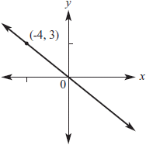

**8** Solve inequalities $8x≤-16$:

**9** The equation of the straight line shown is:

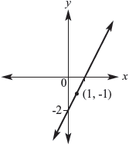

**A**  **B**  **C** 

**D**  **E** 

**10** Solve equation 5a+6=26:

**Part B – Short-answer** (22 marks)

**1** Simplify the following expressions

**a $\left(2a+7\right)+3a-1$** **b $\frac{p^{2}}{q}×\frac{q^{2}}{p}$**

__________________________ __________________________

__________________________ __________________________

**c  d $\frac{10k}{5}$**

__________________________ __________________________

__________________________ __________________________

**e $\frac{7}{m}×\frac{m}{14}$ f $\frac{3n}{2}÷\frac{n}{4}$**

__________________________ __________________________

__________________________ __________________________

**g $\frac{4}{5}+\frac{2}{3}$ h $\frac{2x}{4}+\frac{x}{3}$**

__________________________ __________________________

__________________________ __________________________

(8 × ½ = 4 marks)

**2** Solve the following equations.

**a**  **b** 

__________________________ __________________________

__________________________ __________________________

**c  d $\frac{4x}{3}=\frac{2x}{7}$**

__________________________ __________________________

__________________________ __________________________

(½ + ½ + 1 + 1 = 3 marks)

**3** Solve the following inequalities.

**a $3-x≥7$ b $2x+5<-4$**

__________________________ __________________________

__________________________ __________________________

(1 + 1 = 2 marks)

**4** Graph each of the following linear equations using the given method. Clearly mark the two points you use to draw the graph.

**a y=3x+4 b **

Use gradient and y-intercept. Use axis intercepts.

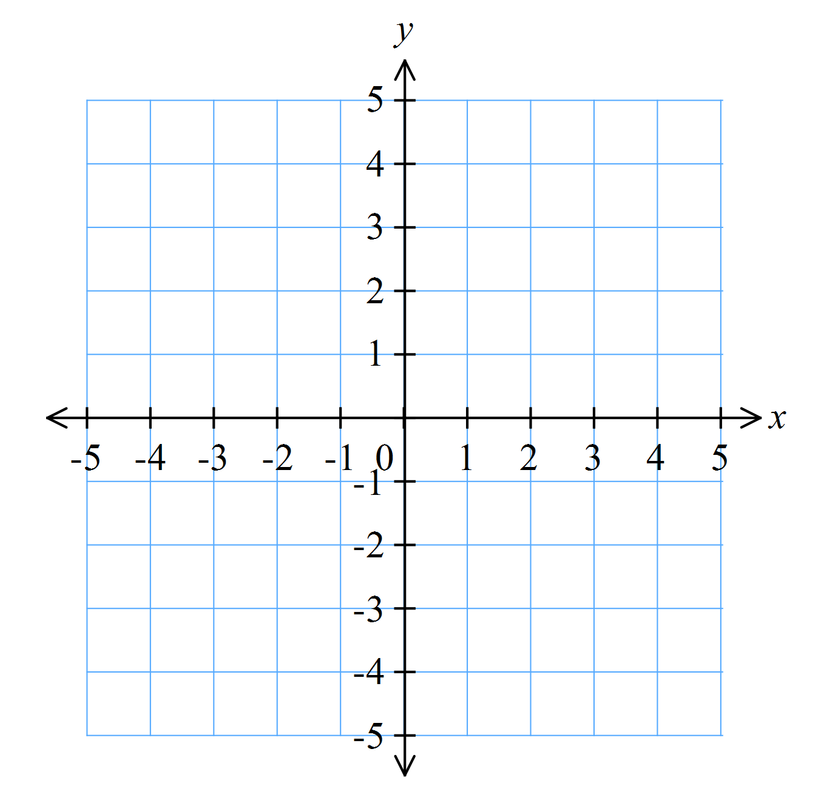 

(2 + 2 = 4 marks)

**5** Find the equation of the straight line shown.

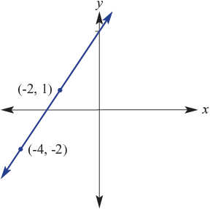

______________________________________________________________________________________________

______________________________________________________________________________________________

(2 marks)