<https://www.youtube.com/watch?v=s2GBL-IfY3Q>

<http://www.historyshistories.com/china-three-philosophies.html>

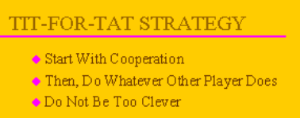

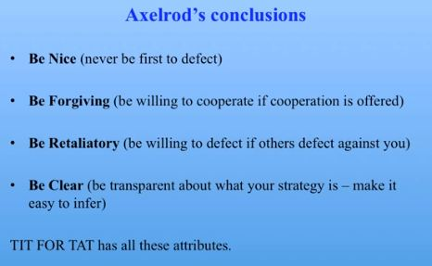

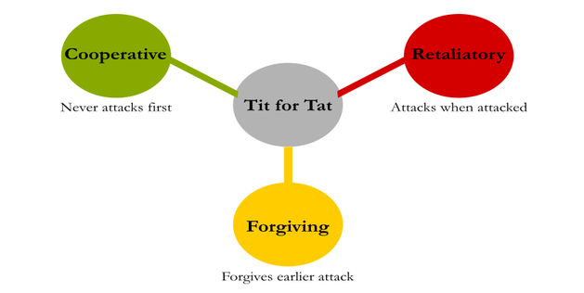

* “*Tit for Tat*”: Always begin by cooperating, then do whatever the opponent did on the last move. *I.e.*, retaliate once, then return to cooperation.

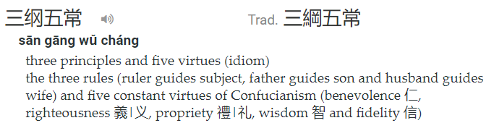

Guan xi & Chinese Philosophies

Confucius: tit for tat, san gang wu chang

Daoism balancing

Legalism lack of reliable legal system