**Chapter 3: Indices and surds**

**Assignment Part A**



**1** Simplify the following.

**a**  **b** 

_______________________________ _______________________________

_______________________________ _______________________________

**c**  **d** 

_______________________________ _______________________________

_______________________________ _______________________________



**2** Simplify the following.

**a**  **b** 

_______________________________ _______________________________

_______________________________ _______________________________

**c**  **d** 

_______________________________ _______________________________

_______________________________ _______________________________



**3** Simplify the following.

**a**  **b** 

_______________________________ _______________________________

_______________________________ _______________________________

**c**  **d** 

_______________________________ _______________________________

_______________________________ _______________________________



**4** Expand and simplify the following.

**a**  **b** 

_______________________________ _______________________________

_______________________________ _______________________________

**c**  **d** 

_______________________________ _______________________________

_______________________________ _______________________________



**5** Rationalise the denominator in the following.

**a**  **b** 

_______________________________ _______________________________

_______________________________ _______________________________

**c**  **d** 

_______________________________ _______________________________

_______________________________ _______________________________



**6** Forthese geometric shapes, determine the exact perimeter and exact area in simplest form.

**a** A rectangle with sides cm and cm.

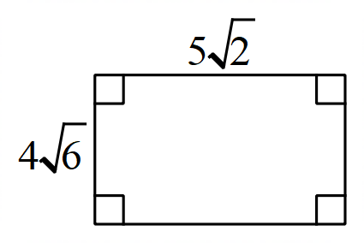

___________________________________________________________________________________

___________________________________________________________________________________

___________________________________________________________________________________

**b** A right angled triangle with side cm and hypotenuse 10 cm.

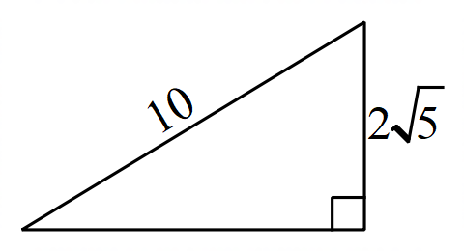

___________________________________________________________________________________

___________________________________________________________________________________

___________________________________________________________________________________

**c** A composite shape where the square has area 32 cm2.

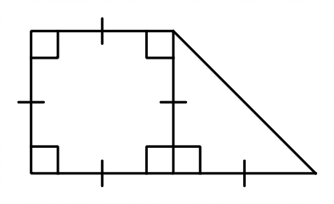

___________________________________________________________________________________

___________________________________________________________________________________

___________________________________________________________________________________

___________________________________________________________________________________

___________________________________________________________________________________

**Chapter 3: Indices and surds**

**Assignment Part B**

**1** Simplify the following using the index laws.

**a**  **b** 

_________________________________ _________________________________

_________________________________ _________________________________

**c**  **d** 

_________________________________ _________________________________

_________________________________ _________________________________

**e**  **f** 

_________________________________ _________________________________

_________________________________ _________________________________

**2** Evaluate using the zero power.

**a**  **b** 

_________________________________ _________________________________

_________________________________ _________________________________

**3** Express each using positive indices.

**a**  **b** 

_________________________________ _________________________________

_________________________________ _________________________________

**4** Simplify the following and express your answers using positive indices.

**a** 

__________________________________________________________________

__________________________________________________________________

__________________________________________________________________

**b** 

__________________________________________________________________

__________________________________________________________________

__________________________________________________________________

**5** Write these numbers as a basic numeral.

**a**  **b** 

_________________________________ _________________________________

**6** Write these numbers in scientific notation using four significant figures.

**a** 9 503 600 **b** 0.0051702

_________________________________ _________________________________



**7** Express the following in index form.

**a**  **b** 

_________________________________ _________________________________

**c**  **d** 

_________________________________ _________________________________

**8** Express the following in surd form.



**a**  **b** 

_________________________________ _________________________________



**9** Evaluate the following without a calculator.

**a**  **b** 

_________________________________ _________________________________

_________________________________ _________________________________

_________________________________ _________________________________



**10** Solve for *x* in each of the following.

**a**  **b** 

_________________________________ _________________________________

_________________________________ _________________________________

_________________________________ _________________________________

**Chapter 3: Indices and surds**

**Assignment Part C**

**1** Define variables and form exponential rules for the following situations.

**a** $400 000 is invested at 16% per annum.

_______________________________________________________________________________________________

_______________________________________________________________________________________________

_______________________________________________________________________________________________

**b** The contents of a leaking water tank, initially 800 litres, is decreasing at a rate of 4% per hour.

_______________________________________________________________________________________________

_______________________________________________________________________________________________

_______________________________________________________________________________________________

**2** The value of a house purchased for $600 000 is expected to grow by 12% per year.

Let $*V* be the value of the house after *t* years.

**a** Write a rule connecting *V* and *t*. ________________________________________________

**b** Use your rule to find the expected value of the house after the following number of years. Round to the nearest dollar.

**i** 2 years _____________________________________________________________________

_____________________________________________________________________

**ii** 10 years _____________________________________________________________________

_____________________________________________________________________

**c** Use trial and error to find the time *t*, when the house is worth close to a million dollars.

_______________________________________________________________________________________________

_______________________________________________________________________________________________

_______________________________________________________________________________________________

**3** Determine the amount if $50 000 is compounded annually at 12% for:

**a** 10 years **b** 20 years

______________________________________ __________________________________________

______________________________________ __________________________________________

**4** Calculate the number of periods (*n*) and the rate of interest (*r*) per period for the following:

**a** 6% p.a. for 5 years, paid monthly **b** 10% p.a. for 6 years, paid bi-annually

______________________________________ __________________________________________

______________________________________ __________________________________________

**c** p.a. for 3 years, paid quarterly **d 7**.8%for 4 years, paid weekly

______________________________________ __________________________________________

______________________________________ __________________________________________

**5** Anna invests $20 000 for 10 years at 9% p.a. compounded monthly.

**a** Calculate the interest rate per month. ________________________________________

**b** State the number of interest periods in 10 years. ______________________________

**c** Determine the amount in Anna’s investment account after 10 years.

______________________________________ __________________________________________

______________________________________ __________________________________________

**d** Determine the interest paid into Anna’s account over 10 years.

_____________________________________________________________________

**6** Determine the coordinates of the intersection point of the graphs of:

**a **and ** b ** and 

______________________________________ __________________________________________

______________________________________ __________________________________________

**c **and ** d ** and 

______________________________________ __________________________________________

______________________________________ __________________________________________

**7** Sketch the graphs of these exponential rules on the same set of axes, labelling each curve with its rule, the *y*-intercept and the point when *x* = 1.

**a** *y* = 3*x* **b** *y* = –3*x* **c** *y* = 3–*x* **d** *y* = –3–*x*

