

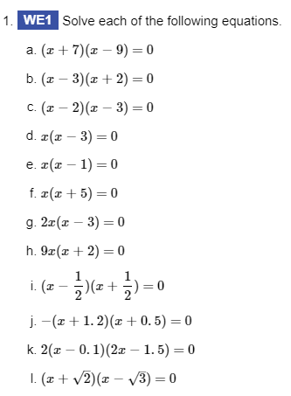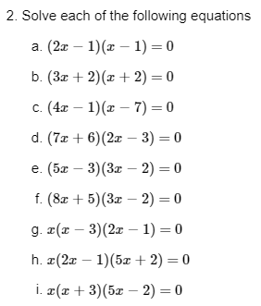

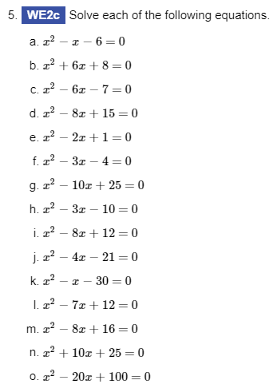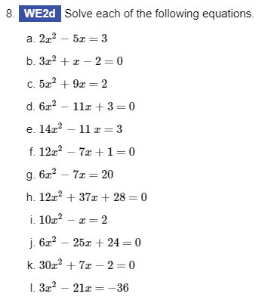



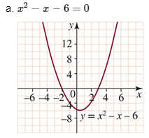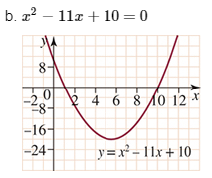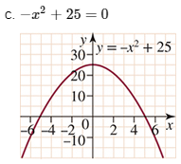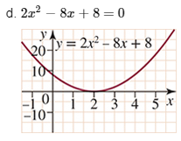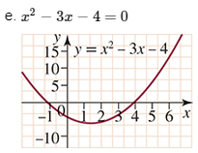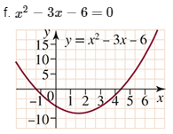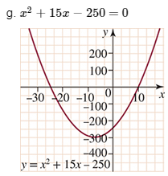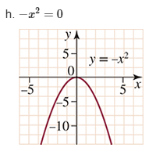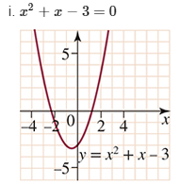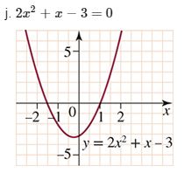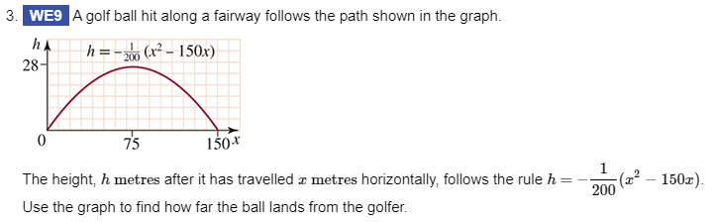

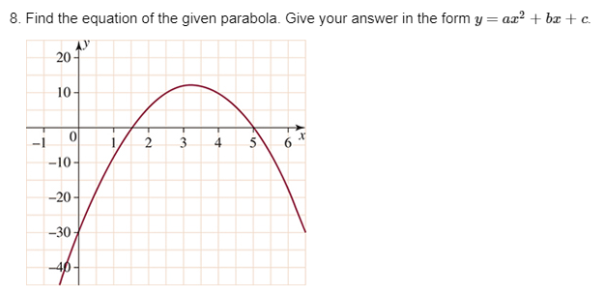

 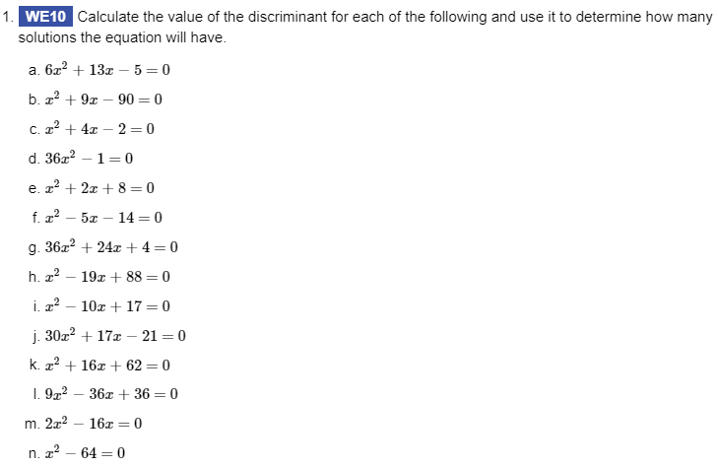

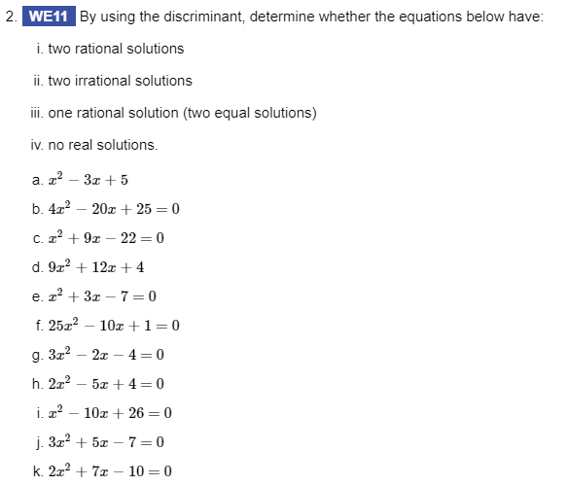

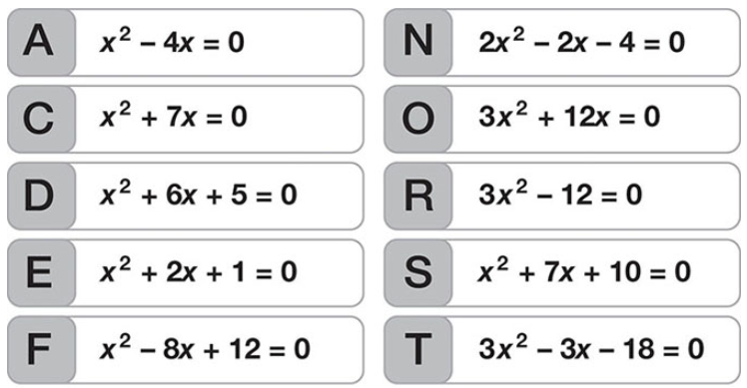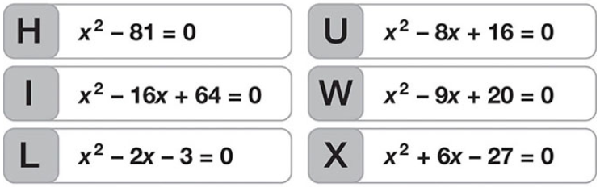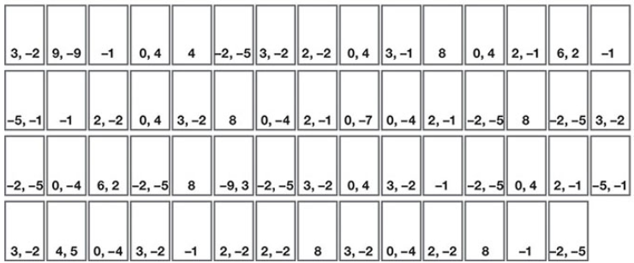

|  |  |
| --- | --- |
|  | Solve for *x*:   1. (*x* – 3)(*x* + 5) = 0 2. −2*x*(3*x* – 4) = 0 |
|  | Solve for *x*:   1. (*x* – 6)(*x* + 5) = 0 2. (5 – 2*x*)(*x* + 7) = 0 |
|  | Solve for *x*:   1. *x*2 + 8*x* + 16 = 0 2. *x*2 – 34*x* + 120 = 0 |
|  | Solve for *x*:   1. *x*2 – 64 = 0 2. 4*x*2 – 49 = 0 |
|  | Solve for *x*:   1. *x*2 + 7*x* = 0 2. 6*x*2 – 15*x* = 0 |
|  | Solve for *x*:   1. 2*x*2 – *x* – 6 = 0 2. 6*x*2 − 7*x* – 20 = 0 |
|  | Solve Equations:   1. *=0* 2. =0 |
|  | Solve Equations:  =0  =0 |